1. 第一批加工试件

1、1矩形缺口试件

|  |  |  |  |  |
| --- | --- | --- | --- | --- |
| 矩形缺口试验 | 编号 | 每个试件尺寸 | 每种比例所需尺寸 | 总共所需尺寸 |
| 1 | Q8A120-1 | 20mm*260mm | 110*000 | 200*600*20 |
| 2 | Q8A120-2 | 20mm*260mm |
| 3 | Q8A120-3 | 20mm*260mm |
| 4 | Q8A120-4 | 20mm*260mm |
| 5 | Q8B120-1 | 20mm*260mm | 90*000 |
| 6 | Q8B120-2 | 20mm*260mm |
| 7 | Q8B120-3 | 20mm*260mm |
| 8 | Q8C120-1 | 20mm*260mm | 90*000 |
| 9 | Q8C120-2 | 20mm*260mm |
| 10 | Q8C120-3 | 20mm*260mm |
| 11 | Q8D120-1 | 20mm*260mm | 110*000 |
| 12 | Q8D120-2 | 20mm*260mm |
| 13 | Q8D120-3 | 20mm*260mm |
| 14 | Q8D120-4 | 20mm*260mm |

注释：8代表母材890,120代表焊材ER120S，A代表比例为1，B代表比例为1.5，C代表比例为2，D代表比例为3.

|  |  |  |
| --- | --- | --- |
| ARnr | lode angle | 应力三轴度 |
| 1 | 1 | 1.297 |
| 1.5 | 0.52 | 1.257 |
| 2 | 0.15 | 1.194 |
| 3 | 0.03 | 1.118 |

1、2高强钢角焊缝试验

|  |  |  |  |  |  |
| --- | --- | --- | --- | --- | --- |
| 高强钢角焊缝试验 | 编号 | 10mmQ890 | 20mmQ890 | 10mmQ890 | 20mmQ890 |
| 1 | J8-120-90-1 | 360mm*250mm | 580mm*250mm | 2020*640 | 1260*1140 |
| 2 | J8-120-90-2 |
| 3 | J8-120-90-3 |
| 4 | J8-120-75-1 | 400mm*250mm | 600mm*250mm |
| 5 | J8-120-75-2 |
| 6 | J8-120-75-3 |
| 7 | J8-120-60-1 | 450mm*250mm | 640mm*250mm |
| 8 | J8-120-60-2 |
| 9 | J8-120-60-3 |
| 10 | J8-120-45-1 | 500mm*250mm | 680mm*250mm |
| 11 | J8-120-45-2 |
| 12 | J8-120-45-3 |
| 13 | J8-120-45-4 | 520mm*320mm | 580mm*320mm |
| 14 | J8-120-45-5 |
| 15 | J8-120-45-6 |
| 16 | J8-120-00-1 | 600mm*320mm | 580mm*320mm |
| 17 | J8-120-00-2 |
| 18 | J8-120-00-3 |
| 19 | J8-120-15-1 | 580mm*320mm | 580mm*320mm |
| 20 | J8-120-15-2 |
| 21 | J8-120-15-3 |
| 22 | J8-120-00-1 | 540mm*300mm | 580mm*320mm |
| 23 | J8-120-00-2 |
| 24 | J8-120-00-3 |

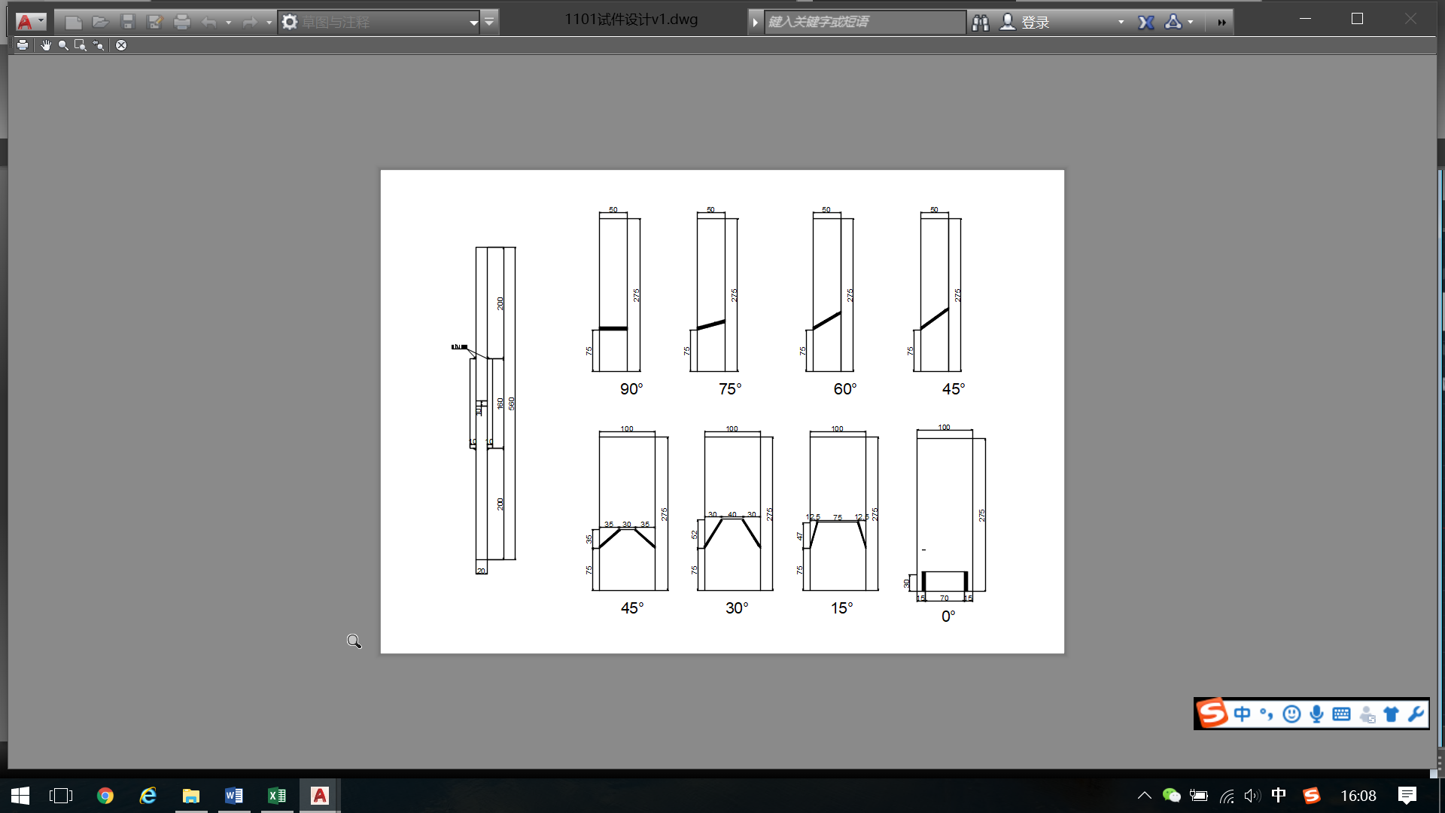

图：高强钢角焊缝试件尺寸

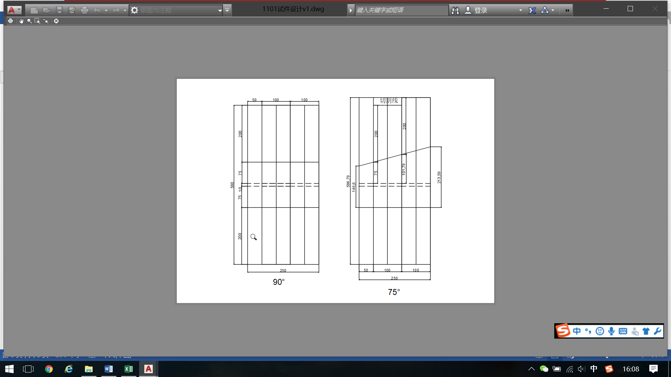

图：90°和75°焊接加工试件示意图

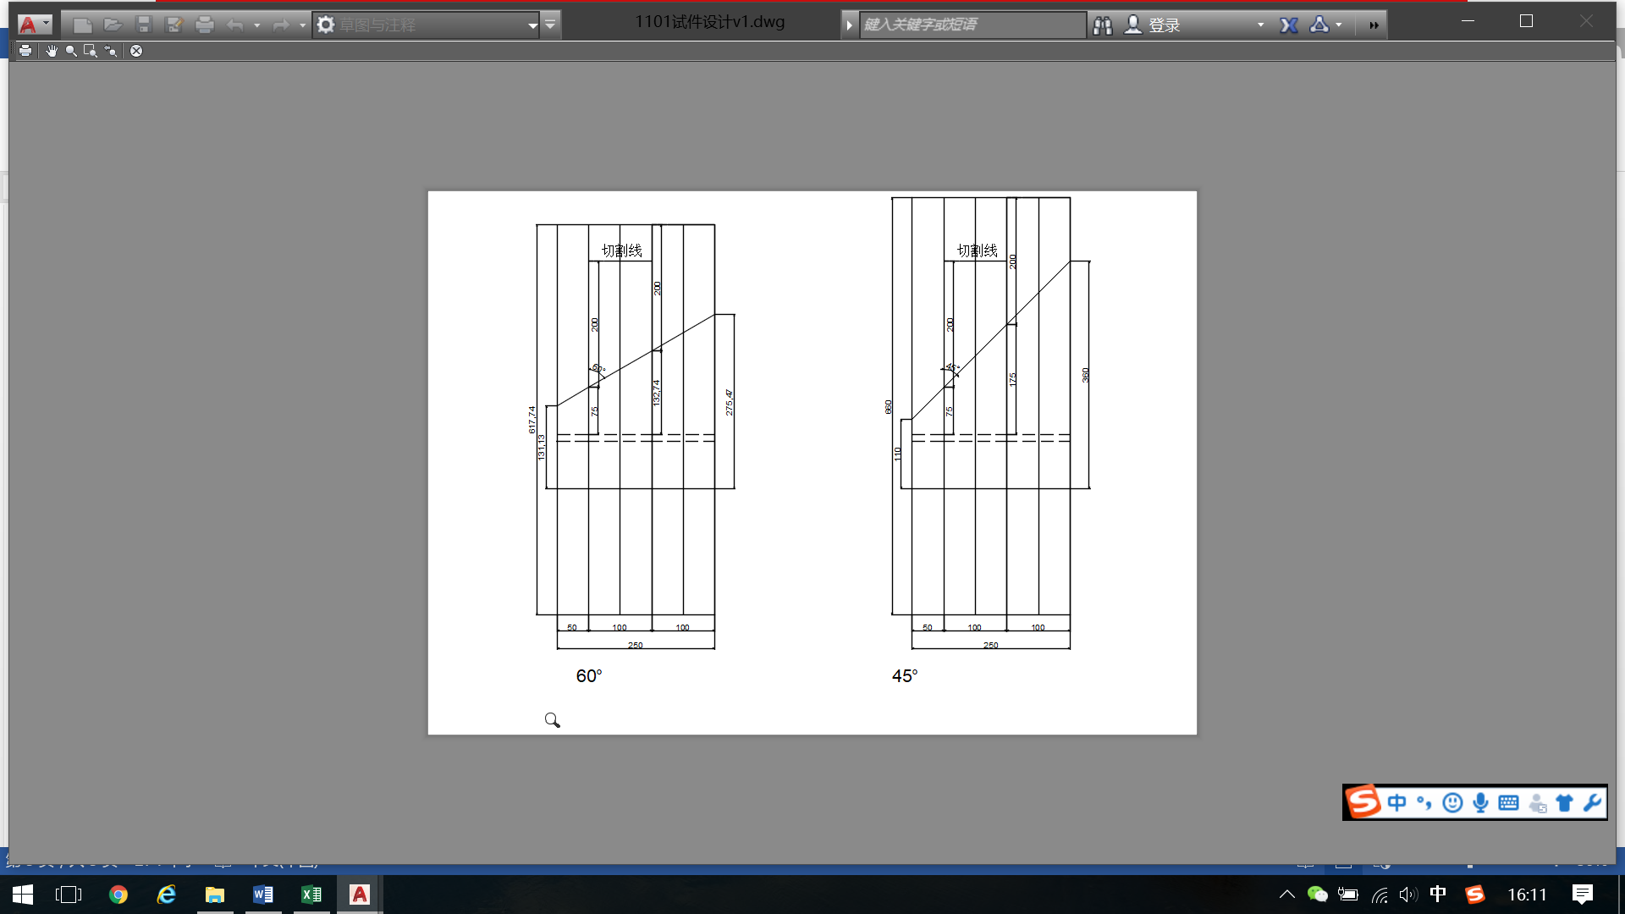

图：60°和45°焊接加工试件示意图

2、第二批加工试件

|  |  |
| --- | --- |
| 母材 | 焊材 |
| 690 | 50 |
| 76 |
| 120 |

钢板所需材料如第一批所示。

3、magi ABAQUS里面材料参数如下：

|  |  |  |
| --- | --- | --- |
|  | Q890 | ER120S |
| density | 7.85E-06 | 7.85E-06 |
| elastic | 杨氏模量、泊松比0.3 | 杨氏模量、泊松比0.3 |
| 强化准则 | 各向同性强化 | 各向同性强化 |
| 屈服准则 | von mises 屈服准则 | von mises 屈服准则 |