Instructions for authors

First A. AUTHOR[1]; Second B. AUTHOR[2]; Third C. AUTHOR2

1 Name of First Institution, Country

2 Name of Second Institution, Country

ABSTRACT

This template provides instructions to authors of papers to be included in the Proceedings of ICSC2018. All papers shall be submitted on-line as MS-Word files (*.doc or *.docx) AND Adobe Portable Document Format (*.pdf). An abstract is required at the start of all papers and shall contain **no more than 300 words**. The paper should **have 6 pages minimum but not exceed 12 pages in length and 15 MB in file size**. The paper must be written in English with A4 paper size and 25 mm margins. The corresponding author must submit the required files via the Conference Website (<http://www.icsc2018.com/>) no later than **31 May 2018**. Each corresponding author is allowed to present up to 2 papers.

Keywords: Maximum Five Keywords, Steel Structures, Tubular Structures, Fourth, Fifth

# INTRODUCTION

Use this document as a guide when writing your paper. Wherever possible, use the styles that have been defined in this document. The exclusive use of SI units is strongly recommended. If the imperial units are used, the imperial units shall be inserted in parentheses following the values in SI units, for example 25.4 mm (1 in).

# MANUSCRIPT FORMAT

## Title

The font of paper title shall be **Times New Roman 14-point bold font**. All words of the title are capitalized. Center the title as shown above. The pre-defined style is **“TITLE”**.

## Author Information

Author information shall be inserted below the title and centered using the above example as a guide. The font for author names is **Times New Roman, 11-point regular**. The pre-defined style is “Authors”. For each author, provide the first name(s) followed by the SURNAME in upper case. Separate multiple author names by a semi-colon. Place authors’ institutions and countries below the list of authors’ names using **Times New Roman 10-point regular**. The pre-defined style is “Affiliation”. If there are more than three authors, please continue adding authors and their affiliations according to the examples. The authors’ e-mail addresses at the bottom of the first page by using the “Footnote” option of Microsoft Word and setting this option to ‘on page’ not ‘end of document’.

## Submission of Papers

Your paper can only be accepted if the Word Document AND the PDF file are uploaded via the Conference Website (<http://www.icsc2018.com/>). The filename of paper should be the paper id number provided in abstract submission and the surname of the first author (e.g. **“123-SURNAME.docx” and** **“123-SURNAME.pdf”**). A submission notification email will be sent to the corresponding author (who submitted the paper). If you do not receive the notification email within 24 hours, please email the Conference Secretary. ([submission@icsc2018.com](mailto:submission@icsc2018.com)).

## Intellectual Property

Authors must obtain permission from the intellectual property holders before publishing or reproducing figures, images or other intellectual property in their manuscript.

# MAIN BODY

## Headings

As shown in this document, major headings shall be numerically ordered as 1, 2, etc. while subheadings are numerically ordered as 2.1, 2.2, etc. If finer subheadings are required, they shall be numbered as 2.6.1, 2.6.2, etc.

The pre-defined style of Level 1 headings is **“1. MAJOR HEADINGS”**. Level 1 headings shall be 12-point upper case Times New Roman bold font and numerically ordered. The spacing before the heading is 12-point with 1-point after.

The pre-defined style of Level 2 subheadings is **“1.1 Subheadings”**. Level 2 subheadings shall be in 12-point Times New Roman bold type with upper and lower case. The spacing before the subheading is 6-pt with no space after.

The pre-defined style of Level 3 heading is **“1.1.1 Third Headings”**. If required, which uses 11-point Times New Roman bold type with upper and lower case. The space before the third heading is 3-pt with no space after.

## Main Body

The text font for the main body is **11-point, regular Times New Roman**. The first line of a paragraph is indented by 0.5 cm. The pre-defined style for the text of the main body is **“Paragraph”.**

## Figures, Photos and Tables

### Figures and Photos

Incorporate all graphics, charts, tables, illustrations, photos, etc. directly into your manuscript shortly after their first mention. An example of the preferred layout of a graphic is shown in Figure 1.

The graphic was centered on the page using the pre-defined style “Figure”. The figure has a caption label beneath the graphic and in 10 point Times New Roman, and centered by using the pre-defined style “Caption”.

If your paper includes photographs, you need to reduce the dimensions of each image and place the reduced image in the text after first mention. Do not use high-resolution pictures, since that is likely to increase the size of your final PDF file. A resolution of 200 dpi should be sufficient for most papers. Ensure that the colour modes of all images are RGB, not CMYK.

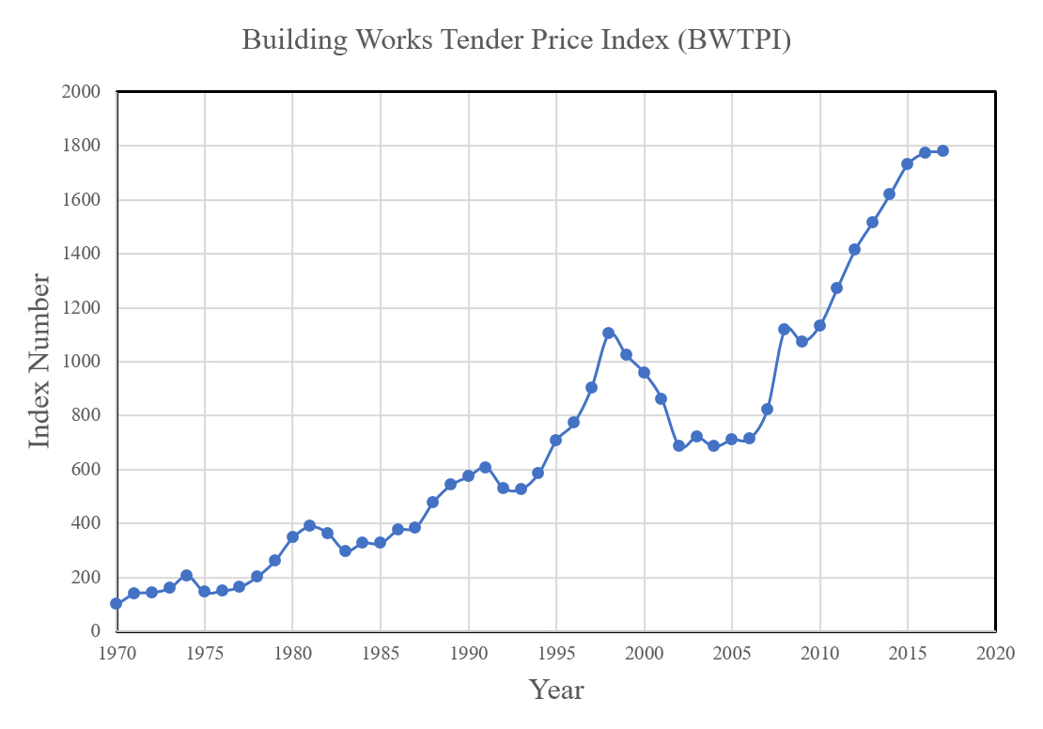

Figure 1: This is a caption for the figure

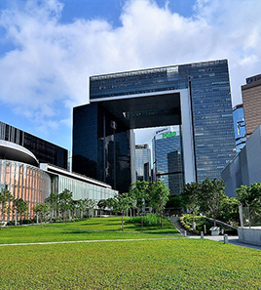

Figure 2: Photo of Hong Kong Central Government Office

### Tables

Tables are centered on the page. The caption is placed just above the table and in 10 point Times New Roman by using the pre-defined style is “Caption”. A table example is shown as follows.

Table 1: Material Properties

|  |  |  |
| --- | --- | --- |
|  | **Steel** | **Concrete** |
| **Density (kN/m3)** | 78.5 | 17 - 24 |
| **Poisson’s ratio** | 0.3 | 0.15 - 0.2 |
| **Modulus of elasticity, E (GPa)** | 205 | 24 - 32 |
| **Modulus of rigidity, G (GPa)** | 80 | ~ 20 |

## Equations

Equations shall be typeset (using the Microsoft Equation Editor if using MS Word) as follows

|  |  |
| --- | --- |
|  | (1) |

The equation is set into a two-column 160-mm-wide table where the left-hand 150-mm-wide column contains the equation, and the right-hand column contains the equation number enclosed in parentheses. The equation is centered within the cell, and the equation number is vertically centered to align with the equation.

## Conclusions

The section before acknowledgements and references, where the authors describe the most-relevant findings of their work.

# ACKNOWLEDGEMENTS

Authors may acknowledge financial or other forms of support in this Section. All acknowledgements shall be placed after Conclusions and before References.

# REFERENCES

In the text, references should be cited by brackets (e.g., “…the design of cold-formed system [1,2]”, “… shaking table study by Li and Ding [3]” and “… study reported by Han *et. al.* [4].”)

REFERENCES

1. Nethercot D.A., Kyvelou P., Hui C. and Gardner L. “The changing basis for the design of cold-formed purlin systems”, *Proceedings of the 8th International Conference on Advances in Steel Structures*, Lisbon, Portugal, Paper number 4, 2015.

2. *Specification for the Design of Cold-Formed Stainless Steel Structural Members*. ASCE Standard SEI/ASCE 8-02, Reston, VA, American Society of Civil Engineers, 2002.

3. Li, G., Zhou, X., & Ding, X. (2001). “Shaking Table Study on a Model of Steel-Concrete Hybrid Structure Tall Buildings”. *Journal of Building Structures*, 2(22), 2-7.

4. Han, L. H., Tao, Z., & Liu, W. (2001). “Concrete filled steel tubular structures from theory to practice”. *Journal of Fuzhou University (Natural Sciences Edition)*, 6, 003.

1. FirstAuthor@aaa.com (corresponding author)
2.