**NUMERICAL ANALYSIS of transverse fillet weld joints made of Q890 steel grade**

Chen Zhao1; Fei-fei Sun2

1College of Civil Engineering, Tongji University, Shanghai, China

2 State Key Laboratory of Disaster Reduction in Civil Engineering, Tongji University, Shanghai, China

ABSTRACT

This paper was focused on numerical analysis of transverse fillet weld joints made of Q890 steel grade combined with ER120 electrodes. The true stress-strain relationship for high strength steel Q890 grade was calibrated, which was based on a trial-and-error approach using simulation through comparing the load-deformation response. Good coherence on the load-deformation response between the simulation and the experiments was also validated. The calibrated material parameters were applied into the finite element models which were made of Q890 steel combined with ER120 electrodes.

Keywords: High Strength Steel, Transverse Fillet Welds,

# INTRODUCTION

With the development of steel manufacturing technology, HSS with high toughness and weldability has been used in applications of different fields, not only in construction but also in crane and truck industry [1]. One of the most significant concerns for the engineering world is whether the designed structure members are connected safely. Fillet weld joint is one of the most frequently-used joints in steel structures due to its economical efficiency in construction and adaptability to the site as well as welding position. This kind of weld requires less precision than groove weld as the two base metal parts are overlapped, and requires less preparation as the edges are not generally treated once cut by any kind of cutting technology. Some researches about the behavior of welded connections have been done concerning some important factors such as weld-to-load angle, weld size and weld type.

The majority of researches from the early 1930’s to the present has been done on transversely-loaded or longitudinally-loaded fillet welds [2]. On one hand, it has shown that transversely-loaded fillet welds (the angle between the weld and the load is 90°) present the upper bound of strength resistance and the lower bound of joint ductility. On the other hand, longitudinally-loaded fillet welds present lower strengths but higher ductility than the transversely-loaded ones [3]. The most significant experiments on fillet welds loaded at intermediate angles are those of *Butler and Kulak (1971), Biggs et al. (1981), Mizaga and Kennedy (1989), Lesik and Kennedy (1990). Miazga and Kennedy (1989)* reported results from 42 fillet weld double splice experiments with different load angles from 0⁰ to 90⁰ with (Δθ=15⁰) and with two different weld sizes (5 and 9 mm). *Lesik and Kennedy (1990)* [4]extended the work of *Miazga and Kennedy (1989)* to consider the strength of a fillet weld loaded eccentrically in-plane using the method of instantaneous center of rotation. A simplified formulation about the influence of the weld-to-load angle provided by *Miazga and Kennedy (1989)* was given.Figure1 and Eq(1) gives such expression.

 (1)

where: Pθ is the strength at any angle of equivalent characteristics of the reference longitudinal weld; Plong is the strength of a longitudinal weld; θ is the weld-to-load angle.

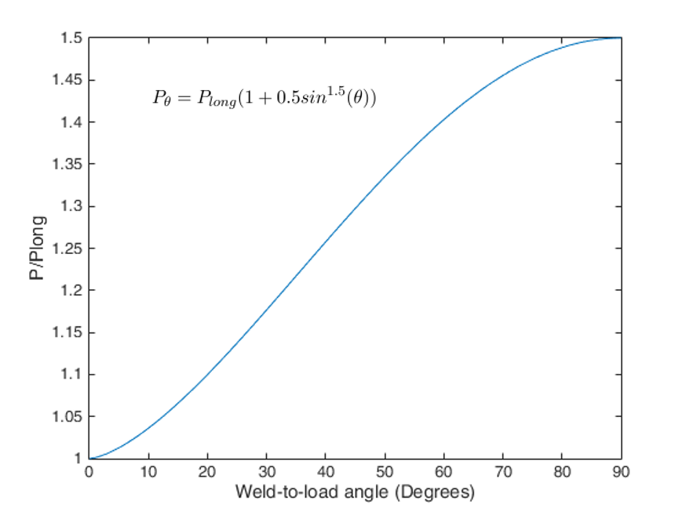

Figure 1: Graphical representation of Eq.(1)

This paper was focused on numerical analysis of transverse fillet weld joints made of Q890 steel grade combined with ER120 electrodes. The true stress-strain relationship for high strength steel Q890 grade was calibrated, which was based on a trial-and-error approach using simulation through comparing the load-deformation response. Good coherence on the load-deformation response between the simulation and the experiments was also validated. The calibrated material parameters were applied into the finite element models which were made of Q890 steel combined with ER120 electrodes.

# EXPERIMENT DETAILS

## Experiment Specimen and Material

The experimented steel was quenched and tempered (QT) steel(Q890) which was made into plates with 10mm and 20mm thickness. The weld material is AWS A5.28 ER120S-G provided by KUNSHAN MCC BAOSTEEL Welding Consumables. Co,LTD. The chemical composition and mechanical properties are shown in Table 1 and 2.

Table 1: Chemical Composition of Q890 and ER120S-G(%)

|  |  |  |  |  |  |  |
| --- | --- | --- | --- | --- | --- | --- |
|  | **C** | **Si** | **Mn** | **P** | **S** | **V** |
| **Q890D-10mm** | 0.160 | 0.310 | 1.30 | 0.012 | 0.001 | 0.047 |
| **Q890D-20mm** | 0.140 | 0.280 | 1.07 | 0.012 | 0.004 | 0.013 |
| **ER120S-G** | 0.09 | 0.74 | 1.73 | 0.006 | 0.003 |  |
|  | **Ti** | **Cr** | **Nb** | **Al** | **Mo** | **Ni** |
| **Q890D-10mm** | 0.018 | 0.260 | 0.023 | 0.039 | 0.570 | 0.07 |
| **Q890D-20mm** | 0.013 | 0.520 | 0.013 | 0.029 | 0.460 | 0.820 |
| **ER120S-G** |  | 0.33 |  |  | 0.58 | 2.29 |

Table 2: Mechanical Properties of Q890 and ER120S-G

|  |  |  |  |  |  |  |
| --- | --- | --- | --- | --- | --- | --- |
|  |  |  | **Elongation%** | **IMPACT TEST AKV(J)** | | |
| **Q890D-10mm** | 1040 | 1050 | 13.5 | 58 | 77 | 72 |
| **Q890D-20mm** | 914 | 979 | 15.4 | 191 | 189 | 175 |
| **ER120S-G** | 908 | 1022 | 16.4 | 84 | 90 | 84 |

The experiment to be simulated with numerical method consists of a double lapped configuration with transverse fillet welds. The thickness of the side plate and the middle plate is 10mm and 20mm respectively. The leg size of weld 1 is 5mm and weld 2 is 10mm. The detailed size of experiment specimen is shown in Figure 2.



Figure 2: Experiment specimen

## Experiment procedure

The specimens were tested in monotonic tension in a 2000kN capacity MTS device. A constant feed rate of displacement loading 0.5 mm/min was used to simulate quasi-static loading conditions. Another device called digital imaged correlation (DIC) which was a kind of non-contact 3d strain optical measurement system recorded every frame from the beginning of the experiment to the end during the whole experiments. The experimental instrument is shown in Figure3.

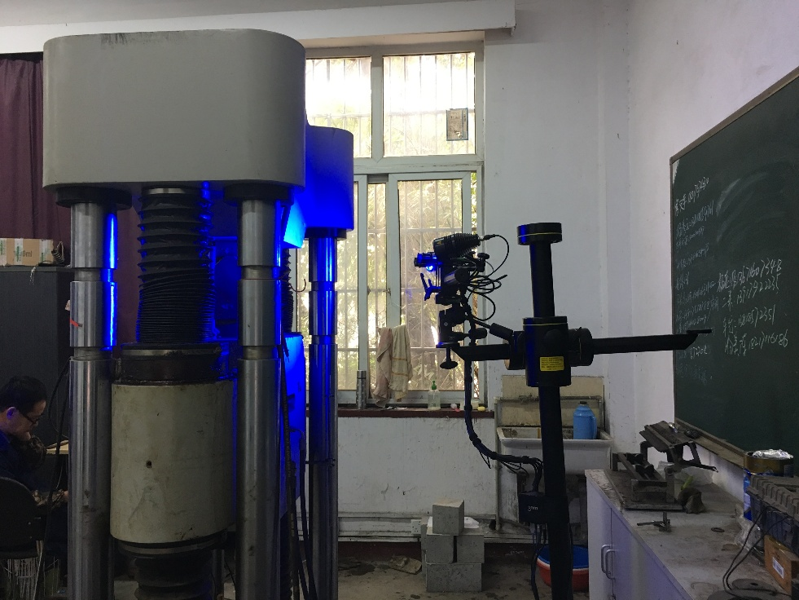

Figure 3: Experimental instrument

# EXPERIMENT RESULTS

## Constitutive Model

In order to simulate the fillet weld accurately, it is necessary to acquire the real stress–strain relationship before and after necking of each material and to dictate the load–deformation curve and ultimate load-carrying capacity of the butt weld specimen. For base metal Q890, coupon tests represent an effective and common approach to calibrate their material model. Before necking, the following formula (Equation 2) can be used as their constitutive model because the strain in the whole specimen is almost the same.

  (2)

where , ,andare the nominal strain, nominal stress, real strain and real stress, respectively .

First, the coupon test needs to be conducted and then Equation 2 can be used to obtain the real stress–strain before necking. Second, according to the Ramberg–Osgood model, an improved function based on the power law stress–strain relationship is used.

 for 

 for  (3)

where  is the plastic strain at the end of the yield plateau,σ0 is the real stress at the end of the yield plateau, if there is no obvious plateau, then suppose the point of (, σ0) is equal to the intersection point between the test curve and σ=Eεp ;σ is the real stress and εp is the plastic strain, σy is the yield stress, K is a constant and n is the strain hardening exponent.

Derived from Equation 3

 for  (4)

At the peak point ( , σu) in the nominal stress plotted against strain curves

 (5)

and comparing Equation 3 with Equation 5, the following equation can be obtained. Thus the initial values of the parameters can be found.

 (6)

Third, the specimen with the same geometry is simulated using the material model obtained from the last step. Fourth, the load–displacement responses were compared between the simulation result and the experiment result and the values of K and n were modified. Then the third and fourth steps should be repeated until the error between simulation result and experiment result is within the tolerance limits defined. From the four steps mentioned above, constitutive model parameters of base metal (Q890-10mm/Q890-20mm) can be obtained which are shown in Table 3. Procedures for finding the constitutive model of the material are shown in Figure 4. The experiment data and the finite element results were well simulated and the load-deformation response of the Q890-10mm and 20mm is shown in Figure 5-6.

Table 3: Mechanical Properties of Q890

|  |  |  |  |  |  |
| --- | --- | --- | --- | --- | --- |
|  |  |  | **Yield ratio%** | **R-O model parameter** | |
| **K** | **n** |
| **Q890D-10mm** | 1128.90 | 1153.45 | 0.98 | 1559 | 0.09 |
| **Q890D-20mm** | 934.73 | 980.23 | 0.95 | 1280 | 0.0738 |

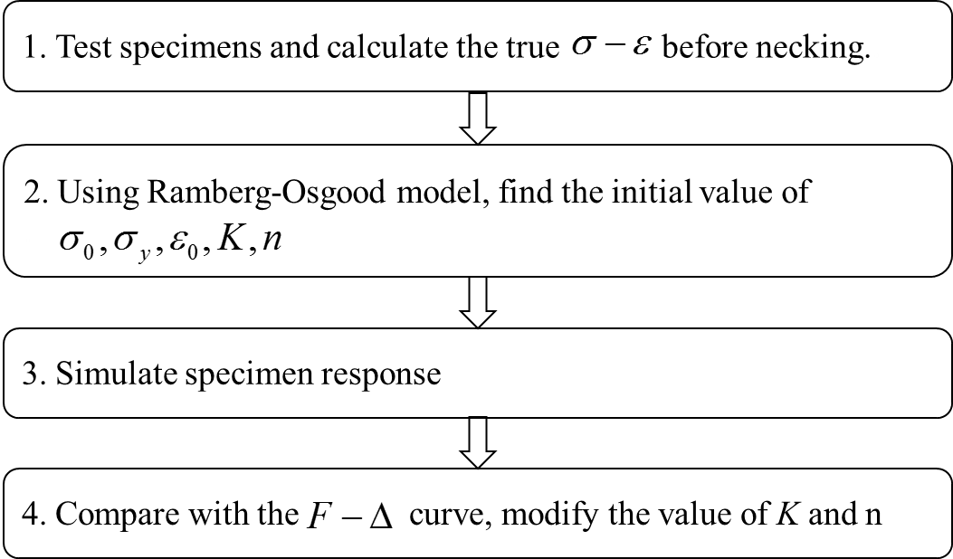

Figure 4: Procedures for finding the constitutive model of the material

|  |  |
| --- | --- |
|  |  |
| Figure 5: Load-deformation response of the Q890-10mm | Figure 6: Load-deformation response of the Q890-20mm |

## Finite Element Model

Considering the symmetry of the specimen, a reduced model is created with the aim of increasing the accuracy of the output and reduce the computational time. From Figure 7, it can be seen the reduced model is one eighth of the full model, The applied mesh to the welded region is 0.5 0.5 mm2, a restricted movement in the X, Y, Z-axis direction is defined on the left face, bottom face and front face respectively.

|  |  |
| --- | --- |
| C:\Users\zhaochen\AppData\Local\Temp\1528723935(1).png | C:\Users\zhaochen\AppData\Local\Temp\1528724436(1).png |
| Figure 7.1 Model mesh | Figure 7.2 Bottom face boundary condition |
| C:\Users\zhaochen\AppData\Local\Temp\1528724449(1).png | C:\Users\zhaochen\AppData\Local\Temp\1528724463(1).png |
| Figure 7.3 Front face boundary condition | Figure 7.4 Left face boundary condition |

Figure 7: Mesh and boundary condition of the reduced model

## Reduced Model Results

The results for the reduced model are presented in Figure 8. It can be said that the elastic regime is still not well simulated, as the experimental results seems to plasticize earlier. In addition, the failure of the model is not perfectly simulated, as the numerical curve is slightly extended after the failure of the experimental results and an important drop in the load-carrying capacity is seen.

Figure 8: Load Displacement comparison between the experiment and the reduced model

# CONCLUSIONS

This paper was focused on the experiments of transverse fillet weld joints made of Q890 steel grade combined with ER120 electrodes. Based on the experimental and numerical analysis results, the conclusions can be drawn as follows.

(1) The real stress-strain relationship for high strength steel Q890 grade was calibrated, which was based on a trial-and-error approach using simulation through comparing the load-deformation response. Good coherence of the load-deformation response between the simulation and the experiment was also validated.

REFERENCES

1. Klein M, Spindler H, Luger A et al. (2005) Thermomechanically hot rolled high and ultra high strength steel grades – processing, properties and application. *Materials Science Forum*. Trans Tech Publications, Zurich, Switzerland, vol. 500, pp. 543–550.

2. Miazga GS, Kennedy DJL. Behaviour of fillet welds as a function of the angle of loading. *Can J Civ Eng* 1989;16:583–99.

3. Ng AKF, Driver RG, Grondin GY. *Behaviour of Transverse Fillet Welds*, 2002.

4. Lesik DF, Kennedy DJL. Ultimate strength of fillet welded connections loaded in plane. *Can J Civ Eng* 1990;17:55–67.