#include <iostream>

using namespace std;

int main(int argc, char const \*argv[])

{

cout << "\t\t\t九九乘法表" << endl;

cout << "\t\t\t====================" << endl;

for (int i = 1; i < 10; ++i)

{

for (int j = 1; j < 10; ++j)

{

if (j < i)

{

cout << "\t";

continue;

}

cout << i << "×" << j << "=" << j\*i << "\t";

}

cout << endl;

}

return 0;

}

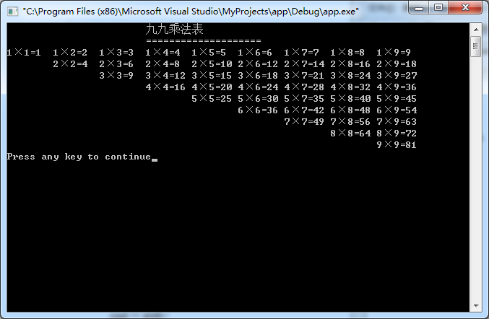

#include <iostream>

using namespace std;

int main(int argc, char const \*argv[])

{

cout << "\t\t\t九九乘法表" << endl;

cout << "\t\t\t====================" << endl;

for (int i = 1; i < 10; ++i)

{

for (int j = 1; j <= i; ++j)

{

cout << i << "×" << j << "=" << j\*i << "\t";

}

cout << endl;

}

return 0;

}

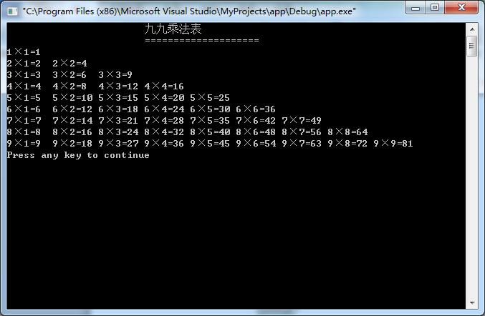

#include <iostream>

using namespace std;

int main(int argc, char const \*argv[])

{

unsigned short year,month,days;

cout << "输入年月：" ;

cin >> year >> month;

switch(month)

{

case 2:

if(year%4 == 0 && year%100 != 0|| year %400 == 0)

{

days = 29;

}

else

{

days = 28;

}

break;

case 4:

case 6:

case 9:

case 11:days = 30;break;

default :days = 31;

}cout << year << "年" << month << "月的天数为：" << days << endl;return 0;}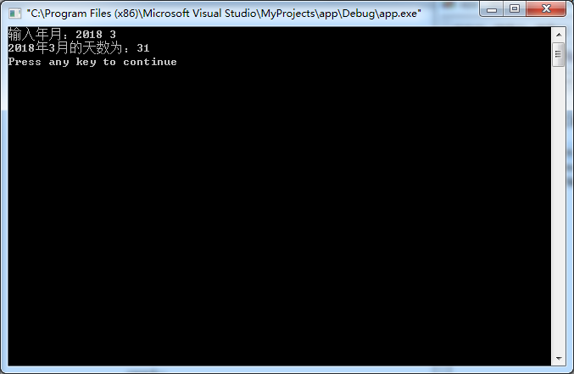

#include <iostream>

using namespace std;

int main(int argc, char const \*argv[])

{

int num, max, min;

cout << "输入数m:";

cin >> num;

max = min = num;

while(cin >> num,num != 0)

{

if (num > max)

{

max = num;

}

if (num < min)

{

min = num;

}

}

cout << "最大值是" << max <<endl

<< "最小值是 " << min <<endl;

return 0;

}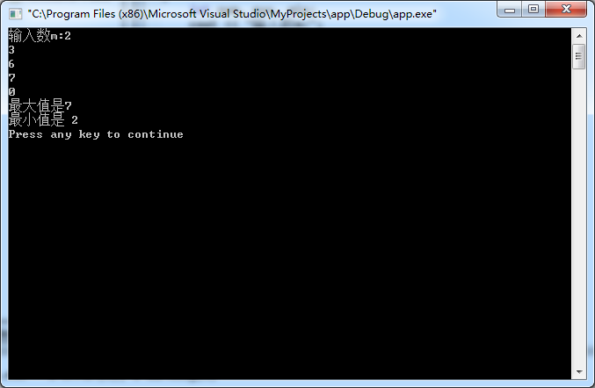

#include <iostream>

using namespace std;

int main(int argc, char const \*argv[])

{

int a, q, n, sum;

a = 1;

q = 2;

n = sum = 0;

do{

sum += a;

++n;

a \*= q;

}while(sum < 100);

--n;

cout << n <<endl;

return 0;

}

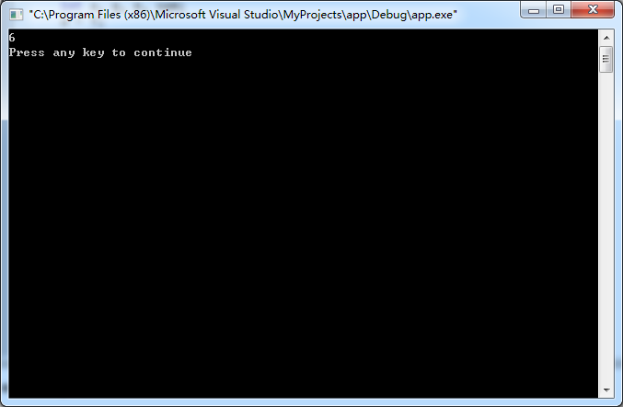

#include <iostream>

using namespace std;

int main(int argc, char const \*argv[])

{

int a = 1;

cout << "\t\t\tASCII对照表"<<endl;

for (char asc = 32; asc < 127; ++asc,++a)

{

cout << "\""<< asc << "\"" <<"=" << int(asc) << "\t";

if (a % 7 == 0)

{

cout << endl;

}

}

return 0;

}

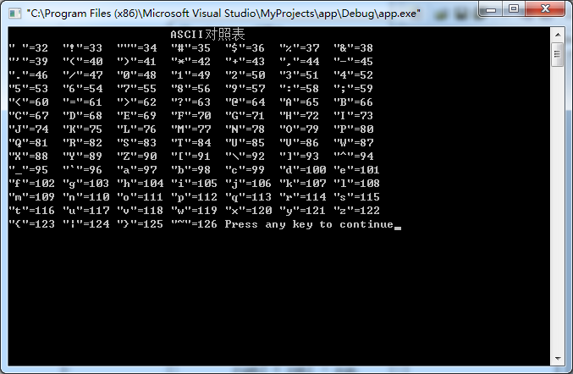

#include <iostream>

#include <iomanip>

using namespace std;

int main(int argc, char const \*argv[])

{

int n;

float d, sum = 0, rmb1, rumb2;

while(1)

{

cout << "请输入单价和数量:";

cin >> d >> n ;

if(n == 0) break;

sum += d\*n;

}

cout << "----------------------" << endl;

cout << setiosflags(ios::fixed)<<setprecision(2);

cout << "总计:" << sum << endl;

cout << "应收:" << sum << endl;

cout << "----------------------" << endl;

cout << "现金:";

cin >>rmb1;

rumb2 = rmb1 - sum;

cout << "找零:" << rumb2 <<endl;

return 0;}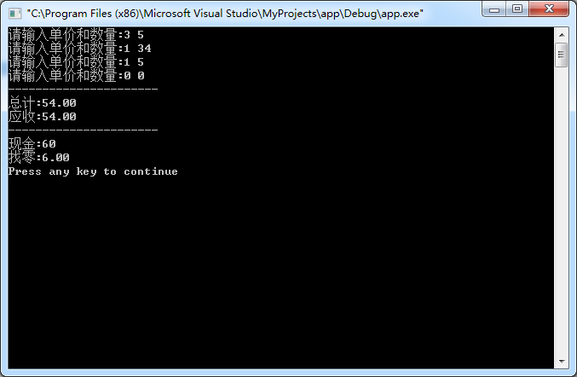

#include <iostream>

#include <iomanip>

using namespace std;

int main(int argc, char const \*argv[])

{

int row;

cout << "请输入行数：";

cin >> row;

int i,j,n;

n = row/2+1;

for(i = 1; i <= n; i++)

{

for(j=1;j<=n-i;j++) cout <<' ';

for(j=1;j<=2\*i-1;j++) cout << '\*';

cout << endl;

}

for(i = 1; i <= n-1; i++)

{

for(j=1;j<=i;j++) cout <<' ';

for(j=1;j<=row-2\*i;j++) cout << '\*';

cout << endl;

}

return 0;

}

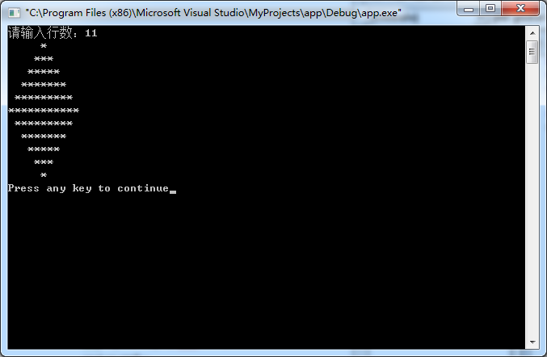

#include <iostream>

using namespace std;

double cul(int n)

{

double result = 0;

for (int i = 1; i <= n; ++i)

{

result += i\*i;

}

return result/double(n);

}

int main(int argc, char const \*argv[])

{

int n;

cin >> n;

cout << "(1^2 + 2^2 + 3^2 +...+ n^2)/n = " << cul(n) <<endl;

return 0;

}