下三角：

#include <iostream>

using namespace std;

int main(int argc, char const *argv[])

{

cout << "\t\t\t九九乘法表" << endl;

cout << "\t\t\t====================" << endl;

for (int i = 1; i < 10; ++i)

{

for (int j = 1; j < 10; ++j)

{

if (j < i)

{

cout << "\t";

continue;

}

cout << i << "×" << j << "=" << j*i << "\t";

}

cout << endl;

}

return 0;

}

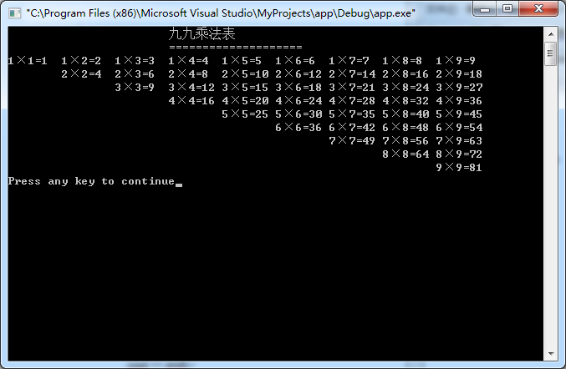

上三角

#include <iostream>

using namespace std;

int main(int argc, char const *argv[])

{

cout << "\t\t\t九九乘法表" << endl;

cout << "\t\t\t====================" << endl;

for (int i = 1; i < 10; ++i)

{

for (int j = 1; j <= i; ++j)

{

cout << i << "×" << j << "=" << j*i << "\t";

}

cout << endl;

}

return 0;

}

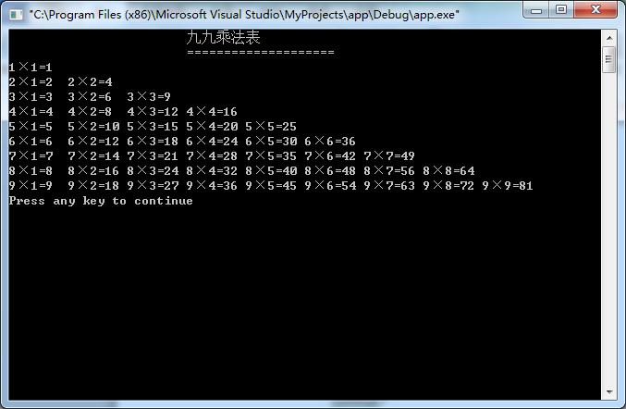

实验二 5

#include <iostream>

using namespace std;

int main(int argc, char const *argv[])

{

unsigned short year,month,days;

cout << "输入年月：" ;

cin >> year >> month;

switch(month)

{

case 2:

if(year%4 == 0 && year%100 != 0|| year %400 == 0)

{

days = 29;

}

else

{

days = 28;

}

break;

case 4:

case 6:

case 9:

case 11:days = 30;break;

default :days = 31;

}cout << year << "年" << month << "月的天数为：" << days << endl;return 0;}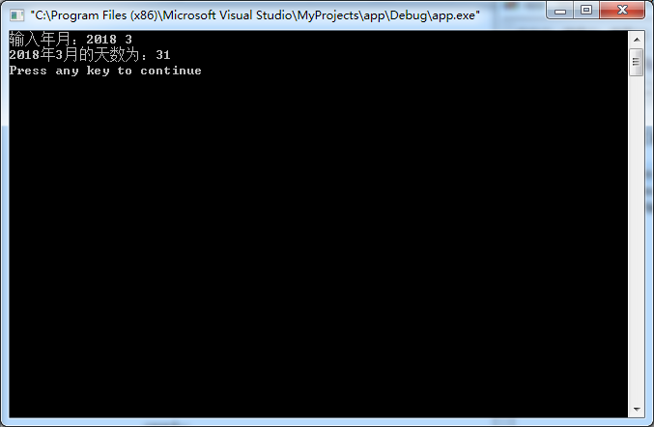

实验三1

#include <iostream>

using namespace std;

int main(int argc, char const *argv[])

{

int num, max, min;

cout << "输入数m:";

cin >> num;

max = min = num;

while(cin >> num,num != 0)

{

if (num > max)

{

max = num;

}

if (num < min)

{

min = num;

}

}

cout << "最大值是" << max <<endl

<< "最小值是 " << min <<endl;

return 0;

}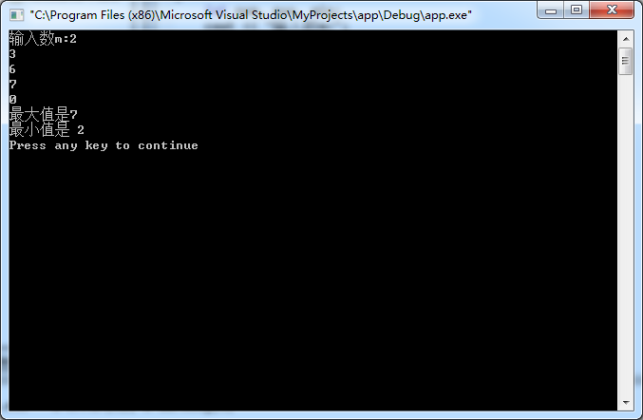

实验三 2

#include <iostream>

using namespace std;

int main(int argc, char const *argv[])

{

int a, q, n, sum;

a = 1;

q = 2;

n = sum = 0;

do{

sum += a;

++n;

a *= q;

}while(sum < 100);

--n;

cout << n <<endl;

return 0;

}

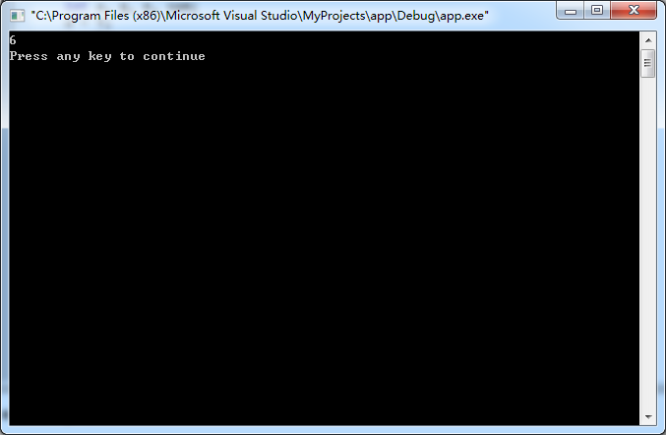

实验三 3

#include <iostream>

using namespace std;

int main(int argc, char const *argv[])

{

int a = 1;

cout << "\t\t\tASCII对照表"<<endl;

for (char asc = 32; asc < 127; ++asc,++a)

{

cout << "\""<< asc << "\"" <<"=" << int(asc) << "\t";

if (a % 7 == 0)

{

cout << endl;

}

}

return 0;

}

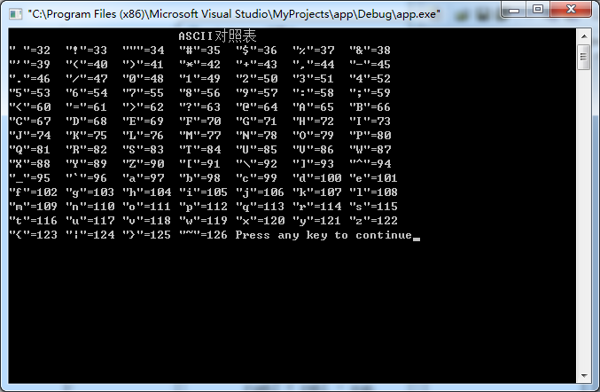

实验三 4

#include <iostream>

#include <iomanip>

using namespace std;

int main(int argc, char const *argv[])

{

int n;

float d, sum = 0, rmb1, rumb2;

while(1)

{

cout << "请输入单价和数量:";

cin >> d >> n ;

if(n == 0) break;

sum += d*n;

}

cout << "----------------------" << endl;

cout << setiosflags(ios::fixed)<<setprecision(2);

cout << "总计:" << sum << endl;

cout << "应收:" << sum << endl;

cout << "----------------------" << endl;

cout << "现金:";

cin >>rmb1;

rumb2 = rmb1 - sum;

cout << "找零:" << rumb2 <<endl;

return 0;}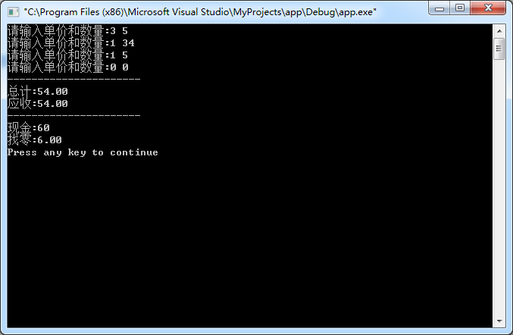

实验三 5

#include <iostream>

#include <iomanip>

using namespace std;

int main(int argc, char const *argv[])

{

int row;

cout << "请输入行数：";

cin >> row;

int i,j,n;

n = row/2+1;

for(i = 1; i <= n; i++)

{

for(j=1;j<=n-i;j++) cout <<' ';

for(j=1;j<=2*i-1;j++) cout << '*';

cout << endl;

}

for(i = 1; i <= n-1; i++)

{

for(j=1;j<=i;j++) cout <<' ';

for(j=1;j<=row-2*i;j++) cout << '*';

cout << endl;

}

return 0;

}

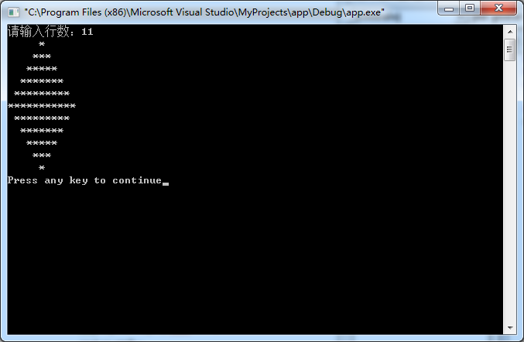

实验三思考 1

#include <iostream>

using namespace std;

double cul(int n)

{

double result = 0;

for (int i = 1; i <= n; ++i)

{

result += i*i;

}

return result/double(n);

}

int main(int argc, char const *argv[])

{

int n;

cin >> n;

cout << "(1^2 + 2^2 + 3^2 +...+ n^2)/n = " << cul(n) <<endl;

return 0;

}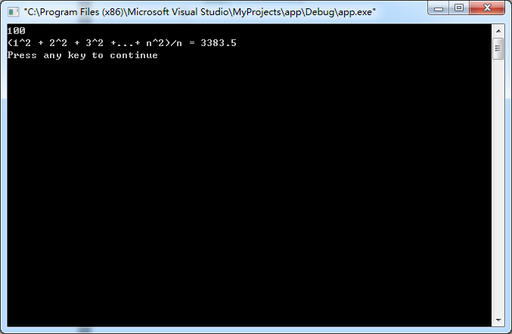

实验三思考 4

#include<iostream>

using namespace std;

int main() {

int sum = 1;

for(int i = 1; i < 10; i++) {

sum = (sum + 1)*2;

}

cout <<"第一天摘了" <<sum<<"个桃子";

return 0;

}

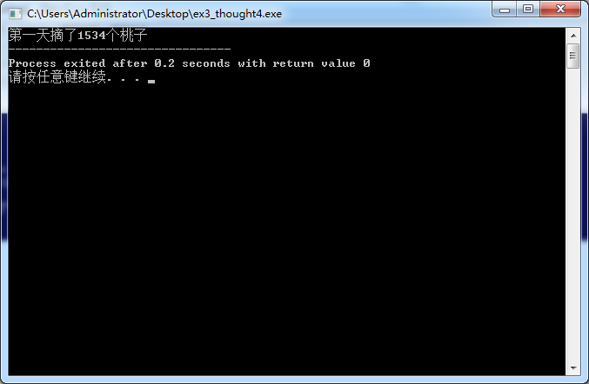

实验三思考5

#include <iostream>

using namespace std;

int main(int argc, char const *argv[])

{

int a = 1,sum = 1,n;

cout<<"enter the n :";

cin>>n;

for(int i = 2;i <= n;i++)

{

a += i;

sum += a;

}

cout<<"s = 1 + (1+2) + ... + (1 + 2 + ... +n ) = "<< sum <<endl;

return 0;

}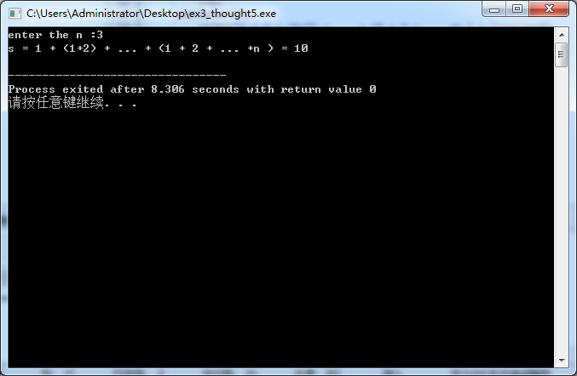

实验四思考 2

#include <iostream>

#include <cmath>

using namespace std;

int main(int argc, char const *argv[])

{

int i;

double sum = 0, t = 0;

for (i = 1; fabs(t-8) >= fabs(sum-8); ++i)

{

t = sum;

sum += 1.0/i;

}

i -= 2;

cout << "s = 1 + 1/2 + ... + 1/n ->8" << endl

<< "n = " << i << ", s = " << t <<endl;

return 0;

}

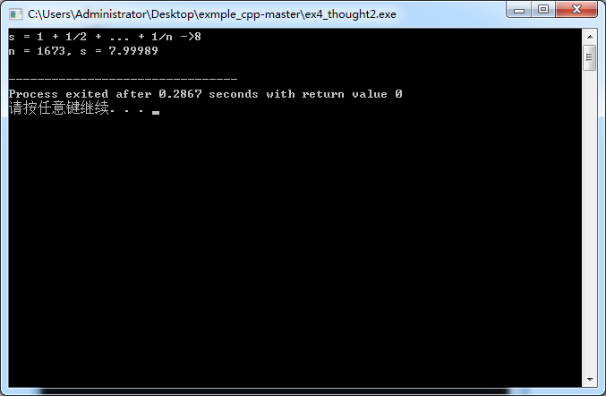

实验四思考4

#include <iostream>

using namespace std;

int main(int argc, char const *argv[])

{

int a,b,c,d;

for (int i = 31; i < 100; ++i)

{

a = i*i /1000;

b = i*i /100 %10;

c = i*i /10 %10;

d = i*i %10;

if (a == b && c == d)

{

cout << i*i <<endl;

}

}

return 0;

}

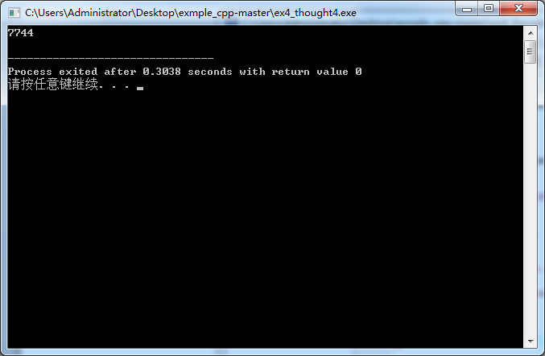

灯塔题

#include <iostream>

using namespace std;

int main(int argc, char const *argv[]) {

int sum,a;

for(int x = 1; x < 381; x++) {

a = x;

sum = x;

for(int i = 2; i<=7; i++) {

a = a*2;

sum += a;

}

if(sum == 381) {

cout <<"第一层灯塔为"<< x <<endl;

a = x;

for(int j = 2; j<=7; j++) {

a = a*2;

if(a == 48) {

cout << "第"<< j << "层为48";

break;

}

}

}

}

return 0;

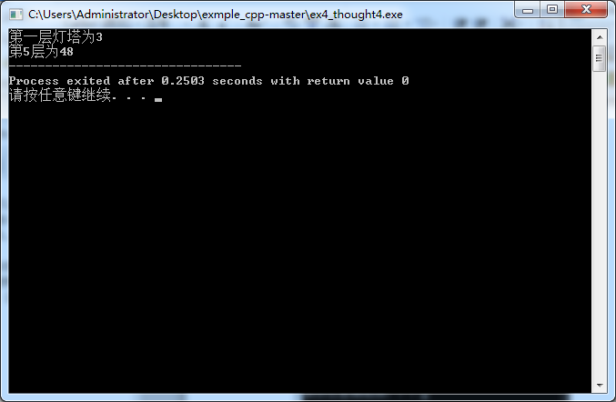}

实验五思考1

#include <iostream>

using namespace std;

long fib(int n)

{

if (n < 2) return 1;

else return fib(n-1) + fib(n-2);

}

int main(int argc, char const *argv[])

{

int i,t;

cin >> t;

for (i = 0; t >= fib(i); ++i);

cout << "大于" << t << "的最小fibonacci数为" << fib(i) << endl;

return 0;

}

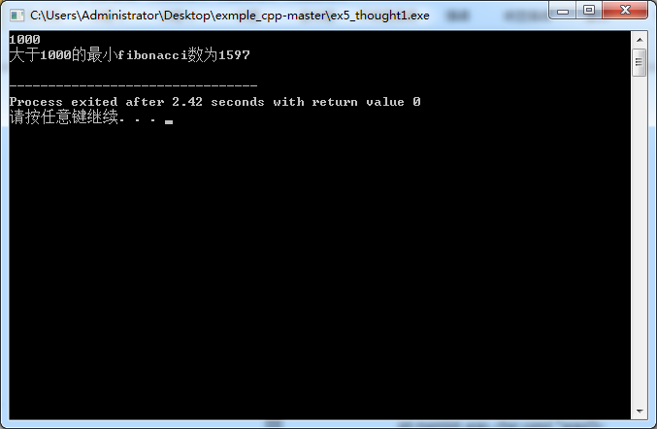

实验五思考2

#include <iostream>

using namespace std;

int two(int n)

{

if (n < 2)

{

return 2;

}

else

{

return two(n-1)*10 + 2;

}

}

int main(int argc, char const *argv[])

{

int sum = 0,count;

cin >> count;

for (int i = 1; i <= count; ++i)

{

sum += two(i);

}

cout << “2 + 22 + 222 + … +2…2 = ” <<sum << endl;

return 0;

}

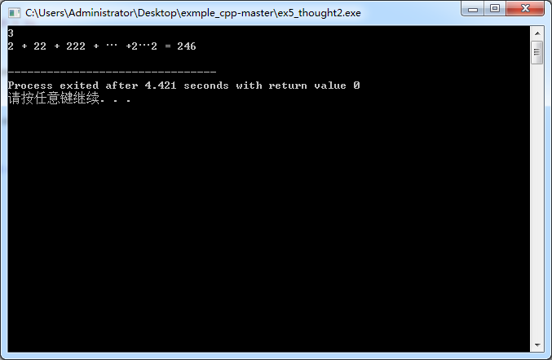

实验五3

#include <iostream>

using namespace std;

int is_prime(int num)

{

for (int i = 2; i < num; ++i)

{

if (num % i == 0)

{

return 0;

}

}

return 1;

}

int main(int argc, char const *argv[])

{

int flag = 0,t;

for (int i = 1001; i < 2001; i+=2)

if (is_prime(i))

{

if (flag == 0)

{

cout << "the minimum prime number is" << i << ".\n";

flag = 1;

}

t = i;

}

cout << "the maximum prime number is" << t << ".\n";

return 0;

}

