Multi-objective Linear Programming for Retail Distribution Digitalization: Field Evidence from Cigarette Supply Allocation

Abstract
Purpose - Multi-objective, multi-round, and multi-constraint allocation of cigarette supplies determines outlet-level stability and customer responsiveness. Experience-based planning often lacks efficiency and execution consistency. This study develops a unified linear programming (LP) framework that embeds quota-based, rule-calibrated policies to improve matching efficiency, cross-round stability, and policy consistency while keeping frontline workload unchanged and supporting transparent, auditable distribution digitalization.
Design/methodology/approach - Business rules on supply ceilings, demand and price bands, category/channel policies, and logistics capacity are formalized as hard/soft constraints in a weighted multi-objective LP and deployed inside the company’s operational system. A six-month field deployment (January–June 2025) evaluates accuracy via the Global Normalized Allocation Error (GNAE) and speed via solve time.
Findings - The deployment yields a mean GNAE of 0.2185, indicating strong structural consistency with historical multi-round allocations. Plan-generation time is reduced from approximately one day of manual work to 9.2 seconds on average.
Originality/value - The paper operationalizes a unified LP that translates layered business rules into a solvable mix of hard and penalized soft constraints, and introduces GNAE to consistently measure multi-round deviation. A six-month in-situ deployment demonstrates external validity. The approach is replicable to retail categories governed by price-band management and logistics-capacity constraints.
Practical implications - Within a quota-based policy regime and without adding frontline burden, the LP reduces outlet-level supply volatility, mitigates waiting/stockouts, and improves service continuity and planning stability—providing a transparent, auditable pathway for retail distribution digitalization.

Keywords
Retail distribution; Supply allocation; Linear programming; Multi-objective optimization; Hard/soft constraints; Price-tier management; Global Normalized Allocation Error (GNAE); Decision support system; Field deployment

1 Introduction
Cigarette supply allocation—the link between upstream capacity and store-level fulfilment—has become critical for channel stability, resource utilization and policy execution amid China’s market-oriented industry reform and the parallel digitalization of retail channels. In SKU-rich (stock keeping unit), constraint-dense and fast-paced settings, experience-based planning often struggles to deliver efficiency and execution consistency, leading to supply–demand mismatches, policy drift and delayed store responses. These shortcomings motivate transparent, auditable model-based decision processes within digital governance systems (Frasquet et al., 2021, Brusset and Kotzab, 2024).
Methodologically, cigarette allocation is a multi-objective, multi-constraint problem coupled across allocation rounds. A unified model must jointly handle total volume and demand satisfaction, price-tier and mean-price control, assortment structure and round planning, as well as operational limits such as sorting capacity and C-class (non-standard) packs. Retail distribution frequently exhibits goal conflicts and hierarchical couplings (Luceri et al., 2020). Under omni-channel and time-sensitive operations, interval, proportional and capacity constraints interact with requirements for round smoothing and price stability, while logistics reachability and workload pressure add further complexity (Yumurtacı Hüseyinoğlu et al., 2017, Eriksson et al., 2022).
Within this context, operations research (OR) provides explainable and reproducible decision support. The diffusion of data/analytics and in-store technologies is shifting decisions from craft rules to model-based governance (Lorente-Martínez et al., 2021, Vadruccio et al., 2024). Compared with heuristics, linear/mixed-integer programming (LP/MILP) supports explicit multi-objective trade-offs under complex constraints and integrates cleanly with enterprise systems, improving process consistency and traceability (Eriksson et al., 2022). Prior studies show that formulating retail resource allocation as an “optimization + constraints” decision framework yields superior results under budgetary and operational limits (Luceri et al., 2020), aligning with aims of reliable service and manageable frontline workload (Sandberg and Jafari, 2018, Mayr and Teller, 2024).
This study develops a unified, weighted multi-objective LP framework for cigarette supply allocation. Industry rules—total and inventory bounds, price-tier and mean-price bands, structural ratios and sorting capacity—are encoded as a combination of hard constraints and penalized soft constraints to optimize matching efficiency, round balancing, price stability and policy alignment. The model is embedded in an enterprise system to ensure execution consistency and auditability (Luceri et al., 2020). We conduct a six-month field deployment (January–June 2025) within a tobacco company, evaluating accuracy via the Global Normalized Allocation Error (GNAE) and speed via solve time. Adhering to a minimal-change principle, the intervention preserves quota-based policies and avoids extra frontline workload while smoothing rounds and structural controls to reduce store waiting and stock-outs (Eriksson et al., 2022, Jafari et al., 2023, Brusset and Kotzab, 2024).
Our contributions are threefold. (1) We present, to our knowledge, the first systematic optimization study of cigarette supply allocation and engineer a deployable LP framework that linearly and transparently encodes multi-level business rules in a single model. (2) We construct and calibrate a composite multi-objective function with hard/soft constraints to deliver auditable trade-offs among efficiency, round balancing and price/policy alignment—offering a replicable optimization paradigm for omni-channel, constraint-dense retail operations. (3) We introduce GNAE to consistently measure overall deviations in multi-round allocation and report evidence from a six-month in-situ deployment, demonstrating the feasibility of moving from experience-based allocation to optimization-driven, system-integrated decision-making without altering existing policies or adding frontline workload.
The remainder of the paper is organized as follows. Section 2 reviews related work. Section 3 defines the problem and details the methodology. Section 4 describes the data and evaluation design. Section 5 reports and discusses the empirical results. Section 6 concludes and outlines avenues for future research.

2 Related works
In cigarette distribution, quota-based allocation with rule adjustments has long dominated, typically steering volumes by historical sales, quotas and customer tiering (Lao et al., 2022). With SKU proliferation, stringent policy constraints and a fast operational cadence, this practice struggles to simultaneously deliver efficiency, structural fairness and policy consistency, leading to mismatches and execution drift. Spreadsheet-driven checks can mitigate isolated issues but—without a unifying mathematical model—cannot represent multi-objective, multi-round, coupled constraints in an auditable, globally consistent way (Wang et al., 2025).
Across the broader resource-allocation literature, weighted multi-objective programming and MILP are widely used for supplier/order selection and allocation, balancing efficiency, fairness and cost (Talluri and Narasimhan, 2005, Narasimhan et al., 2006). To address uncertainty or large-scale combinatorics, two-stage/chance-constrained formulations and (meta-)heuristics are also reported (Sodenkamp et al., 2016, Koutsokosta and Katsavounis, 2024). For explainability and auditability in enterprise settings, LP/MILP remains mainstream to structurally encode business rules and integrate with operational systems; retail studies show LP-based decision support achieves superior outcomes under budgetary/operational limits and aligns with omni-channel logistics redesign (Luceri et al., 2020, Eriksson et al., 2022).
Retail digitalization emphasizes analytically transparent optimization and the co-production of value by technology and people, with sustainability as a boundary condition (Frasquet et al., 2021, Brusset and Kotzab, 2024). Within this perspective, customer responsiveness and logistics flexibility are critical to service experience and resilience (Jafari, 2015, Jafari et al., 2023). The growing adoption of data/analytics at supplier and store levels is shifting decisions from experiential rules to model-based governance, requiring optimization to be embedded in information systems for consistent and traceable execution (Lorente-Martínez et al., 2021, Eriksson et al., 2022).
However, prior studies have not provided a unified linear framework for cigarette supply allocation that simultaneously covers price-tier and mean-price bands, structural ratios and sorting-capacity constraints, and is validated across multiple allocation rounds in real settings. This study addresses that gap by proposing a weighted multi-objective LP with a hard/soft-constraint design that systematizes industry rules in linear form, enabling coordinated optimization of round balancing and structural control without altering existing policies or adding frontline burden.

3 Methodology

3.1 Problem definition
Cigarette supply allocation is a multi-objective, multi-constraint, and multi-round resource-optimization problem. Given a fixed monthly supply distributed over several rounds, the planner must comply with quota-based policies and channel rules while avoiding additional frontline workload. Decisions are influenced by several factors: total-volume and inventory bounds, SKU-level demand, price-tier and mean-price bands, structural ratios, and sorting-capacity limits. As each allocation round consumes part of the feasible space for subsequent rounds, the problem exhibits stagewise coupling and combinatorial tension, making it a suitable candidate for mathematical programming.

3.2 Modelling approach
We adopt Linear Programming (LP) because the dominant business rules in this setting—such as total volumes, demand/ratio limits, mean-price bands, and capacity caps—can naturally be expressed as linear relations. LP handles equalities/inequalities and variable bounds in a unified framework, which allows domain knowledge to be formalized and integrated into enterprise information systems for consistent and auditable execution (Lorente-Martínez et al., 2021, Eriksson et al., 2022). In human-centric retail operations, model-based governance not only improves operational responsiveness but also ensures explainability (Jafari, 2015, Frasquet et al., 2021).
Our LP framework includes three elements:
- Objective function: a weighted multi-objective programme
- Decision variables: the release quantity of each SKU in each round
- Constraints: a co-design of hard and soft constraints that encodes business rules, enabling auditable trade-offs between mandatory compliance and preferential priorities

3.2.1 Decision variables
Let there be n SKUs and m release rounds. Denote by $x_{ij}$ the allocated quantity (cases) of SKU i in round j, where $i=1,…,n$ and $j=1,…,m$ with the non-negativity condition $x_{ij}⩾0$.

3.2.2 Objective function
We pursue four main objectives:
- Minimizing inter-round disparities in released volume
- Smoothing the release profile across rounds
- Improving cross-SKU allocation balance
- Limiting SKU-level jumps between adjacent rounds
We adopt a weighted-sum formulation:
$min\sum_{k=1}^{4}{w_{k}}⋅f_{k}\left(X\right)$ (1)
where $X=\left[X_{ij}\right]$ is the allocation of SKU $i=1,…,n$ in round $j=1,…,m$, $w_{k}⩾0$ are business-set weights.
The four components of the objective function are:
$f_{1}\left(X\right)=max_{j}\left(\sum_{i=1}^{n}{X_{ij}}\right)−min_{j}\left(\sum_{i=1}^{n}{X_{ij}}\right)$ (2)
$f_{2}\left(X\right)=\sum_{j=1}^{m}{\left|\sum_{i=1}^{n}{X_{ij}}−\overline{R}\right|},\overline{R}=\frac{1}{m}\sum_{j=1}^{m}{\sum_{i=1}^{n}{X_{ij}}}$ (3)
$f_{3}\left(X\right)=\sum_{i=1}^{n}{\left(max_{j}X_{ij}−min_{j}X_{ij}\right)}$ (4)
$f_{4}\left(X\right)=\sum_{j=1}^{m−1}{\left|\sum_{i=1}^{n}{X_{i,j+1}}−\sum_{i=1}^{n}{X_{ij}}\right|}$ (5)
To keep the model linear and suitable for enterprise-scale application, we handle non-linear operators in the objective components using standard epigraph/split-variable techniques:
- Introduce auxiliary scalars to bound the round totals and minimize their gap (for the max–min term in $f_{1}$).
- Represent absolute deviations in $f_{2}$ and $f_{4}$ by non-negative “positive/negative” parts.
- Bound per-SKU round levels with auxiliaries to realize the max–min spread in $f_{3}$.
These are routine LP transformations and do not introduce binary variables, ensuring the model remains a linear program.

3.2.3 Constraints
To jointly satisfy total-release targets, demand fulfilment, price-tier and average-price controls, category structure by round, and logistics (sorting) capacity, we specify three families of constraints: resource and release, demand and price strategy, and category/channel strategy. All parameters are configurable in the system, and the following thresholds are illustrative. Most of these constraints are enforced as hard constraints, while relaxable requirements (e.g., early delivery of demand-prioritized SKUs) are modeled as soft constraints via penalty terms in the objective function. This soft/hard constraint mix ensures flexibility while maintaining auditability and execution consistency, which are crucial in digitalized retail operations (Cong et al., 2009, Frasquet et al., 2021, Brusset and Kotzab, 2024).
Resource and release constraints. These ensure a reasonable total scale per round, avoid over/under-release, and keep SKU-level feasibility.
(1) Total volume per round. For target $R_{j}$​ and tolerance $ε$, the round j total must remain within bounds:
$\left(1−ε\right) R_{j}≤x_{i,j}≤\left(1+ε\right) R_{j},∀j$ (6)
This aligns with the industry principle of “quota control with tight balance” (Lao et al., 2022).
(2) SKU availability in round 1. Do not exceed the round-1 available stock $A_{i}$:
$x_{i,1}≤A_{i},∀i$ (7)
(3) Demand fulfilment across rounds. Cumulative release equals total demand $D_{i}$:
$\sum_{j=1}^{m}{x_{i,j}}=D_{i},∀i$ (8)
Demand and price strategy constraints. These reflect differentiated release policies by demand class and price-tier.
(4) Average price range per round. Let $p_{i}$​ be the unit price of SKU i. The per-round average price must lie within $\left[P^{min},P^{max}\right]$:
$P^{min}⩽\frac{\sum_{i}{p_{i}}x_{i,j}}{\sum_{i}{x_{i,j}}}⩽P^{max},∀j$ (9)
(5) Early release for demand-prioritized SKUs (soft). For $i∈N$ (demand-prioritized SKUs), most or all volume should be completed in the first two rounds:
$x_{i,1}+x_{i,2}⩾D_{i},∀i∈N$ (10)
with a penalty if delivery is pushed to round $t⩾3$:
$\sum_{t=3}^{m}{\sum_{j∈N_{t}}{\left(50×2^{t−3}\right)}}p_{t,j}$ (11)
The exponentially increasing weights (50, 100, 200, …) discourage late fulfilment to improve responsiveness without over-burdening front-line operations (Lao et al., 2022).
Category structure and channel strategy constraints. These preserve market structure, brand laddering, and channel stability while respecting sorting capacity.
(6) Price-tier representation per round. Let $N_{j}$​ be the number of SKUs released in round j and $N_{j}^{\left(price\right)}$​ those governed by the price-tier policy:
$\frac{N_{j}^{\left(price\right)}}{N_{j}}⩾0.3,∀i$ (12)
(7) Fixed patterns for strategic/new SKUs. For $(i,j)∈F_{fixed}$,
$x_{i,j}=fixed_{i,j},∀(i,j)∈F_{fixed}$ (13)
(8) Non-standard packs (C-class) and sub-types. Let C denote all non-standard pack SKUs (e.g., “Square”, “Long”, “Thin”). To reflect sorting pressure (Dao et al., 2023), in each round:
$\sum_{i∈C}{x_{i,j}}⩽0.4\sum_{i}{x_{i,j}},\sum_{i∈C}{x_{i,j}}⩽4900,∀j$ (14)
“Square” SKUs concentrated in few rounds. Introduce $δ_{j}^{Square}∈\{0,1\}$ with
$\sum_{j=1}^{m}{δ_{j}^{Square}}⩽2,\sum_{i∈S}{x_{ij}}⩽Mδ_{j}^{Square},∀j$ (15)
where S is the set of “Square” SKUs and M a sufficiently large constant. This reduces repeated set-ups and helps stabilize sorting operations.
“Long” SKUs share limits.
$\sum_{i∈L}{x_{i,j}}≤0.2\sum_{i∈C}{x_{i,j}},\sum_{i∈L}{x_{i,j}}≤1000,∀j$ (16)
“Thin” SKUs share limits.
$\sum_{i∈T}{x_{i,j}}≤0.6\sum_{i∈C}{x_{i,j}},\sum_{i∈T}{x_{i,j}}≤3000,∀j$ (17)
In sum, the constraints across the three dimensions—supply-demand balance, price policy, and category strategy—ensure the feasibility and practical relevance of the model. They adhere to industry rules on quota balance and total-volume control (Lao et al., 2022), account for price-structure and market-strategy requirements, and remain within the effective capacity of logistics and sorting operations (Dao et al., 2023). This design anchors the optimization outputs in the operational rules of cigarette distribution, making the allocation plans implementable and effective in practice. By introducing a small number of soft constraints on top of hard requirements, the model retains limited flexibility to enable informed trade-offs in exceptional cases (Cong et al., 2009). The technical workflow is summarized in Figure 1.
Table 1. Pseudocode
Algorithm: LP-based multi-round cigarette allocation
Inputs: product data D, round plan R, constraint configuration C, objective weights O
Outputs: allocation matrix A, solver status S
- Initialization
1.1 Load and validate data/parameters (schema, ranges, completeness).
1.2 Create helper flags (e.g., C-class/non-standard packs, price-tier SKUs).
1.3 Retrieve any pre-committed allocations.
- Model construction
2.1 Create decision variables $x_{i,j}$ (boxes of SKU i in round j).
– For fixed allocations: set $x_{i,j}$​ to given values.
– For round 1: impose stock caps.
– Otherwise: enforce non-negativity.
2.2 Add constraints (volume, demand, average-price band, category/structure, logistics capacity, policy rules).
2.3 Build the objective:
– Set multi-objective weights.
– Form the weighted objective $\sum_{k=1}^{4}{w_{k}f_{k}(X)}$.
- Solve
3.1 Configure solver parameters (time limit, gap/precision).
3.2 Optimize and record solver status S.
- Post-processing
4.1 Extract variable values to A.
4.2 Handle negligible residual unmet demand (rounding/ties).
4.3 Compute fill rate and total allocated volume.
4.4 Generate solution summary and constraint-validation report.
- Return
5.1 If feasible/optimal: return A and summary statistics.
5.2 If infeasible: return error message and diagnostic suggestions.

4 Data and evaluation

4.1 Field deployment
To verify feasibility, effectiveness, and auditability, we embedded the proposed optimization algorithm as a decision support service (DSS) within Tobacco Company X's marketing information system, running it on the company’s intranet (backend: 2-core CPU/8 GB RAM; frontend: 2-core CPU/4 GB RAM). The system went live in January 2025 and has since operated stably, seamlessly integrating with existing business processes. Data exchange occurs via structured tabular interfaces linked to sales and inventory systems, enabling low-friction integration without changes to the legacy IT infrastructure.
Unlike studies confined to simulation or purely analytical evaluation, our model was deployed directly into the production workflow and validated over six consecutive months, showcasing technology–operations alignment in a digital transformation setting (Dao et al., 2023).
Deployment Workflow (See Figure 1-8):
Step 1: Data Ingestion and Validation (Figure 1). The system accepts structured input for each period, automatically checks schema and completeness, and extracts key descriptors (e.g., SKU count, planned number of rounds), generating a statistical overview for downstream modeling.
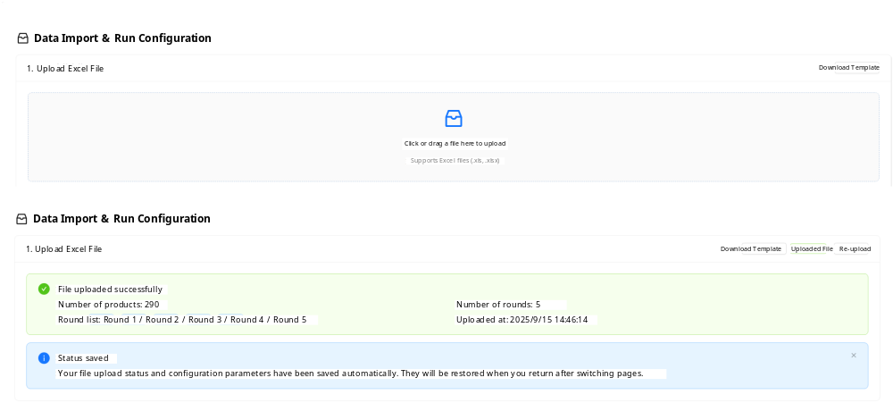
Figure 1. Data upload interface
Step 2: Constraint and Objective Configuration (Figures 2–4). Users configure hard constraints (e.g., demand fulfilment, total volume control, average price band, C-class share limits, allocation balance) and set tolerances for soft constraints (e.g., early release of demand-prioritized SKUs). Multi-objective weights are adjusted to reflect managerial preferences, optimizing for total throughput, round balance, and structural stability.
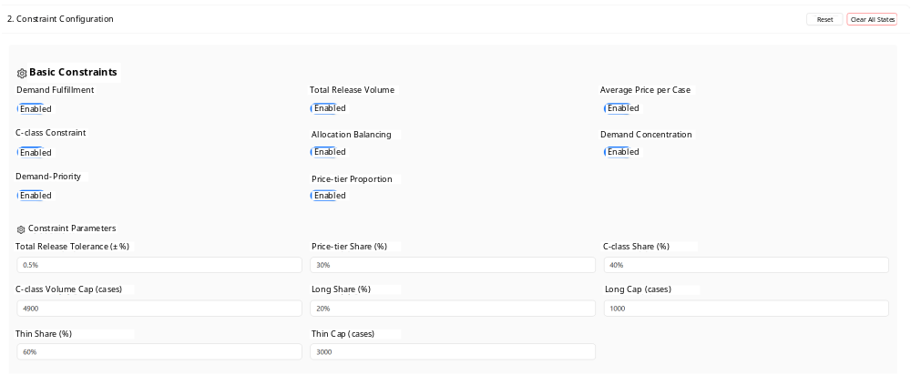
Figure 2. Constraint configuration
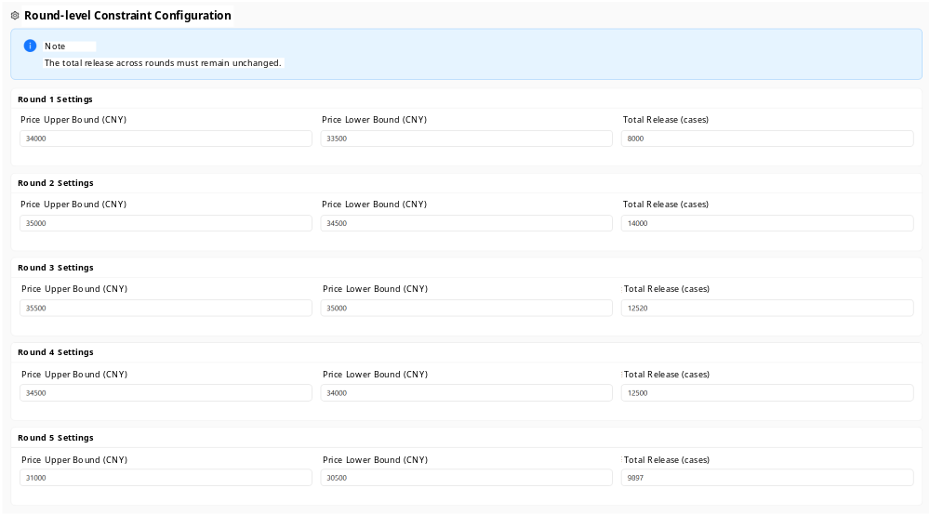
Figure 3. Round-level constraints
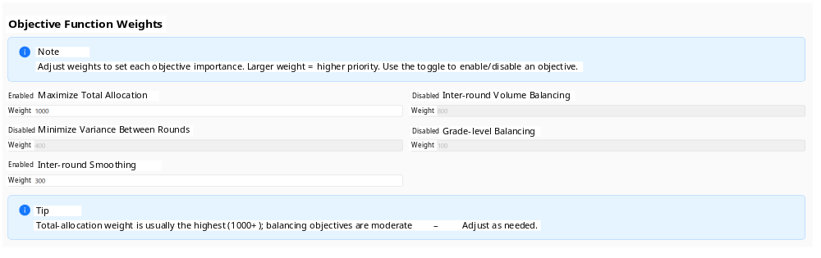
Figure 4. Objective configuration
Step 3: Solve and Monitor (Figure 5). Upon triggering the LP solver, the system streams solver status and key metrics (current objective value, allocated share, etc.), ensuring process visibility and progress tracking.
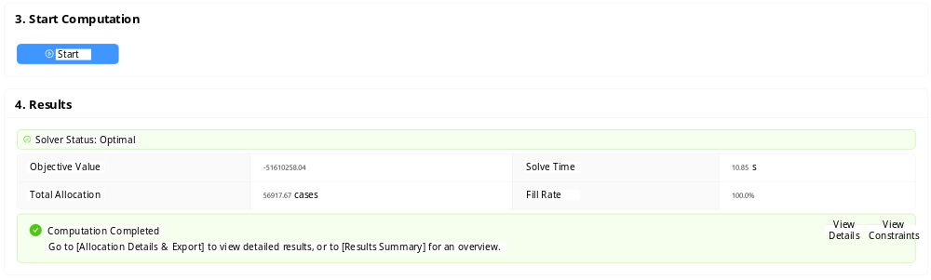
Figure 5. Start optimization
Step 4: Results, Audit, and Export (Figures 6–8). The allocation detail page reports the SKU-by-round matrix and summary statistics (SKU count, total allocated volume, demand fill rate). The analytics page provides round-level and aggregate metrics (volume, average price, structural shares). The constraint-validation page flags each constraint as “pass/fail” and quantifies deviations, allowing traceability and compliance auditing. Results are exported as structured files for business archiving and review.
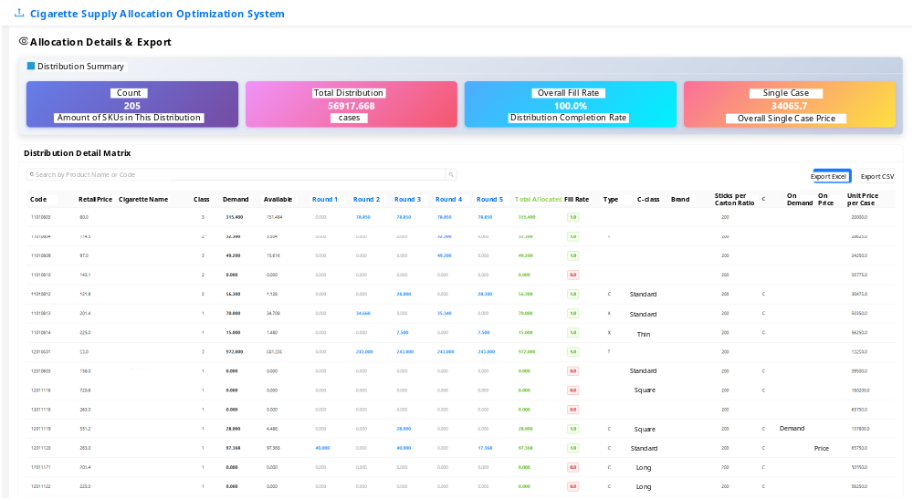
Figure 6. Allocation results
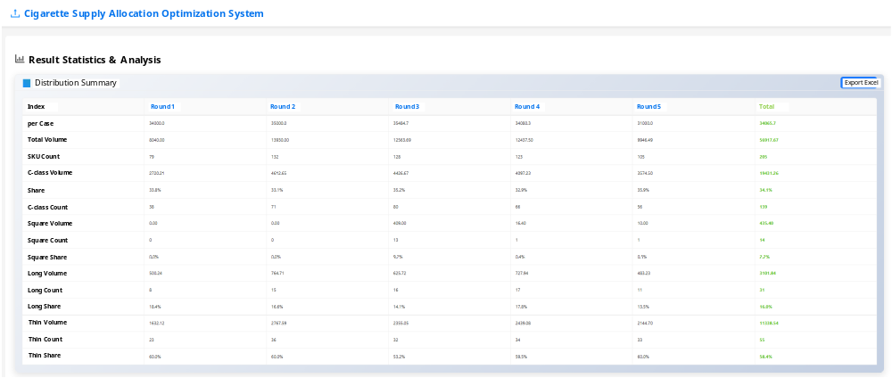
Figure 7. Statistical summaries
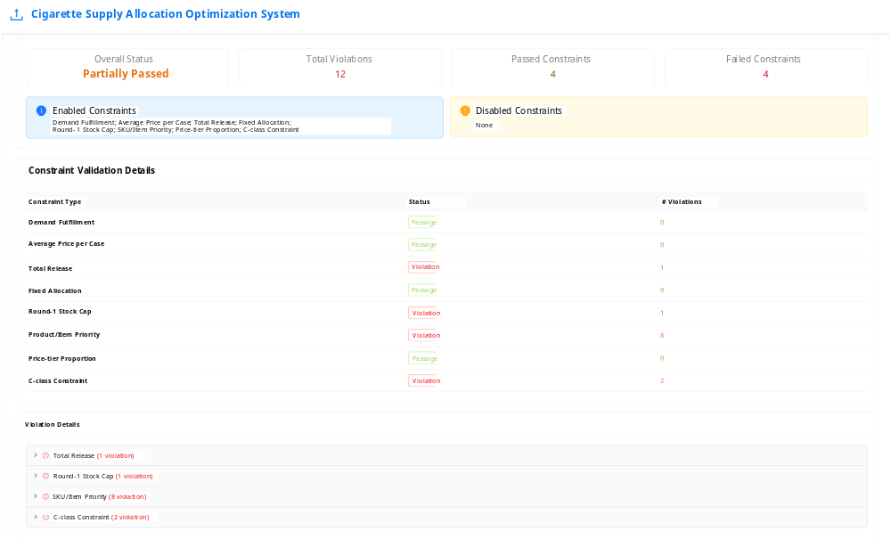
Figure 8. Constraint overview
To date, the system has shown no solver failures or material anomalies and consistently produces executable monthly allocation plans, demonstrating its stability and practical value in a live environment. By automatically comparing optimization outputs with business rules and generating an auditable trail, the DSS meets managerial needs for interpretability and verifiability in supply-chain decision-making (Dao et al., 2023, Brusset and Kotzab, 2024).

4.2 Evaluation metric
In a multi-round setting, one-to-one comparisons between the algorithmic plan and the realized plan do not offer an intuitive view of the overall divergence. Therefore, we define the Global Normalized Allocation Error (GNAE) to quantify the total deviation of the algorithmic allocation from the historical allocation across all SKUs and rounds. This metric is tailored for multi-round evaluation and compresses cross-SKU, cross-round discrepancies into a single number, indicating how well the model reproduces the historical allocation structure and its cross-round coordination. This aligns with retail digitalization’s emphasis on traceable, interpretable KPIs for decision support (Lorente-Martínez et al., 2021, Eriksson et al., 2022, Brusset and Kotzab, 2024, Kotzab et al., 2024), and with metrics that focus on customer responsiveness and process consistency (Jafari, 2015, Jafari et al., 2023).
Let there be n SKUs and m rounds. Denote by $A_{ij}$​ the algorithm’s allocation for SKU i in round j, and by $R_{ij}$​ the historical (realized) allocation, where $i=1,2,…,n$ and $j=1,2,…,m$. Define the aggregate absolute deviation:
$D=\sum_{i=1}^{n}{\sum_{j=1}^{m}{\left|A_{ij}−R_{ij}\right|}}$ (18)
and the total realized volume:
$T=\sum_{i=1}^{n}{\sum_{j=1}^{m}{R_{ij}}}$ (19)
In a “worst misplacement” scenario, moving one unit from its correct round to an incorrect round contributes two units of absolute deviation (one in the correct round and one in the wrong round), implying an upper bound of 2T for D. The GNAE is thus:
$GNAE=\frac{D}{2T}$ (20)
A GNAE of 0 indicates a perfect match with the historical plan, while GNAE = 1 represents extreme misplacement. By normalizing for scale, GNAE enables like-for-like comparisons across months with different total volumes or round numbers, providing a concise, dimensionless indicator of plan fidelity and cross-round consistency.

4.3 Results
To assess the model in production, we tested six consecutive months of real data from Tobacco Company X (January–June 2025). Table 1 summarizes the total volume, number of rounds, GNAE, and solve time per month. Overall, the model reproduced the historical multi-round structure well and solved much faster than manual planning.
Table 1. Alignment between model-generated and realized allocations (Jan–Jun 2025)
Month | Total volume (cases) | Rounds | GNAE | Solve time (s)
Jan 2025 | 83,399 | 5 | 0.1777 | 9.4
Feb 2025 | 34,400 | 4 | 0.1530 | 6.9
Mar 2025 | 50,350 | 4 | 0.1833 | 7.9
Apr 2025 | 52,398 | 4 | 0.4862 | 15.0
May 2025 | 50,198 | 4 | 0.0987 | 7.4
Jun 2025 | 30,167 | 3 | 0.2123 | 8.7
Mean | 50,125 | 4 | 0.2185 | 9.21
Note. GNAE = Global Normalized Allocation Error; lower is better. Solve time is wall-clock seconds on the production server.
Across the six months, each optimization completed within 15 seconds (mean 9.21 seconds). Relative to manual, experience-based planning that typically takes hours to a full day, the cycle time drops from day-scale to seconds-scale, illustrating the tangible benefits of digital transformation. The optimization significantly reduces planning time, freeing staff from time-consuming manual planning processes (Wang et al., 2025).
Except for one outlier, monthly GNAE values lie around 0.10–0.21 (with May at 0.0987), yielding a six-month average of 0.2185, well below one-quarter of the theoretical worst-case. The model adapts to substantial variation in both volume (e.g., 83,399 cases in January vs. 30,167 cases in June) and round design (five vs. three rounds) without month-specific retuning, indicating robustness and generalizability.
The higher GNAE in April (0.4862) stems from an end-loaded release applied operationally that month. The realized plan concentrated volume in the last round, while the model, absent a prior policy flag, pursued a smoother allocation across rounds. Since GNAE aggregates round-wise absolute deviations, the single large deviation in the final round inflated the month’s score. In similar situations, adding a month-specific policy switch or a soft constraint recognizing intentional end-round concentration would reduce this gap while preserving the model’s transparency and auditability (Lorente-Martínez et al., 2021, Eriksson et al., 2022).
In sum, excluding the intentional April exception, the model delivers stable accuracy (low, narrowly dispersed GNAE) and seconds-level solve times with no parameter tinkering between months. This performance supports its use as an operational, auditable DSS for retail distribution digitalization, consistent with prior calls to embed explainable analytics into retail operations (Jafari, 2015, Jafari et al., 2023, Brusset and Kotzab, 2024).

5 Discussions and Conclusions

5.1 Main findings
This study addresses the inefficiencies of experience-based cigarette supply allocation by upgrading the traditional quota-plus-rules practice into a model-driven digital solution. Our unified linear programming (LP) framework linearizes and jointly solves multiple business rules—such as total volume control, price-tier/average price management, price stratification, SKU/packaging restrictions, and sorting capacity—enabling fine-grained, multi-round allocation with fast optimization. Notably, this approach does not alter existing policy intentions, preserving the core principles while enhancing efficiency.
A six-month field evaluation (January–June 2025) in a live business environment demonstrates consistently strong performance across different allocation scales, round counts, and market conditions. The mean GNAE of 0.2185 and mean solve time of approximately 9.2 seconds confirm the model’s practical effectiveness. Since go-live, the system has operated stably and produced executable monthly plans, achieving a key milestone of “explainable optimization embedded in business processes and audit-ready within the information system” (Brusset and Kotzab, 2024).

5.2 Practical implications
This study provides a field-validated, auditable, and configurable LP-based decision path that replaces traditional experience-based planning while respecting the “quota-based allocation with rule-based adjustments” policy framework. The practical implications of the model are threefold:
First, the formalization of industry rules as hard/soft constraints within the system enables automatic, constraint-by-constraint checks, with an audit trail. This ensures transparency and aligns with human-centric retail digitalization, where decision-making is both efficient and explainable (Brusset and Kotzab, 2024).
Second, the model helps reduce inter-round volatility, minimizing terminal waiting and ad-hoc stockouts, thus promoting more continuous store service. This aligns with research linking responsiveness and flexibility to improved retail operations (Jafari, 2015, Siddh et al., 2017, Jafari et al., 2023).
Last, by parameterizing critical elements—such as total volume, price-tier/average-price constraints, and sorting capacity—the framework is portable to other FMCG categories facing similar constraints, such as beverages with heterogeneous packaging. Migration primarily requires scenario-specific tuning of thresholds and weights, ensuring broad applicability across sectors.

5.3 Limitations and future directions
While the unified optimization design offers a replicable engineering pathway for cigarette allocation—and a model for broader retail and distribution management—it does have some limitations:
First, the model optimizes at the SKU–round level and does not yet allocate within-round volumes down to stores/households. Future work will extend the framework downstream, adding store-level rules and profile features to optimize the entire supply-to-retail chain, ensuring end-to-end auditability without altering existing policies.
Second, the model assumes deterministic demand and supply. Robust or scenario-based stochastic extensions could introduce uncertainty handling, improving stability under forecast error and supply fluctuations.
Third, while LP is preferred for interpretability and governance, the model may encounter non-linear objectives (e.g., price elasticity, substitution/complementarity, or switching costs). Future iterations may incorporate piecewise-linearization, MILP, or convex block approximations to address such complexities while maintaining auditability.
Last, given the staged, rolling nature of allocation, future work will explore rolling-horizon re-optimization or simplified sequential decision schemes, enabling adaptive coupling of real-time state–constraint relaxation–penalty weights, while maintaining human-in-the-loop explainability (Jafari et al., 2023, Brusset and Kotzab, 2024).

References
Brusset, X. & Kotzab, H., (2024). "Technology, people and sustainability: shaping a better retail future", International Journal of Retail & Distribution Management, 52, 985-987.
Cong, J., Liu, B. & Zhang, Z., (2009). Scheduling with soft constraints. In J. Roychowdhury (ed.) Proceedings of the 2009 International Conference on Computer-Aided Design. Association for Computing Machinery: San Jose, California, 47–54.
Dao, R., Li, L., Che, W., Zhao, Z. & Chen, C., (Year). Simulation analysis of finished product distribution and delivery logistics system in cigarette industry enterprisesed.^eds. 6th International Conference on Traffic Engineering and Transportation System (ICTETS 2022), Guangzhou, China: SPIE.
Eriksson, E., Norrman, A. & Kembro, J., (2022). "Understanding the transformation toward omnichannel logistics in grocery retail: a dynamic capabilities perspective", International Journal of Retail & Distribution Management, 50, 1095-1128.
Frasquet, M., Ieva, M. & Ziliani, C., (2021). "Complaint behaviour in multichannel retailing: a cross-stage approach", International Journal of Retail & Distribution Management, 49, 1640-1659.
Jafari, H., (2015). "Logistics flexibility: a systematic review", International Journal of Productivity and Performance Management, 64, 947-970.
Jafari, H., Ghaderi, H., Malik, M. & Bernardes, E., (2023). "The effects of supply chain flexibility on customer responsiveness: the moderating role of innovation orientation", Production Planning & Control, 34, 1543-1561.
Kotzab, H., Yumurtacı Hüseyinoğlu, I.Ö., Şen, I. & Mena, C., (2024). "Exploring home delivery service attributes: Sustainability versus delivery expectations during the COVID-19 pandemic", Journal of Retailing and Consumer Services, 78, 103769.
Koutsokosta, A. & Katsavounis, S., (2024). "Stochastic transitions of a mixed-integer linear programming model for the construction supply chain: chance-constrained programming and two-stage programming", Operational Research, 24, 46.
Lao, M., Han, J. & Zhu, B., (2022). "Research on Precision Delivery Model of High-End and High-Price Cigarettes Based on Business Circle: A Case Study of Yulin City", Statistics and Applications, 11, 1159-1167.
Lorente-Martínez, J., Navío-Marco, J. & Rodrigo-Moya, B., (2021). "Are retailers leveraging in-store analytics? An exploratory study", International Journal of Retail & Distribution Management, 50, 599-618.
Luceri, B., Laurini, F. & Latusi, S., (2020). "Store flyers: managing spatial distribution under budget constraints", International Journal of Retail & Distribution Management, 48, 901-916.
Mayr, K. & Teller, C., (2024). "Channel-switching behaviour and customer deviance", International Journal of Retail & Distribution Management, 52, 1073-1091.
Narasimhan, R., Talluri, S. & Mahapatra, S.K., (2006). "Multiproduct, Multicriteria Model for Supplier Selection with Product Life-Cycle Considerations", Decision Sciences, 37, 577-603.
Sandberg, E. & Jafari, H., (2018). "Retail supply chain responsiveness: Towards a retail-specific framework and a future research agenda", International Journal of Productivity and Performance Management, 67, 1977-1993.
Siddh, M.M., Soni, G., Jain, R., Sharma, M.K. & Yadav, V., (2017). "Agri-fresh food supply chain quality (AFSCQ): a literature review", Industrial Management & Data Systems, 117, 2015-2044.
Sodenkamp, M., Kozlovskiy, I. & Staake, T., (2016). "Supervised classification with interdependent variables to support targeted energy efficiency measures in the residential sector", Decision Analytics, 3, 1.
Talluri, S. & Narasimhan, R., (2005). "A note on "A methodology for supply base optimization"", IEEE Transactions on Engineering Management, 52, 130-139.
Vadruccio, R., Pantano, E. & Tumino, A., (2024). "Space jam: how retail technologies are influencing store space production", International Journal of Retail & Distribution Management, 52, 1092-1107.
Wang, W., Zhao, F., Wang, M., Sun, Q., Gao, H., Jian, W., Li, R. & Luo, S., (2025). "Multi-objective optimisation of cigarette production planning and inventory management", International Journal of Computing Science and Mathematics, 21, 64-76.
Yumurtacı Hüseyinoğlu, I.Ö., Galipoğlu, E. & Kotzab, H., (2017). "Social, local and mobile commerce practices in omni-channel retailing: Insights from Germany and Turkey", International Journal of Retail & Distribution Management, 45, 711-729.

