An Object-Oriented Translation and Data Processing Module Design for Computer Programming Language Compiler or Interpreter

Author: Xing, Zhaohui

Date: November 12, 2004

Table of Contents

1. Introduction 0
2. Abstract 0
3. Basic Composite of Computer Compiler/Interpreter 1
4. The Object-Oriented Translation and Data Processing Module Design 3
4.1. The Design Overview 3
4.2. The Design Detail 3
4.2.1. The architecture of this translation module design 3
4.2.2. Everything is object 4
4.2.3. Descriptor (Template) – Object Instance Pattern 5
4.2.4. Basic, Generic Data Type Object Definition 5
4.2.5. Function Object (Functor) 6
4.2.6. The Category of Function Objects (Functors) 6
4.2.7. The Late Binding of Function Object and Function Object Parameters 9
5. Conclusion 21
6. Appendix: The Prototype of the Translation and Data Processing Module 22
6.1. The C++ Implementation of the Prototype 22
6.2. The Test Cases of the Prototype Implementation 23
6.2.1. The Simulation Test 23
6.2.2. The Pseudo Code Compiler/Interpreter Test 30
7. References: 42
Note: 42

Introduction
This article describes a method to design and implement an object-oriented computing language compiler system. The computing language destinated in the system is reference base data type language.

Abstract
The object-oriented translation and data processing module presented in this document implements the functionalities of generic, common process of the translation, storage, interpretation or execution of data objects, including data object properties and behaviors, which are originated or generated from computer programming language source code scanners and parsers system, or command instruction from virtual machine service.

The object-oriented translation and data processing module in this document is designed based on the object-oriented programming technology, and completely followed the fundamental principles of the object-oriented programming philosophy. In this design, any object is consisted of its property objects (generally called as class member data) and class behavior object (generally called as class member function); any object is assembled or manufactured by or with other objects either presenting the property of object (class member data) or presenting the behavior of object (class member function or class member function object). The traditional object-oriented programming concept of class member data and class member function is processed as the same in this design, where both of them are the objects which serve with different functionality in this system, one storing the owner object’s property information, the other acting the owner object’s behavior.

In this design, late-bind technology is applied. During the compiling time, all objects, which information is scanned from source code, are fabricated into their own description object (or template object); in run time, the real object instance is created from the object’s description object, or the real object is bound or attached into the execution processing based on the information in its description object.

In the appendix, a prototype of this translation and data processing module and test cases are provided. The prototype and test cases are implemented with C++.

Basic Composite of Computer Compiler/Interpreter
In modern computer technology, the computer compiler or interpreter is consisted of the basic following modules or components:
- Scanner: Scanner object reads in the source code written with specific programming language.
- Parser: Parser object analyzes and parses the syntax of the source code, which is scanned in by scanner object, based on the syntax/semantic specification of the designated programming language.
- Translator: Translator object processes and stores the related data information and operation passed from parser object.
- Code Generator (Compiler Only): Code Generator object of the Compiler converts the related data and operation translated from translator object into binary executable code.
- Executor (Interpreter Only): Executor object of the Interpreter directly executes the instructions based on the data and operation translated from translator object.

Figure 3.1 shows the basic architecture of the modern computer compiler; and figure 3.2 shows the basic architecture of the modern computer interpreter.

Figure 3.1, Basic Architecture of Computer Compiler

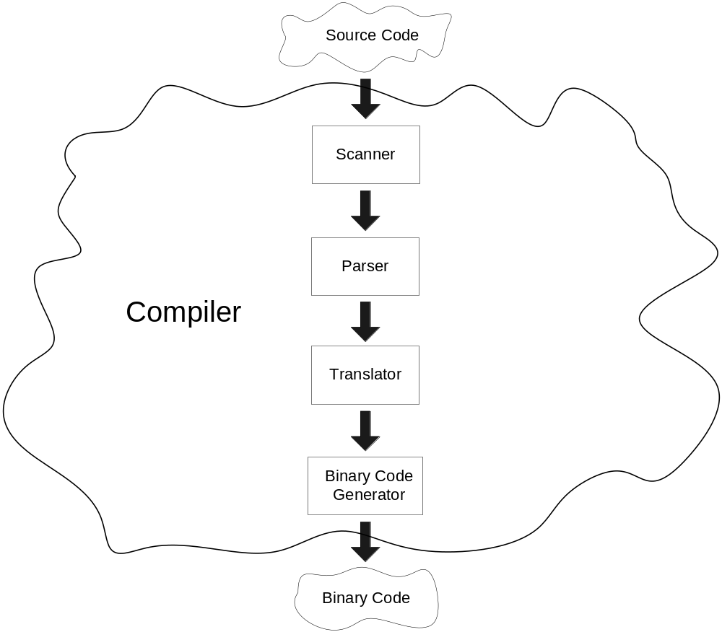

Figure 3.2, Basic Architecture of Computer Interpreter

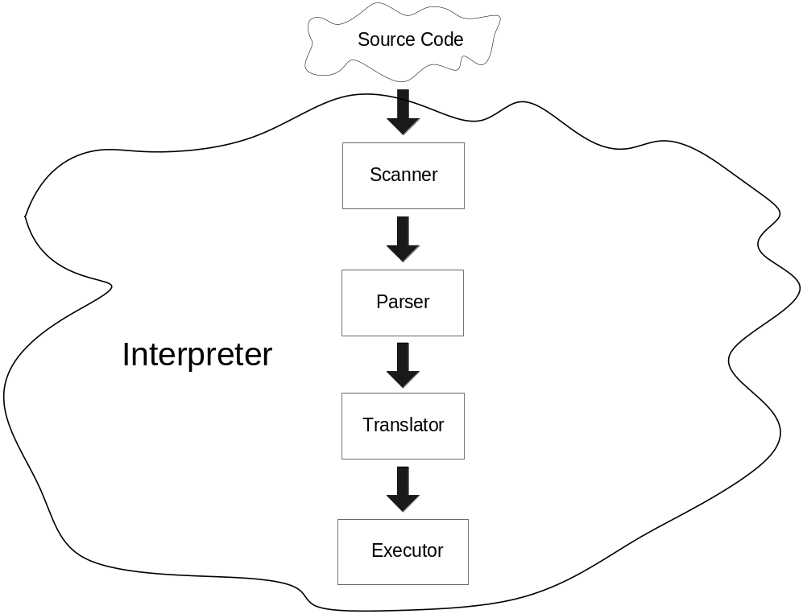

The Object-Oriented Translation and Data Processing Module Design

The Design Overview
This design is focused on technology of neutral, common translator module system which is capable to support various object-oriented programming languages compiler and interpreter on multiple operating systems. The major features are realized by the means of common generic data type definition, pure object-oriented programming implementation.

The object-oriented programming technology is heavily applied in this design; the philosophy of object-oriented programming technology is extremely followed in every aspect of the design detail.

The concept of function object or functor is used to present the function object (or functor) owner object behavior. The object containing the general information with regard to the upper/owner object presents the upper/owner object's property information.

The object member function, the operation of object behavior, can be cataloged into two types:
- The first type is basic and elemental. This type of function object (functor) is a kind of single and simple function object/functor and is the elements of other function objects. This type function object includes the basic logical comparison function object (like x <= y), single expression or assignment (like x+10, y = x+z, etc), the delegation function object of the other function.

- The second type function object is the composite of a group of the first type function objects which are called in sequence and under some conditions. for example:
class MyClass
{
void MyFunc(void)
{
int x, y, z;
z = 4*sin(45); ← single, simple type function object
y = 3 + z; ← single, simple type function object
x = y+z; ← single, simple type function object
}
}

The template/descriptor technology is adopted to create the descriptor objects in compiling time, which keeps all information of the object itself. During run time, the descriptor object creates the instance of the real object.

The late binding technology is adopted in this design to introduce the real object instance into real function object (functor) operation at run time.

The Design Detail

The architecture of this translation module design
The architecture of translation and data processing and storage module is consisted of the object (class object) descriptor sub-system, global descriptor object table, and real object (class object) instance sub-system.

The object descriptor object is template of the real object instance creation. It collects and stores the information of the real object property and behavior parsed out from the source code by the compiler's scanner and parser. The object descriptor object is going to work as the template to create all real object instances with same object type during the run time.

The object descriptor object table is the set to store object descriptor objects created based on the information of source code parsed out by the compiler scanner and parser. The descriptor object stored in the table will be called to create the real object instance in run time.

The real object (class object) instance is the object-oriented programming element to execute the program instruction/command at run time. The real object (class object) instance is created from the object descriptor object.

For the computer compiler system, the working flow of this translation module can be two step processes, compiling process and execution process.
- Compiling process:
First the descriptor object is created based on the object information parsed out from the source code by the compiler scanner and parser; then the descriptor is saved to the descriptor table; finally after creating, processing and storing all descriptor objects, the descriptor object s' information are compiled and saved into binary execution code. The figure 4.1 shows the procedure of compiling process.

- Execution process:
The descriptor objects’ information is reloaded from binary execution code; the real object instances are created from the descriptor objects' information, and then executed. The figure 4.2 shows the procedure of execution process.

For the computer interpreter system, the working flow of this translation module can be single step process. First the descriptor object is created based on the object information parsed out from the source code by compiler scanner and parser; then the descriptor is saved to the descriptor table; after creating, processing and storing all descriptor objects, the real object instances are created from the descriptor objects in the descriptor table, and then executed. The figure 4.3 shows the procedure of interpreter working process.

Everything is object
The key technology in this translation and data processing module design is object-oriented programming technology. In this design, every key element of the module is designed as object.

In this translation and data processing module, a root, base type object is designed as the ancestor object of all objects in the system.

A set of generic, common, basic data type objects is designed to implement the basic, fundamental functionality of programming language; for example, the object presenting double/complex data type, the object presenting the integer type, the object presenting the Boolean type, the object presenting the character type, etc. All these specific type objects are derived from the system root object.

In general, any composite of property and behavior is designed as a general object derived from the system root object. The object's property objects can be the common data type object, or any other general object. The behavior objects are the function objects to operate the object behaviors.

A general function object, derived from the system root object, is defined in this design; it can be applied directly, or as the ancestor object of other specific derived function object. Derived from the root function objects, some generic, common and basic function object can be pre-defined. These generic and basic function objects implement the most basic programming function features, like basic logic comparison, basic expression and assignment, etc. In fact, all general function objects are the composite of a group of the basic function objects which are called in sequence.

The figure 4.4 shows relationship among the object definitions

The figure 4.5 shows the structure of a general object. A general object has a set of property objects and behavior objects. The property object can be a common, basic, generic data type object or another general object instance. The behavior object is consisted of a group of the basic, generic function objects.

Descriptor (Template) – Object Instance Pattern
The object instance creation process algorithm is designed and implemented within Descriptor (Template)-Object Instance pattern. This is a very important and renovated technical feature in this design.

In this translation and data processing module, there are two important categories of "object" (class) sets with regard to the concept of "Object", one is the "object" (class) group associated with the presentation of concept of "Object Descriptor", and the other one is the "object" (class) group associated with the presentation of concept of "Object Instance".

The Object Descriptor Object contains the necessary information to create the Object Instance Object. The information is from the source code parsed by the scanner and parser, and describes the detail of object's property and behavior.

The Object Instance Object is the real "operator" to run the program according to the object-self property and behavior. Each Object Instance Object is created from its Object Descriptor Object.

The technical detail of the procedure of Object Descriptor Object and Object Instance Object is following:
Step One: Translation module creates the Object Descriptor Object according to the information parsed out from source code by scanner and parser.
Step Two: Translation module stores each Object Descriptor Object into a Descriptor Object table.
Step Three: The real object instance is created based on its related descriptor object stored in descriptor object table.

To the same type objects, only one copy of such type descriptor object is stored in the descriptor object table; but multiple same type object instances can be created according to the program instructions or commands.

The figure 4.6 shows relationship between the Object Descriptor Object and the Object Instance Object.

Basic, Generic Data Type Object Definition
To support different programming languages’ compiler, a set of special objects is defined to present the basic, common and generic data type used in a variety of programming language, such as float type, complex type, integer type, Boolean type, character type, etc. And these data type object definitions can be extended to cover more specific type under the real application requirement.

In this design, the special type objects are defined to present for the basic logical element and logical condition. The logical element object operates a single logical comparison with the basic comparison function object and the comparison result (the Boolean type data); the logical condition object is consisted of a group of logical element objects to present the result of a serial logic operations which link each other with the logical relationship “AND” or “OR”. Figure 4.7 shows the structure of the logical element object; figure 4.8 shows the structure of the logical condition object.

Following the descriptor (template) – object instance pattern in this design, these basic data type object definition includes the basic data type object descriptor object definition and the basic data type object instance object definition.

Function Object (Functor)
Function object (or called functor) is the very important concept or technology in modern object-oriented programming technology, especially in C++/STL programming.

The concept of function object is that any function implementing the object behavior is treated as a object same as other objects like object presenting property. The concept of function object tremendously simplifies, modulates the procedure of object-oriented programming.

In this translation and data processing module design, function object technology is heavily applied in all object related processes.

As the description in Section 4.1, the general object is built up with its property objects and its behavior objects. Function object is served for general object as its behavior object. In the translation module, with the function object technology, the creation, operation and execution of the object in the program procedure is well-organized and managed.

Generally, each function object contain a local variable object table to store the local objects and a parameter object table to store the function input and output parameter objects.

The Category of Function Objects (Functors)
Generally, the function objects (or called functors) can be categorized into two types, the elemental basic function object and general function object.

The elemental basic function object implements the most basic programming function features: logical comparison, expression/assignment, function delegation/proxy.

The logical comparisons object implements the logic operation of “equal to/same as”, “not equal to”, “smaller than”, “smaller than or equal to”, “larger than”, “larger than or equal to”. It has a data object member, which is Boolean type data, to keep the result of logic operation.

The expression/assignment object implements the functionality of mathematical expression calculation and record the calculation result within a data object.

The function delegation object is based on the late binding technology, it records the information of the real called function object at compiling time; at run time, when the function is called, and the function delegation object attaches (or load) the real function object instance into the function call to execute the call. Figure 4.9 shows the function call procedure of function delegation objects; figure 4.10 shows the flow chat of function call procedure via function delegation object.

The general function object is presenting the regular programming language function/procedure, which is the composite of a group of the elemental basic function objects.

In the general function category, there are some special types of the function object being defined, multi-conditions function group object, single condition function object, loop function object.

The single condition function object presents the sub-function call process under a single condition inside a general function object or a multi-conditions function group object. The single condition function object deals with the typical case like the following pseudo code expression:

if (x < 11 || 12 < y) ← Condition
{
z = 14 + x; ← Sub-Function Object
y = x+ z; ← Sub-Function Object
…………
}
The single condition function object is consisted of a condition object and a sub-set of function objects (either elemental basic function object or general function object). The function call process of the single condition function object is that, if the condition is satisfied, then the sub function objects are called to execute, otherwise, the function call process is passed without any sub function object being called. The figure 4.11 shows the structure of the single condition function object and the figure 4.12 flow chat of the single condition function object process.

The multi-conditions function object is consisted of a group of single condition function objects. It deals with the case of multi-conditions check and process, like the code segment of “if – else if – else if … else”, “switch – case – case … default” in programming language C, C++, Java, C#. The typical samples are shown in the following pseudo code segment:
“if – else if – else if … else” case:

if (x < 11) ← Condition ---
{ |
z = 12 + x; ← Sub-Function Object | --- Single Condition
y = x+ z; ← Sub-Function Object | Function Object
………… ---
}
else if (x < 45) ← Condition ---
{ |
z = x -5; ← Sub-Function Object | --- Single Condition
y = z - 12; ← Sub-Function Object | Function Object
………… ---
}
…………
…………
…………
else ← Condition ---
{ |
z = 14 + x; ← Sub-Function Object | --- Default Condition
y = 2*x+ z; ← Sub-Function Object | Function Object
………… ---
}

“switch – case – case … default” case:

switch (x)
{
case 1: ---
z = x*2+1; |
y = z+x; | --- Single Condition Function Object
………… |
break; ---
case 2: ---
z = x*3-4; |
y = 2*z+x; | --- Single Condition Function Object
………… |
break; ---
…………
…………
…………
default: ---
z = 0; |
y = 0; | --- Default Condition Function Object
………… |
break; ---
}

The multi-conditions function object is consisted of a group of single condition function objects, the last function object in the single condition object group is a special one to present the function process under the default condition, like “else” segment in the case of “if – else if – else if … else”, “default” segment in the case of “switch – case – case … default”. The function call procedure of the multi-conditions function object is that, by checking each single condition function object’s condition, the one which condition is matched will be picked up to execute its sub-functions’ call. The figure 4.13 shows the structure of the multi-conditions function group object; the figure 4.14 shows the flow chat of function call procedure of the multi-conditions function group object.

The loop function object deal with the case of loop process, such as the code segment of “for” loop and “while” loop in programming language like C, C++, Java, C#. Generally, the loop function object contains the initialization function object to initialize the all necessary variables, the loop condition object to check and decide the loop process stop, loop step function object to operate the necessary increment or decrement process for each loop step, the sub function objects for each loop step to process. To “while” type loop, the initialization function object and the loop step function object can be ignored. The following C/C++ -- like pseudo code describes the loop function object’s contents:
“while” loop case
|--------------------------------- Loop Condition Object
while(i < 5)
{
x = i*3; ← Sub-Function Object
y = x +6; ← Sub-Function Object
…………
}
“for” loop case

|--------------------------------- Initialization Function Object
| |------------------------- Loop Condition Object
| | |------------------ Loop Step Function Object
| | |
for(int i = 0; i < 4; i++)
{
x = i*3; ← Sub-Function Object
y = x +6; ← Sub-Function Object
…………
}

The figure 4.15 shows the structure of the loop function object; the figure 4.16 shows the flow chat of function call procedure of the loop function object.

The Late Binding of Function Object and Function Object Parameters
Late binding of the real function object instance (for delegation object) and the function parameter objects is another important technology applied in this translation and data processing module. The major aspects of later bind in this design are the function delegation object, the parameters and variables process in the function object.

To function delegation object, as described in Section 4.2.6, The function delegation object is created to keep the real called function object related information; when it is called, the function delegation object real-time search the real function object instance according to its information and bind the real function object instance to execute the function call.

In this design, each general object has its own property object, and these property objects can be accessed and processed by the behavior objects (function objects). Each object's behavior object, the function object, has its own local variable table, function parameter table to record the information of the function input and output parameters' type, name etc. Since all function input and output parameters are assigned the real object instances only at the real time the function being called, then a parameter-object instance look-up table is designed for all function objects to real time search the real function object to bind with the parameter during each function call. The parameter-object instance look-up table keeps the information of the parameter name and the bound real object instance name for each function call. The following describes the detail of the function object parameters binding:

class MyClass ← Object Class
{
………
int m_i1; ← Property Object
int m_i2; ← Property Object
float m_d1; ← Property Object

|-------|-----------|----------------← Parameter Objects
| | |
void Func1(int p1, int p2, float p3) ← Function 1 Object
{
………
}
………
………
void Func2(void) ← Function 2 Object
{
………
|-------|-------|------ ← Objects Binding to Parameters
| | |
Func1(m_i1, m_i2, m_d1);
|
|---------------------- ← Function Call of Func1
}
………
………
}

In function object Func2, for the call of Func1, a function delegation object of Func1 is created, then the reference information (object instance name) of the bound objects m_i1, m_i2, m_d1 is recorded into look-up table to map the parameters p1, p2, p3; the look-up table is saved into the function delegation object of Func1. During the real time call, the function delegation object of Func1 searches the real object instances of m_i1, m_i2, m_d1 from the object property object list or function object local variable table, binds these object into the Func1’s delegation object to execute the call. The figure 4.17 shows the creation of parameter-object instance look-up table; the figure 4.18 shows the mapping and binding process between parameter and real object instance in the function call execution.

Figure 4.1, The Compiling Processing Diagram of Compiler.
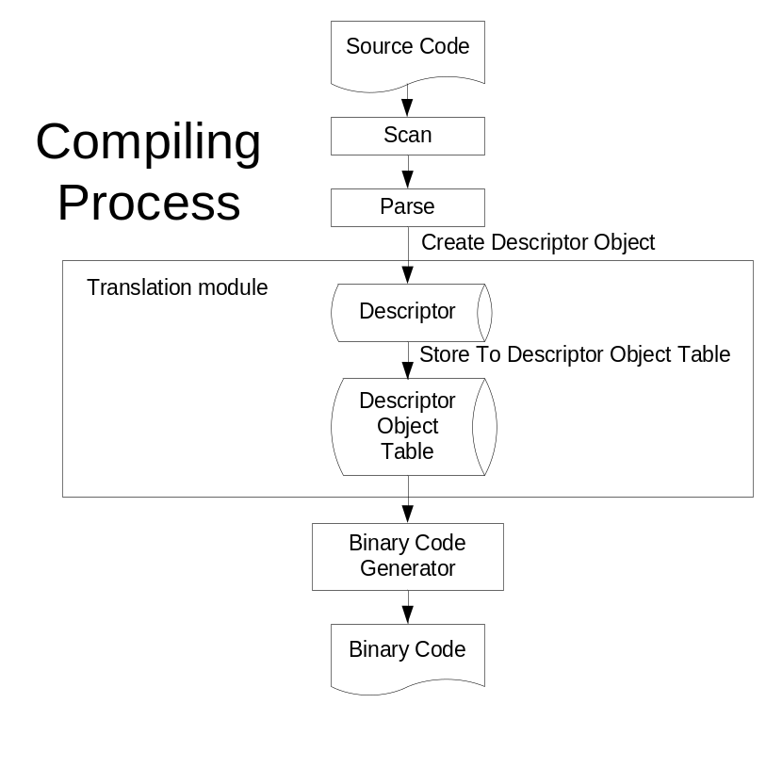

Figure 4.2, The Execution Processing Diagram of Compiler’s Binary Execution Code.
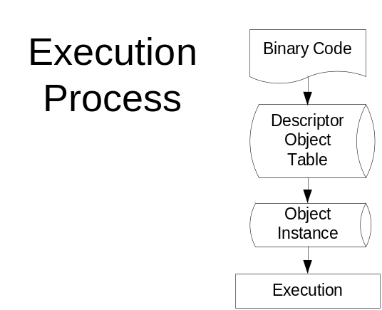

Figure 4.3, The Process Diagram of Interpreter.
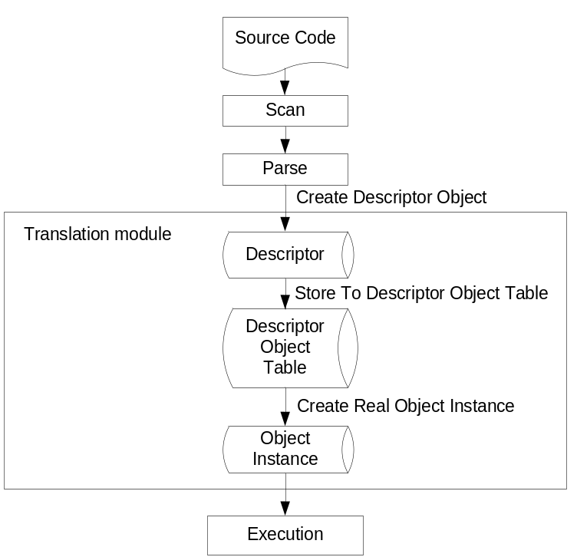

Figure 4.4, The Relationship of Objects.

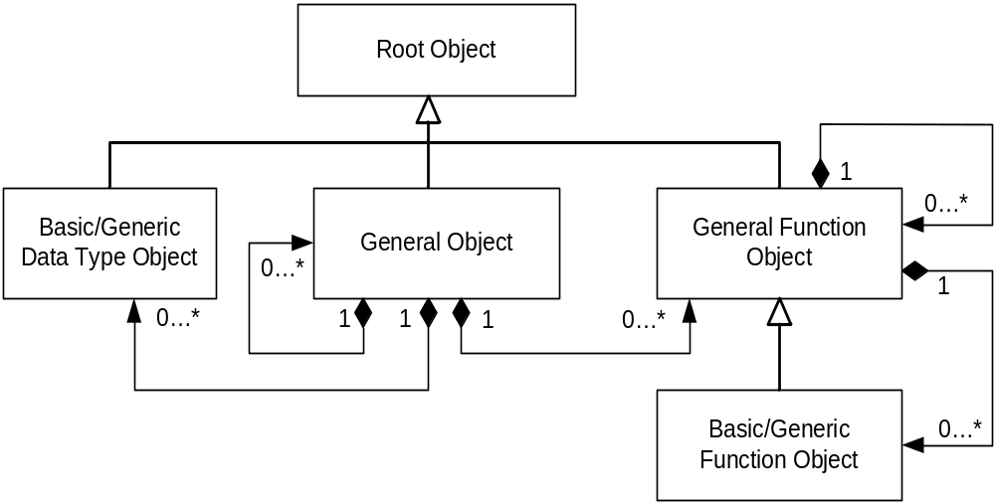

Figure 4.5, The Structure of The General Object.

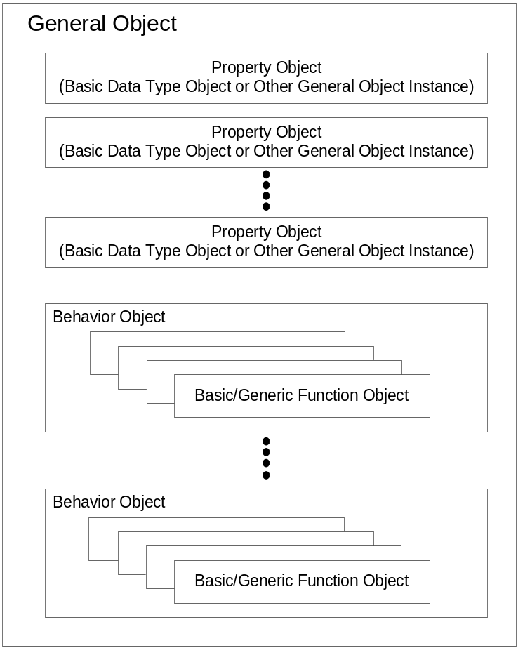

Figure 4.6, The Relationship between Object Descriptor And Object Instance.
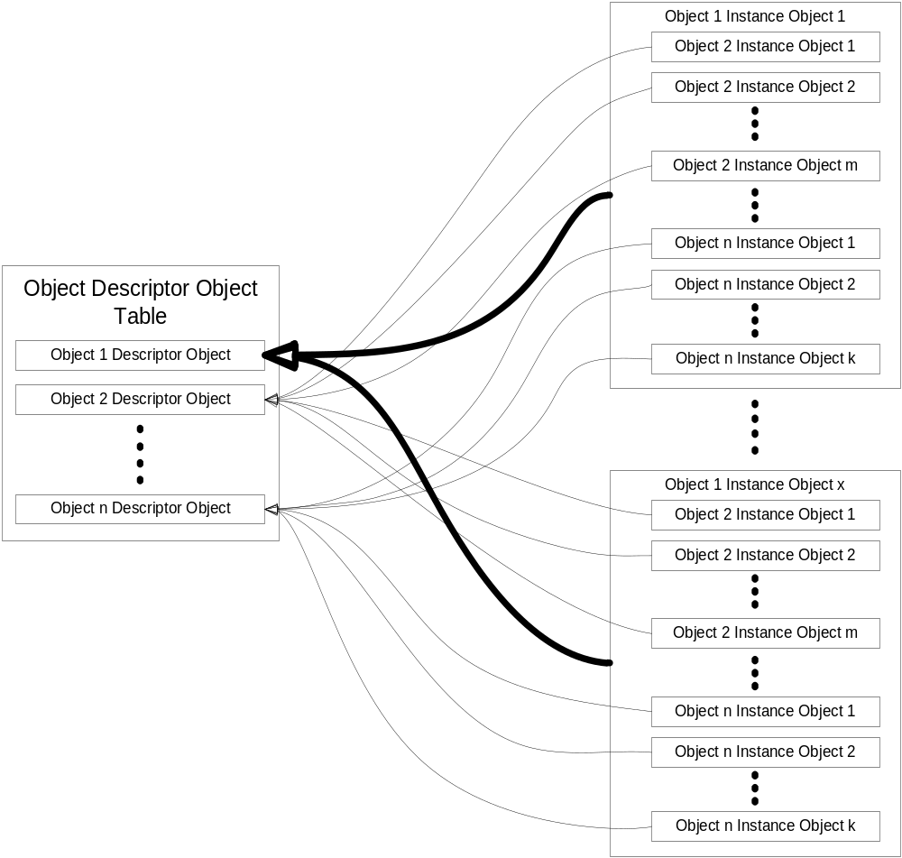

Figure 4.7, The Structure Of The Logic Element Object.

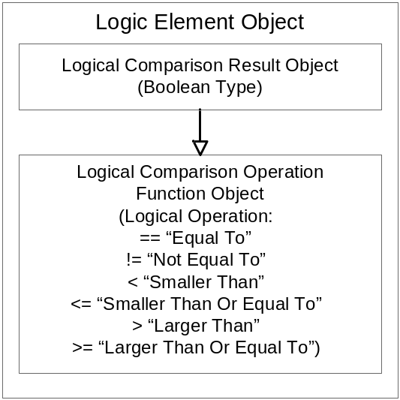

Figure 4.8, The Structure Of The Logic Condition Object.

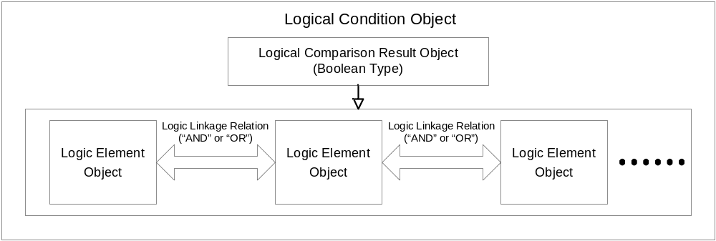

Figure 4.9, The Function Call Process Of The Function Delegation Object.

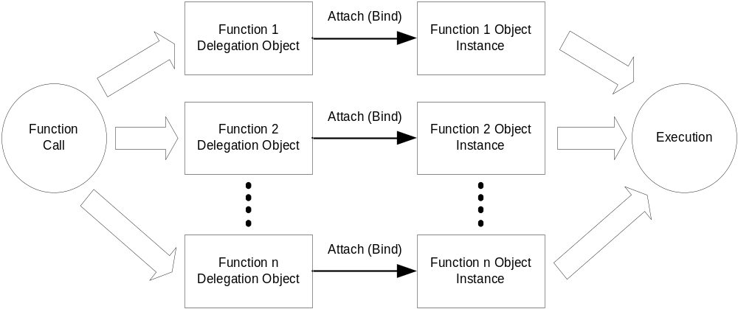

Figure 4.10, The Flow Chat Of The Function Call Via. Function Delegation Object.
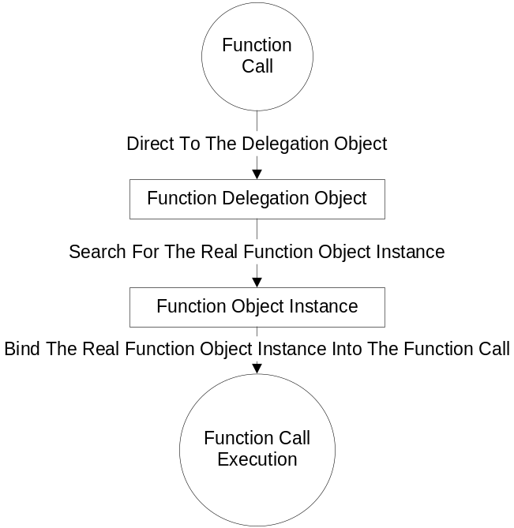

Figure 4.11, The Structure Of The Single Condition Function Object.

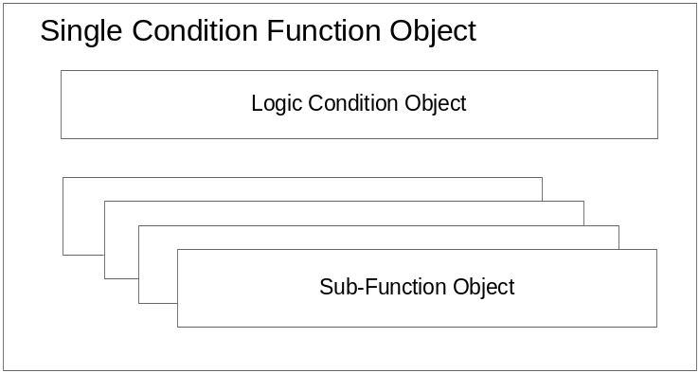

Figure 4.12, The Flow Chat Of The Process Of The Single Condition Function Object.

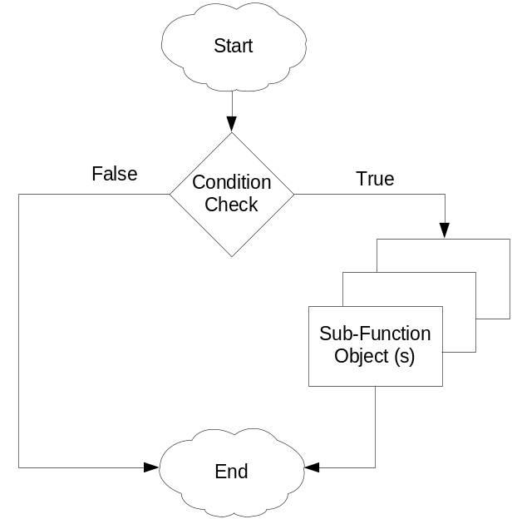

Figure 4.13, The Structure Of The Multi-Conditions Function Group Object.

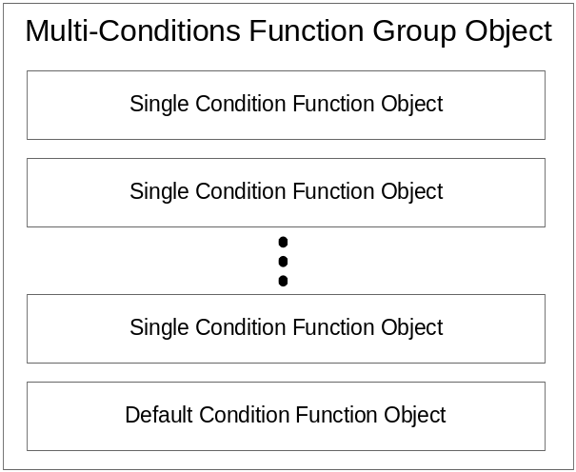

Figure 4.14, The Flow Chat Of The Process Of The Multi-Conditions Function Group Object.

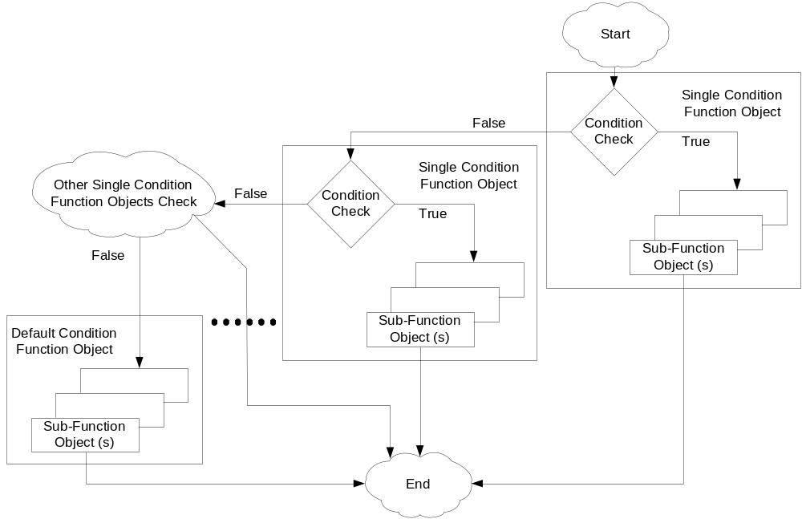

Figure 4.15, The Structure Of The Loop Function Group Object.

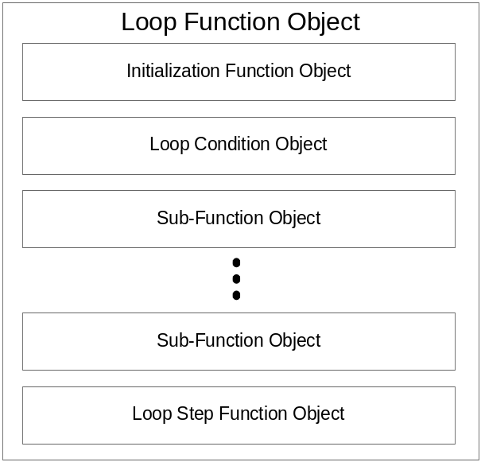

Figure 4.16, The Flow Chat Of The Loop Function Object Process.

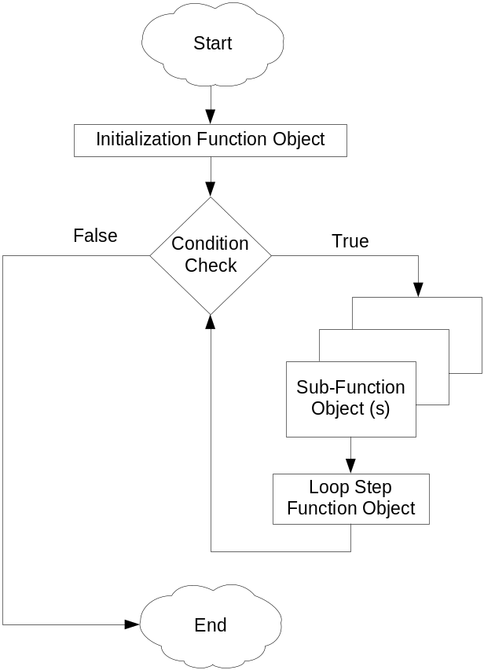

Figure 4.17, The Parameter-Object Instance Look-up Table Creation Process.

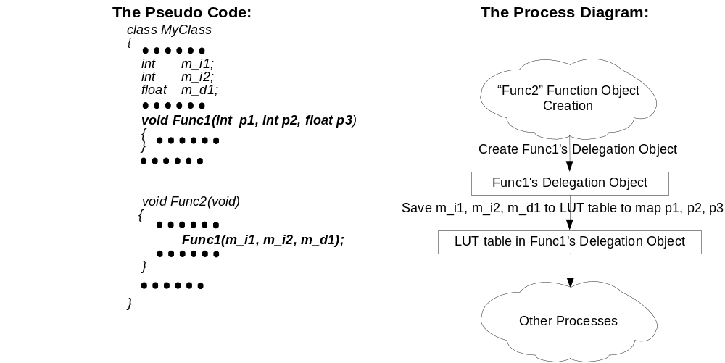

Figure 4.18, The Parameters-Object Mapping and Binding Process In Function Call Execution.

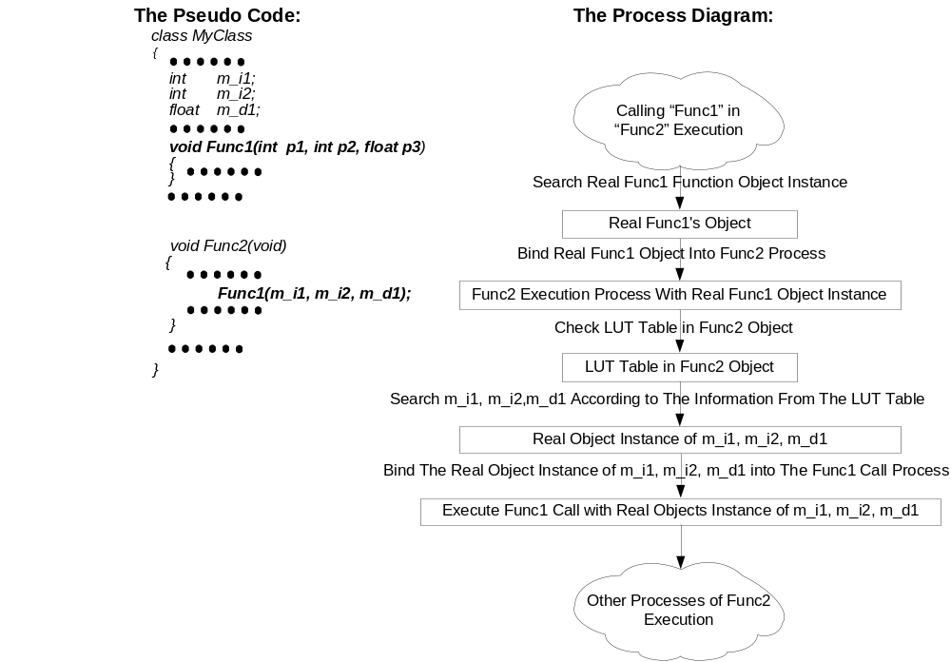

Conclusion
This translation and data processing module is designed and implemented based on Object-Oriented Programming Technology. It realizes the functionality and capability of Object-Oriented translation and processing for various Object-Oriented Programming language compilers. Since the design of this translation and data processing module is modulated and object-oriented, this module is easy to maintain, use and re-develop.

With the key technologies applied in this module design and implementation, such as pure "Object" based architecture, the common generic basic data type object definition, function object serving as the object's behavior, special basic operation function object definition, this translation and data processing module realizes the feature and functionality of the common data translating and processing sub-system for Object-Oriented Programming language compilers. It is able to support various Object-Oriented Programming language compilers' requirements. Working with different source code scanners and syntax parsers, this module design can produce various, different Object-Oriented Programming language compiler products.

Appendix: The Prototype of the Translation and Data Processing Module

The C++ Implementation of the Prototype
The prototype of this translation and data processing module is implemented with pure standard C++ and C++ Standard Template Library (STL) code, its source code is operating system neutral and can be used in multiple operating systems.

According to the design, there is a root object being defined as the root of other objects. The object's class definitions are the descriptor class CXOS_BaseDescriptor as the root class for other descriptor classes, object class CXOS_Base as the root class for other object instance classes.

Following the descriptor (template) -- object instance pattern, most of the object classes in the prototype can be classified into descriptor class or object class. The figure 6.1 shows the object descriptor class hierarchy; the figure 6.2 shows the object instance class hierarchy and some other utility and helper object classes. The class CXOS_ClassMap and CXOS_BuildInType are defined as the global descriptor object table to store all descriptor objects in the program so that the real object instances can be created from it.

The class CXOS_ClassObject/CXOS_ClassDescriptor implements the design of the general object.

The common basic, generic data type classes are defined as the following classes.
- CXOS_Data/CXOS_DataDescriptor implements the presentation object of the “float” and “complex” type data.
- CXOS_Number/CXOS_NumberDescriptor implements the presentation object of the “integer” type data.
- CXOS_Boolean/CXOS_BoolDescriptor implements the presentation object of the “Boolean” type data.
- CXOS_Char/CXOS_CharDescriptor implements the presentation object of the “character” type data.
- CXOS_Byte/CXOS_ByteDescriptor implements the presentation object of the “byte” type data.
- CXOS_String/CXOS_StrDescriptor implements the presentation object of the “string” type data.
- CXOS_Array/CXOS_ArrayDescriptor implements the presentation object of the data array.

The following classes are defined to present the logical relationship.
- CXOS_Logic/CXOS_LogicDescriptor implements the presentation object the single logic relation by a logical comparison operation.
- CXOS_Condition/CXOS_CnditDescriptor implements the presentation condition object formed with multiple logic relation objects.

The class CXOS_Method/CXOS_MethodDescriptor implements the design of the general function object.

Some basic and special function object classes, which are derived from class CXOS_Method/CXOS_MethodDescriptor, are defined for the most generic and special function processes.
- CXOS_Math/CXOS_MathDescriptor implements the basic mathematical operation upon two or single variable(s), such as X+Y, sin(X) etc. This class’s functionality can be substituted by CXOS_Express/CXOS_ExpressDescriptor.
- CXOS_Assign/CXOS_AssignDescriptor implements the basic assignment operation, like X = Y, etc. This class’s functionality can be substituted by CXOS_Assign2/CXOS_ Assign2Descriptor.
- CXOS_Comparsion/CXOS_CmpDescriptor implements the basic logical comparison operation, like X < Y, X == Y, X != Y, X >= Y etc.
- CXOS_ClsObjFn/CXOS_COFnDescriptor implements the simple class function delegation object.
- CXOS_ConditionFn/CXOS_CnditFnDescriptor implements the single condition function object in which a group of sub-function objects are executed under a single condition.
- CXOS_CnditBlockFn/CXOS_CnditBlkDescriptor implements the multiple conditions function group object which is formed by a group of single condition function objects.
- CXOS_Loop/CXOS_LoopDescriptor implements the loop process function object.
- CXOS_ReturnFn/CXOS_ReturnFnDescriptor implements the interruption process for the return step inside a function process.
- CXOS_ClsFnDelegate/CXOS_CFDDescriptor implements the complicated class function delegation object.
- CXOS_ArrayFn/CXOS_ArrayFnDescriptor implements the data array process function object.
- CXOS_Express/CXOS_ExpressDescriptor implements the functionality of expression calculation and process, such as X+Y*Z, a*sin(b)+c/d, etc.
- CXOS_Assign2/CXOS_Assign2Descriptor implements the assignment with expression such as Y=X + Z* sin(Q), a = abs(b) + tg(c) – d/e, etc.

Some utility and helper object classes are provided to assist the translation process.
- CXOS_Application/CXOS_AppDescriptor implements the functionality of general program entry.
- CXOS_Execution is the object to execute the program by the means of executing related objects in the program.
- CXOS_AncestorDescriptor is the helper object to store the information of object inheritance.
- CXOS_AccessPolicy is the helper object to store the information of the access to object’s property and behavior objects.
- CXOS_ClassType is the helper object to record the object class type-related information.
- CXOS_EElement/CXOS_EEDecriptor, CXOS_EEAction, CXOS_EEActFilter are the helper objects to process the expression parse, analysis, formation.
- CXOS_Parameter/CXOS_ParaDescriptor, CXOS_CFnParameter/CXOS_CFnParaDescriptor, CXOS_FmtParaName, CXOS_ParamType are the helper objects with regard to the function object parameter-related processes.

The Test Cases of the Prototype Implementation
The test cases are provided to verify the prototype implementation. There are two types of test case implemented. One is simulation test which simulates the process of compiler translation and data processing, the other is a real compiler/interpreter test case for a pseudo code similar to Java and C# syntax. Both type test cases are developed with Microsoft Visual C++7.0 on Microsoft Windows2000 operating system.

The Simulation Test
Test Case 1:
Simulate the process of translating and executing the following source code:
class MyClass
{
double m_d1;
void Set()
{
m_d1 = 3.0;
}
}

class Application
{
void main()
{
MyClass m;
m.Set();
}
}

Verify the assignment function object.

Run the test program with command line: xosdemo sim1, or run the program “sim1.cmd”

Test Case 2:
Simulate the process of translating and executing the following source code:
class MyClass
{
double m_d1;
void Set()
{
m_d1 = 3.0;
}
}

class Application
{
void main()
{
MyClass m;
m.Set();
}
}

Verify the extended assignment function object (CXOS_Assign2/CXOS_Assign2Descriptor) and extended the function delegation object.

Run the test program with command line: xosdemo sim2, or run the program “sim2.cmd”

Test Case 3:
Simulate the process of translating and executing the following source code:
class MyClass
{
double m_d1;
double m_d2;
void Set()
{
m_d1 = 3.0;
}
void Plus()
{
Set();
m_d2 = m_d1 + 4.0;
}
}

class Application
{
void main()
{
MyClass m;
m.Plus();
}
}

Verify the extended assignment function object and extended the function delegation object.

Run the test program with command line: xosdemo sim3, or run the program “sim3.cmd”

Test Case 4:
Simulate the process of translating and executing the following source code:
class MyClass
{
double m_d1;
double m_d2;
double m_d3;
void Set()
{
m_d1 = 3.0;
}
double Set2(double d)
{
m_d2 = pow(4.5, d);
return m_d2;
}
void Plus(double d)
{
Set();
m_d3 = m_d1 + Set2(5.5) + d;
}
}

class Application
{
void main()
{
MyClass m;
m.Plus(5.0);
}
}

Verify the extended assignment function object, extended the function delegation object, function object with return value.

Run the test program with command line: xosdemo sim4, or run the program “sim4.cmd”

Test Case 5:
Simulate the process of translating and executing the following source code:
class MyClass
{
double m_d1;
double m_d2;
double m_d3;
void Set()
{
m_d1 = 5.0;
}
void Set2(double d)
{
m_d2 = d;
}
double Time(double d1, double d2)
{
return (d1*d2);
}
double Plus(double d1, double d2)
{
return (d1+d2);
}
void Check()
{
if(m_d1 <= 4.0)
Set2(4.5);
else
Set2(6.0);
}
void Set3()
{
if(m1 <= (m_d2 + 3))
m_d3 = Time(m_d2, m_d1);
else
m_d3 = Plus(m_d1, m_d2);
}
}

class Application
{
void main()
{
MyClass m;
m.Set();
m.Check();
m.Set3();
}
}

Verify the extended assignment function object, extended the function delegation object, function object with return value.

Run the test program with command line: xosdemo sim5, or run the program “sim5.cmd”

Test Case 6:
Simulate the process of translating and executing the following source code:
class MyClass
{
double m_d1;
double m_d2;
void Set()
{
m_d1 = 6.0;
m_d2 = -1.0
}
void Set2(double d)
{
m_d3 = m_d2 + d;
}
void Check()
{
while(m_d2 <= 132.0)
{
Set2(m_d1);
}
}
}
class Application
{
void main()
{
MyClass m;
m.Set();
m.Check();
}
}

Verify the while-loop process, extended assignment function object, extended the function delegation object, function object with return value.

Run the test program with command line: xosdemo sim6, or run the program “sim6.cmd”

Test Case 7:
Simulate the process of translating and executing the following source code:
class MyClass
{
double m_d1;
double m_d2;
void Set()
{
m_d1 = 6.0;
m_d2 = -1.0
}
void Set2(double d)
{
m_d3 = m_d2 + d;
}
void Check()
{
for(int i = 0; i <= 33; i++)
{
Set2(m_d1);
}
}
}

class Application
{
void main()
{
MyClass m;
m.Set();
m.Check();
}
}

Verify the for-loop process, extended assignment function object, extended the function delegation object, function object with return value.

Run the test program with command line: xosdemo sim7, or run the program “sim7.cmd”

Test Case 8:
Simulate the process of translating and executing the following source code:
class MyBase
{
public:
double m_d1;
double m_d2;
public:
void Set(void)
{
m_d1 = 2.0;
m_d2 = 1.5;
}
}

class MyClass : public MyBase
{
public:
void Set(double d1, double d2)
{
m_d1 = d1;
m_d2 = d2;
}
void Test1(void)
{
Set();
}
double Test2(void)
{
Set(4.5, 6.9);
}
}

class Application
{
void main()
{
MyClass m1;
MyClass m2;
m1.Test1();
m2.Test2();
}
}

Verify the class inheritance, function overloading, access, extended assignment function object, extended the function delegation object, function object with return value.

Run the test program with command line: xosdemo sim8, or run the program “sim8.cmd”

Test Case 9:
Simulate the process of translating and executing the following source code:
class MyBase
{
public:
double m_d1;
double m_d2;
public:
void Set(void)
{
m_d1 = 2.0;
m_d2 = 1.5;
}
}

class MyClass : public MyBase
{
public:
void Set(double d1, double d2)
{
m_d1 = d1;
m_d2 = d2;
}
}

class MyCallClass
{
public:
MyClass m_cls;
double m_d3;
void Init(void)
{
m_cls.Set(3.4, 9.6);
}
void Plus(void)
{
m_d3 = m_cls.m_d1 + m_cls.m_d2;
}
void Time(void)
{
m_cls.Set();
m_d3 = m_cls.m_d1 * m_cls.m_d2;
}
}

class Application
{
void main()
{
MyCallClass m1;
MyCallClass m2;
m1.Init();
m1.Plus();
m2.Init();
m2.Time();
}
}

Verify the class inheritance, function overloading, access, class type data member’s function call, extended assignment function object, extended the function delegation object, function object with return value.

Run the test program with command line: xosdemo sim9, or run the program “sim9.cmd”

Test Case 10:
Simulate the process of translating and executing the following source code:
class MyClass
{
public:
double m_d[12];
void Init(void)
{
for(int i = 0; i <12; i++)
m_d[i] = i;
}
}

class Application
{
void main()
{
MyClass m;
m.Init();
}
}

Verify the for-loop process, data array, extended assignment function object, extended the function delegation object.

Run the test program with command line: xosdemo sim10, or run the program “sim10.cmd”

The Pseudo Code Compiler/Interpreter Test
In this type test, a pseudo programming language code is defined with the syntax similar to the Java and C#, the source code scanner and parser are developed for the pseudo code. Working with the scanner and parser, the test program tests the feature and performance of the translation and data processing module prototype by reading the source code file, parsing, translation and execution the program declared in the source code.

Test Case 1:
Compile and execute the program declared in source file “class1.cls”. The source code in file “class1.cls” is:
namespace MyNS
{

class MyClass
{
public double m_d1;
public double m_d2;

public void Set()
{
m_d1 = 3.0;
}
public void Plus()
{
Set();
m_d2 = m_d1 + 4.0;
}
};

class Application
{
public void Main()
{
MyClass m;
m.Plus();
}
};
};

Run the test program with command line: xosdemo cpl1, or run the program “cpl1.cmd”

Test Case 2:
Compile and execute the program declared in source file “class2.cls”. The source code in file “class2.cls” is:
namespace MyNS
{
class MyBase
{
public double m_d1;
public void Set()
{
m_d1 = 5.0;
}
};

class MyClass : public MyBase
{
public double m_d2;
public double m_d3;
public void Set2(double d)
{
m_d2 = d;
}
public void Time(double d1, double d2)
{
m_d3 = d1*d2;
}
public void Plus(double d1, double d2)
{
m_d3 = d1+d2;
}
public void Check()
{
if(m_d1 <= 4.0)
Set2(4.5);
else
Set2(6.0);
}
public void Set3()
{
if(m1 <= 3.0)
Time(m_d2, m_d1);
else
Plus(m_d1, m_d2);
}
};

class Application
{
public void Main()
{
MyClass m;
m.Set();
m.Check();
m.Set3();
}
};
};

Run the test program with command line: xosdemo cpl2, or run the program “cpl2.cmd”

Test Case 3:
Compile and execute the program declared in source file “class3.cls”. The source code in file “class3.cls” is:
namespace MyNS
{
class MyClass
{
public double m_d1;
public double m_d2;
public double m_d3;
public void Set()
{
m_d1 = 5.0;
}
public void Set2(double d)
{
m_d2 = d;
}

public void Time(double d1, double d2)
{
m_d3 = d1*d2;
}
public void Plus(double d1, double d2)
{
m_d3 = d1+d2;
}
public void Check()
{
if(m_d1 <= 6.0)
{
Set2(4.5);
m_d1 = m_d2+1.0;
}
else
{
Set2(6.0);
m_d1 = m_d2+4.0;
}
}
public void Set3()
{
if(m1 <= 3.0)
{
Time(m_d2, m_d1);
m_d2 = m_d1 -1.5;
}
else
{
Plus(m_d1, m_d2);
m_d2 = m_d1 + 2.5;
}
}
};

class Application
{
public void Main()
{
MyClass m;
m.Set();
m.Check();
m.Set3();
}
};
};

Run the test program with command line: xosdemo cpl3 , or run the program “cpl3.cmd”

Test Case 4:
Compile and execute the program declared in source file “class4.cls”. The source code in file “class4.cls” is:
namespace MyNS
{
class MyBase
{
public double m_d1;
public void Set()
{
m_d1 = 5.0;
}
};

class MyClass : public MyBase
{
public double m_d2;
public double m_d3;
public double m_d4;
public void Set2(double d)
{
m_d2 = d;
}

public void Time(double d1, double d2)
{
m_d3 = d1*d2;
}
public void Plus(double d1, double d2)
{
m_d3 = d1+d2;
}
public void Check()
{
Set2(6.0);
for(m_d4 = 0.0; m_d4 <= m_d2; m_d4 = m_d4+1.0)
{
Plus(m_d1, m_d4);
m_d1 = m_d1+0.5;
}
}
};

class Application
{
public void Main()
{
MyClass m;
m.Set();
m.Check();
}
};
};

Run the test program with command line: xosdemo cpl4, or run the program “cpl4.cmd”

Test Case 5:
Compile and execute the program declared in source file “class5.cls”. The source code in file “class5.cls” is:
namespace MyNS
{
class MyClass
{
public double m_d1;
public double m_d2;
public double m_d3;
public double m_d4;
public void Set()
{
m_d1 = 5.0;
}
public void Set2(double d)
{
m_d2 = d;
}

public void Time(double d1, double d2)
{
m_d3 = d1*d2;
}
public void Plus(double d1, double d2)
{
m_d3 = d1+d2;
}
public void Check()
{
Set2(6.0);
for(m_d4 = 0.0; m_d4 <= m_d2; m_d4 = m_d4+1.0)
Plus(m_d1, m_d4);
}
};

class Application
{
public void Main()
{
MyClass m;
m.Set();
m.Check();
}
};
};

Run the test program with command line: xosdemo cpl5, or run the program “cpl5.cmd”

Test Case 6:
Compile and execute the program declared in source file “class6.cls”. The source code in file “class6.cls” is:
namespace MyNS
{
class MyClass
{
public double m_d1;
public double m_d2;
public double m_d3;
public double m_d4;
public void Set()
{
m_d1 = 5.0;
}
public void Set2(double d)
{
m_d2 = d;
}

public void Time(double d1, double d2)
{
m_d3 = d1*d2;
}
public void Plus(double d1, double d2)
{
m_d3 = d1+d2;
}
public void Check()
{
double d1;
Set2(6.0);
for(m_d4 = 0.0; m_d4 <= m_d2; m_d4 = m_d4+1.0)
{
for(d1 = 0.0; d1 <= m_d1; d1 = d1+1.5)
Plus(m_d1, m_d4);
}
}
};

class Application
{
public void Main()
{
MyClass m;
m.Set();
m.Check();
}
};
};

Run the test program with command line: xosdemo cpl6, or run the program “cpl6.cmd”

Test Case 7:
Compile and execute the program declared in source file “class7.cls”. The source code in file “class7.cls” is:
namespace MyNS
{
class MyClass
{
public double m_d1;
public double m_d2;
public double m_d3;
public double m_d4;
public void Set()
{
m_d1 = 5.0;
}
public void Set2(double d)
{
m_d2 = d;
}

public void Time(double d1, double d2)
{
m_d3 = d1*d2;
}
public void Plus(double d1, double d2)
{
m_d3 = d1+d2;
}
public void Check()
{
double d1;
Set2(6.0);
for(m_d4 = 0.0; m_d4 <= m_d2; m_d4 = m_d4+1.0)
{
for(d1 = 0.0; d1 <= m_d1; d1 = d1+1.5)
Plus(m_d1, m_d4);
m_d1 = m_d1+0.5;
}
}
};

class Application
{
public void Main()
{
MyClass m;
m.Set();
m.Check();
}
};
};

Run the test program with command line: xosdemo cpl7, or run the program “cpl7.cmd”

Test Case 8:
Compile and execute the program declared in source file “class8.cls”. The source code in file “class8.cls” is:
namespace MyNS
{
class MyClass
{
public double m_d1;
public double m_d2;
public double m_d3;
public double m_d4;
public void Set()
{
m_d1 = 5.0;
}
public void Set2(double d)
{
m_d2 = d;
}

public void Time(double d1, double d2)
{
m_d3 = d1*d2;
}
public void Plus(double d1, double d2)
{
m_d3 = d1+d2;
}
public void Check()
{
double d1;
Set2(6.0);
for(m_d4 = 0.0; m_d4 <= m_d2; m_d4 = m_d4+1.0)
{
for(d1 = 0.0; d1 <= m_d1; d1 = d1+1.5)
{
Plus(m_d1, m_d4);
m_d1 = m_d1+0.5;
}
}
}
};

class Application
{
public void Main()
{
MyClass m;
m.Set();
m.Check();
}
};
};

Run the test program with command line: xosdemo cpl8, or run the program “cpl8.cmd”

Test Case 9:
Compile and execute the program declared in source file “class9.cls”. The source code in file “class9.cls” is:
namespace MyNS
{
class MyClass
{
public double m_d1;
public double m_d2;
public double m_d3;
public double m_d4;
public void Set()
{
m_d1 = 5.0;
}
public void Set2(double d)
{
m_d2 = d;
}

public void Time(double d1, double d2)
{
m_d3 = d1*d2;
}
public void Plus(double d1, double d2)
{
m_d3 = d1+d2;
}
public void Check()
{
Set2(6.0);
m_d4 = 0.0;
while(m_d4 <= m_d2)
{
Plus(m_d1, m_d4);
m_d4 = m_d4+1.0;
}
}
};

class Application
{
public void Main()
{
MyClass m;
m.Set();
m.Check();
}
};
};

Run the test program with command line: xosdemo cpl9, or run the program “cpl9.cmd”

Test Case 10:
Compile and execute the program declared in source file “class10.cls”. The source code in file “class10.cls” is:
namespace MyNS
{
class MyClass
{
public double m_d1;
public double m_d2;
public double m_d3;
public double m_d4;
public void Set()
{
m_d1 = 5.0;
}
public void Set2(double d)
{
m_d2 = d;
}

public void Time(double d1, double d2)
{
m_d3 = d1*d2;
m_d4 = d2 + 1.0;
}
public void Check()
{
Set2(8.5);
m_d4 = 0.0;
while(m_d4 <= m_d2)
Time(m_d1, m_d4);
}
};

class Application
{
public void Main()
{
MyClass m;
m.Set();
m.Check();
}
};
};

Run the test program with command line: xosdemo cpl10, or run the program “cpl10.cmd”

Figure 6.1, The Object Descriptor Class Hierarchy.

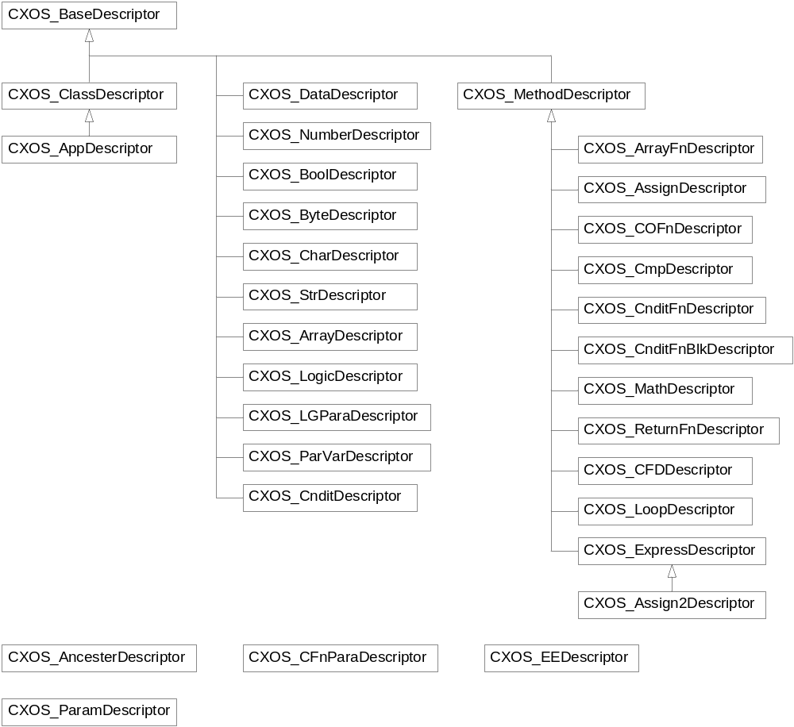

Figure 6.2, The Object Instance Class and Other Helper Object Hierarchy.

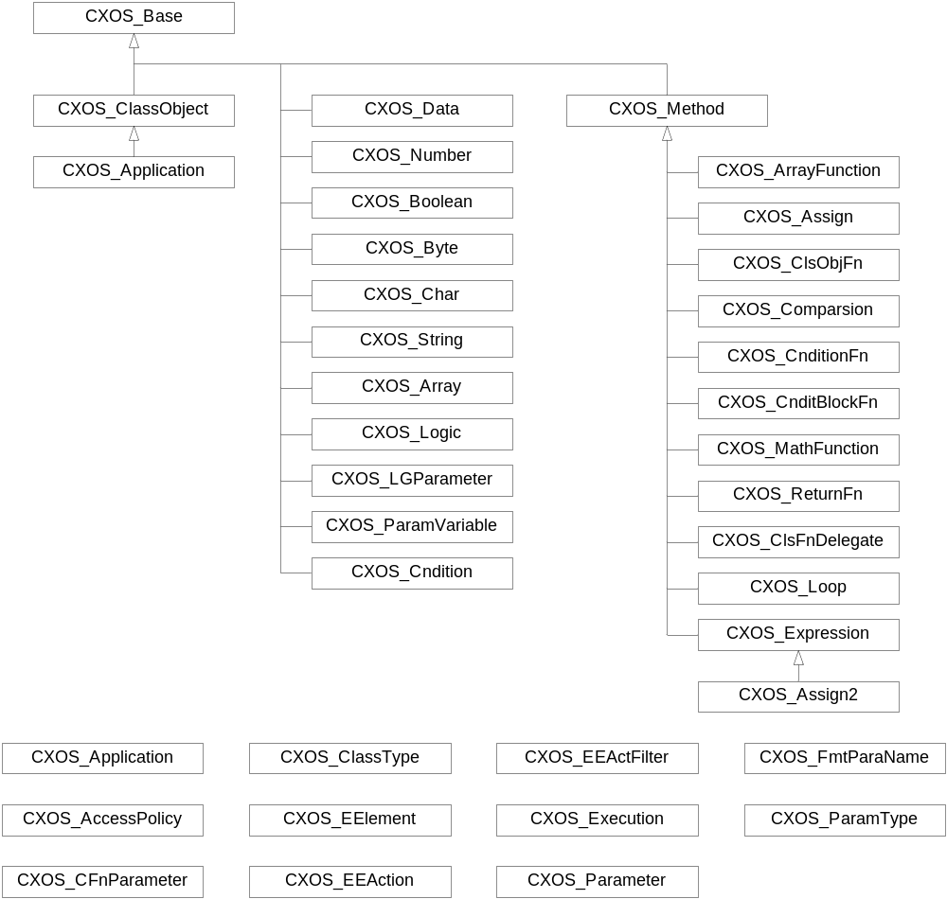

References:
[1]. Andrew S. Tanenbaum: “Modern Operating Systems” (2nd Edition); Pearson Education; February 28, 2001; ISBN: 0130313580.
[2]. William Ford and William Topp: “Data Structures with C++” (4th Edition); Prentice Hall.
[3]. Ronald Mak: “Writing Compilers and Interpreters” (2nd Edition); John Wiley & Sons, Inc; 1996; ISBN: 0471113530.

Note:
- Microsoft Windows Operation System, Visual C++ and C# are trademark of Microsoft Corp.
- Java is trademark of Sun Microsystem Corp.

