TDRBuilder and TDR Technology (Thinking-Drawing-Running)

Introduce.
In summer 2000, after many years of working in various industrial software projects, a thought came into my mind that the process of software product development should be more independent from programming technique so that more technical professional without specific programming skill can design and create the software application to implement their technical requirement by themselves.

With such idea, I develop the technology with concept of TDR (Thinking-Drawing-Running), which bridge the gap between current CASE tools and software programming tools.

What is TDR?
The philosophy of “Thinking-Drawing-Running” (TDR) comes from my thought with regard to the software creation process:
- Modern computer science technology could let more people, without special programming technical skill or knowledge, able to create software solution for their technical idea, design or algorithm easily; in other words, the software design and creation process should be more idea/design/algorithm oriented rather than programming technique oriented.

- Modern software application design and creation process should be more visualized and more independent from programming technique/programming language.

- The software application creation process should be more naturally and directly reflecting the people's idea, design or algorithm rather than the demonstration of programming technique, skill or trick.

In the concept of “Thinking-Drawing-Running” (TDR), “Thinking” (T) indicates the people's technical idea, computing design or algorithm. “Drawing” (D) means that people can present implement or transform their technical idea, computing design or algorithm (“Thinking” (T)) by drawing the technical diagrams. “Running” (R) means that people can easily analyze, validate their design diagrams by compiling and running the design diagram, the result can be checked or verified by user.

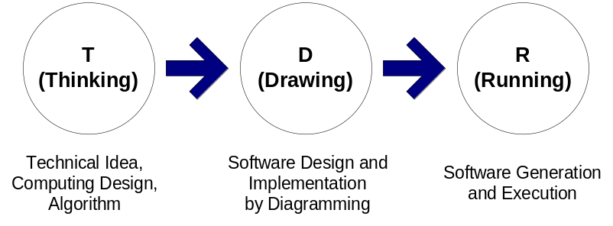

The Essential of TDR Technology.
The TDR technology combines current CASE technology with software compiler technology together.

Traditional CASE tools only provide design diagram functionality which is so-called “presentation/drawing” type feature. The source code generation functionality in current CASE products only create basic class layout source code and hardcopy of the implementation source code input by user, all of these source code’s logic process and syntax cannot be compiled and checked. The final executable program file cannot be generated directly.

On the other hand, traditional software development process is “from source code to compiling/building, then executable program”.

Since TDR combines general CASE technology and compiler technology together, it makes the software development by the way of “programming by diagramming”; the boundary between design and coding process will be blurred and the two processes will be melting together.

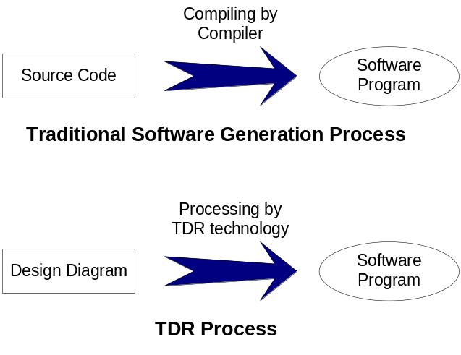

About TDRBuilder.
TDRBuilder v1.0 is first TDR technology base CASE and Computing solution software. With TDRBuilder v1.0, people can implement or transform their computing algorithm, technical design or idea by drawing the logical flowchart diagram, editing the computing/logical process in each flowchart block/step; people also can verify or check the result of their design by compiling and running their design module represented by the flowchart diagram.

The main functionalities of TDRBuilder v1.0 are:

- Creating new/empty module flowchart diagram.
- Adding, deleting, moving the processor block or block connector in flowchart diagram.
- Adding, editing, and deleting the various variables in the flowchart diagram (the module presented by the flowchart diagram).
- Adding, editing, deleting the computing processes (equations/functions) or logical comparison processes in each block.
- Compiling the flowchart diagram (the module presented by the flowchart diagram) to validate the design logical or syntax correction.
- Running/Operating the flowchart diagram (the module presented by the flowchart diagram) to verify the design result; or Running the diagram step by step and real-time checking each individual computing/logic block process result (like the Debug steps in most famous IDE).
- Saving the flowchart diagram (the module presented by the flowchart diagram) to disk files (XML format) which can be re-opened by TDRBuilder v1.0 or run by TDRRun service.
- Exporting the design and operating result of flowchart diagram (the module presented by the flowchart diagram) and to various format files including C++ class, text file, XML file, Microsoft Word and Excel file etc.
- Printing out the design and operating result of flowchart diagram (the module presented by the flowchart diagram).
- Copying and Pasting the flowchart diagram (the module presented by the flowchart diagram) or individual block in the flowchart diagram.

The internal architecture of TDRBuilder v1.0 software solution is that one software design diagram is built into one module; each process block in the diagram is created as the processor unit in the module.

New Features in TDRBuilder V2.0
TDRBuilder V2.0 is developing; the new features are introduced into the program. The new features are:
- The sub-module is used as a process block in the module.
- Class type data is used and UML class diagram is used for class design.
- More sophisticated compiling functionality.
- Better user interface.

Figure 1. One software design diagram
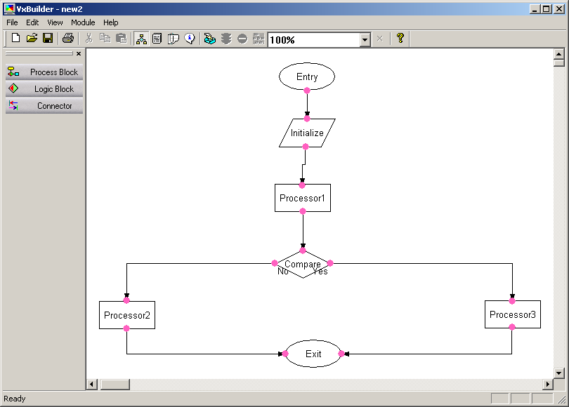

Figure 2. The screen shot of compiling the design diagram
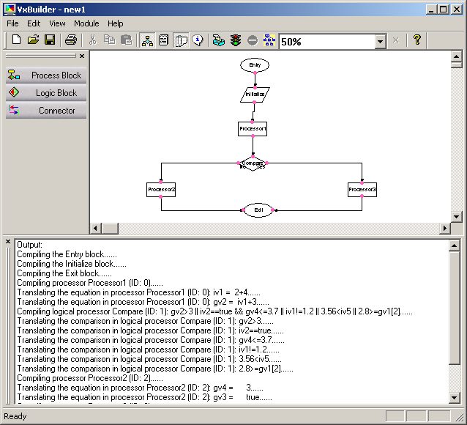

Figure 3. The screen shot of running the design diagram step by step (Debug process)
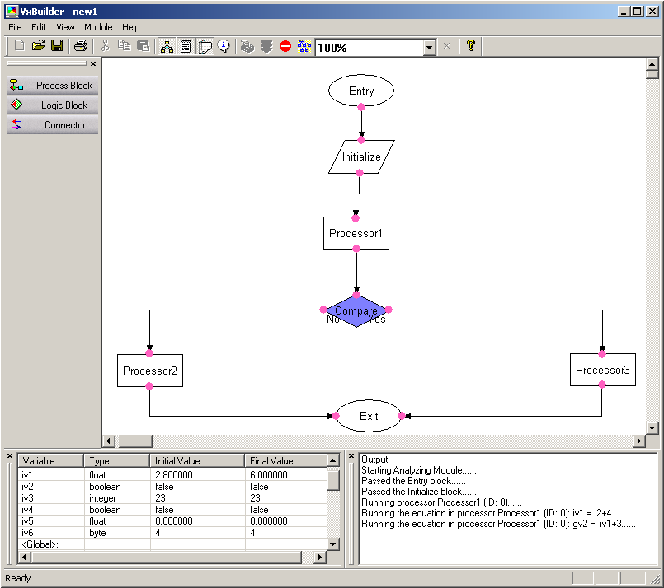

Figure 4. The UI of computing expression editing
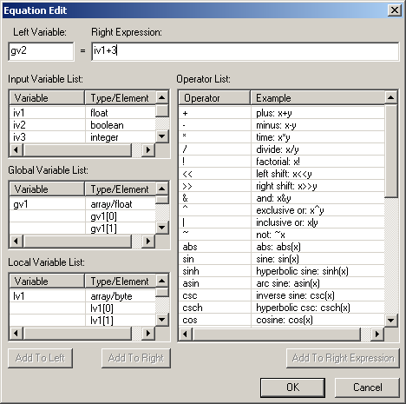

Figure 5. The UI of logical expression editing
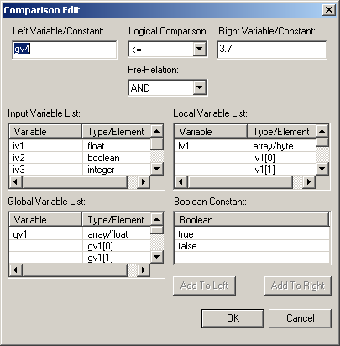

Figure 6. The screen shot of tool tip

