All case senarios are based on the Process Center server.

Admin Portal: <https://un1c-pc.banquelaurentienne.ca/ProcessAdmin>

1. If the BPM app is using application cache then clear it first. For example: read the database content and cache it when app launches for the 1st time.

Note: clear the cache for the relevant snapshot.

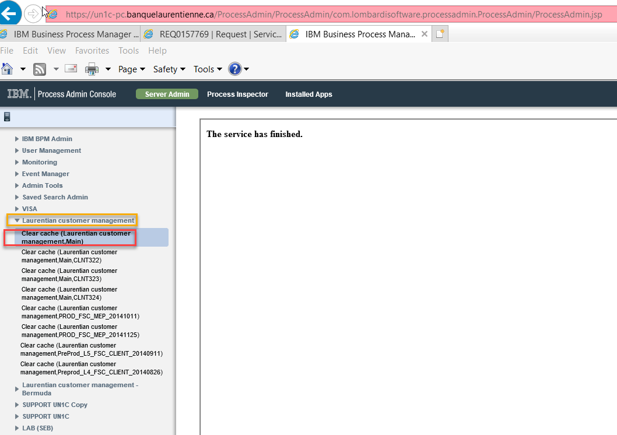

1. From the Process Designer, select the app or user activity for debug process

* Select Inspector tab and go to the diagram, set the break point, then click the debug button.

Note: if needed you may want to update the default value for some input parameters.

* During the debug steps, you can watch the variable’s value by running Execution Evaluator.
* At the same time, the browse window will show up and allow you to step the process, and you can see the variable output on the web page.

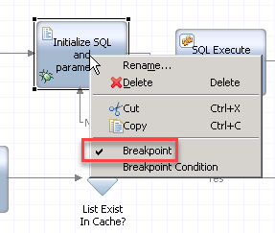

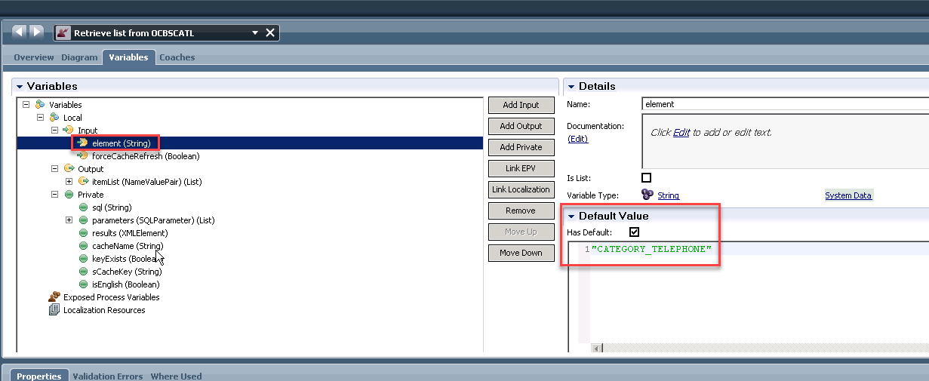

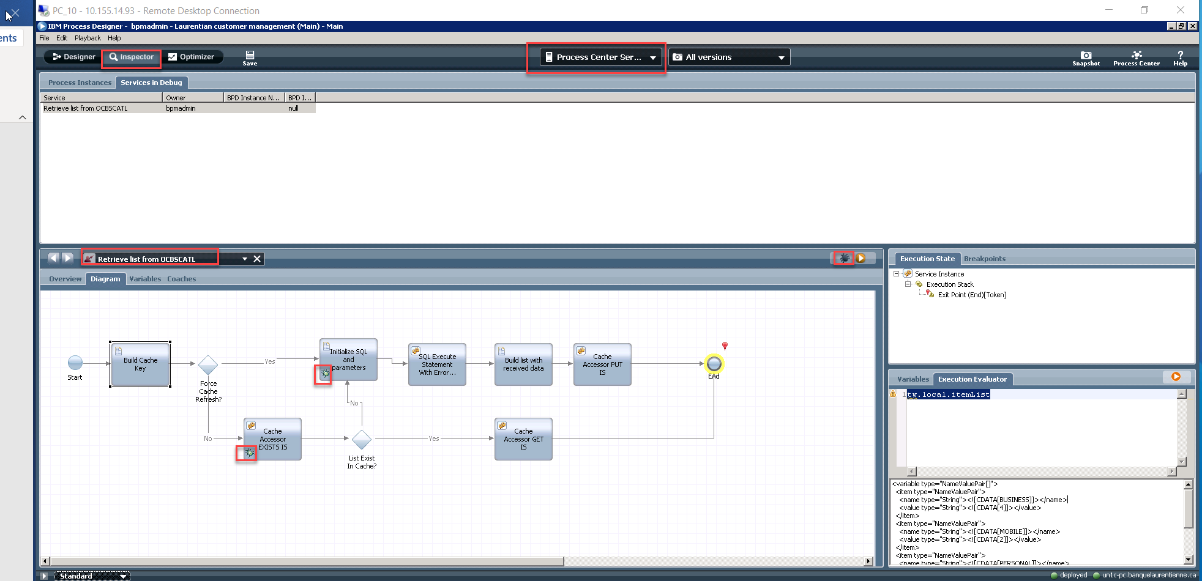

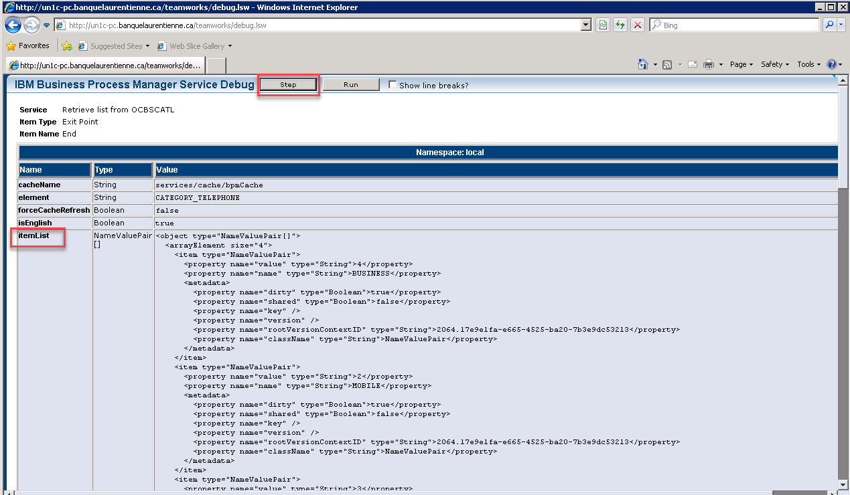

1. You can also put some log info and check the output value in system out.

