#### Recipe: Service Caching in IBM BPM / IBM BAW

<https://community.ibm.com/community/user/automation/blogs/atanu-roy/2021/09/24/recipe-service-caching-in-ibm-bpm-ibm-baw>

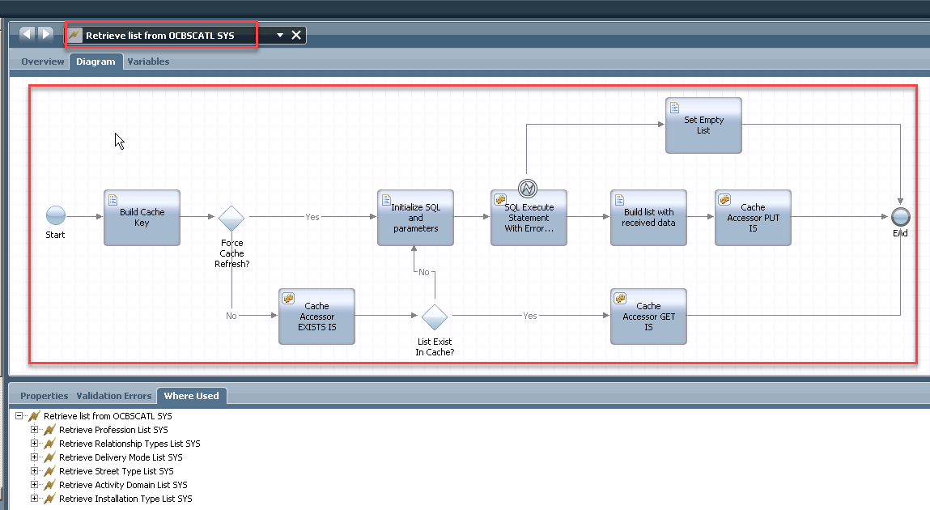

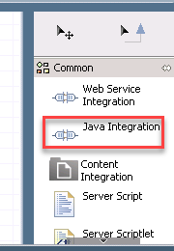 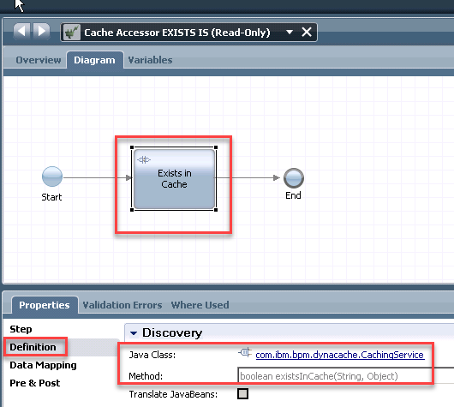

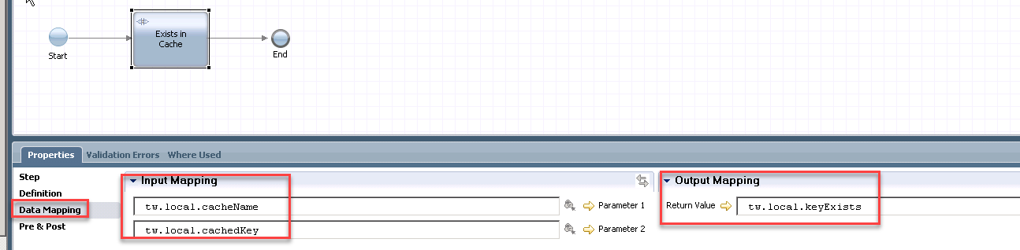

Get Cache

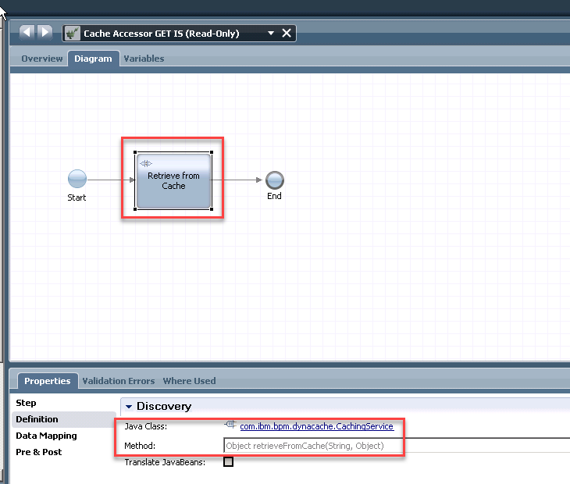

Set Cache

