BPM exposed service from Process App

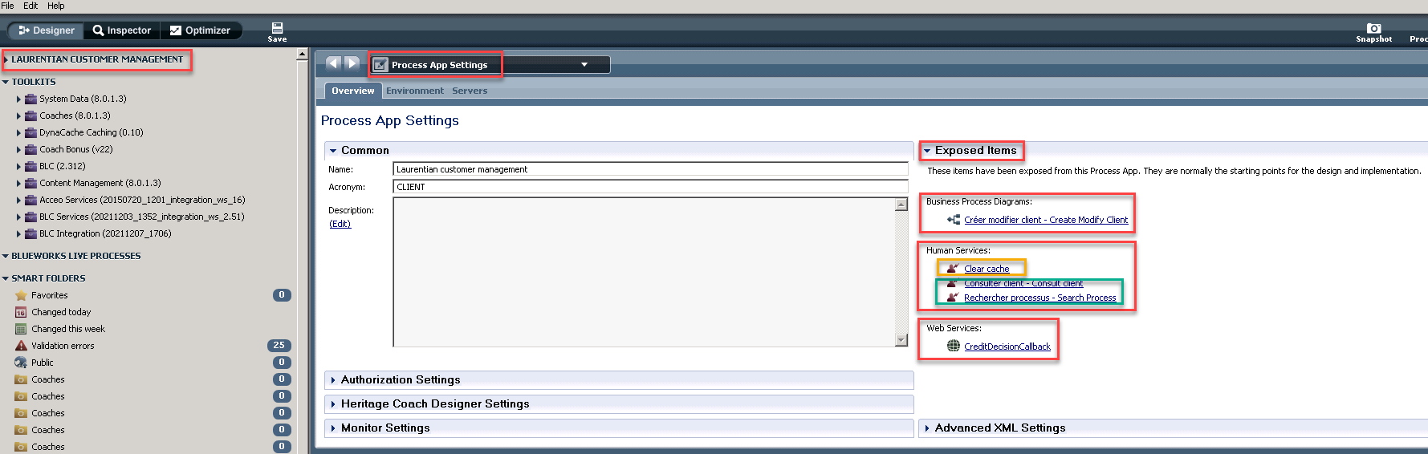

<https://www.ibm.com/docs/en/baw/19.x?topic=applications-editing-process-application-settings>

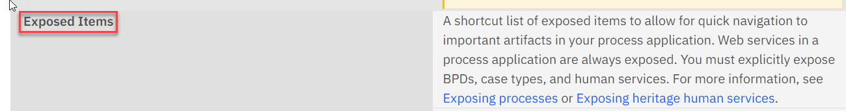

Exposed items are normally the starting points for the design and implementation.

* Business Process Diagram (BDP) is exposed

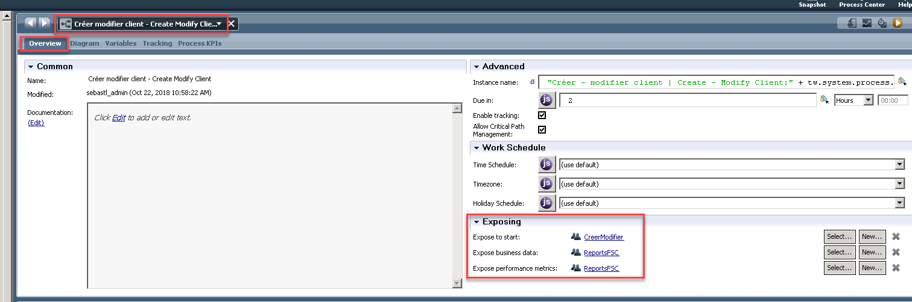

* Human Service is exposed

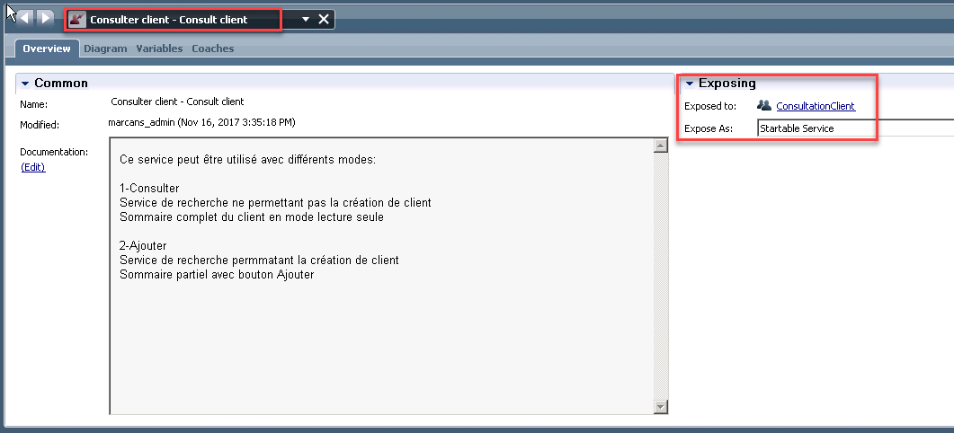

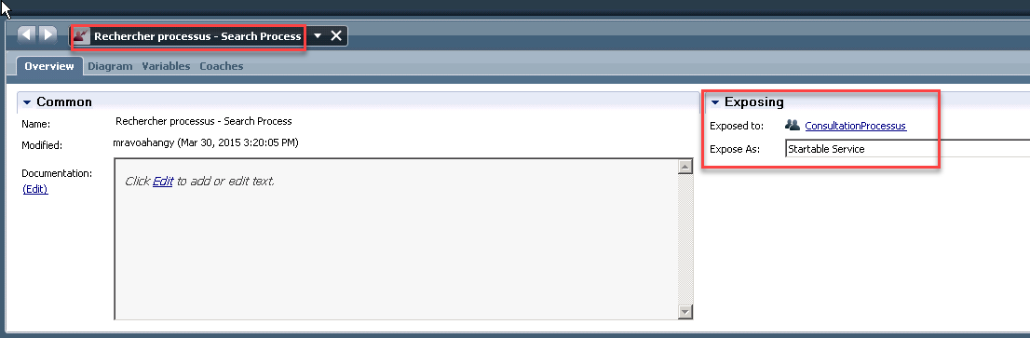

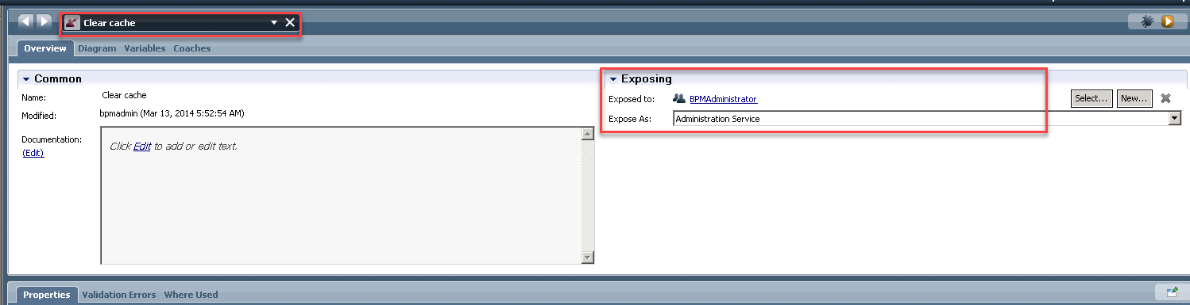

* Web Service is exposed

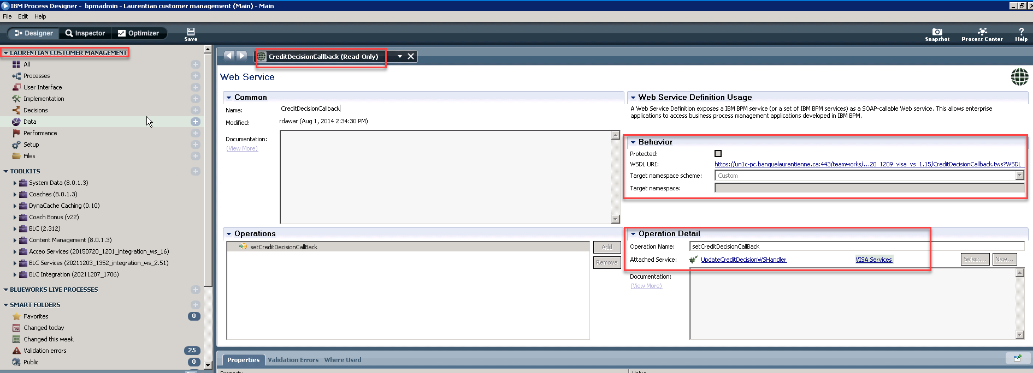

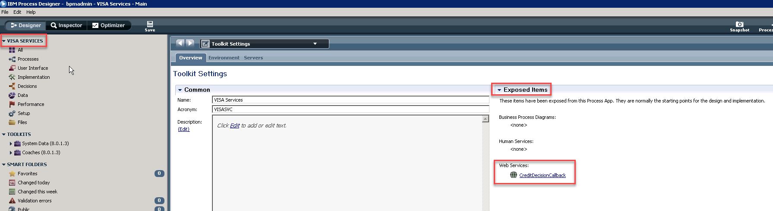

All exposed service can be seen either in Process Portal or Process Admin Console depending on the Role of the ID.

* Process Admin Console (user: bmpadmin)

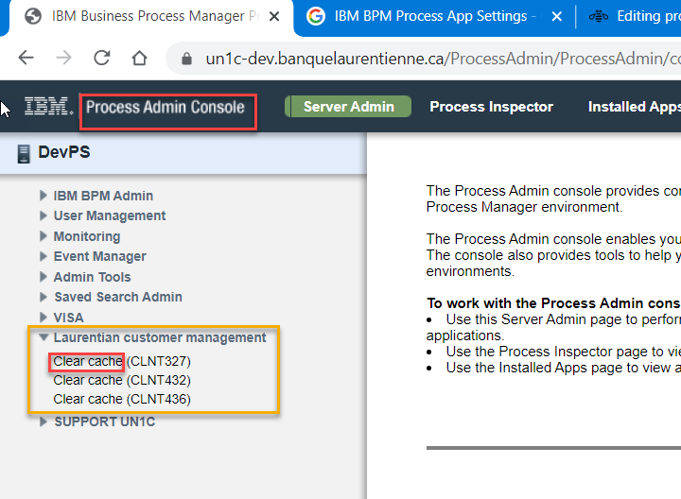

* Process Portal (user: zhaoj3)

NOTE : the highlighted exposed services are from CLIENT APP.

