U.S. Airline Arrival Delay Prediction
Case Study Report
Jocelyn Zhao
Exploratory analysis, leakage-safe feature engineering, and binary delay classification

1. Executive summary
Business question. Can a flight be identified as likely to arrive at least 15 minutes late using only information that would be available at its scheduled departure time?

Answer. Yes. The current XGBoost candidate materially outperforms a prevalence-only baseline and produces useful risk ranking, while remaining well calibrated overall. The model is best viewed as a risk-screening tool: it can prioritize higher-risk flights, but the final intervention threshold should be chosen from business capacity or error costs rather than defaulting to 0.50.
- Arrival-delay risk is strongly structured by time of day, weather, airport/carrier context, scheduled demand, and recent operating conditions.
- Four experiments were conducted, and the current leading specification, Experiment 3b, contains a short-term national pressure feature (7-day delay rate minus 28-day delay rate) with schedule, weather, demand, historical, and recent-rate features.
- On 2025 validation, Experiment 3b achieved PR-AUC 0.4250 versus a 0.2250 no-skill prevalence baseline, ROC-AUC 0.7032, Brier score 0.1570, ECE-10 0.0096, and 22.55% capture of all delayed flights in the top-risk 10% of flights.
- At the diagnostic max-F1 threshold of 0.217, precision is 34.5%, recall 65.0%, specificity 64.2%, and 42.4% of flights are flagged. This threshold is a benchmark, not necessarily an operational recommendation.
- Given time constraints, Experiment 3b was temporarily frozen and evaluated on Jan-May 2026 as an out-of-time check. Results remained broadly consistent with 2025 validation. Because those results have now been inspected, any further tuning should be evaluated on a later unseen period rather than reusing 2026 as an untouched final holdout.
A future Stage 2 regression model could estimate delay severity among flights with actual arrival delays of at least 15 minutes, using ArrDelayMinutes as the conditional target. Together with Stage 1, a combined probability–severity matrix could support clearer operational prioritization across different disruption scenarios.

Decision summary
Decision | Current recommendation
Target | Binary arrival delay: ArrDel15 (arrival at least 15 minutes late).
Prediction point | Scheduled departure; exclude post-departure and outcome-time fields.
Leading model | Experiment 3b: XGBoost with schedule + weather + demand + historical + recent operating rates + national pressure.
Model use | Risk ranking and operational classification; select threshold from alert capacity/costs.
Training | 2024 for development; 2024-2025 combined for the frozen 2026 out-of-time check.
Validation | 2025 development/validation, with monthly stability checks.
Final test | Jan-May 2026 out-of-time check completed; use a later unseen period for any post-2026 tuning.

2. Problem framing and data design

2.1 Target and scope
Primary target: ArrDel15, indicating whether a flight arrives at least 15 minutes late. The report reflects the current binary-classification scope; given the time constraint, a stage 2 delay-severity regression model is considered but is not part of the present recommendation. Some quick thoughts on the stage 2 and combine 2-stage model is briefly mentioned in Section 10.
- 2024 is used for model training and historical feature construction. Ideally a longer time series should be used but due to Covid disruption, it might be better to start from 2024 onwards.
- Given the lack of data, 2025 is used for development, validation, EDA, threshold analysis, and model comparison.
- Jan-May 2026 is used as an out-of-time check of the temporarily frozen Experiment 3b specification; because its results have now been inspected, it is no longer an untouched holdout for subsequent tuning.
- Cancelled flights and diversions that never reach the scheduled destination are not treated as ordinary non-delayed arrivals; they are separate non-arrival disruptions and are excluded in the model.
- For diversions that do reach the destination, the arrival target is recovered from DivArrDelay when available.

2.2 Leakage controls
The core design principle is that every model feature must be available at scheduled departure. Post-outcome variables such as departure delay, taxi-out time, actual elapsed time, cancellations/diversions, and BTS delay-cause fields are excluded from the feature set.
- Static historical risk features use past-only values in training and 2024-only mappings for 2025 validation.
- Recent operating-rate features use a two-day availability lag: a flight on date D can use outcomes only through D - 2.
- Origin and destination weather are joined to the same physical scheduled-departure instant, with timestamp-age checks preventing future weather observations.
- Categorical levels are learned from training data; unseen validation categories are mapped explicitly rather than silently leaking future category information.
Project basis: features.py, historical_features.py, recent_performance_features.py

3. Exploratory findings
Project basis: 02_eda.ipynb
The EDA was designed to connect descriptive patterns directly to feature design and leakage policy. The most important findings are summarized below.
Area | Finding | Modeling implication
Outcome distribution | About 63% of flights arrive on time or early; 21.7% are delayed at least 15 minutes. Delays have a long right tail. | A binary delay target is appropriate for the current project; class imbalance makes PR-AUC more informative than accuracy alone.
Airlines | The top five carriers account for about 70.6% of flights. Carrier delay differences are meaningful but confounded by route, airport, schedule, and cancellation mix. | Retain carrier as a predictive categorical feature; do not interpret model effects causally.
Airports | The top 30 of 362 airports account for about 65% of flights. | Keep origin and destination separate; account for airport-specific structure and rare/unseen categories.
Time | Delay risk rises strongly through the operating day, from roughly 10% in early morning to about 31% in the evening. Summer peaks recur, but 2024 and 2025 differ. | Retain scheduled departure time, day-of-week, month/seasonality, and use time-based validation.
Weather | Poor flight category, gusts, precipitation, low visibility, frozen precipitation, and thunderstorms are associated with more frequent/severe delays. Recent IFR/LIFR can remain informative after conditions improve. | Use current origin/destination weather, recent origin weather history, and weather missingness/age indicators.
Demand and weather | Delay risk increases with scheduled airport-hour demand, especially under IFR/LIFR conditions. | Retain scheduled demand and allow nonlinear weather-demand interactions.
Operating Systems | The short-term national delay rate responds more quickly to changes in the operating environment, but the long-term rate provides a smoother baseline. | System wide changes should be incorporated
Anomalies | Daily delay spikes and carrier reporting changes occur; 15 upper-tail outlier days were identified in 2024-2025. | Use time-based validation and targeted error analysis; do not use same-day anomaly/cause fields as predictors.

4. Feature engineering and model design
Project basis: 03_modeling_stage1_*.ipynb
The features are carefully selected based on the results from Section 2.2 and Section 3.

4.1 Feature groups
Please find a list of all features in Appendix A.
Feature group | Purpose
Schedule/calendar  (present in all Experiments) | Carrier, origin, destination, month, day of week/month, scheduled departure hour/minute, scheduled elapsed time, distance, holiday proximity/name.
Weather  (present in all Experiments) | Current origin and destination weather, recent origin weather history, flight category, precipitation/frozen precipitation, thunderstorms, visibility, gusts, and weather observation age/missingness.
Scheduled demand  (present in all Experiments) | Origin departures/operations and destination arrivals in the scheduled airport-hour.
Static historical priors  (added in Experiment 2) | Smoothed historical delay rates and support counts for carrier, origin, destination, route, carrier-route, and origin-departure-hour.
Recent operating rates  (added in Experiment 3) | National 7-day and 28-day delay rates plus 28-day carrier, origin, and destination rates, all lagged to preserve the prediction-time boundary.
National pressure  (added in Experiment 3b) | national_delay_rate_7d - national_delay_rate_28d, expressing short-term deterioration or improvement relative to the broader operating regime.  Why this feature matters? The two source rates were already available to XGBoost, so the pressure feature adds no new raw data. It simplifies an operationally meaningful relationship for an axis-aligned tree model and was motivated directly by EDA rather than by an unrestricted feature search.

4.2 Model
The problem has high-cardinality categorical variables e.g., airports, routes, weather factors, etc. that need to be handled natively rather than one-hot encoded or target-encoded. Weather data has great coverage, but missing values should be handled automatically without imputation. Non-monotonic effects like hour-of-day and weather, carrier, origin, destination interactions that drive delay is complex and difficult to engineer by hand. These conditions could be best accommodated with tree-based models, particularly XGBoost.
Four experiments (Experiment 1, 2, 3, and 3b) using XGBoost (same hyperparameters for control) were separately carried out to find the best representative feature set. The current best candidate is an XGBoost binary classifier with the feature groups stated in 4.1, i.e. Experiment 3b. Given the time constraint, further experiments should be continued to examine effects with hyperparameter tuning, which is discussed in Section 6.
Here is a list of its current model and hyperparameter settings.
- Objective: binary:logistic
- Learning rate: 0.05; up to 3,000 trees with early stopping
- max_depth: 8; min_child_weight: 20
- subsample: 0.85; colsample_bytree: 0.85
- reg_alpha: 0.05; reg_lambda: 5.0
- Evaluation monitoring includes log loss and PR-AUC; PR-AUC is the final early-stopping metric in the current ordering.

Please note that scale_pos_weight was left at its default of 1 because the primary objective was to obtain well-ranked and well-calibrated delay probabilities rather than artificially increase minority-class recall. Class imbalance was instead addressed through PR-AUC-based evaluation and operational threshold/alert-volume selection.

5. Model results

5.1 Aggregated metrics
Here is a list of the metrics we used and why we chose to do so.
Metric | Importance
PR-AUC | Measures how well the model identifies delayed flights when delays are the minority class, emphasizing precision and recall.
ROC-AUC | Measures how well the model separates delayed from non-delayed flights across all possible thresholds.
Log loss | Evaluates the quality of predicted probabilities and penalizes confident incorrect predictions heavily.
Brier score | Measures the average squared error between predicted delay probabilities and actual outcomes.
ECE-10 | Measures how closely predicted probabilities match observed delay rates across 10 probability bins.
Top-10% delay capture | Measures what share of all delayed flights is found within the 10% of flights assigned the highest risk.

5.2 Aggregate validation performance
Experiment 3b improves every reported aggregate metric relative to Experiment 1,2, and 3 - it consistently improves across ranking, discrimination, probability accuracy, calibration, and top-risk capture.
To help with interpretation, a 2025 validation no-skill baseline is provided. The no-skill PR-AUC equals the 2025 delay prevalence of 0.225. Experiment 3b reaches about 0.425, and the top-risk 10% of flights contains 22.55% of all delayed flights - about 2.26 times random capture.
Metric | 2025 no-skill baseline | Experiment 1 | Experiment 2 | Experiment 3 | Experiment3b | Direction
PR-AUC | 0.2250 | 0.4176 | 0.4235 | 0.4197 | 0.4249 | Higher is better
ROC-AUC | 0.5000 | 0.6982 | 0.7015 | 0.7015 | 0.7032 | Higher is better
Log loss | 0.5339 | 0.4880 | 0.4877 | 0.4863 | 0.4847 | Lower is better
Brier score | 0.1746 | 0.1581 | 0.1578 | 0.1576 | 0.1570 | Lower is better
ECE-10 | 0.0151 | 0.0170 | 0.0259 | 0.0118 | 0.0096 | Lower is better
Top-10% delay capture | 0.0994 | 0.2212 | 0.2244 | 0.2234 | 0.2255 | Higher is better

Calibration and temporal stability
Experiment 3b has an aggregated ECE-10 of 0.0096, indicating that predicted probabilities are well aligned with observed outcomes across 10 probability bins. Figure 2 calibration graph shows great calibration for probability bins below about 30% with slight over prediction in higher probability bucket. Monthly calibration still varies, which is expected in a changing operating environment and is important for deployment monitoring. This is exactly why we should look at temporal difference - strong overall ECE does not guarantee perfect month-by-month calibration because ECE groups predictions by probability level rather than by calendar period.

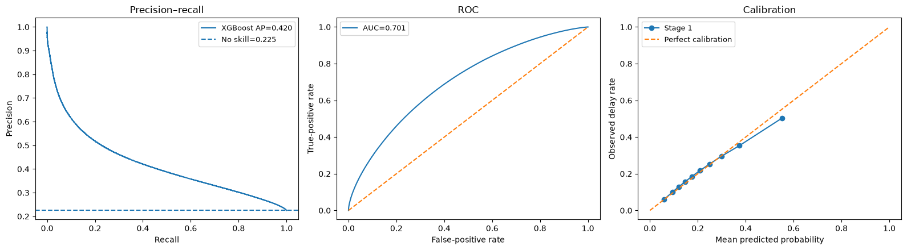
Figure 2. Experiment 3b aggregate precision-recall, ROC, and calibration curves on 2025 validation.
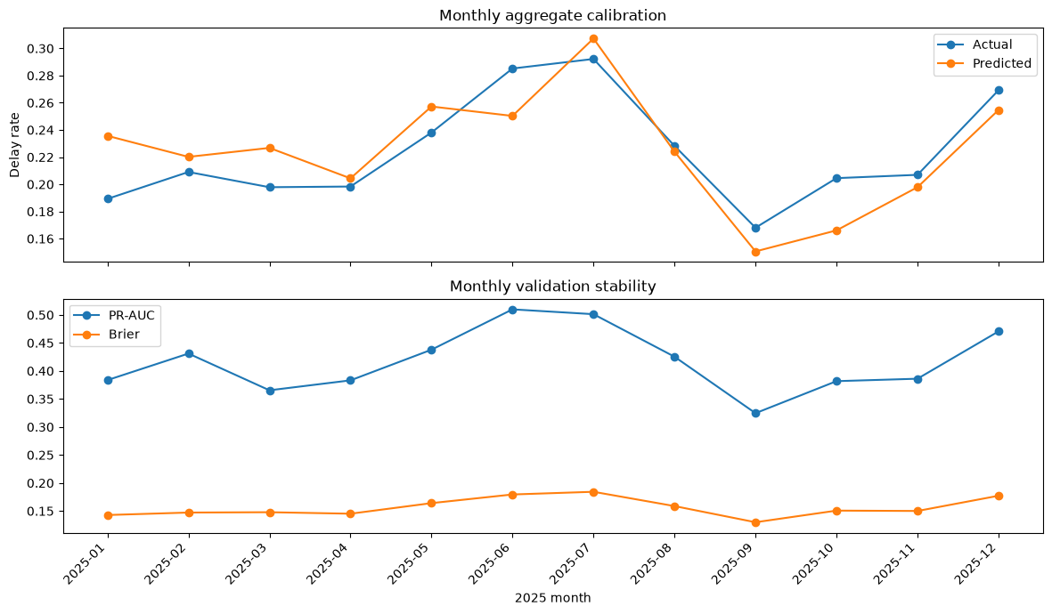
Figure 3. Experiment 3b monthly aggregate calibration on 2025 validation.

5.4 Operating threshold trade-off
The probability threshold controls the balance between missed delays and false alerts. Below is the threshold trade-off for Experiment 3b. The diagnostic max-F1 threshold on the 2025 validation is 0.217.
Threshold | Precision | Recall | Specificity | Flights flagged
0.100 | 25.7% | 94.0% | 21.0% | 82.4%
0.200 | 33.2% | 69.6% | 59.4% | 47.2%
0.217 | 34.5% | 65.0% | 64.2% | 42.4%
0.300 | 40.9% | 44.4% | 81.4% | 24.4%
0.400 | 49.0% | 25.5% | 92.3% | 11.7%
0.500 | 58.4% | 13.6% | 97.2% | 5.2%
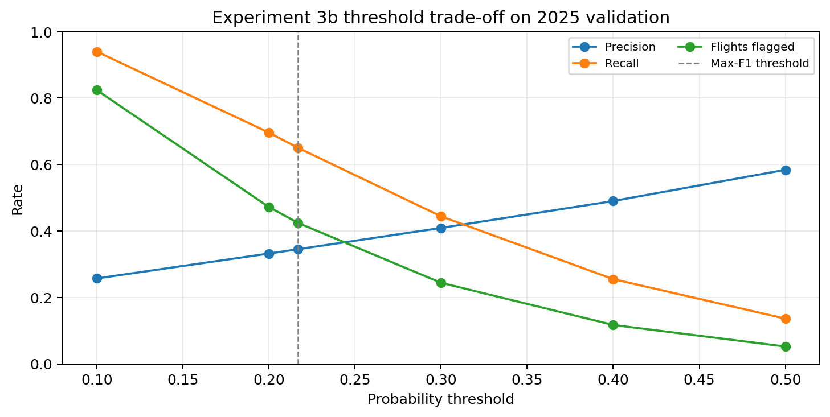
Figure 4. Precision-recall-alert-volume trade-off for Experiment 3b.

At this threshold (0.217), here is what we can summarize:
- Recall = 65.0%: captures about two thirds of delayed flights.
- Precision = 34.5%: about one in three flagged flights is delayed.
- Specificity = 64.2%: correctly leaves 64.2% of non-delayed flights unflagged.
- Predicted-positive rate = 42.4%: flags substantially more flights than the actual 22.5% delay prevalence.

Lower thresholds prioritize disruption capture but create many false alarms; higher thresholds improve precision but miss most delayed flights. The final operational threshold should therefore reflect the relative cost of missed delays and unnecessary alerts rather than relying automatically on maximum F1. For example, a passenger warning system may prioritize recall and therefore tolerate more false alarms to avoid missing potentially delayed flights. In contrast, an airport intervention system may have limited operational capacity and should prioritize a more concentrated set of high-risk flights. In that setting, performance may be better evaluated by how many actual delays are captured within the highest-risk 10% or 20% of flights, allowing resources to be focused where timely intervention is most valuable.

Note: For a two-stage system, an operating threshold is not required to compute the combined risk score. Stage 1 probability is combined with Stage 2 conditional severity, so probability quality and calibration become especially important.

5.5 Model drivers and SHAP interpretation
TreeSHAP analysis on the 2025 validation sample provides a model-based view of which features contribute most strongly to Experiment 3b predictions. Mean absolute SHAP values measure the average magnitude of each feature's contribution across flights; larger values indicate greater global influence on the model.
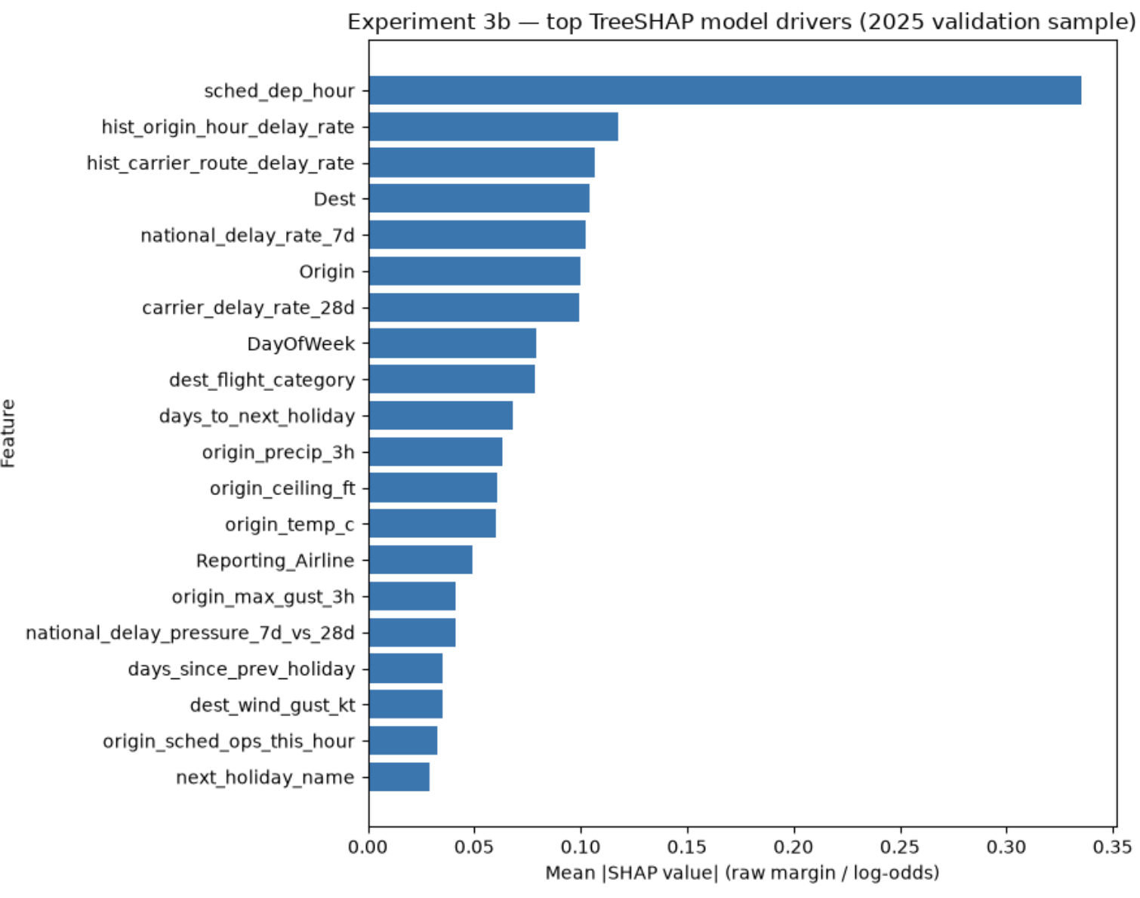
Figure 5. Experiment 3b top TreeSHAP model drivers on the 2025 validation sample.

The clearest result is that scheduled departure hour is the dominant global model driver. The next strongest features combine structural operating history, airport context, and recent network conditions, showing that the model is not relying on a single source of information.
Rank | Feature | Interpretation
1 | sched_dep_hour | Strongest model driver; captures the pronounced time-of-day structure in delay risk.
2 | hist_origin_hour_delay_rate | Represents persistent origin-airport risk at a given scheduled departure hour.
3 | hist_carrier_route_delay_rate | Captures structural historical performance for a specific carrier-route combination.
4 | Dest | Destination identity remains informative after schedule, weather, and historical context are considered.
5 | national_delay_rate_7d | Measures the current short-term operating regime across the network.
6 | Origin | Origin-airport identity contributes additional structural operating context.
7 | carrier_delay_rate_28d | Recent carrier performance adds dynamic information beyond static historical rates.
8 | DayOfWeek | Calendar structure contributes to predicted delay risk across the weekly operating cycle.

Other notable top-20 contributors with details are listed in Appendix B, which include destination flight category, holiday proximity, recent origin precipitation, origin ceiling and temperature, recent wind gusts, scheduled origin operations, and the national 7-day-versus-28-day delay-pressure feature. Weather therefore remains important, but its contribution is distributed across several related variables rather than concentrated in a single feature.

The national delay-pressure feature is not one of the largest global SHAP drivers, but it remains among the top contributors and can still add useful incremental information during changes in the operating regime. A feature does not need to dominate global importance to improve out-of-time performance.

Note: These are predictive model drivers, not causal effects. Mean absolute SHAP values show contribution magnitude but not direction; a SHAP beeswarm or dependence analysis would be needed to show which feature values push predicted delay risk higher or lower. Correlated variables can also share or redistribute attribution.

6.1 Modeling recommendation (step by step)
- Promote Experiment 3b to the leading feature specification.
- Freeze feature engineering temporarily; avoid uncontrolled addition of ratios or pairwise transformations after repeated validation inspection.
- Run staged hyperparameter tuning, beginning with tree complexity (max_depth and min_child_weight), then sampling and regularization, and learning rate last.
- Evaluate tuning candidates on PR-AUC, top-risk capture, monthly stability, log loss/Brier/ECE, and fixed alert-volume precision/recall.
- Choose the final operating threshold only after the model specification is selected.
- For future tuning, freeze all choices before evaluation and use a later unseen period as the final holdout; do not reuse Jan-May 2026 as an untouched final test.

6.2 Out-of-time Jan-May 2026 check
Given time constraints, the Experiment 3b specification was temporarily frozen and evaluated on Jan-May 2026. Results remained broadly consistent with 2025 validation, providing a useful out-of-time robustness check.
Operational targeting remained useful in 2026. The highest-risk 10% of flights contained 23.05% of all delayed flights with 49.64% precision; expanding the alert group to 30% captured 51.72% of delays.
Alert fraction | Flights flagged | Score cutoff | Precision | Delay capture
5% | 140,691 | 0.4905 | 57.94% | 13.45%
10% | 281,381 | 0.4100 | 49.64% | 23.05%
20% | 562,762 | 0.3264 | 41.82% | 38.83%
30% | 844,142 | 0.2728 | 37.13% | 51.72%
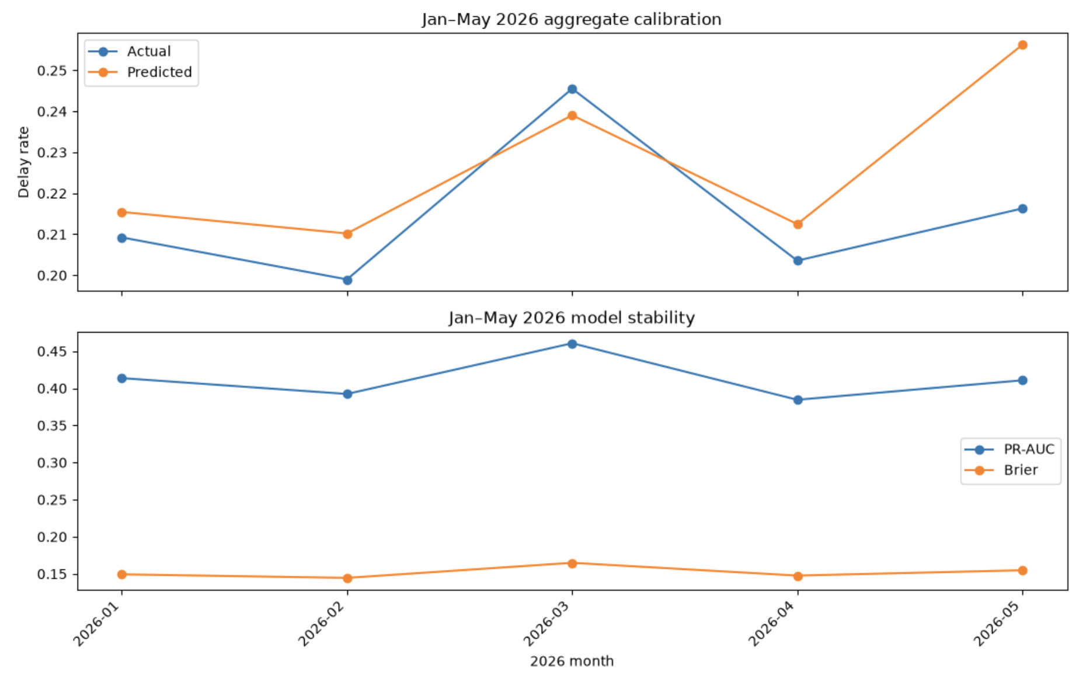
Figure 6. Jan-May 2026 aggregate calibration and monthly model stability for the frozen Experiment 3b check.
Monthly PR-AUC remains approximately 0.39-0.46, so ranking does not collapse across the five months. Aggregate calibration is close in January-April, while May overpredicts the delay rate by roughly four percentage points, indicating a calibration shift rather than a loss of ranking skill.

Note: Because this period has now been inspected, later tuning should be evaluated on a new unseen period.
Project basis: 04_final_test_2026_experiment_3b.ipynb

6.3 Suggested tuning batch
Hypotheses: model might be too complex – a simpler model might work better. Below are a few trials to help produce a more conservative model and test the hypothesis.
Candidate | max_depth | min_child_weight | subsample | colsample | Regularization
Benchmark | 8 | 20 | 0.85 | 0.85 | alpha=.05, lambda=5
Shallower A | 6 | 20 | 0.85 | 0.85 | alpha=.05, lambda=5
Shallower B | 6 | 50 | 0.85 | 0.85 | alpha=.05, lambda=5
Compact | 4 | 50 | 0.85 | 0.85 | alpha=.05, lambda=5
Regularized | 6 | 50 | 0.85 | 0.85 | alpha=.10, lambda=10
Row sample | 6 | 50 | 0.7 | 0.85 | alpha=.10, lambda=10
Feature sample | 6 | 50 | 0.85 | 0.7 | alpha=.10, lambda=10

7. Deployment and monitoring considerations

- The Recent-rate features require a production data pipeline that reliably updates completed prior-day outcomes.
- The two-day availability lag used in development should be preserved unless the production pipeline can prove a tighter information boundary.
- Monitor calibration and ranking by month, carrier, origin/destination airport, and weather regime. Aggregate metrics alone can hide temporal drift.
- Track categorical coverage and reporting-code changes. The EDA found carrier reporting/volume shifts, including a 9E disappearance from active reporting after December 2024.
- Be mindful of leakage features. Do not use outcome-time delay causes, actual departure information, taxi-out, or other post-scheduled-departure variables in live prediction.
- Treat cancellations and non-arrival diversions as separate disruption outcomes if a broader operational-risk product is later required.

8. Limitations
- Because of the limited time series after the Covid disruption, 2025 is both an EDA and development/validation period, so repeated decisions may gradually adapt to 2025. Jan-May 2026 was used as an out-of-time check of the temporarily frozen Experiment 3b specification; because its results have now been inspected, any subsequent tuning requires a later unseen holdout for an unbiased final check.
- Experiment 3b has not yet undergone the planned hyperparameter search, so its current configuration is a leading candidate rather than the final model.
- For a binary classification model, the max-F1 threshold is diagnostic and may not correspond to real operational costs or intervention capacity.
- Historical and recent rate features are predictive summaries, not causal estimates of carrier or airport performance.
- Extreme disruption events can change the data-generating process abruptly, e.g. massive IT outage caused by a faulty CrowdStrike software update on 07/19/2024; no pre-departure model should be expected to perfectly anticipate all such events.

9. Reproducibility and supporting materials
The supporting-materials package accompanying this report contains the current EDA, the leading modeling experiment, feature helpers, selected project utilities, and the figures used in this report.
Artifact | Role
01_data_acquisition.py | Data acquisition methodologies with basic quality checks.
02_eda.py | Structured 2024-2025 EDA, including recent-rate diagnostics.
03_modeling_stage1_03b_history_recent_pressure.py | Leading binary-classification experiment and evaluation workflow.
03_modeling_stage1_*.py | Experiment 1,2, and 3 and their evaluation workflows.
clean_data.py | Target construction and split-loading utilities.
features.py | Schedule, weather, holiday, timezone, and demand feature engineering.
historical_features.py | Leakage-safe static historical risk features.
recent_performance_features.py | Lagged 7- or 28-day national and 28-day group recent-performance features.
figures | Figure directory containing all the figure artifacts generated throughout the study.

10. Next Step: Stage 2 Conditional Delay-Severity Model and Combined significant-delay burden

Stage 1 answers which flights are likely to experience a significant arrival delay. A natural next extension is a conditional severity model trained on flights with ArrDel15 = 1 to estimate ArrDelayMinutes, separating disruption probability from potential operational impact.
Stage 2 would start with the same 55 leakage-safe scheduled-departure features as Stage 1 and preserve the same prediction-time boundary; post-departure variables remain excluded. Stage 2 should first be evaluated only among truly delayed flights using MAE, median absolute error, RMSE, bias, and segment/month stability. This isolates severity accuracy from Stage 1 errors.
In terms of combining the two stages, mathematically, Stage 1 estimates p = P(delay >= 15 min | X), Stage 2 estimates m = E[ArrDelayMinutes | delay >= 15 min, X], and the combined expected significant-delay burden is their product. For example, 70% probability x 40 predicted minutes = 28 expected significant-delay minutes. However, this means a 20% probability of 140 minutes delay would also be treated the same even though their operation impacts are different.

In this case, A 2×2 of probability against severity gives operations four named situations: routine friction (high p, low m), tail risk (low p, high m), act now (high p, high m), monitor (low both). That is perhaps more informative than a combined minutes figure, and it provides more concrete recommendations to different situations.
 | Low predicted severity | High predicted severity
Low delay probability | Monitor / low priority  Unlikely and limited impact | Tail risk  Unlikely but potentially severe
High delay probability | Routine friction  Likely but relatively manageable | Act now  Likely and operationally severe

Note: The expected-burden product remains useful as a secondary continuous score, while the 2 x 2 matrix provides the more interpretable business-facing recommendation.

11. Conclusion
Current conclusion. The case study has progressed from descriptive airline-delay analysis to a leakage-safe, operationally interpretable binary risk model. Experiment 3b is the strongest current candidate, combining schedule, holiday, weather, demand, historical performance, recent operating rates, and national delay-pressure features. Given the time constraints, further hyperparameter tuning was deferred, and a temporarily frozen version of Experiment 3b was evaluated on Jan–May 2026 for demonstration purposes. Its out-of-time performance was broadly consistent with the 2025 validation results, with stable ranking performance but some probability calibration drift in May. A natural next step is to add a Stage 2 conditional-severity regression model and combine its severity estimate with the Stage 1 delay probability in a probability–severity matrix, providing a clearer framework for operational prioritization and business decision-making.

Appendix

A. Feature Details

- 55 Features
Feature group | Purpose
Schedule/calendar  (present in all Experiments) | 'Reporting_Airline',  'Origin',  'Dest',  'Month',  'DayOfWeek',  'DayofMonth',  'sched_dep_hour',  'sched_dep_minute',  'CRSElapsedTime',  'Distance',  'days_to_next_holiday',  'days_since_prev_holiday',  'next_holiday_name',  'prev_holiday_name'
Weather  (present in all Experiments) | 'origin_visibility_sm',  'origin_ceiling_ft',  'origin_flight_category',  'origin_wind_speed_kt',  'origin_wind_gust_kt',  'origin_precip_mm',  'origin_frozen_precip',  'origin_thunderstorm',  'origin_temp_c',  'origin_ifr_hours_past3',  'origin_precip_3h',  'origin_max_gust_3h',  'dest_flight_category',  'dest_wind_gust_kt',  'dest_frozen_precip',  'dest_thunderstorm',  'origin_weather_age_minutes',  'dest_weather_age_minutes',  'origin_weather_observation_missing',  'dest_weather_observation_missing'
Scheduled demand  (present in all Experiments) | 'origin_sched_deps_this_hour',  'origin_sched_ops_this_hour',  'dest_sched_arrivals_this_hour'
Static historical priors  (added in Experiment 2) | 'hist_carrier_delay_rate',  'hist_carrier_log_count',  'hist_origin_delay_rate',  'hist_origin_log_count',  'hist_dest_delay_rate',  'hist_dest_log_count',  'hist_route_delay_rate',  'hist_route_log_count',  'hist_carrier_route_delay_rate',  'hist_carrier_route_log_count',  'hist_origin_hour_delay_rate',  'hist_origin_hour_log_count'
Recent operating rates  (added in Experiment 3) | 'national_delay_rate_7d',  'national_delay_rate_28d',  'carrier_delay_rate_28d',  'origin_delay_rate_28d',  'dest_delay_rate_28d'
National pressure  (added in Experiment 3b) | 'national_delay_pressure_7d_vs_28d'

B. SHAP model drivers
