Test Data for Assignment3

1.http:// … …/test1.txt

Word Count Statistics for http:// … …/test1.txt

The document contains 136 words

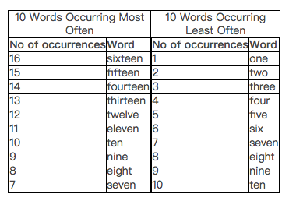

2..http:// … …/test2.txt

Word Count Statistics for http:// … …/test2.txt:

In total, the document contains 136 words

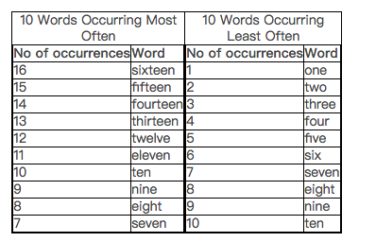

3.http:// … …/test3.txt

Word Count Statistics for http:// … …/test3.txt:

The document contains 0 words

If the document does not contain any words, printing out the tables is optional. A script that does not print the tables if the document does not contain any words will receive more marks.

4.http:// … …/test4.txt

Word Count Statistics for http:// … …/test4.txt:

The document contains 1 word

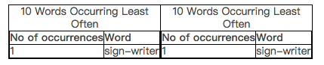

Note that the output of the total word count uses `1 word' instead of `1 words'. Also, since there are less than 10 words in the document, the two tables only have as many rows as there are words in the document. A script that reproduces this behaviour will receive more marks than a script that reports the word count for this example as `1 words' or produces tables with empty rows.