SAFER-SIM University Transportation Center, 69A3551747131

Various results for network safety improvement using VSLC
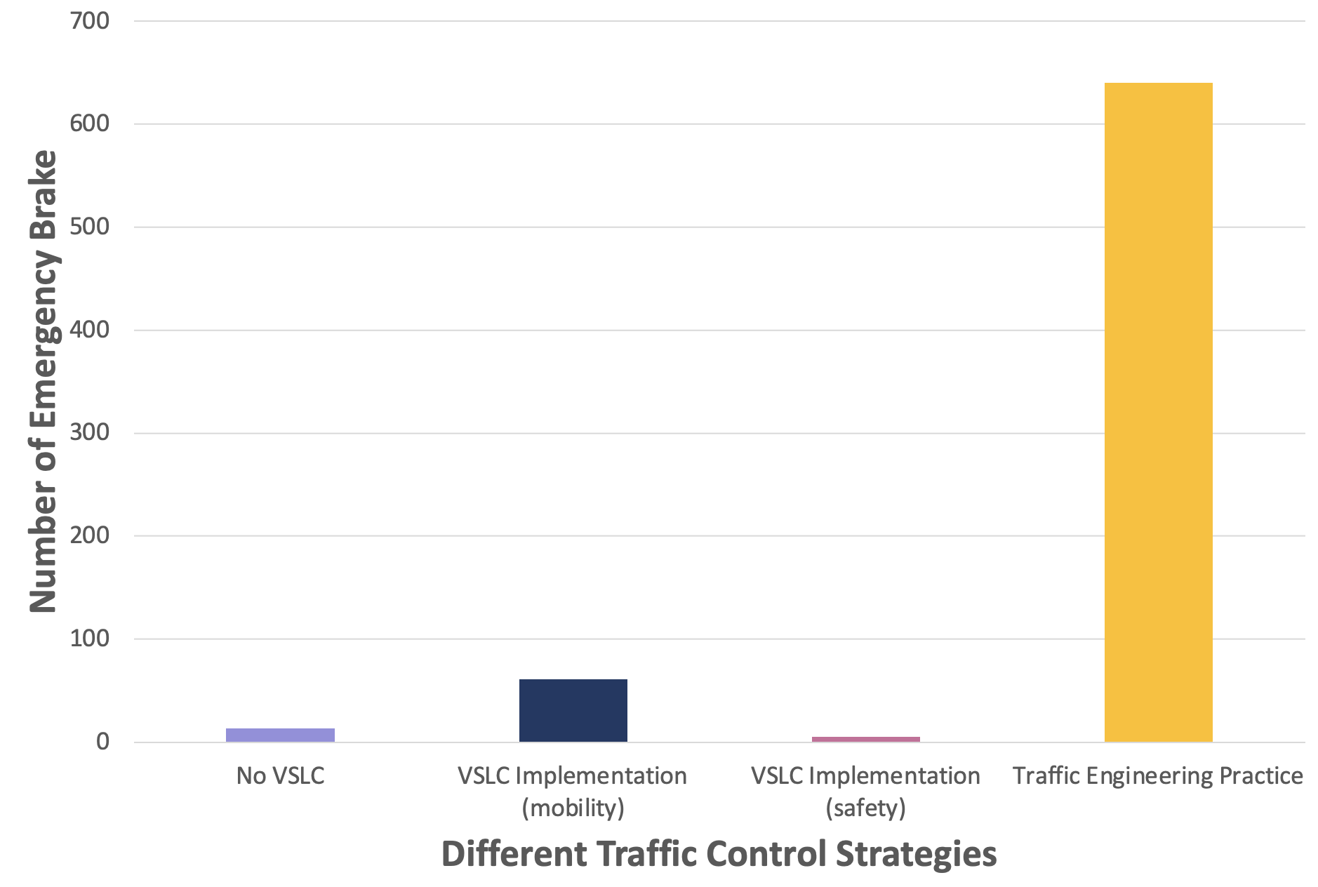
Network safety assessment for different traffic control strategies.
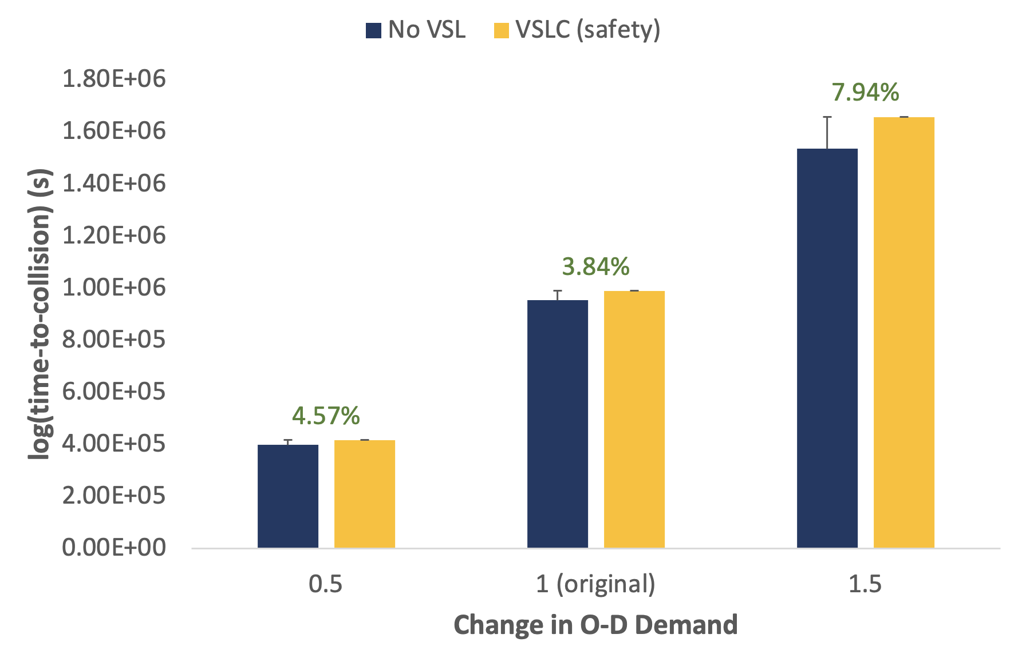
The generalization capability of the TD3 algorithm for improving network safety with different O-D demand.
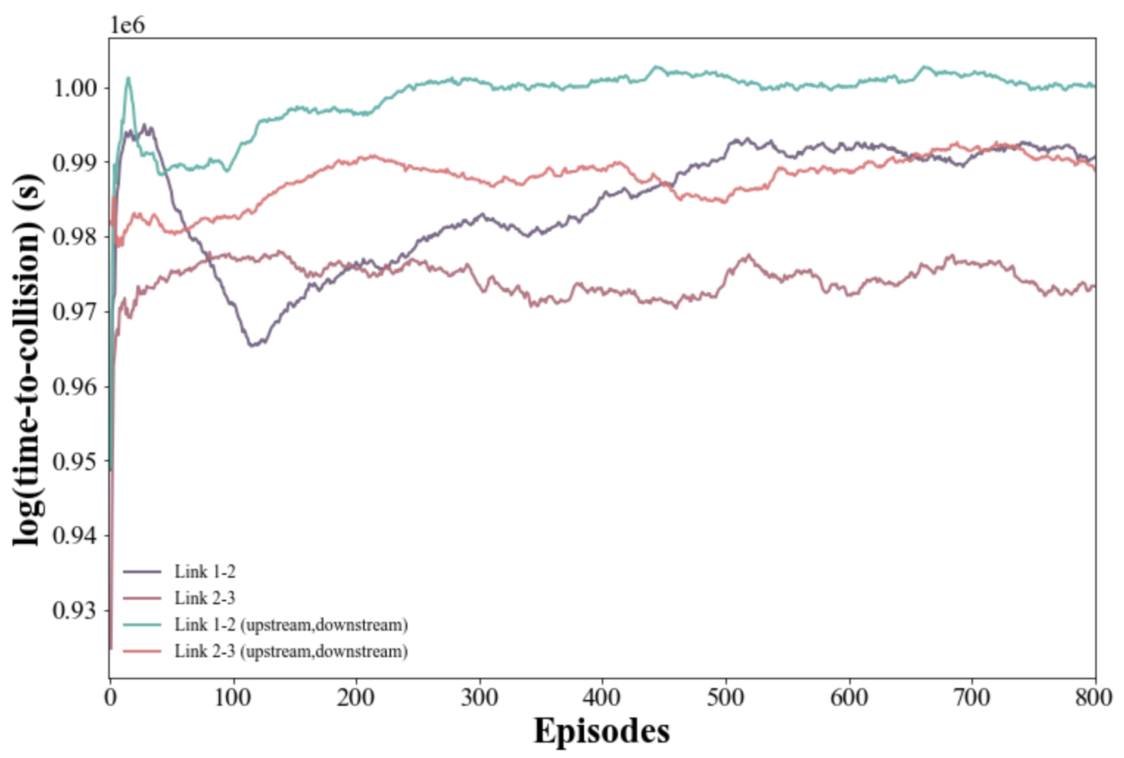
Spatial distribution of VSLC placement to improve network safety.

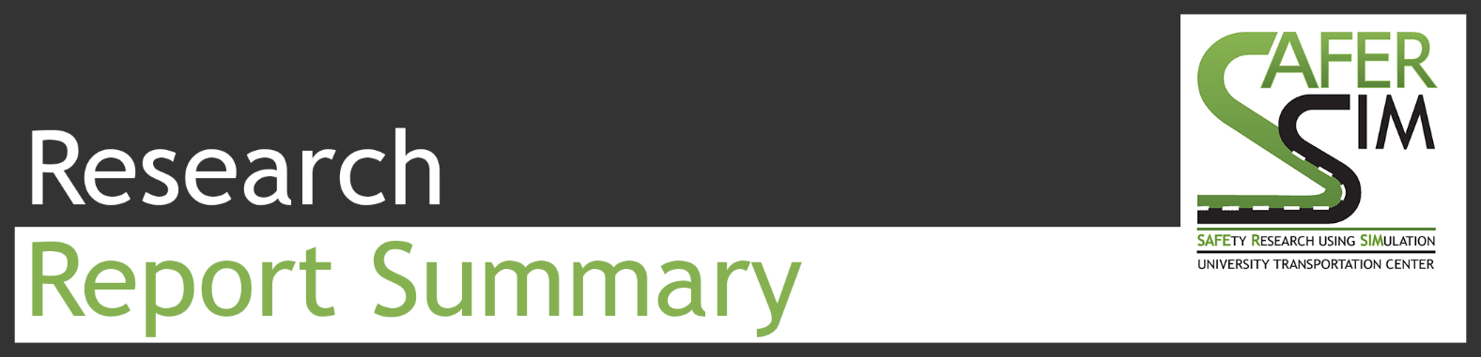
Zhaomiao Guo, PhD, https://orcid.org/0000-0002-1665-5437 5/31/21

Policy Gradient Reinforcement Learning Based Optimal Speed Limit Control for Network Mobility and Safety
The goal of this study is to develop efficient Variable Speed Limit Control (VSLC) strategies that improve safety and mobility across a transportation network. VSLC allows traffic management authorities to dynamically regulate traffic progression based on prevailing system conditions, such as traffic and weather, offering a cost-effective approach to mitigate congestion and improve safety. However, optimizing VSLC strategies at a network level poses challenges due to adaptive decision-making and interconnected network topology. Real-time information enables vehicles to reroute based on their own data, influencing VSLC decisions and potentially causing traffic oscillation between alternative routes, leading to higher frequency lane changes and potential bottlenecks. The existing methods often focus on enhancing local traffic performance and overlook potential impacts on surrounding links, hindering a comprehensive analysis of VSLC's effects on the entire transportation system [1][2].
  - 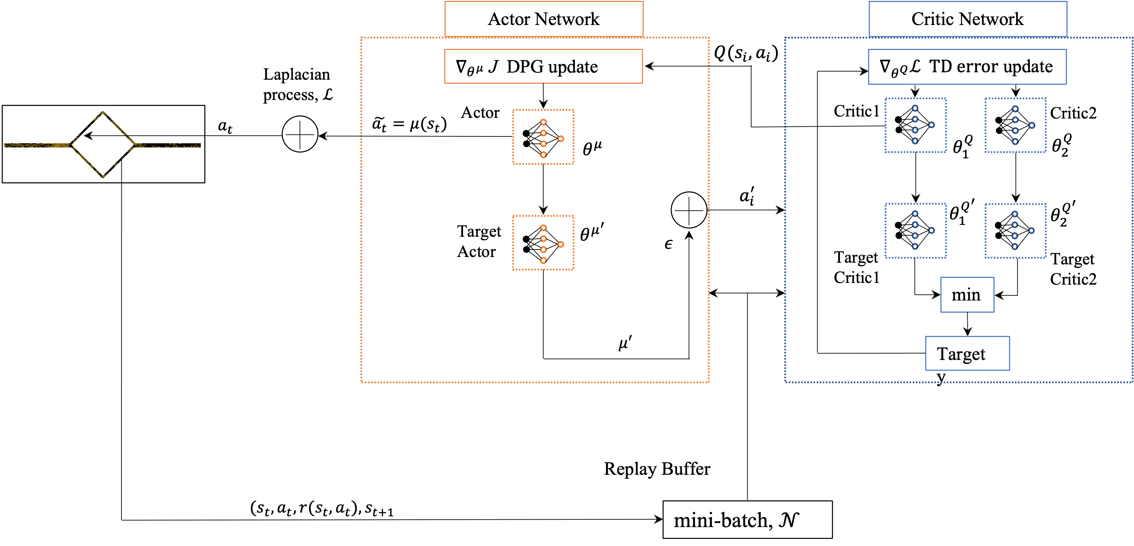
Figure 1 Structure of the algorithm with the network used for the study

To address these challenges, first, the study proposes a deep reinforcement learning (DRL) approach enabling dynamic speed limits to reduce congestion and accident risks. The approach employs a deep actor-critic framework, efficiently handling a large number of possible speed limits at each time step. Novel reward functions for network mobility, safety, and traffic oscillation are introduced to better characterize the transportation network's performance. Second, the study investigates the transferability of the control algorithm by testing it in environments with different traffic and driving behavior attributes. Third, it assesses the efficacy of various control algorithms, encompassing different RL algorithms and control objectives. Furthermore, the impacts of VSLC implementations in different locations are analyzed, comparing their performance in improving overall network mobility and safety.
Impacts
The impact of research outcome on transportation systems, transport authorities and the society are as follows:
- reduced traffic accidents and fatalities through the adaptation of the DRL-based VSLC strategy, enhancing network safety and mobility
- decreased capital and operating cost for transport authorities due to efficient traffic flow and network congestion from optimized VSLC implementation
- shorter travel time for residents in areas benefiting from enhanced traffic management

Outcomes
This study proposes a DRL-based VSLC to improve network mobility and safety. The potential outcomes include:
- potential adoption of DRL-based VSLC by transport authorities to optimize network mobility and safety on a broader scale
- development of new policies and regulations governing the use of dynamic speed limits and their optimal placement in different traffic environment may be influenced by the study’s insights into VSLC placement impacts.

“Improving network safety and mobility using VSLC is dependent on the specific location where VSLC is implemented. Optimizing network mobility comes at the expense of compromising network safety, and vice versa.”

References
[1] Wu, Y., Tan, H., & Ran, B. (2018). Differential variable speed limits control for freeway recurrent bottlenecks via deep reinforcement learning. arXiv preprint arXiv:1810.10952.
[2] Wang, C., Zhang, J., Xu, L., Li, L., & Ran, B. (2019). A new solution for freeway congestion: Cooperative speed limit control using distributed reinforcement learning. IEEE Access, 7, 41947-41957.

