
算法与数据结构课程设计报告
系 （院）： 计算机科学学院
专业班级： 软工11601
姓 名： 赵惹儿
学 号： 201603659
指导教师： 周云才
设计时间： 2018.6.11 - 2018.6.15
设计地点： 主教机房

目录

一、课程设计目的 3
二、设计任务及要求 3
- 单链表的基本操作及应用……………………………………..3
2. 栈的基本操作及应用…………………………………………...3
3. 矩阵的基本操作及应用………………………………………...3
4. 二叉树的基本操作及应用…………………………………3 5. 图的基本操作及应用…………………………………………….3

三、设计方案 4
四、实现过程 5
五、实现代码 6
六、测试结果 ···································48
七、难点与收获小结···························56
1.小结…………………………………………………………56
2.老师指导意见………………………………………………56

一．设计目的
1．提高数据抽象能力。根据实际问题，能利用数据结构理论课中所学到的知识选择合适的逻辑结构及存储结构，并设计出有效解决问及的算法。
2．提高程序设计和调试能力。学生通过上机实习，验证自己设计的算法的正确性。学会有效利用基本调试方法，迅速找出程序代码中的错误并且修改。
3．初步掌握软件开发过程中问题分析、系统设计、程序编码、测试等基本方法和技能。
4．训练用系统的观点和软件开发一般规范进行软件开发，培养软件工作者所应具备的科学的工作方法和作风，以及思维方式的训练和培养。
5．培养自己动手设计，操作系统，主动完成程序设计的能力，增强对所学理论知识的应用。

二．设计任务及要求
根据《算法与数据结构》课程的结构体系，设计一个基于DOS菜单的应用程序。要利用多级菜单实现各种功能。所有子菜单退出到他的父菜单。编程实现时，要用到C++的面向对象的功能。
- 单链表的基本操作及应用
2. 栈的基本操作及应用
3. 矩阵的基本操作及应用
4. 二叉树的基本操作及应用
5. 图的基本操作及应用

三．设计方案：
在学习完《算法与数据结构》这门课程后，基于初步了解的知识结构体系，构建设计方案，绘制基本知识结构逻辑示意图，如下：
菜单基类BaseMenu
数组Array

单链表LinkList
图Graph
二叉树BiTree
栈stack
创建链表
应用
矩阵创建
查找元素
删除元素
插入元素
矩阵显示
矩阵乘法
创建图
遍历
拓扑排序
应用
应用

创建二叉树
取栈顶元素
应用
树的深度
叶子结点的个数
查找兄弟和
双亲
出栈
进栈
Huffman编码
遍历二叉树

根据算法与数据及结构的课程安排，可以设计如上所示的菜单。在主菜单里可以有“线性表”、“栈”、“数组、矩阵”、“树”、“图”。然后要在线性表里创建一个子菜单实现“创建链表”、“插入元素”、“删除元素”、“查找元素”的功能，同时做一个通讯录的应用，并且可以退出这个子菜单回到上一级菜单。栈的基本操作和应用是创建一个子菜单，包含进栈和出栈，以及取栈顶元素的功能，然后做一个表达式的求解。数组里可以创建子菜单包含矩阵乘法功能。树里创建子菜单，有树的创建、先序遍历、中序遍历、后序遍历、树的深度、计算叶子结点个数，查找双亲，查找兄弟，然后做Huffman编码的应用。这些子菜单都能退出回到上一级菜单。

四．实现过程：
1、先做一个主菜单类BaseMenu：用show函数显示出主菜单内容，通过DoEvent函数选择二级菜单，此时主菜单指针指向相应二级菜单中的类；
2、编写主函数；
3、做二级菜单（分别做二级菜单LinkList、Stack、BiTree、Array、Graph）：以二级菜单LinkList为例，做一个LinKMenu的类，用show函数显示二级菜单内容，通过DoEvent函数选择二级菜单的某一个功能；再做一个LinkList的子类CMyLinkList，在CMyLinkList相关文件中写出LinkList的结构体、构造函数和析构函数、要实现的功能函数的声明及其方法，CMyLinkList这个子类做完后，再在LinkList里面通过类的对象来调用CMyLinkList里面的功能函数来执行用户所需要的操作；接着在主菜单中对二级菜单进行连接；
4、将二级菜单里面的应用相应的做成一个类：如做一个LinkListApplication类，在show函数里面显示应用菜单内容，通过DoEvent函数来让用户选择相应的函数进行操作；
5、建立二级菜单与应用菜单之间的联系

五．实现代码：
1.BaseMenu
BaseMenu.h
#pragma once
class BaseMenu
{
protected:
BaseMenu*parent;
public:
BaseMenu(void);
~BaseMenu(void);
virtual void Show();
virtual void DoEvent(int ID);
protected:
void OnList();
void OnStack();
void OnArray();
void OnTree();
void OnGraph();
void OnExit();
void OnInputError(int n);
};

BaseMenu.cpp
#include "stdafx.h"
#include "BaseMenu.h"
#include "stackMenu.h"
#include"ListMenu.h"
#include"ArrayMenu.h"
#include"TreeMenu.h"
#include"GraphMenu.h"
#include <iostream>
using namespace std;
extern BaseMenu *pBase;
BaseMenu::BaseMenu(void) :parent(0)
{
}

BaseMenu::~BaseMenu(void)
{
}
void BaseMenu::Show()
{
cout << endl;
cout << "*******************算法与数据结构******************\n";
cout << "* 1 单链表的基本操作及应用 *\n";
cout << "* 2 栈的基本操作及应用 *\n";
cout << "* 3 数组的基本操作及应用 *\n";
cout << "* 4 树的基本操作及应|用 *\n";
cout << "* 5 图的基本操作及应用 *\n";
cout << "* 6 退出 *\n";
cout << "***************************************************\n";

}
void BaseMenu::DoEvent(int ID)
{
switch (ID)
{
case 1:
OnList();
break;
case 2:
OnStack();
break;
case 3:
OnArray();
break;
case 4:
OnTree();
break;
case 5:
OnGraph();
break;
case 6:
OnExit();
break;
default:
OnInputError(6);
break;
}
}
void BaseMenu::OnList()
{
pBase = new ListMenu(pBase);
}
void BaseMenu::OnStack()
{
pBase = new StackMenu(pBase);
}
void BaseMenu::OnArray()
{
pBase = new ArrayMenu(pBase);
}
void BaseMenu::OnTree()
{
pBase = new TreeMenu(pBase);
}
void BaseMenu::OnGraph()
{
pBase = new GraphMenu(pBase);
}
void BaseMenu::OnExit()
{
BaseMenu *tmp = pBase;
pBase = tmp->parent;
delete tmp;
}
void BaseMenu::OnInputError(int n)
{
cout << "输入错误，请选择1～" << n << endl;
}

testDS.cpp:
#include "stdafx.h"
#include "basemenu.h"

#include <iostream>
using namespace std;

BaseMenu*pBase;

int main(int argc, _TCHAR* argv[])
{
pBase = new BaseMenu();
int ID;
while (pBase)
{
pBase->Show();
cin >> ID;
pBase->DoEvent(ID);
}
return 0;
}
2.LinkList:
ListMenu.cpp
#include "stdafx.h"
#include"ListMenu.h"
#include"CMyList.h"
#include "ListApplicationMenu.h"
#include<iostream>
extern BaseMenu *pBase;

using namespace std;

CMyList list;
ListMenu::ListMenu(BaseMenu*p)
{
parent = p;
}
ListMenu::~ListMenu(void)
{

}
void ListMenu::Show()
{
cout << "\n";
cout << "************单链表的基本操作及应用************\n";
cout << "*1 创建 *\n";
cout << "*2 插入 *\n";
cout << "*3 删除 *\n";
cout << "*4 查找 *\n";
cout << "*5 通讯录应用 *\n";
cout << "*6 退出 *\n";
}
void ListMenu::DoEvent(int ID)
{
switch (ID)
{
case 1:
OnCreate();
break;
case 2:
OnInsert();
break;
case 3:
OnDelete();
break;
case 4:
OnGetElem();
break;
case 5:
OnListApplication();
break;
case 6:
OnExit();
break;
default:
OnInputError(6);
break;

}
}
void ListMenu::OnCreate()
{
int L,n;
n = 3;
cout << "---逆序输入L的三个元素---" << endl;
cin >> n;
list.Create(n);

}
void ListMenu::OnInsert()
{
int e;
int i = 1;
cout << "在i的位置插入元素e\n";
cin >> e;

}
void ListMenu::OnDelete()
{
if (!list.empty())
{
int e;
e = 1;
cout << e << endl;
cout << "---删除第三个元素的值---" << endl;

}
else
cout << "空表\n";

}
void ListMenu::OnGetElem()
{
int i, e;
i = 1, e = 0;
cout << e << endl;
cout << "---输出第三个元素的值---" << endl;
e = rand();

}
void ListMenu::OnTraverse()
{

}
void ListMenu::OnListApplication()
{
pBase = new ListApplicationMenu(pBase);
}
CMyList.cpp:
#include "stdafx.h"
#include"def.h"
#include"CMyList.h"
#include<stdlib.h>

CMyList::CMyList(void)
{
InitList_L(L);
}
CMyList::~CMyList(void)
{
int i=1, e=3;
while (!empty())
Insert(i,e);
delete L;
L = 0;
}
int CMyList::Create(int n)
{
return 0;
}
int CMyList::InitList_L(List &L)
{
L = (LNode*)malloc(sizeof(LNode));
L->next = NULL;
return OK;
}
int CMyList::Create(List & L,int n)
{
List p;
L = (List)malloc(sizeof(LNode));
L->next = NULL;
int i;
for (i = n; i > 0; --i) {
p = (List)malloc(sizeof(LNode));
scanf_s("%&", p->data);
p->next = L->next; L->next = p;
}
return OK;
}
int CMyList::ListEmpty_L(List L)
{
if (L->next)
return ERROR;
return OK;
}

int CMyList::Insert(List &L, int i, ElemType e)
{
List p = L;
int j = 0;
for (j = 0; j < i - 1; j++)
{
if (p)
p = p->next;
}
if (p)
{
List q = new LNode;
q->data = e;
q->next = p->next;
p->next = q;
return OK;
}
return ERROR;
}
int CMyList::Delete(List &L, int i, ElemType &e)
{
List p = L;
int j = 0;
for (j = 0; j < i - 1; j++)
{
if (p)
p = p->next;
}
if (p && p->next)
{
e = p->next->data;
List q = p->next;
p->next = q->next;
delete q;
return OK;
}
return ERROR;
}
int CMyList::GetElem(List & L, int i, ElemType e)
{
List p = L->next;
int j = 1;
while (p && j < i)
{
p = p->next;
j++;
}
if (!p || j>i)return ERROR;
e = p->data;
return OK;

}
int CMyList::Traverse(List L, int(*visit)(int)) {
List p = L->next;
while (p)
{
if (visit(p->data) == ERROR)return ERROR;
p = p->next;
}
return OK;
}
bool CMyList::ListEmpty(List L)
{
return L->next == 0;
}
int CMyList::Insert(int i,int e)
{
Insert (L,i, e);
return OK;
}
int CMyList::Delete(int i,int e)
{
Delete(L, i, e);
return OK;
}
int CMyList::GetElem(int i, int e)
{
GetElem(L, i, e);
return OK;
}
int CMyList::Traverse(int i, int & e)
{
Traverse( i, e);
return OK;
}
bool CMyList::empty()
{
return ListEmpty(L);
}

ListApplicationMenu.h:
#pragma once
#pragma once
#include "basemenu.h"
class ListApplicationMenu :public BaseMenu
{
public:
ListApplicationMenu(BaseMenu*p);
~ListApplicationMenu(void);
void Show();
void DoEvent(int ID);
protected:
void OnAddressList();
void OnRegistrationList();
};

ListApplicationMenu.cpp:
#include "stdafx.h"
#include "ListApplicationMenu.h"
#include <iostream>
using namespace std;

ListApplicationMenu::ListApplicationMenu(BaseMenu*p)
{
parent = p;
}
ListApplicationMenu::~ListApplicationMenu(void)
{
}
void ListApplicationMenu::Show()
{
cout << "\n";
cout << "****************链表的基本应用*****************\n";
cout << "* 1 通讯录 *\n";
cout << "* 2 学生健康情况登记表 *\n";
cout << "* 3 退出 *\n";
cout << "***********************************************\n";
}
void ListApplicationMenu::DoEvent(int ID)
{
switch (ID)
{
case 1:
OnAddressList();
break;
case 2:
OnRegistrationList();
break;
case 3:
OnExit();
break;
default:
OnInputError(3);
break;
}
}
void ListApplicationMenu::OnAddressList()
{
cout << "OnAddressList()\n";
}
void ListApplicationMenu::OnRegistrationList()
{
}
3.Stack:
StackMenu.cpp:
#include "stdafx.h"
#include "StackMenu.h"
#include"CMyStack.h"
#include "StackApplicationMenu.h"
#include<iostream>
using namespace std;
extern BaseMenu *pBase;
CMyStack stack;

StackMenu::StackMenu(BaseMenu*p)
{
parent = p;
}
StackMenu::~StackMenu()
{
}
void StackMenu::Show()
{
cout << "\n";
cout << "****************栈的基本操作及应用*****************\n";
cout << "* 1 进栈 *\n";
cout << "* 2 出栈 *\n";
cout << "* 3 取栈顶元素 *\n";
cout << "* 4 栈的应用 *\n";
cout << "* 5 退出 *\n";
cout << "***************************************************\n";

}
void StackMenu::DoEvent(int ID)
{
switch (ID)
{
case 1:
OnPush();
break;
case 2:
OnPop();
break;
case 3:
OnTop();
break;
case 4:
OnStackApplication();
break;
case 5:
OnExit();
break;
default:
OnInputError(5);
break;
}
}
void StackMenu::OnPush()
{
int e;
cout << "输入进栈元素\n";
cin >> e;
stack.Push(e);
}
void StackMenu::OnPop()
{
if (!stack.empty())
{
int e;
stack.Pop(e);
cout << "栈顶元素" << e << "出栈\n";
}
else
cout << "空栈\n";
}
void StackMenu::OnTop()
{
if (!stack.empty())
{
int e;
stack.GetTop(e);
cout << "栈顶元素为" << e << "\n";
}
else
cout << "空栈\n";
}
void StackMenu::OnStackApplication()
{
pBase = new StackApplicationMenu(pBase);
}
CMyStack.cpp:
#include "stdafx.h"
#include "CMyStack.h"
#include <stdlib.h>

CMyStack::CMyStack(void)
{
InitStack(S);
}
CMyStack::~CMyStack(void)
{
int e;
while (!empty())
Pop(e);
delete S;
S = 0;
}
void CMyStack::InitStack(Stack &S)
{
S = (Stack)malloc(sizeof(Node));
S->next = 0;
}
void CMyStack::Push(Stack&S, int e)
{
Node*p = (Node*)malloc(sizeof(Node));
p->data = e;
p->next = S->next;
S->next = p;
}
void CMyStack::Pop(Stack&S, int&e)
{
Node*p = S->next;
if (p)
{
e = p->data;
S->next = p->next;
free(p);
}
}
void CMyStack::GetTop(Stack S, int&e)
{
Node*p = S->next;
if (p)
e = p->data;
}
bool CMyStack::StackEmpty(Stack S)
{
return S->next == 0;
}
void CMyStack::Push(int e)
{
Push(S, e);
}
void CMyStack::Pop(int&e)
{
Pop(S, e);
}
void CMyStack::GetTop(int &e)
{
GetTop(S, e);
}
bool CMyStack::empty()
{
return StackEmpty(S);
}
StackAPPlication.cpp:
#include "stdafx.h"
#include "StackApplicationMenu.h"
#include <iostream>
using namespace std;

StackApplicationMenu::StackApplicationMenu(BaseMenu*p)
{
parent = p;
}
StackApplicationMenu::~StackApplicationMenu(void)
{
}
void StackApplicationMenu::Show()
{
cout << "\n";
cout << "****************栈的基本应用***********************\n";
cout << "* 1 表达式求值 *\n";
cout << "* 2 进制转换 *\n";
cout << "* 3 迷宫 *\n";
cout << "* 4 退出 *\n";
cout << "***************************************************\n";
}
void StackApplicationMenu::DoEvent(int ID)
{
switch (ID)
{
case 1:
OnExpression();
break;
case 2:
OnBaseConversion();
break;
case 3:
OnMaze();
break;
case 4:
OnExit();
break;
default:
OnInputError(4);
break;
}
}
void StackApplicationMenu::OnExpression()
{
cout << "OnExpression()\n";
}
void StackApplicationMenu::OnBaseConversion()
{
}
void StackApplicationMenu::OnMaze()
{
}
4.Array
ArrayMenu.cpp
#include"stdafx.h"
#include"def.h"
#include "ArrayMenu.h"
#include "CMyArray.h"
#include"ArrayApplicationMenu.h"
#include <iostream>
using namespace std;
extern BaseMenu *pBase;
CMyArray Array;
ArrayMenu::ArrayMenu(BaseMenu*p)
{
parent = p;
}
ArrayMenu::~ArrayMenu(void)
{
}
void ArrayMenu::Show()
{
cout << "\n";
cout << "****************系数矩阵的压缩存储及应用**********\n";
cout << "* 1 创建 *\n";
cout << "* 2 遍历 *\n";
cout << "* 3 矩阵乘法应用 *\n";
cout << "* 4 退出 *\n";
cout << "**************************************************\n";

}
void ArrayMenu::DoEvent(int ID)
{
switch (ID)
{
case 1:
OnInitArray();
break;
case 2:
OnPrintArray();
break;
case 3:
OnArrayApplication();
break;
case 4:
OnExit();
break;
default:
OnInputError(4);
break;
}
}

int ArrayMenu::OnInitArray()
{

cout << "*******创建一个矩阵********" << endl;
Array.InitArray();

return 0;
}
int ArrayMenu::OnPrintArray()
{
cout << "*******打印矩阵********" << endl;
Array.PrintArray();

return 0;
}
int ArrayMenu::OnMultSMatrix()
{
cout << "*****矩阵乘法****" << endl;
Array.MultSMatrix();
return 0;
}

void ArrayMenu::OnArrayApplication()
{
cout << "***矩阵乘法的值***" << endl;
Array.MultSMatrix();
pBase = new ArrayApplicationMenu(pBase);
}
CMyArray.cpp:
#include "stdafx.h"
#include"def.h"
#include "CMyArray.h"
#include<iostream>
using namespace std;

int CMyArray::InitArray(TSMatrix &A, TSMatrix &B)
{
int n, r;
cout << "1*\t创建矩阵A\n2*\t创建矩阵B\n" << endl;
cin >> r;
if (r == 1)
{
cout << "创建矩阵A成功" << endl;
cout << "请输入稀疏矩阵的行数，列数和非零数" << endl;
cout << "行数"; cin >> A.mu; cout << endl;
cout << "列数"; cin >> A.nu; cout << endl;
cout << "非零项"; cin >> A.tu; cout << endl;
cout << "请输入稀疏矩阵的内容:" << endl;
for (n = 0; n < A.tu; n++)
{
cout << "输入该非零项所在行"; cin >> A.data[n].i; cout << endl;
cout << "输入该非零项所在列"; cin >> A.data[n].j; cout << endl;
cout << "输入该非零项的元素值"; cin >> A.data[n].e; cout << endl;
}
}
if (r == 2)
{
cout << "创建矩阵B成功" << endl;
cout << "请输入稀疏矩阵的行数，列数和非零数" << endl;
cout << "行数"; cin >> B.mu; cout << endl;
cout << "列数"; cin >> B.nu; cout << endl;
cout << "非零项"; cin >> B.tu; cout << endl;
cout << "请输入稀疏矩阵的内容:" << endl;
for (n = 0; n < B.tu; n++)
{
cout << "输入该非零项所在行"; cin >> B.data[n].i; cout << endl;
cout << "输入该非零项所在列"; cin >> B.data[n].j; cout << endl;
cout << "输入该非零项的元素值"; cin >> B.data[n].e; cout << endl;
}
}
return OK;
}
int CMyArray::PrintArray(TSMatrix A)
{
cout << "矩阵的总行数为：" << A.mu << "\t" << "矩阵的总列数为：" << A.nu << endl;
//依次输出每个非零元的行标、列标及其值
for (int i = 0; i< A.tu; i++)
cout << A.data[i].i << "\t"
<< A.data[i].j << "\t"
<< A.data[i].e << endl;
cout << endl;
return OK;
}

int CMyArray::MultSMatrix(TSMatrix A, TSMatrix B, TSMatrix & C)
{
if (A.nu != B.mu)
return ERROR;
C.mu = A.mu;
C.nu = B.nu;
C.tu = 0;

int*Anum = new int[A.mu + 1];
memset(Anum, 0, (A.mu + 1)*sizeof(int));
int*Arpos = new int[A.mu + 1];
memset(Arpos, 0, (A.mu + 1)*sizeof(int));

int*Bnum = new int[B.mu + 1];
memset(Bnum, 0, (B.mu + 1)*sizeof(int));
int*Brpos = new int[B.mu + 1];
memset(Brpos, 0, (B.mu + 1)*sizeof(int));

int i, arow, p, p_up, brow, q, q_up, ccol;

for (i = 0; i < A.tu; i++)
Anum[A.data[i].i]++;
//计算A中每行的非零元在data中的起始下标
for (i = 1; i <= A.mu; i++)
Arpos[i] = Arpos[i - 1] + Anum[i - 1];

for (i = 0; i < B.tu; i++)
Bnum[B.data[i].i]++;
//计算B中每行的非零元在data中的起始下标
for (i = 1; i <= B.mu; i++)
Brpos[i] = Brpos[i - 1] + Bnum[i - 1];

ElemType*mult = new ElemType[B.nu + 1];

for (arow = 0; arow <= A.mu; arow++)
{

p_up = arow < A.mu ? Arpos[arow + 1] : A.tu + 1;
for (p = Arpos[arow]; p < p_up; p++)
{
memset(mult, 0, (B.nu + 1)*sizeof(ElemType));

brow = A.data[p].j;
q_up = brow < B.mu ? Brpos[brow + 1] : B.tu + 1;
for (q = Brpos[brow]; q < q_up; q++)
{
mult[B.data[q].j] += A.data[p].e*B.data[q].e;
}
for (ccol = 1; ccol <= B.nu; ccol++)
{
if (fabs(mult[ccol])>1e-7)
{
C.data[C.tu].i = arow;
C.data[C.tu].j = ccol;
C.data[C.tu].e = mult[ccol];

C.tu++;
}
}
}
}
delete[] Anum;
delete[] Arpos;
delete[] Bnum;
delete[] Brpos;

return OK;

}
CMyArray::CMyArray(void)
{
}
CMyArray::~CMyArray(void)
{
}
int CMyArray::InitArray()
{
InitArray(A, B);
return OK;
}
int CMyArray::PrintArray()
{
PrintArray(A);
return OK;
}
int CMyArray::MultSMatrix()
{
MultSMatrix(A, B, C);
return 0;
}
void CMyArray::OnArrayApplication()
{
}
ArrayApplicationMenu.cpp:
#include "stdafx.h"
#include "CMyArray.h"
#include"ArrayMenu.h"
#include "ArrayApplicationMenu.h"
#include<iostream>
using namespace std;
ArrayApplicationMenu::ArrayApplicationMenu(BaseMenu * p)
{
parent = p;
}
ArrayApplicationMenu::~ArrayApplicationMenu(void)
{
}
void ArrayApplicationMenu::Show()
{
cout << "\n";
cout << "****************系数矩阵的基本应用*****************\n";
cout << "* 1 矩阵乘法 *\n";
cout << "* 2 退出 *\n";
cout << "***************************************************\n";
}
void ArrayApplicationMenu::DoEvent(int ID)
{
switch (ID)
{
case 1:
OnMultSMatrix();
break;
case 2:
OnExit();
break;
default:
OnInputError(2);
break;
}
}
void ArrayApplicationMenu::OnMultSMatrix()
{
cout << "矩阵乘法的值\n";
Array. MultSMatrix()
}
5.BiTree：
TreeMenu.cpp:
#include "stdafx.h"
#include"def.h"
#include "TreeMenu.h"
#include"CMyTree.h"
#include "TreeApplicationMenu.h"
#include<iostream>
using namespace std;
extern BaseMenu *pBase;
CMyTree tree;
TreeMenu::TreeMenu(BaseMenu * p)
{
parent = p;
}
TreeMenu::~TreeMenu(void)
{
}

void TreeMenu::Show()
{
cout << "\n";
cout << "****************二叉树的基本操作及应用*****************\n";
cout << "* 1 创建二叉树 *\n";
cout << "* 2 先序遍历二叉树 *\n";
cout << "* 3 中序遍历二叉树 *\n";
cout << "* 4 后序遍历二叉树 *\n";
cout << "* 5 计算树的深度 *\n";
cout << "* 6 计算叶子结点个数 *\n";
cout << "* 7 查找双亲 *\n";
cout << "* 8 查找左兄弟 *\n";
cout << "* 9 查找右兄弟 *\n";
cout << "* 10 Huffman编码（应用） *\n";
cout << "* 11 退出 *\n";
cout << "*******************************************************\n";
}
void TreeMenu::DoEvent(int ID)
{
switch (ID)
{
case 1:
OnCreate();
break;
case 2:
OnPreOrderTraverse();
break;
case 3:
OnInOrderTraverse();
break;
case 4:
OnPostOrderTraverse();
break;
case 5:
OnDepth();
break;
case 6:
OnLeaves();
break;
case 7:
OnParents();
break;
case 8:
OnLeftSibling();
break;
case 9:
OnRightSibling();
break;
case 10:
OnTreeApplication();
break;
case 11:
OnExit();
break;
default:
OnInputError(11);
break;
}
}
int TreeMenu::OnCreate()
{
cout << "*******创建二叉树********" << endl;
tree.Create();
return 0;
}
int TreeMenu::OnPreOrderTraverse()
{
cout << "******先序遍历********" << endl;
tree.OnPreOrderTraverse();
return 0;
}
int TreeMenu::OnInOrderTraverse()
{
cout << "******中序遍历********" << endl;
tree.OnInOrderTraverse();
return 0;
}
int TreeMenu::OnPostOrderTraverse()
{
cout << "******后序遍历********" << endl;
tree.OnPostOrderTraverse();
return 0;
}
int TreeMenu::OnDepth()
{
cout << "******树的深度*****" << endl;
tree.OnDepth();
return 0;
}

int TreeMenu::OnLeaves()
{
cout << "*******叶子结点的个数*****" << endl;
tree.OnLeaves();
return 0;
}
int TreeMenu::OnParents()
{
cout << "*******查找双亲*****" << endl;
tree.OnParents();
return 0;
}
int TreeMenu::OnLeftSibling()
{
cout << "*******查找左兄弟******" << endl;
tree. OnLeftSibling();
return 0;
}
int TreeMenu::OnRightSibling()
{
cout << "******查找右兄弟******" << endl;
tree. OnLeftSibling();
return 0;
}
void TreeMenu::OnTreeApplication()
{
pBase = new TreeApplicationMenu(pBase);
}
CMyTree.cpp:
#include "stdafx.h"
#include "CMyTree.h"
#include"def.h"
#include<iostream>
using namespace std;

int CMyTree::Create(Tree & T)
{
char ch;
cin >> ch;
if (ch == '0')
T = 0;
else
{
T = new TNode;
T->data = ch;
Create(T->lchild);
Create(T->rchild);
}
return OK;
}
int CMyTree::OnPreOrderTraverse(Tree T, int(*Visit)(TElemType e))
{
if (T == 0)
return OK;
if (Visit != 0)
Visit(T->data);
else
cout << T->data << " ";
OnPreOrderTraverse(T->lchild, Visit);
OnPreOrderTraverse(T->rchild, Visit);
return OK;
}
int CMyTree::OnInOrderTraverse(Tree T, int(*Visit)(TElemType e))
{
if (T == 0)
return OK;
OnInOrderTraverse(T->lchild, Visit);
if (Visit != 0)
Visit(T->data);
else
cout << T->data << " ";
OnInOrderTraverse(T->rchild, Visit);
OnInOrderTraverse(T->lchild, Visit);
return OK;
}
int CMyTree::OnPostOrderTraverse(Tree T, int(*Visit)(TElemType e))
{
if (T == 0)
return OK;
OnPostOrderTraverse(T->lchild, Visit);
OnPostOrderTraverse(T->rchild, Visit);
if (Visit != 0)
Visit(T->data);
else
cout << T->data << " ";
return OK;
}
int max(int a, int b) {
return a>b ? a : b;
}
int CMyTree::OnDepth(Tree & T)
{
if (!T) return 0;
else {
return 1 + max(OnDepth(T->lchild), OnDepth(T->rchild));
}

}
int CMyTree::OnLeaves(Tree T)
{
if (!T)
{
return ERROR;
}
else if (!T->lchild&&!T->rchild)
return 1;
else
return (OnLeaves(T->lchild) + OnLeaves(T->rchild));

}
int CMyTree::Parents(Tree T, TElemType e)
{
TNode node[100];
int i = 0;
if (T == NULL || (T != NULL && e == T->data))
return '\0';
node[i] = *T;
while (i>0)
{
while (node[i].lchild)
{
if (node[i].lchild->data == e)
return node[i].data;
node[i + 1] = *(node[i].lchild);
node[i].lchild = NULL;
i++;
}
if (node[i].rchild)
{
if (node[i].rchild->data == e)
return node[i].data;
node[i + 1] = *(node[i].rchild);
node[i].rchild = NULL;
i++;
}
if (node[i].rchild == NULL && node[i].rchild == NULL)
return '\0';
}
return 1;

}
int CMyTree::LeftSibling(Tree & T, TElemType e)
{
TNode node[100];
int i = 0;
if (T == NULL || (T != NULL && e == T->data))
return '\0';
node[i] = *T;
while (i>0)
{
while (node[i].rchild)
{
if (node[i].rchild->data == e)
{
if (node[i].lchild)
return node[i].lchild->data;
else
return '\0';
}
node[i + 1] = *(node[i].rchild);
node[i].rchild = NULL;
i++;
}
if (node[i].rchild)
{
if (node[i].lchild->data == e)
return '\0';
node[i + 1] = *(node[i].lchild);
node[i].lchild = NULL;
i++;
}
if (node[i].lchild == NULL && node[i].rchild == NULL)
i--;
}
if (i<0)
return '\0';
return 1;

}

int Print(char e) {
printf("%c", e);
return 1;
} //访问结点为输出其值（visit函数调用）
int CMyTree::RightSibling(Tree & T, TElemType e)
{
TNode node[100];
int i = 0;
if (T == NULL || (T != NULL && e == T->data))
return '\0';
node[i] = *T;
while (i>0)
{
while (node[i].lchild)
{
if (node[i].lchild->data ==e)
{
if (node[i].rchild)
return node[i].rchild->data;
else
return '\0';
}
node[i + 1] = *(node[i].lchild);
node[i].lchild = NULL;
i++;
}
if (node[i].rchild)
{
if (node[i].rchild->data == e)
return '\0';
node[i + 1] = *(node[i].rchild);
node[i].rchild = NULL;
i++;
}
if (node[i].lchild == NULL && node[i].rchild == NULL)
i--;
}
if (i<0)
return '\0';
return 1;

}
int visit(char ch)
{
cout << ch << "\t";
return OK;
}
CMyTree::CMyTree(void)
{
}
CMyTree::~CMyTree(void)
{
}
int CMyTree::Create()
{
Create(T);
return 0;
}
int CMyTree::OnPreOrderTraverse(int(*Visit)(TElemType e))
{
OnPreOrderTraverse(T,visit);
return 0;
}
int CMyTree::OnInOrderTraverse(int(*Visit)(TElemType e))
{
OnInOrderTraverse(T, visit);
return 0;
}
int CMyTree::OnPostOrderTraverse(int(*Visit)(TElemType e))
{
OnPostOrderTraverse(T, visit);
return 0;
}
int CMyTree::OnDepth()
{
OnDepth(T);
return 0;
}
int CMyTree::OnLeaves()
{
OnLeaves(T);
return 0;
}
int CMyTree::OnParents(TElemType e)
{
Parents(T, e);
return 0;
}
int CMyTree::OnLeftSibling(TElemType e)
{
LeftSibling(T,e);
return 0;
}
int CMyTree::OnRightSibling(TElemType e)
{
RightSibling(T, e);
return 0;
}
TreeApplicationMenu.cpp:
#include"stdafx.h"
#include"def.h"
#include "TreeMenu.h"
#include "CMyTree.h"
#include"TreeApplicationMenu.h"
#include <iostream>
using namespace std;
extern BaseMenu *pBase;

TreeApplicationMenu::TreeApplicationMenu(BaseMenu * p)
{
parent = p;
}
TreeApplicationMenu::~TreeApplicationMenu(void)
{
}
void TreeApplicationMenu::Show()
{
cout << "\n";
cout << "****************二叉树的基本应用*****************\n";
cout << "* 1 Huffman编码 *\n";
cout << "* 2 退出 *\n";
cout << "************************************************ \n";
}
void TreeApplicationMenu::DoEvent(int ID)
{
switch (ID)
{
case 1:
OnHuffman();
break;
case 2:
OnExit();
break;
default:
OnInputError(2);
break;
}
}
void TreeApplicationMenu::OnHuffman()
{
cout << "OnHuffman()\n";
}
6.Graph
GraphMenu.cpp:
#include "stdafx.h"
#include "GraphMenu.h"
#include"CMyGraph.h"
#include<iostream>
using namespace std;
extern BaseMenu *pBase;
CMyGraph graph;

GraphMenu::GraphMenu(BaseMenu * p)
{
parent = p;
}
GraphMenu::~GraphMenu()
{
}
void GraphMenu::Show()
{
cout << "\n";
cout << "****************图的基本操作及应用*****************\n";
cout << "* 1 创建无向图 *\n";
cout << "* 2 创建无向网 *\n";
cout << "* 3 创建有向图 *\n";
cout << "* 4 创建有向网 \n";
cout << "* 5 遍历 *\n";
cout << "* 6 拓扑排序 *\n";
cout << "* 7 最短路径（应用） *\n";
cout << "* 8 关键路径（应用） *\n";
cout << "* 9 退出 *\n";
cout << "***************************************************\n";
}
void GraphMenu::DoEvent(int ID)
{
switch (ID)
{
case 1:
OnCreateUDG();
break;
case 2:
OnCreateUDN();
break;
case 3:
OnCreateDG();
break;
case 4:
OnCreateDN();
break;
case 5:
OnDFSTraverse();
break;
case 6:
OnDFSTraverse();
break;
case 7:
OnToplogicalSort();
break;
case 8:
OnShortestPath();
break;
case 9:
OnCriticalPath();
break;
case 10:
OnExit();
break;
default:
OnInputError(10);
break;
}
}
int GraphMenu::OnCreateUDG()
{
cout << "*******创建一个无向图*****" << endl;
graph.OnCreateUDG();
return 0;
}
int GraphMenu::OnCreateUDN()
{
cout << "********创建一个无向网*****" << endl;
graph.OnCreateUDN();
return 0;
}
int GraphMenu::OnCreateDG()
{
cout << "********创建一个有向图*****" << endl;
graph.OnCreateDG();
return 0;
}
int GraphMenu::OnCreateDN()
{
cout << "********创建一个有向网*****" << endl;
graph.OnCreateDN();
return 0;
}
int GraphMenu::OnDFSTraverse()
{
cout << "*******深度遍历*****" << endl;
graph.DFSTraverse();
return 0;
}
int GraphMenu::OnBFSTraverse()
{
cout << "*******广度遍历*****" << endl;
graph.BFSTraverse();
return 0;
}
int GraphMenu::OnToplogicalSort()
{
cout << "*******拓扑排序*****" << endl;
OnToplogicalSort();
return 0;

}
int GraphMenu::OnShortestPath()
{
return 0;
}
int GraphMenu::OnCriticalPath()
{
return 0;
}
CMyGraph.cpp:
#include "stdafx.h"
#include"def.h"
#include"BaseMenu.h"
#include "CMyGraph.h"
#include <queue>
#include <stack>
using namespace std;
bool visited[MAX_VERTEX_NUM]; //访问标志数组

#include<iostream>
using namespace std;
int CMyGraph::OnCreateUDG(ALGraph & G)
{
G.kind = UDG;
int i, j, k;
ArcNode *s;
cout << "输入顶点数与边数（输入格式：顶点数 边数):";
cin >> G.vexnum >> G.arcnum;
cout << "输入所有顶点信息（输入格式：顶点号1 顶点号2..):" << endl;
for (i = 0; i < G.vexnum; i++)
{
cin >> G.vertices[i].data;
G.vertices[i].firstarc = NULL; //将顶点的边表头指针设为空
}
cout << "输入所有边的信息（输入格式：i j):" << endl;
for (k = 0; k < G.arcnum; k++)
{
cin >> i >> j;
s = (ArcNode*)malloc(sizeof(ArcNode));
s->adjvex = j;
// 将s的下一个结点域指针指向当前顶点上指向的空边
s->nextarc = G.vertices[i].firstarc;
// 将当前顶点的下一条边指向s
G.vertices[i].firstarc = s;
G.vertices[j].count++;

s = (ArcNode*)malloc(sizeof(ArcNode));
s->adjvex = i;
s->nextarc = G.vertices[j].firstarc;
G.vertices[j].firstarc = s;
G.vertices[i].count++;
}
cout << "无向图创建成功!" << endl;
return OK;
}

int CMyGraph::OnCreateUDN(ALGraph & G)
{
G.kind = UDN;
int i, j, k;
char n;
ArcNode *s;
cout << "输入顶点数与边数（输入格式：顶点数 边数):";
cin >> G.vexnum >> G.arcnum;
cout << "输入所有顶点信息（输入格式：顶点号1 顶点号2..):" << endl;
for (i = 0; i < G.vexnum; i++)
{
cin >> G.vertices[i].data;
G.vertices[i].firstarc = NULL; //将顶点的边表头指针设为空
}
cout << "输入所有边的信息（输入格式：顶点i 顶点j 权值):" << endl;
for (k = 0; k < G.arcnum; k++)
{
cin >> i >> j >> n;
s = (ArcNode*)malloc(sizeof(ArcNode));
s->adjvex = j;
s->info = (char *)malloc(sizeof(char));
*(s->info) = n;
// 将s的下一个结点域指针指向当前顶点上指向的空边
s->nextarc = G.vertices[i].firstarc;
// 将当前顶点的下一条边指向s
G.vertices[i].firstarc = s;
G.vertices[j].count++;

s = (ArcNode*)malloc(sizeof(ArcNode));
s->adjvex = i;
s->info = (char *)malloc(sizeof(char));
*(s->info) = n;
s->nextarc = G.vertices[j].firstarc;
G.vertices[j].firstarc = s;
G.vertices[i].count++;
}
cout << "无向网创建成功!" << endl;
return OK;
}
int CMyGraph::OnCreateDG(ALGraph & G)
{
G.kind = DG;
int i, j, k;
ArcNode *s;
cout << "输入顶点数与边数（输入格式：顶点数 边数):";
cin >> G.vexnum >> G.arcnum;
cout << "输入所有顶点信息（输入格式：顶点号1 顶点号2..):" << endl;
for (i = 0; i < G.vexnum; i++)
{
cin >> G.vertices[i].data;
G.vertices[i].firstarc = NULL; //将顶点的边表头指针设为空
}
cout << "输入所有边的信息（输入格式：i j):" << endl;
for (k = 0; k < G.arcnum; k++)
{
cin >> i >> j;
s = (ArcNode*)malloc(sizeof(ArcNode));
s->adjvex = j;
// 将s的下一个结点域指针指向当前顶点上指向的空边
s->nextarc = G.vertices[i].firstarc;
// 将当前顶点的下一条边指向s
G.vertices[i].firstarc = s;
//入度计算
G.vertices[j].count++;
}
cout << "有向图创建成功:" << endl;
return OK;
}
int CMyGraph::OnCreateDN(ALGraph & G)
{
G.kind = DN;
int i, j, k;
char n;
ArcNode *s;
cout << "输入顶点数与边数（输入格式：顶点数 边数):";
cin >> G.vexnum >> G.arcnum;
cout << "输入所有顶点信息（输入格式：顶点号1 顶点号2..):" << endl;
for (i = 0; i < G.vexnum; i++)
{
cin >> G.vertices[i].data;
G.vertices[i].firstarc = NULL; //将顶点的边表头指针设为空
}
cout << "输入所有边的信息（输入格式：<v,w>的v w 权值):" << endl;
for (k = 0; k < G.arcnum; k++)
{
cin >> i >> j >> n;
s = (ArcNode*)malloc(sizeof(ArcNode));
s->adjvex = j;
s->info = (char*)malloc(sizeof(char)); //在类中已初始化
*(s->info) = n;
// 将s的下一个结点域指针指向当前顶点上指向的空边
s->nextarc = G.vertices[i].firstarc;
// 将当前顶点的下一条边指向s
G.vertices[i].firstarc = s;
G.vertices[j].count++;
}
cout << "有向网创建成功!" << endl;
return OK;
}

int CMyGraph::DFSTraverse(ALGraph G)
{
int v;
for (v = 0; v<G.vexnum; ++v)
visited[v] = false; //访问标志数组初始化
for (v = 0; v<G.vexnum; ++v)
if (!visited[v])
DFS(G, v); //对尚未访问的顶点调用DFS
return OK;
}
int CMyGraph::BFSTraverse(ALGraph G)
{
int i;
queue<int> q;
for (i = 0; i < G.vexnum; ++i) {
visited[i] = false;
}
for (i = 0; i < G.vexnum; ++i) {
if (!visited[i]) {
visited[i] = true;
q.push(i);
cout << q.back() << "->";

while (!q.empty()) {
i = q.front();
q.pop();
ArcNode *p = G.vertices[i].firstarc;
while (p) {
if (!visited[p->adjvex]) {
visited[p->adjvex] = true;
q.push(p->adjvex);
//访问adjvex并打印
cout << q.back() << "->";
}
p = p->nextarc;
}
}
}
}
return OK;
}

int CMyGraph::OnToplogicalSort(ALGraph G)
{
stack<int> s;
int i, k;
//入度为0入栈
for (i = 0; i < G.vexnum; ++i)
{
if (!G.vertices[i].count)//把入度为零的点先放入栈中
s.push(i);
}
int count = 0;
ArcNode *p = new ArcNode;
while (!s.empty())
{
i = s.top();
s.pop();
cout << G.vertices[i].data << "-";
count++;
for (p = G.vertices[i].firstarc; p; p = p->nextarc)
{
k = p->adjvex;
if (!(--G.vertices[k].count))
s.push(k);
}
}
if (count < G.vexnum)
{
cout << "该图(网)有回路！";
cout << endl;
}
else
cout << "该图(网)无回路";
return OK;
}
int CMyGraph::DFS(ALGraph G, int v)
{
ArcNode *p;
visited[v] = true;
//输出被访问顶点信息
cout << G.vertices[v].data << "->";
//p指向顶点v的第一条弧的弧头结点
p = G.vertices[v].firstarc;
while (p)
{
//若p->adjvex顶点未访问,递归访问它
if (!visited[p->adjvex])
DFS(G, p->adjvex);
//p指向顶点v的下一条弧的弧头结点
p = p->nextarc;
}
return OK;
}
CMyGraph::CMyGraph(void)
{
}
CMyGraph::~CMyGraph(void)
{
}
int CMyGraph::OnCreateUDG()
{
OnCreateUDG(G);
return OK;
}
int CMyGraph::OnCreateDG()
{
OnCreateDG(G);
return OK;
}
int CMyGraph::OnCreateUDN()
{
OnCreateUDN(G);
return OK;
}
int CMyGraph::OnCreateDN()
{
OnCreateDN(G);
return OK;
}
int CMyGraph::DFSTraverse()
{
DFSTraverse(G);
return OK;
}
int CMyGraph::BFSTraverse()
{
BFSTraverse(G);
return OK;
}
int CMyGraph::OnToplogicalSort()
{
OnToplogicalSort(G);
return OK;
}
int CMyGraph::DFS(int v)
{
DFS(G, v);
return OK;
}
int CMyGraph::OnShortestPath()
{
return OK;
}
int CMyGraph::OnCriticalPath()
{
return OK;
}
GraphApplicationMenu.cpp:
#include"stdafx.h"
#include"def.h"
#include "GraphMenu.h"
#include "CMyGraph.h"
#include"GrpahApplicationMenu.h"
#include <iostream>
using namespace std;
extern BaseMenu *pBase;
GraphApplicationMenu::GraphApplicationMenu(BaseMenu * p)
{
parent = p;
}
GraphApplicationMenu::~GraphApplicationMenu(void)
{
}
void GraphApplicationMenu::Show()
{
cout << "\n";
cout << "****************图的基本应用*****************\n";
cout << "* 1 最短路径 *\n";
cout << "* 2 关键路径 *\n";
cout << "* 3 退出 *\n";
cout << "******************************************** \n";
}
void GraphApplicationMenu::DoEvent(int ID)
{
switch (ID)
{
case 1:
OnShortestPath();
break;
case 2:
OnCriticalPath();
break;
case 3:
OnExit();
break;
default:
OnInputError(3);
break;
}
}
void GraphApplicationMenu::OnShortestPath()
{
cout << "OnShortestPath\n";
}
void GraphApplicationMenu::OnCriticalPath()
{
}

六．测试结果：

单链表基本操作及应用：
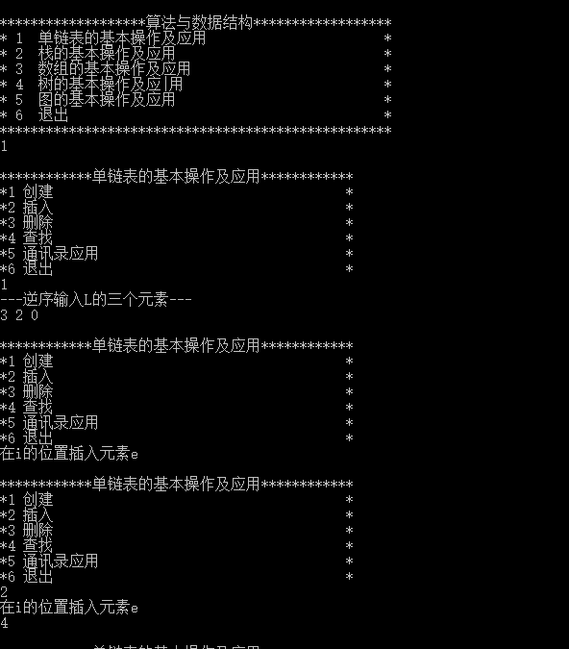
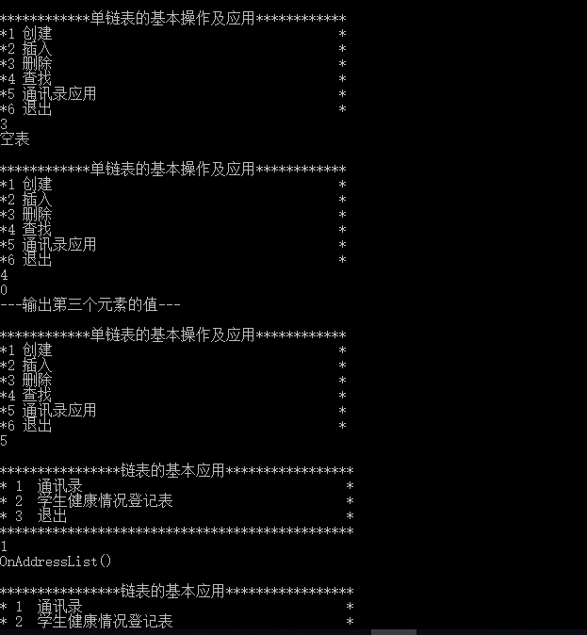

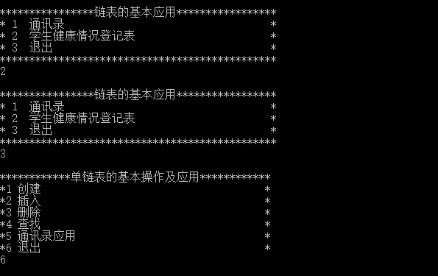

栈的基本操作及应用：
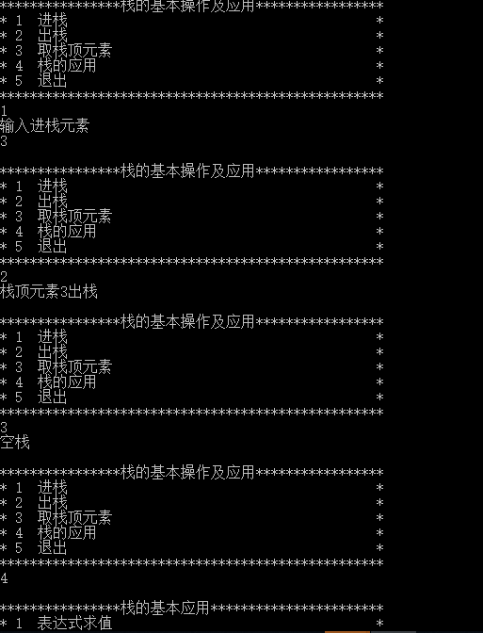

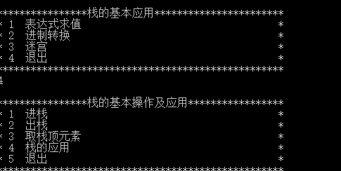

数组的基本操作及应用：
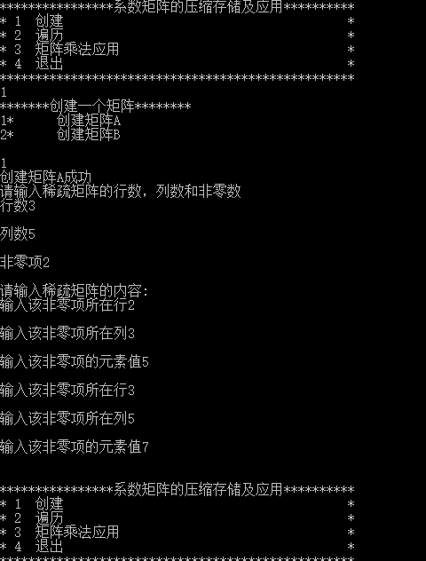
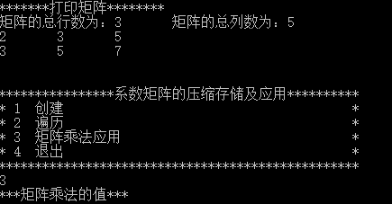

二叉树的基本操作及应用：
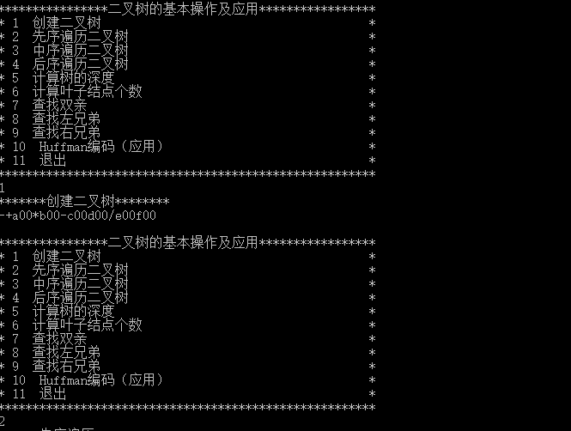

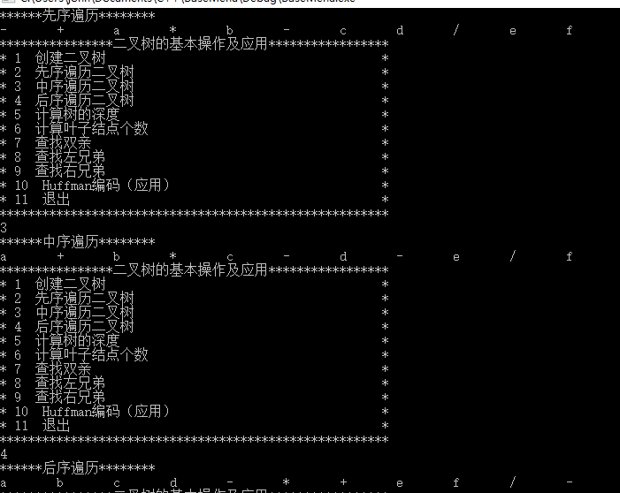
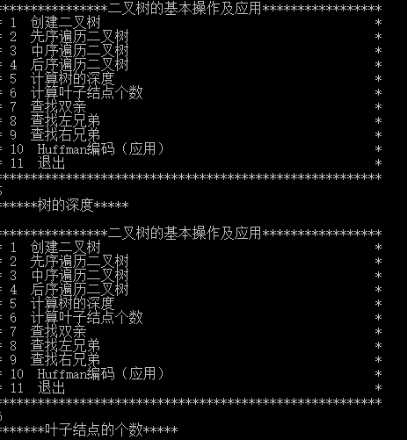

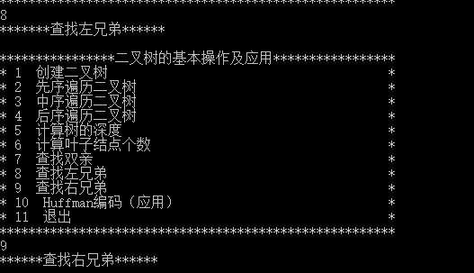

图的基本操作及应用：
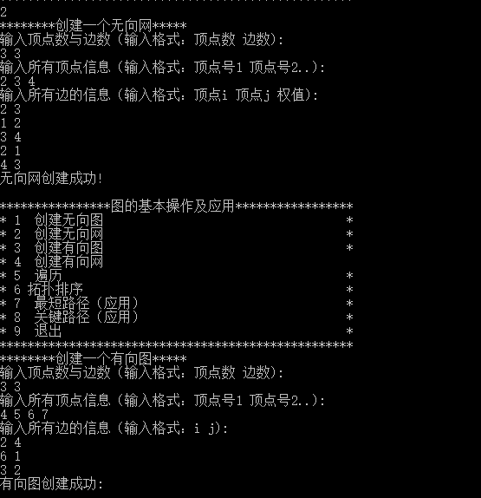

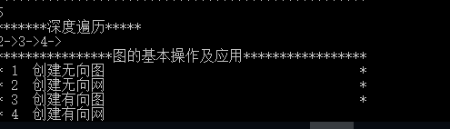

七.难点与收获小结：
1.第一天开始接触时，不清楚具体设计方案，以及具体操作过程，没有清晰的思路。经过老师大概的讲解，同时自己在网上查找资料学习，然后有了一定的理解，并开始做。
2．因为要用到类，继承和多态，所以查看学习了C++里面关于类，继承等知识点的应用，但在做数组中矩阵乘法时出现了问题，我在ArrayApplication中调用了矩阵乘法，结果矩阵乘法的应用实现不了，在和同学讨论中，才发现自己在调用时没有将矩阵乘法的文件包含在应用的文件中。在此过程中还有一些小的基础性问题。
3.在二叉树的基本操作与应用中，计算二叉树中叶子节点的个数时，不能正确计算出叶子节点的个数，经过仔细查看代码，多次调试后改正了代码问题，最后准确计算出了叶子节点的个数。
4. 此课设中的最大难点就是各个基本操作中的应用部分,特别是Huffman编码的应用,最小生成树的应用,最短路径的应用,关键路径的应用。但在具体实现时，因为时间有点急，而且因为我能力并不是很好，所以有部分并未实现。
经过一学期的数据结构课程的学习，模块化编程已经比以前清晰多了。这样既不容易出错，而且出了错也较容易查出，其可读性也加强了。同时，在此过程中也学会了运用类，知道了继承、多态。另外，由于编程的积累，调试程序的速度也明显加快了。

指导老师意见：

成绩: 教师签名：

年 月 日

