**User manual for the toolkit operation procedures**

Figure 1 displays the interface of the Visual Interpretation Toolkit, primarily highlighting descriptions and links to related tools. The tools in Toolkit are designed as standalone applications that can be used independently from each other. Specifically, AIExT and TimeIExT are applied to extract auxiliary information and assign time-series land cover labels for validation datasets, respectively. SSD_VIT and TSD_VIT are designed to manually label land cover information, perform various visualization operations, and store visual interpretation results. The visibility and accessibility of the tools are set to public, so anyone with an internet connection can access the interface for validation dataset collection. The following sections mainly introduces the model design process of all tools in this toolkit.

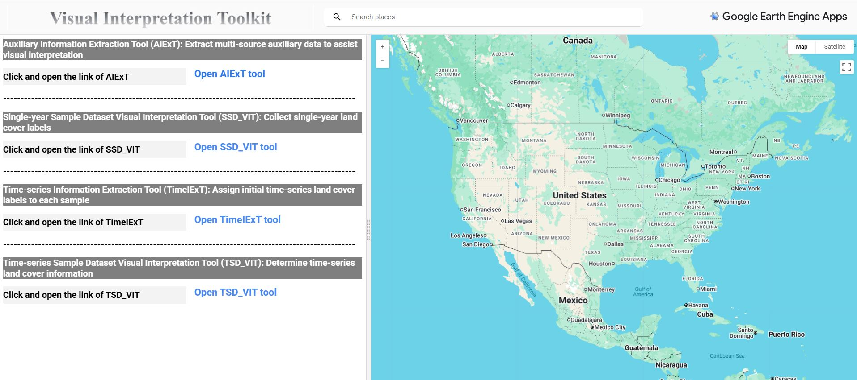

Figure 1. Main interface of the Visual Interpretation Toolkit.

**1** **Auxiliary Information Extraction Tool**

The AIExT is used to extract auxiliary information, including global vegetation cover, vegetation indexes, global canopy height, and terrain characteristics (elevation and slope), as illustrated in Figure 2. The extracted auxiliary information is subsequently imported into the SSD_VIT tool to assist in visual interpretation. The online APP is available at the following link: <https://zhaotingting.users.earthengine.app/view/aiext>. The tool allows users to input the Asset file path of the sample dataset, target year, downloaded filenames, and corresponding file format. Additionally, users can optionally select auxiliary information based on their interests. A button is provided to initiate the auxiliary information extraction process. After extraction, a download URL link is automatically generated, and all attribute names of the sample dataset are displayed in the layer.

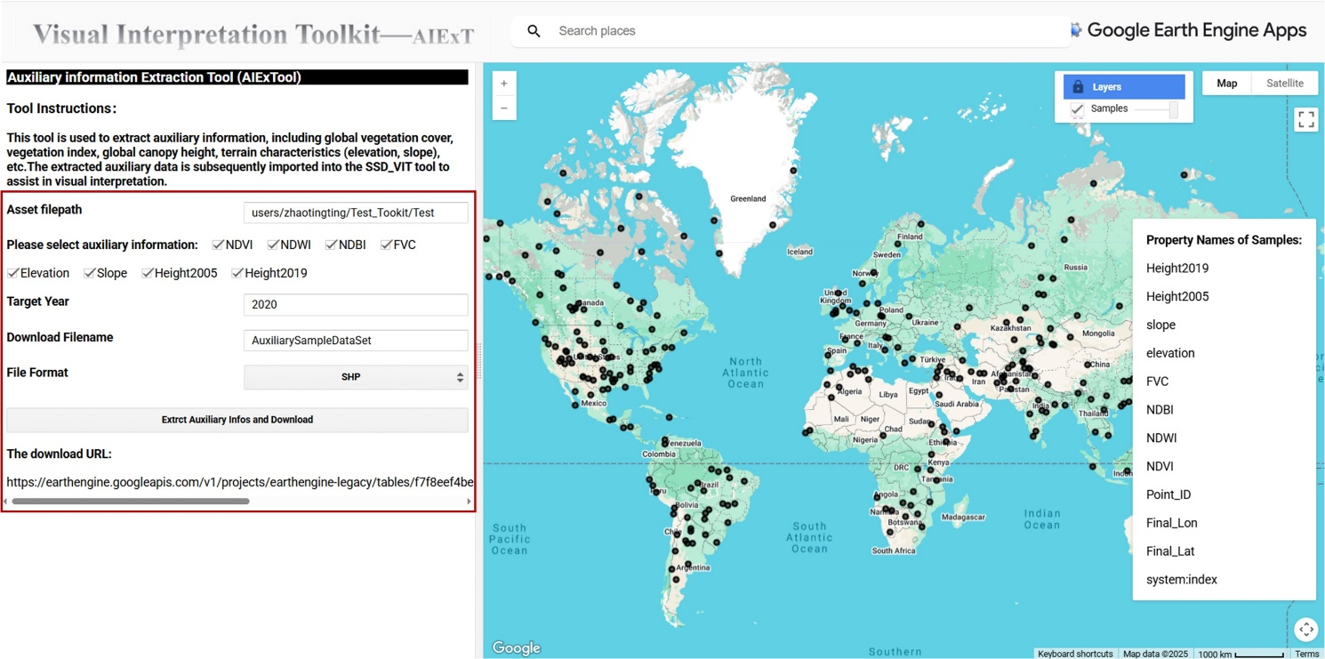

Figure 2. GEE graphical interface of AIExT for extracting auxiliary information of the validation datasets.

**2 Single-year Sample Dataset Visual Interpretation Tool**

Figure 3 shows an overview of the module structure of the SSD_VIT tool. These modules work in combination to streamline the interpretation process, offering a convenient and user-friendly interface for visualizing and interpreting single-year land cover information of the validation datasets (code link: <https://zhaotingting.users.earthengine.app/view/ssdvit>). The SSD_VIT tool is divided into three sections, which will be introduced in detail below.

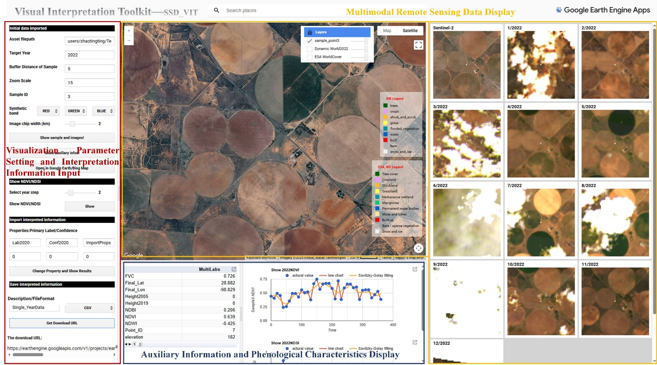

Figure 3. GEE graphical interface of SSD_VIT tool for labeling single-year land cover information at samples.

2.1 Visualization Parameter Setting and Interpretation Information Input

This module allows users to configure visualization parameters and input interpretation details for the sample dataset, consisting of three key components: *Initial Data Import*, *NDVI/NDSI Visualization*, and *Import and Save Interpreted Information*. *Initial data imported* allows users to import the sample dataset by specifying its file path and locate specific samples by entering their ID numbers. Users can customize band combinations, with the default set to true-color synthesis for image visualization. The buffer distance of a sample is set to half the size of the sample unit. By default, this value is 5, indicating that each sample unit is a 10 m × 10 m rectangular area. A sliding window is provided to adjust the zoom level for Sentinel-2 imagery and Landsat monthly imagery. The default value is 2. The provided buttons allow users to visualize multi-source satellite images at the sample location, load interpreted samples, and view associated auxiliary information. And the Dedicated button is also provided for direct access to zoomed-in satellite images of the sample location on Google Earth and Bing Maps. *Show NDVI/NDSI* enables users to adjust the time range for generating synthetic annual time-series curves, with a default range of ±2 years relative to the target year. The module provides interactive switches in the form of clickable buttons, enabling users to display NDVI or NDSI time-series curves. *Import interpreted information* supports the input of interpretation details, containing land cover labels, confidence levels, and properties wanted by users, as well as saving options, including task descriptions, and the choice of data-saving formats such as CSV, GeoJSON, KML, KMZ, SHP, or TFRecord. Finally, the users click the “Get Download URL” button to generate the download URL of the visual interpretation file when all land cover labels in the validation dataset have been annotated.

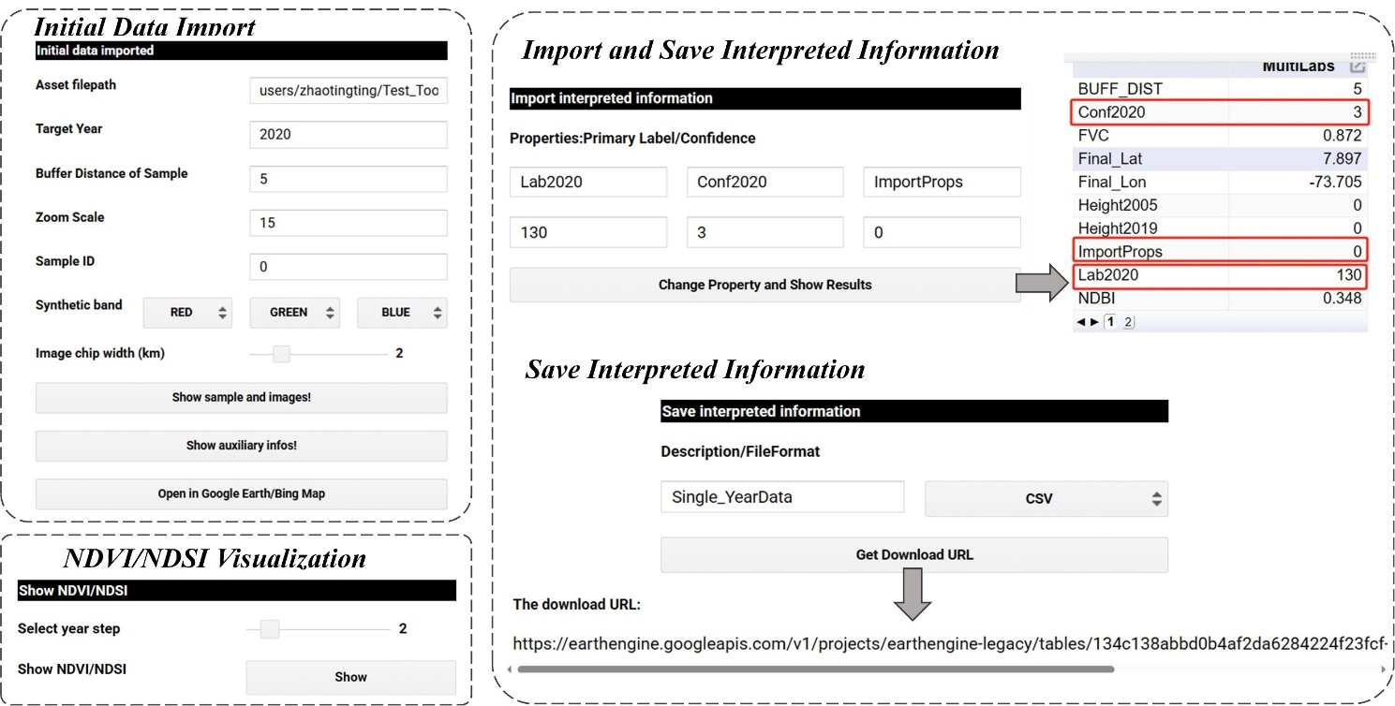

Figure 4. Interface of Visualization Parameter Setting and Interpretation Information Input.

2.2 Auxiliary Information and Phenological Characteristics Display

As visual interpretation is inherently subjective, enhancing its accuracy and objectivity is crucial. To achieve this, additional auxiliary data that directly or indirectly reflect the characteristics of the land features can be incorporated into this module. Here, users can view auxiliary information and phenological characteristics at the sample unit. The auxiliary information section displays properties of the sample that exclude character strings. The information can improve the interpreter's confidence in collecting the sample's land cover information.

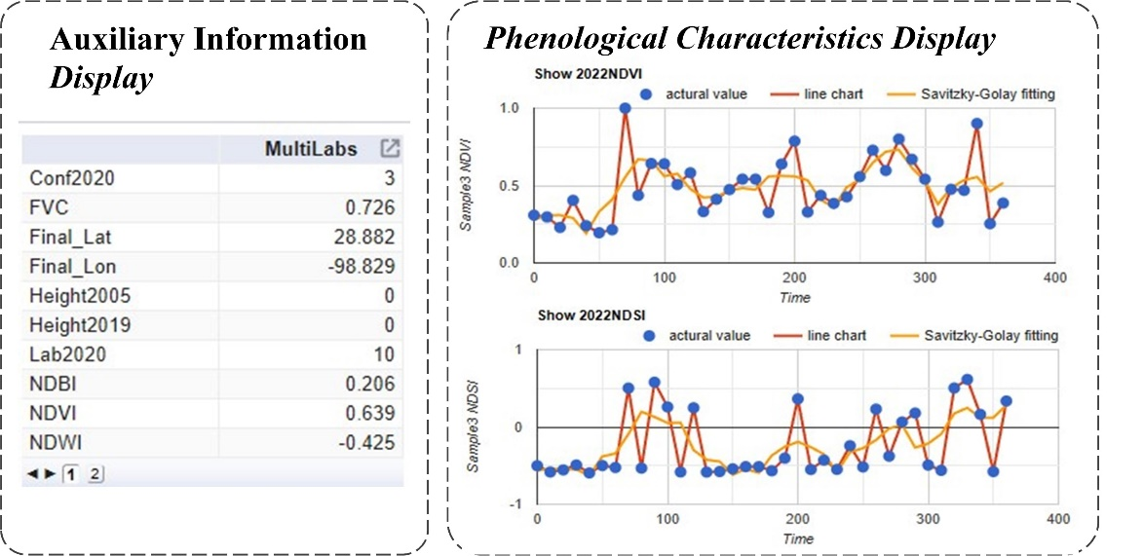

Figure 5. Visualization interface of auxiliary information and phenological characteristics.

2.3 Multimodal Remote Sensing Data Display

This module offers high-resolution imagery from Google Maps as a basemap, providing a detailed view of the area of interest. To support the interpretation process, high-resolution land cover products such as ESA WorldCover and Dynamic World datasets stored in GEE, are integrated into this module as valuable reference layers (Figure 6). This module also presents Sentinel-2 images and monthly Landsat images for a specific year, allowing for comprehensive intra-annual trend analysis. Moreover, a button is set up for jumping to Google Earth and Bing Maps, allowing you to view historical high-resolution images.

Figure 6. Visualization display of the GLC products, Sentinel-2 images, monthly Landsat images and Google Maps at a sample location, with jumps to Google Earth, and Bing Maps.

**3 Time-series Information Extraction Tool**

TimeIExT is designed to assign long-term initial land cover labels using the K-Means clustering algorithm. Afterward, it extracts annual fractional vegetation coverage (FVC), initial land cover labels, and auxiliary information, including global canopy height and terrain characteristics (elevation and slope). The tool is accessible online via the following link: <https://zhaotingting.users.earthengine.app/view/timeiextool>. The tool possesses some key features: (1) Users can import sample datasets by providing the Asset file path; (2) the property name and confidence name for single-year land cover validation datasets must be specified, as these single-year land cover labels are essential for combining with the K-Means clustering algorithm to assign long-term initial land cover labels; (3) the ID name of the samples is required to be input for properties join operations in internal functions; (4) users can define the study period by entering the start year and end year; (5) the tool allows users to specify the file name and format for the final output; (6) a button is provided to trigger the assignment of long-term initial land cover labels and extract auxiliary information. Once completed, the processed file is available for download via a URL link. The attributes contained in the samples are also displayed. This streamlined workflow enables efficient and automated land cover data processing. Notably, this step requires a waiting period.

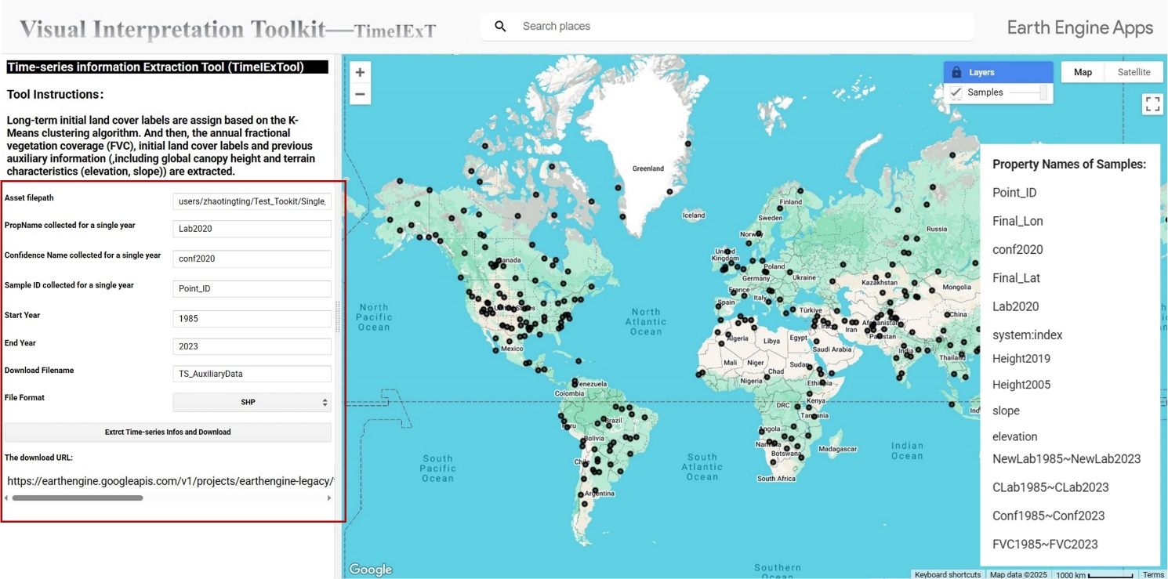

Figure 7. GEE graphical interface of TimeIExT for extracting time-series information of the validation datasets.

**4 Time-series Sample Dataset Visual Interpretation Tool (TSD_VIT)**

TSD_VIT, as a tool for collecting time-series land cover information, mainly includes five modules：(1) *Initial Information Visualization*; (2) *Parameter Settings and Visualization of LandTrendr Model*; (3) *Parameter Settings and Visualization of CCD Model*; (4) *Parameter Settings and Visualization of Phenological Information*; (5) *Input and Save of Time-series Visual Interpretation Information*. These modules jointly provide a comprehensive framework for efficiently interpreting time-series land cover validation datasets (code link: <https://zhaotingting.users.earthengine.app/view/tsdvit>). Next, a detailed presentation and explanation of each module is provided. The module structure of the TSD_VIT tool is displayed in Figure 8.

Figure 8. GEE graphical interface of the TSD_VIT tool for labeling time-series land cover information at samples.

4.1 Initial Information Visualization

This module similarly accesses individual sample units by entering their ID numbers, as shown in Figure 9. A dedicated button allows direct positioning to a specific sample unit, while loading auxiliary information, annual fractional vegetation cover, initial land cover labels derived from the K-Means algorithm, and labels and confidences to be modified. Additionally, it displays the full time-series line chart fitted by the LandTrendr model. Similarly, a button is offered for jumping to Google Earth and Bing Maps.

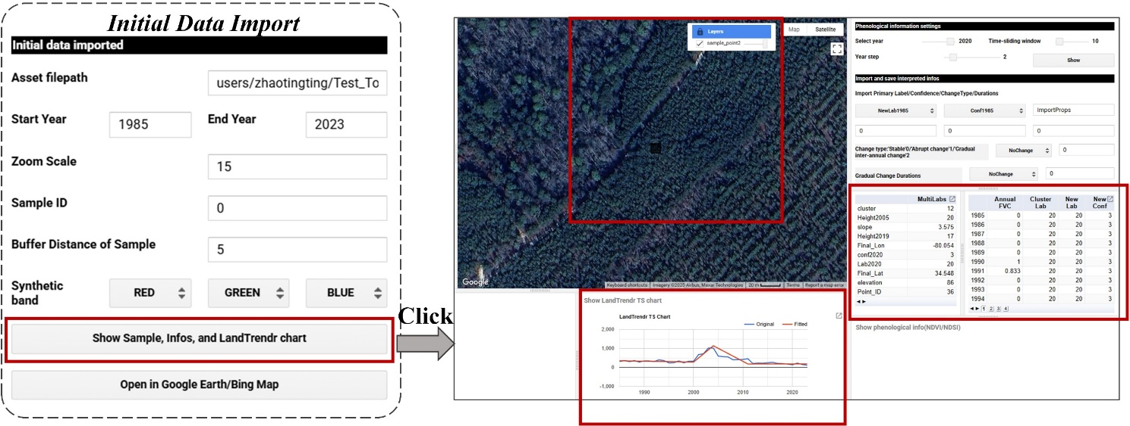

Figure 9. Input of initial information and the visualization of the full time-series line chart fitted by the LandTrendr model and other information.

4.2 Parameter Settings and Visualization of LandTrendr Model

This module is integrated into the graphical interface of the TSD_VIT tool and serves two primary purposes: (1) effectively monitoring land cover changes at sample locations and (2) providing annual composite images for visual interpretation. The module contains parameter settings and a display window for the full time-series line chart, as shown in Figure 10. For parameter settings, users can adjust key parameters used by the LandTrendr model, including: Spectral Band for visualization, Start Year and End Year calculated by the LandTrendr model, Max Segments, Spike Threshold, Vertex Count Overshoot, Recovery Threshold, p-value Threshold, Best Model Proportion, and Min Observations Needed. The display window visualizes the full time-series line chart fitted by the LandTrendr model, clearly representing land cover dynamics over time. This module links the original values on the full time-series line chart to the corresponding annual composite images from Landsat satellite observations for visual interpretation. Users can simply click on these values to display and review the related imagery, enhancing the efficiency of visual interpretation.

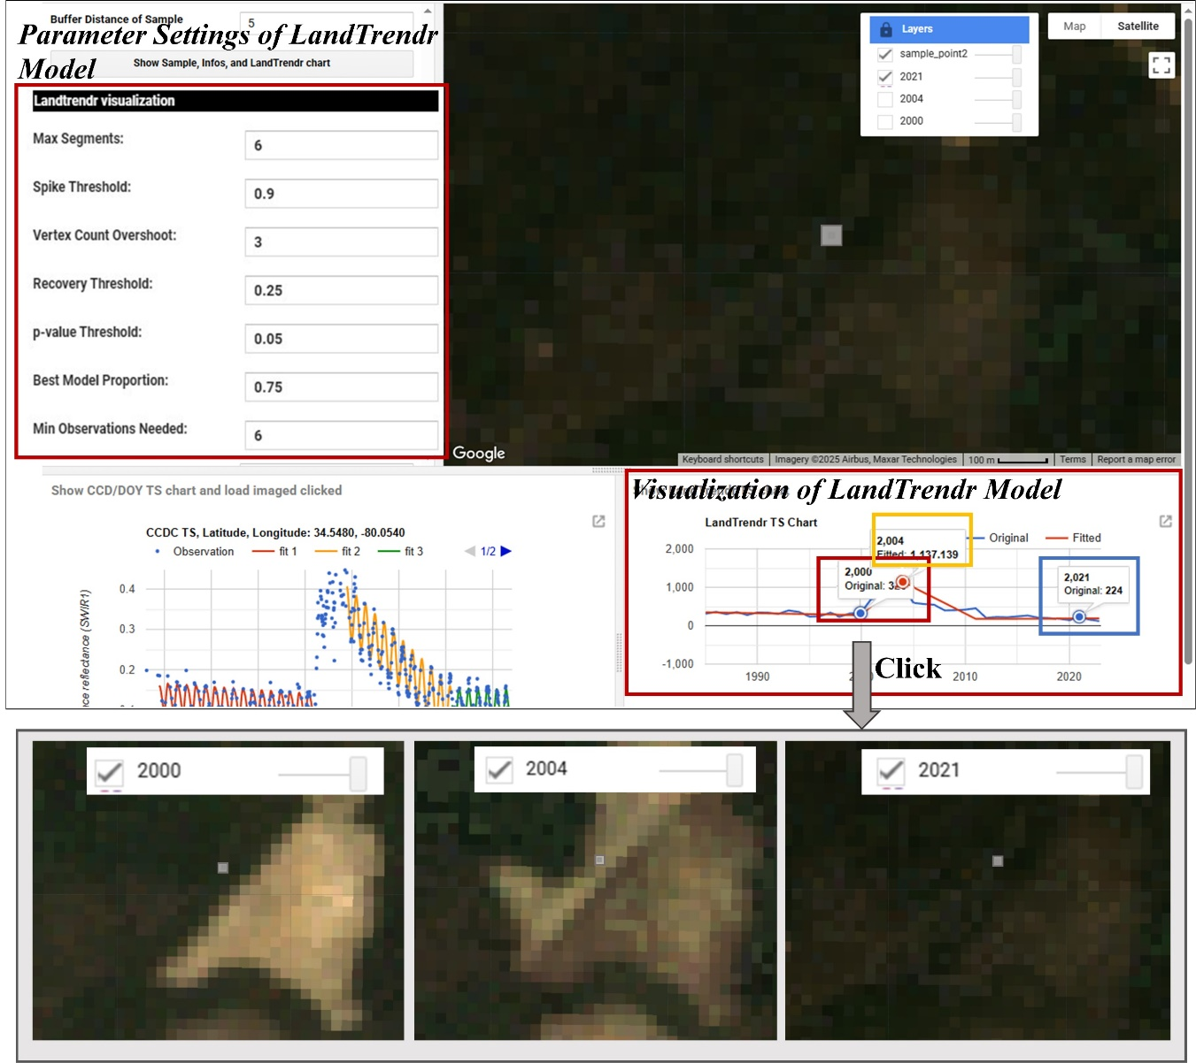

Figure 10. Parameter settings of the LandTrendr model and the visualization of the full time-series line chart.

4.3 Parameter Settings and Visualization of CCD Model

*Parameter Settings and Visualization of CCD Model* is a convenient interactive module to explore the spatiotemporal land cover dynamic trends within certain regions. It comprises two main components: parameter settings and a full time-series trajectory display window, as shown in Figure 11. The parameter settings component allows users to define the time range for the CCD algorithm's background calculations, select the spectral band for visualization, adjust the operational parameters of the CCD algorithm, and choose the preferred display method for the time series. This module facilitates a detailed understanding of land cover changes over time and enhances interpretation capabilities by combining customizable settings with dynamic visualization.

The full time-series trajectory display window shows the full time-series curve of the user-selected spectral bands, fitted using the CCD model. The user interactively clicks on the sample location within the layer, and the curve will be loaded into this window. In the display window, the actual values of Landsat satellite observations at a sample location are represented by blue dots, while the synthetic values are derived from the harmonic model. In addition, this window was designed to allow users to explore all available Landsat observation series at any location on Earth. When the CCD model detects multiple interruptions, indicating land cover changes, users can click on any actual observation point in the full time-series curve, as shown in Figure 11. Then, the corresponding Landsat image will load into the map layer for immediate browsing. This function provides valuable reference information for visual interpretation, and eliminates unnecessary wait times for image loading, improving work efficiency and user experience.

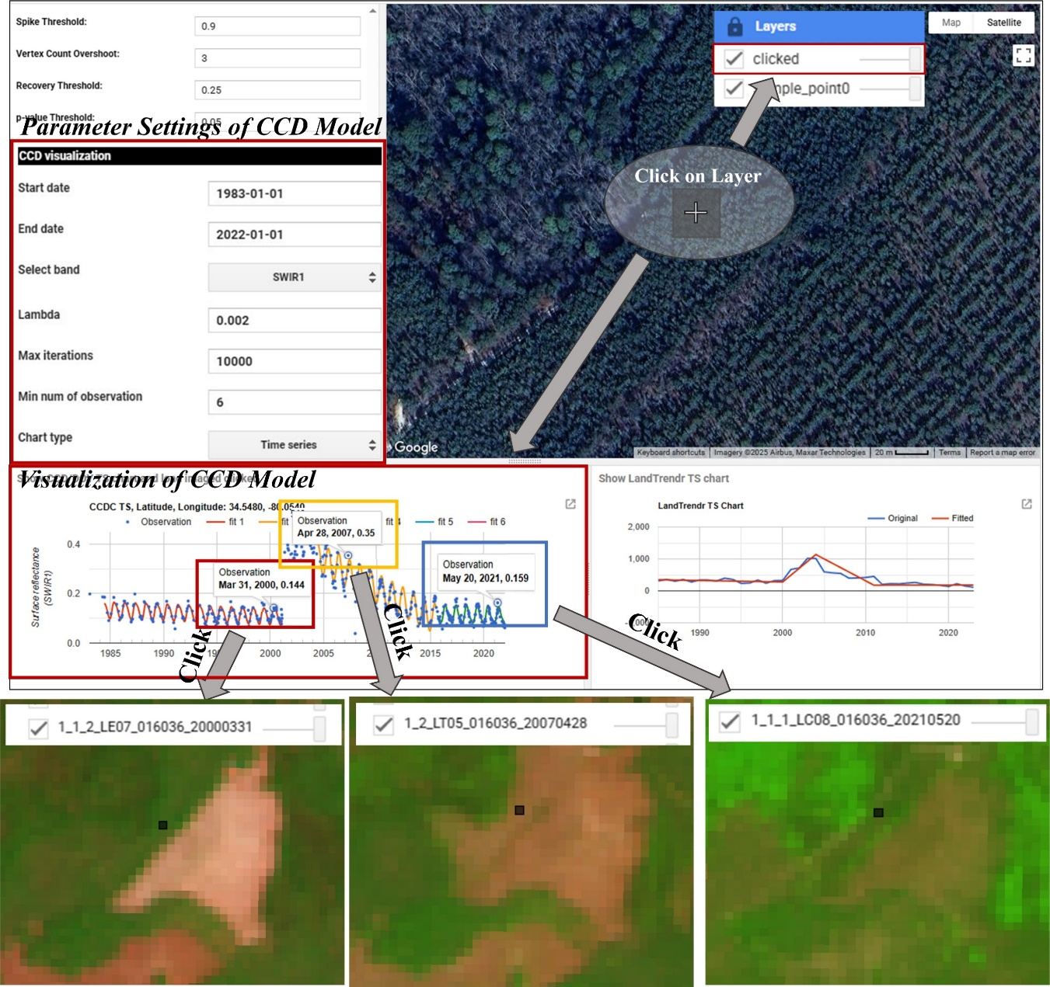

Figure 11. Parameter settings of the CCD model and the visualization of full time-series trajectory fitted using the CCD model.

The visualized spectral bands in this module include the basic bands of Landsat imagery (BLUE, GREEN, RED, NIR, SWIR1, and SWIR2) and synthesized spectral indexes such as NDVI and EVI (Table 1). These indexes assist interpreters in distinguishing various land cover types. Interpreters can switch between various basic bands and synthesize spectral indexes, and then examine the temporal trends of the spectrum at the sample location through the display window.

Table 1. Visualization of spectral bands.

|  |  |
| --- | --- |
| Band | Calculation method |
| BLUE |  |
| GREEN |  |
| RED |  |
| NIR |  |
| SWIR1 |  |
| SWIR2 |  |
| Normalized Difference Vegetation Index (NDVI) |  |
| Normalized Burn Ratio (NBR) |  |
| Enhanced Vegetation Index (EVI) |  |
| Normalized Difference Water Index (NDWI) |  |
| Normalized Difference Fraction Index (NDFI) | (Souza et al., 2005); |
| GREENNESS |  |
| BRIGHTNESS |  |
| WETNESS |  |

4.4 Parameter Settings and Visualization of Phenological Information

The tool similarly integrates the temporal trends of spectral indexes into the display window of phenological characteristics to assist users in visual interpretation. This module allows users to synthesize NDVI or NDSI time series for specific years. Additionally, the module provides options for adjusting the time-sliding window and setting the year step. Specifically, the year step setting defines the time range relative to the target year. The time-sliding window refers to the number of days used to generate the intra-annual time-series curve. These functionalities help users understand vegetation dynamics in greater detail over time and achieve accurate visual interpretation.

4.5 Input and Save of Time-series Visual Interpretation Information

This module manages the input and saves data of collected time-series land cover information. Users observe the change breakpoints detected using the LandTrendr and CCD models, then load pre- and post-change year images into the layer for visual interpretation. Then, users visually record the time-series land cover information of the sample units during the study period by applying these remote sensing images, change information, auxiliary information and phenological characteristics. Users can modify the properties accordingly if the visual interpretation results differ from the initial land cover labels obtained through the clustering method.

For this purpose, the module includes input fields for land cover labels, confidence levels, change types (Stable is 0, abrupt change is 1, and gradual inter-annual change is 2), and the duration of gradual change. Users can choose not to enter certain information they do not want to obtain. They can enter the attribute name and corresponding information in the provided blank text box for other details they wish to include. The final interpretation information for the sample dataset comprises the latitude and longitude of the sample, the initial time-series land cover labels obtained by the clustering method, the visual interpretation time-series labels, the corresponding confidence levels, the change type, the duration of gradual change, and other information that users want to obtain. The button allows users to change properties and display the corresponding change results in the table below. The final file is downloaded in the form of a URL link.

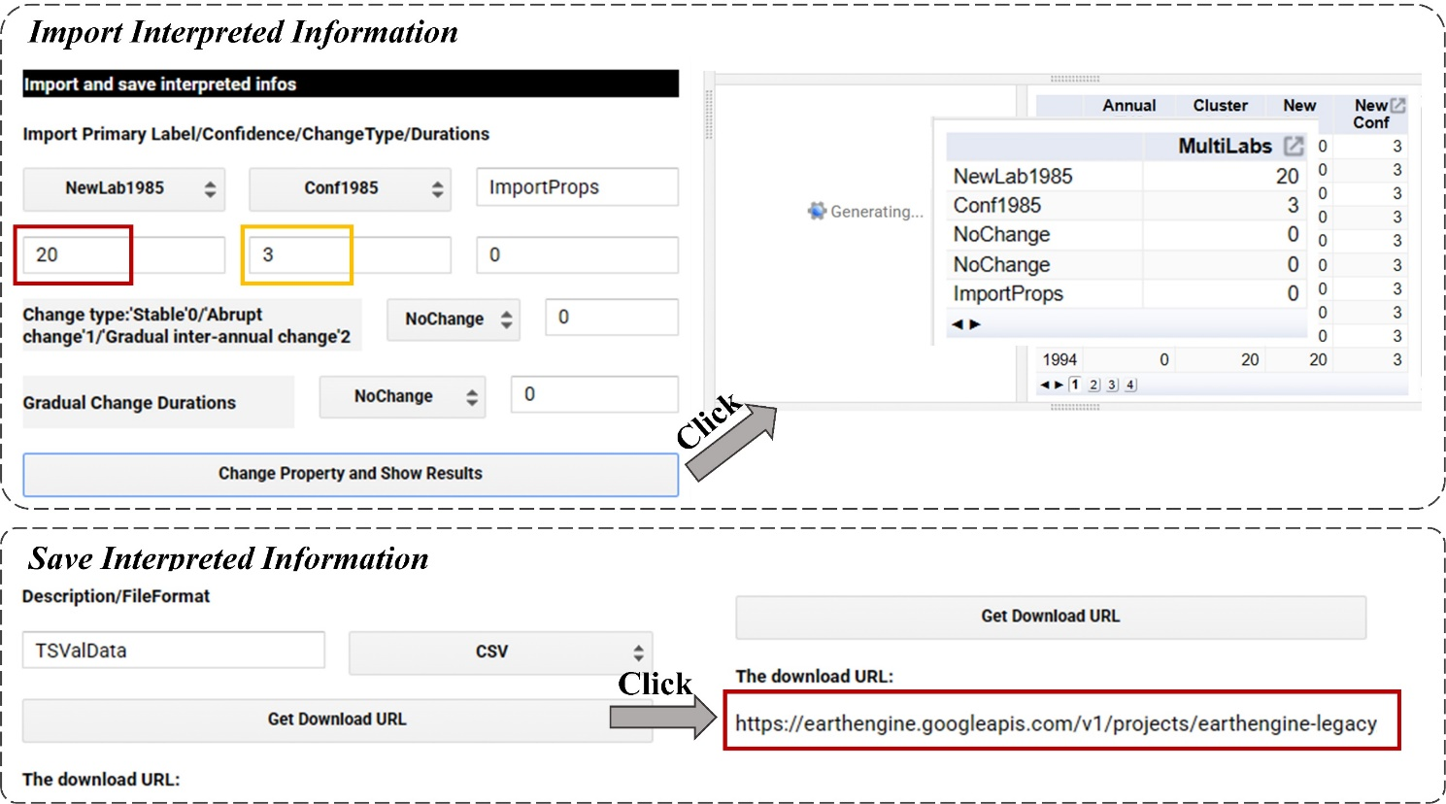

Figure 12. Module of importing and saving time-series land cover information for visual interpretation.

Brown, C. F., Brumby, S. P., Guzder-Williams, B., et al. (2022). Dynamic World, Near real-time global 10 m land use land cover mapping. *Scientific Data, 9*(1), 251. <http://dx.doi.org/10.1038/s41597-022-01307-4>

Potapov, P., Li, X., Hernandez-Serna, A., et al. (2021). Mapping global forest canopy height through integration of GEDI and Landsat data. *Remote Sensing of Environment, 253*, 112165. <http://dx.doi.org/10.1016/j.rse.2020.112165>

Simard, M., Pinto, N., Fisher, J. B., et al. (2011). Mapping forest canopy height globally with spaceborne lidar. *Journal of Geophysical Research, 116*(G4). <http://dx.doi.org/10.1029/2011jg001708>

Souza, C. M., Roberts, D. A., & Cochrane, M. A. (2005). Combining spectral and spatial information to map canopy damage from selective logging and forest fires. *Remote Sensing of Environment, 98*(2-3), 329-343. <http://dx.doi.org/10.1016/j.rse.2005.07.013>

Takaku, J., Tadono, T., Doutsu, M., et al. (2020). Updates of ‘Aw3d30’ Alos Global Digital Surface Model with Other Open Access Datasets. *The International Archives of the Photogrammetry, Remote Sensing and Spatial Information Sciences, XLIII-B4-2020*, 183-189. <http://dx.doi.org/10.5194/isprs-archives-XLIII-B4-2020-183-2020>

Zanaga, D., Van De Kerchove, R., De Keersmaecker, W., et al. (2021). ESA WorldCover 10 m 2020 v100. <http://dx.doi.org/10.5281/zenodo.5571935>