- 举例Spring源码中你见过的委派模式，并画出类关系图。
Spring 中在实例化对象的时候用到 Strategy 模式， 在SimpleInstantiationStrategy 有使用
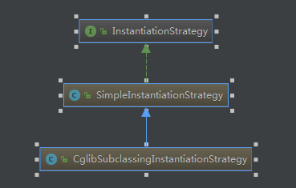
- 利用策略模式重构一段业务代码。
四则运算，由之前的if..else判断选择运算方法，改为策略模式，使之符合开闭原则。
public interface Strategy {
public int doOperation(int num1, int num2);
}
public class OperationAdd implements Strategy {
@Override
public int doOperation(int num1, int num2) {
return num1 + num2;
}
}
public class OperationMultiply implements Strategy{
@Override
public int doOperation(int num1, int num2) {
return num1 * num2;
}
}
public class OperationSubstract implements Strategy{
@Override
public int doOperation(int num1, int num2) {
return num1 - num2;
}
}
public class Context {
private static Map<OptionType, Strategy> options = new HashMap<>();
static {
options.put(OptionType.Add, new OperationAdd());
options.put(OptionType.Multiply, new OperationMultiply());
options.put(OptionType.Substract, new OperationSubstract());
}
private Strategy strategy;
public Context(OptionType optionType) {
strategy = options.get(optionType);
}
public int executeStrategy(int num1, int num2) {
return strategy.doOperation(num1, num2);
}
}
public enum OptionType{
Add,Substract,Multiply
}
public class DemoApplication {
public static void main(String[] args) {
Context context = new Context(OptionType.Add);
System.out.println("10 + 5 = " + context.executeStrategy(10, 5));
context = new Context(OptionType.Substract);
System.out.println("10 - 5 = " + context.executeStrategy(10, 5));
context = new Context(OptionType.Multiply);
System.out.println("10 * 5 = " + context.executeStrategy(10, 5));
}
}

