# *Segmentation*

1. Git Project: <https://github.com/mrgloom/awesome-semantic-segmentation>
2. <https://github.com/handong1587/handong1587.github.io/blob/master/_posts/deep_learning/2015-10-09-segmentation.md>

## UNet

### *NetworkSymbol*

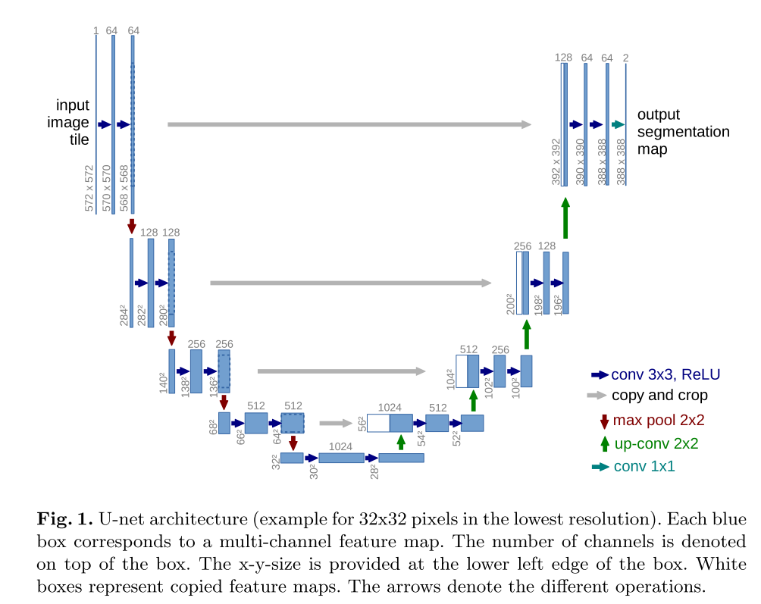

### *Skip Connection*

**What are Skip Connections and Why are they important?**

**These Skip Connections are important because:**  
1) You want your network to learn a combination of low and high level features.  
2) You want to train deeper networks. Short skip connections like in Resnet connecting to earlier layers in the network help propagate the gradient, and fight the  [vanishing gradient problem](https://en.wikipedia.org/wiki/Vanishing_gradient_problem)with very deep networks. (This isn’t a concatenation, but a summation — minor difference)  
3)[Long Skip Connections can help recover spatial information that might be lost during downsampling.](https://arxiv.org/abs/1411.4038) This is essentially important in segmentation because to label pixels in the final image, it’s important to consider the lower level features.   
4) Improve Convergence(收敛) Time. This [paper](https://arxiv.org/pdf/1608.04117.pdf) found that having both long and short skip connections improved convergence time as opposed to only having one type of connection.

#### *Thinking SkipConnection*

**Reference by:**

<https://medium.com/@mikeliao/deep-layer-aggregation-combining-layers-in-nn-architectures-2744d29cab8>

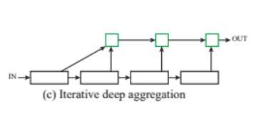

##### ****IDA focuses on fusing resolutions and scales(融合分辨率和尺寸).****

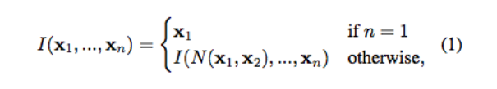

Aggregation in IDA is iterative and starts with the lowest, smallest scale and then iteratively merges deeper larger scales.

##### ****HDA focuses on merging features from all modules and channels****

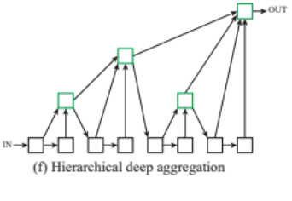

Unlike IDA, which combines layers in a sequential way, HDA’s structure uses a tree-like structure to combine layers that span more of a feature hierarchy. Notice how the output of an aggregation node feeds into the input of the next block — this preserves features from previous layers.

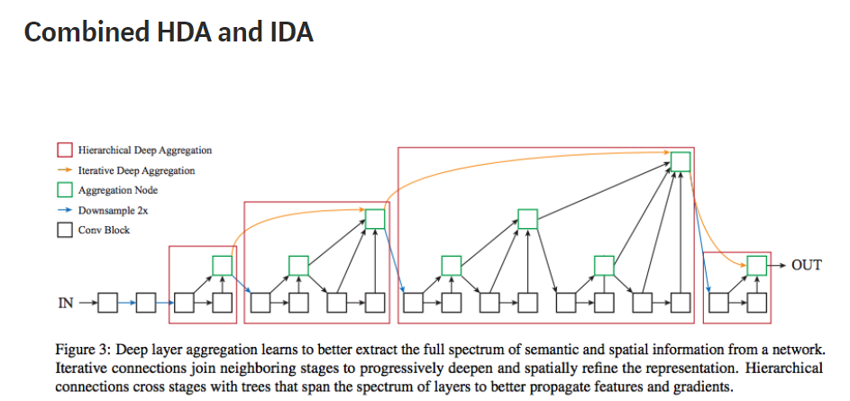

### *More Thinking*

**Reference by:** <https://zhuanlan.zhihu.com/p/44958351> **Must Read~**

#### *****More Effective Skip Connection Way*****

***How Deepth is better?***

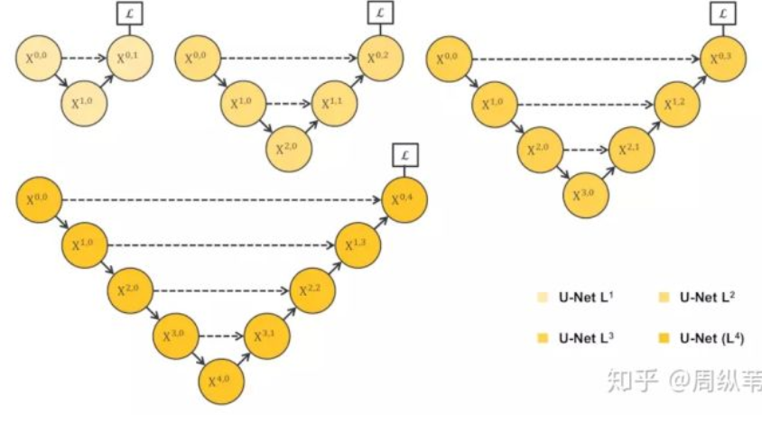 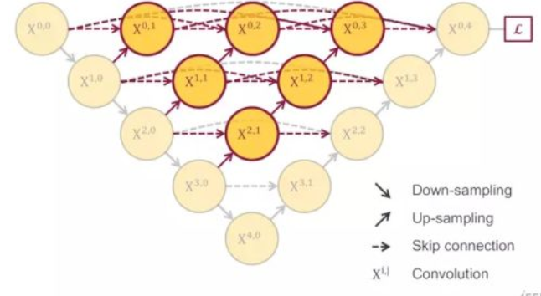

***How to get a balance with Params and Performance?(Deep Supervision)***

