1档案借阅申请流程

1.1:检测脚本执行情况.与预期结果图比较

DECLARE
HAVE_TABLE NUMBER;
BEGIN
SELECT COUNT(1) INTO HAVE_TABLE FROM ALL_TABLES WHERE TABLE_NAME = 'OA_FILE_LENDING_DETAIL' AND OWNER=SYS.LOGIN_USER;
IF(HAVE_TABLE>0) THEN
dbms_output.put_line('1OK');
END IF;

SELECT COUNT(1) INTO HAVE_TABLE FROM ALL_TABLES WHERE TABLE_NAME = 'OA_FILE_LENDING' AND OWNER=SYS.LOGIN_USER;
IF(HAVE_TABLE>0) THEN
dbms_output.put_line('2OK');
END IF;

SELECT COUNT(1) INTO HAVE_TABLE FROM oa_flow_busitype where busitype_code = 'uuid-336';
IF(HAVE_TABLE>0) THEN
dbms_output.put_line('3OK');
END IF;

SELECT COUNT(1) INTO HAVE_TABLE FROM oa_flow_form where form_path = '/ccapp/oa/file/jsp/filelendingflow.jsp';
IF(HAVE_TABLE>0) THEN
dbms_output.put_line('4OK');
END IF;

SELECT COUNT(1) INTO HAVE_TABLE FROM oa_md_columns where TABLE_ID = 'cfa24116-4813-4e62-b1ea-8ac4ea15f519';
IF(HAVE_TABLE>0) THEN
dbms_output.put_line('5OK');
END IF;

SELECT COUNT(1) INTO HAVE_TABLE FROM oa_md_table where TABLE_ID = 'cfa24116-4813-4e62-b1ea-8ac4ea15f519';
IF(HAVE_TABLE>0) THEN
dbms_output.put_line('6OK');
END IF;
END;
/
预期结果：
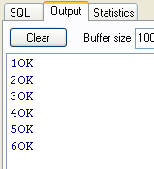

1.2:流程管理--流程配置 添加
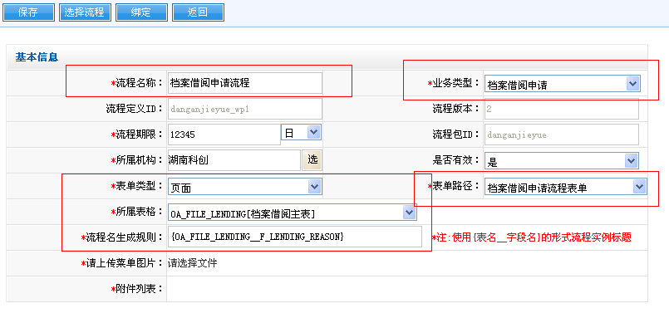

流程名称：档案借阅申请流程
流程名生成规则：{OA_FILE_LENDING__F_LENDING_REASON}

1.3：获取流程包，绑定流程

1.4：配置流程活动环节
(如下图)
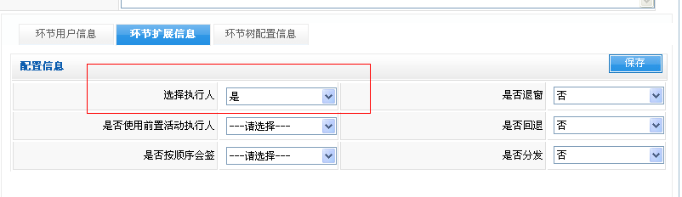

2档案借阅申请流程

2.1:检测脚本执行情况..与预期结果图比较

DECLARE
HAVE_TABLE NUMBER;
BEGIN
SELECT COUNT(1) INTO HAVE_TABLE FROM ALL_TABLES WHERE TABLE_NAME = 'OA_FILE_DESTROY_DETAIL' AND OWNER=SYS.LOGIN_USER;
IF(HAVE_TABLE>0) THEN
dbms_output.put_line('1OK');
END IF;

SELECT COUNT(1) INTO HAVE_TABLE FROM ALL_TABLES WHERE TABLE_NAME = 'OA_FILE_DESTROY' AND OWNER=SYS.LOGIN_USER;
IF(HAVE_TABLE>0) THEN
dbms_output.put_line('2OK');
END IF;

SELECT COUNT(1) INTO HAVE_TABLE FROM oa_flow_busitype where busitype_code = 'uuid-337';
IF(HAVE_TABLE>0) THEN
dbms_output.put_line('3OK');
END IF;

SELECT COUNT(1) INTO HAVE_TABLE FROM oa_flow_form where form_path = '/ccapp/oa/file/jsp/filedestroyflow.jsp';
IF(HAVE_TABLE>0) THEN
dbms_output.put_line('4OK');
END IF;

SELECT COUNT(1) INTO HAVE_TABLE FROM oa_md_columns where TABLE_ID = '7a4b4d0d-cb83-402f-9d5a-d866b770c087';
IF(HAVE_TABLE>0) THEN
dbms_output.put_line('5OK');
END IF;

SELECT COUNT(1) INTO HAVE_TABLE FROM oa_md_table where TABLE_ID = '7a4b4d0d-cb83-402f-9d5a-d866b770c087';
IF(HAVE_TABLE>0) THEN
dbms_output.put_line('6OK');
END IF;
END;
/
预期结果：

2.2:流程管理--流程配置 添加
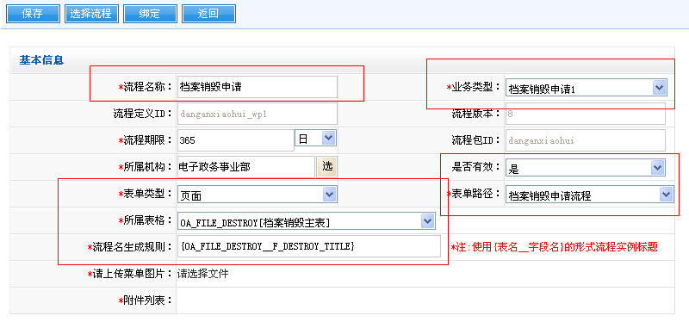

流程名称：档案销毁申请
流程名生成规则：{OA_FILE_DESTROY__F_DESTROY_TITLE}

2.3：获取流程包，绑定流程

2.4：配置流程活动环节
(如下图)

