Share resources:github.com/sa-46/day1

Case1:calculate your salary

using System;

using System.Collections.Generic;

using System.Linq;

using System.Text;

using System.Threading.Tasks;

namespace ConsoleApp1

{

class program

{

static void Main(string[] args)

{

Console.WriteLine("input your salary");

string stringsalary = Console.ReadLine();

double salary = double.Parse(stringsalary);

double tax = 0.0898765 \* salary;

Console.WriteLine("your tax is {0:0,0.00},and your salary is {1:0.00}", tax, salary);

Console.WriteLine("your tax is {0:c},and your salary is {1:c}", tax, salary);

}

}

}

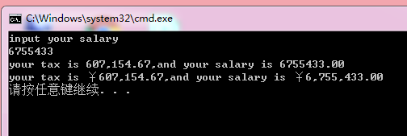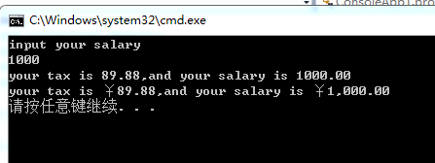

Console.WriteLine("Your salary is ${0:0,000.00}, your tax is ${1:0,0.00}"

, salary,tax);

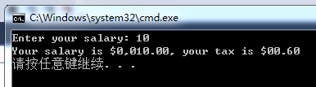

Console.WriteLine("Your salary is ${0:0,000.##}, your tax is ${1:0,0.##}"

, salary, tax);

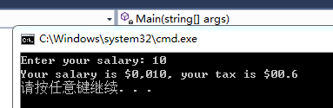

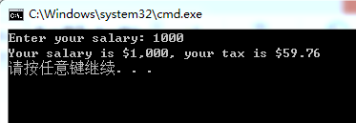

Console.WriteLine("Your salary is ${0:#,###.00}, your tax is ${1:#,###.00}"

, salary, tax);

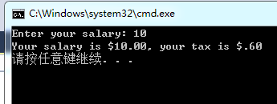

Console.WriteLine("Your salary is ${0:c}, your tax is ${1:c}"

, salary, tax);

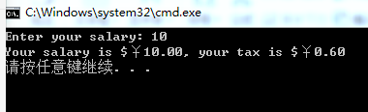

namespace ConsoleApp1

{

class program

{

static void Main(string[] args)

{

int i = 10;

Console.WriteLine("{0} \* {1} = {1}", i, i \* 4);

}

}

}

