Doctor management
The doctor management feature is for website administrators to create or delete doctors and edit doctors' profiles. There many hospitals under UHN, therefore it is necessary to be able to manage the profiles of doctors from all of those hospitals, so that information about each doctor is correct and well organized. When patients look for doctors, they expect to see a well organized page with up-to-date information about the doctor, and it includes availability, biography, areas of expertise, etc..

Database

first_name | nvarchar
last_name | nvarchar
department | nvarchar
biography | nvarchar
phone | nvarchar
email | nvarchar
id | int

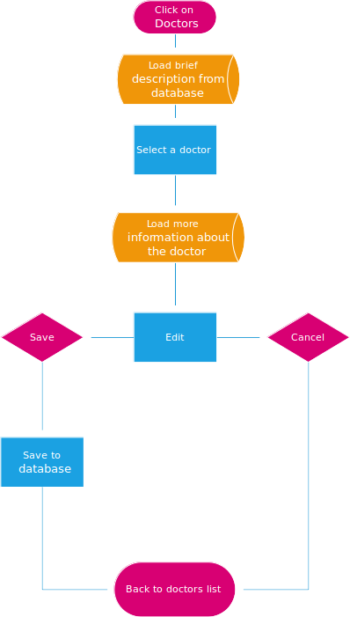
Dataflow of Editing a doctor

