Card Sorting
Now that you have your inventory and have drafted a set of navigation terms it is time to try them out. Card sorting is a low-resolution means of testing your assumptions about the system (in this case a navigation system) you are trying to create. How do users see the content? Do they put it into processes or groups? How do they cluster the content? Does it match how the organization sees it? What would they call it? Moreover, how would they move through the content in order to reach their goals? Would this change if they were to meet organizational or corporate goals? Where are your features going to go? What are you going to call them? How will your features work with your users?

Users do the strangest things – but what they give us are insights into the content that can be useful.

There are two types of card sorting:

Open Card Sorting: Participants are given cards showing site content with no pre-established groupings. They are asked to sort cards into groups that they feel are appropriate and then describe each group. Open card sorting is useful as input to information structures in new or existing sites and products.

Closed Card Sorting: Participants are given cards showing site content with an established initial set of primary groups. Participants are asked to place cards into these pre-established primary groups. Closed card sorting is useful when adding new content to an existing structure, or for gaining additional feedback after an open card sort. (Donna Spencer, Card sorting: a definitive guide, http://www.boxesandarrows.com/view/card_sorting_a_definitive_guide, accessed December 4, 2011)

How to do it

Taking your proposed navigation terms put one term on a card and then do that for all the terms you have from your content map. If you have not incorporated your features into the content map – now is the time to do so! Do not worry too much about the terms you are using – they can be changed later if needed.

Each card should have an identification number and you will use that to create a record of what card has been put where. Next you will determine who will interact with the participant and who will record the results.

We will be doing an open card sort for our exercise – so let’s talk about that.

We will start out with a pile of cards each with a term on it. We would then ask the participants to put them into an order they feel is important and easy for them to understand. We would do this with about three or four people and then take a look at the results.

If there were large agreement among the users – we would then deduce that this was a good place to start with the sequence and naming. If the participants were struggling with the concepts presented to them then we would have to consider changing our scheme. Asking the participants directly is a good idea.

As well we could also use the participants as a means of refining the terms we were using. If they were unable to find a satisfactory sort – then we could ask them “what would you change?” This would change our cards and we would have to record these changes carefully when evaluating the results.

In a closed sort – we would start off with the set of existing content areas or piles of cards. Then we would give the participants the cards representing the content we wanted them to figure out. We would ask them to put the new cards into the appropriate piles as made sense to them. We would record the result and then see if the feedback was something we could implement.

What will we do?

Today we will work to create a taxonomy for the navigation and use card sorting to figure out the sequence.

Put one term from the content map on one card. Also give the card a number – but put the number on the back. We don’t want the numbers to confuse the users.

Your job will be, with your team, create a suitable taxonomy and check it with a card sorting exercise. Once you have the cards ready – you will use members of another team as your test subjects. I would also like you to find 4 more subjects not affiliated with the program to act as test subjects. Your records will show who was and who was not a member of our program.

The end result will be a series of cards and these cards will be matched with the content. Each sequence provided by the user will be photographed. Also input the results into Excel – one term per cell in the same sequence.

Finishing your Web site architecture
Now that you have your navigation terms and have tested them with “users” it is time to plan out the content. We will do this by creating a bunch of boxes. The first box is Home and the next series of boxes will be labeled with the link name and put into the sequence, left to right, across the page. Finally, you will put the secondary navigation with the appropriate top link. Something like this:

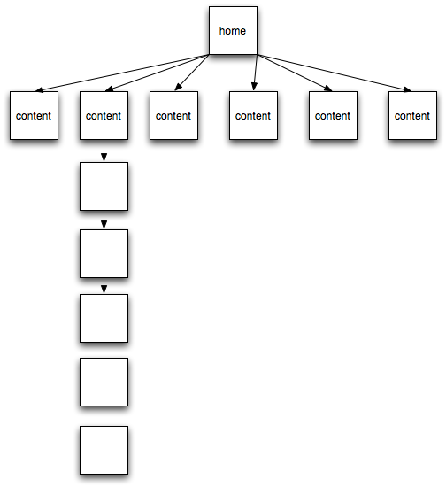

From this document you will construct your wireframe. The wireframe is simply the layout of the page without any aesthetic elements. It is again the relationship between the page and the content: placement and size. What goes on the top, what is second, and so on.

This is not the time to talk about colours, graphics, or any kind of visual element. We are concerned about how and where to place the content on the page.

We would then show these documents to our stakeholders so that they could understand the Web site content and layout. If we have to change it – there’s no problem as these can be easily changed, edited, and changed again.

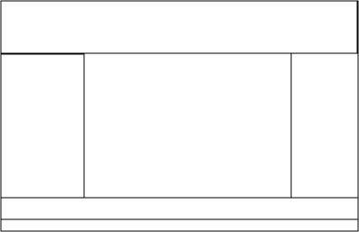

You will then draft a report including the architecture and wireframe that will be included in the requirements document.

