HTTP 5206 Information Architecture
Navigation exercise:

- Collect the navigation terms from the content inventory.

Create a hierarchy of the current terms. Start with the home page and moving down creating a content map:

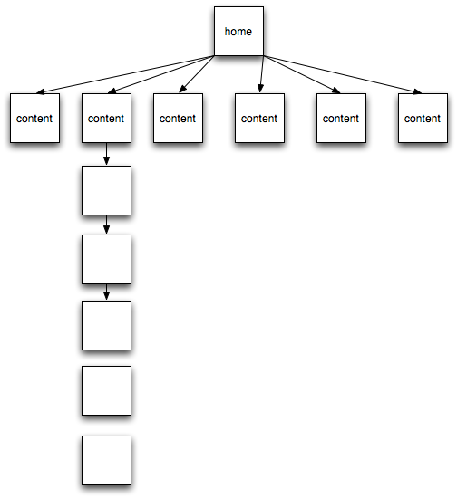
Each line in the content inventory (that you made last week) should have a box and a link name. For example: Home has a file name called index.aspx (or index.php or default.aspx), “Contact Us” has a link called contact.aspx. “Contact Us” is the label and contact.aspx is the link. It best to make the connection between these two labels clear. But the link is usually shorter and does not contain spaces.

- Based on the proposal and your experience last semester what content will have to be added. Give them a box and a link name (make the new boxes red).

- Based on what you know of other hospital Web sites – what terminology should be used in your case? What about a French translation – is there one? Where is it located? Create a matching list of French and English terms. What are the mental models people will use when visiting a hospital Web site? For example: trust, truthfulness, currency, and accuracy are all mental models that might have a bearing on a hospital Web site that would not matter so much to the Onion or Humber College.
- Consider information spaces: what content will require or represent a particular information space?
  - For example: a database driven FAQ tool. You would want to have a mechanism, like a wizard, that could guide the user through the different questions and answers. Or a shopping cart for the gift store…
At the end of the class show me your content map.

