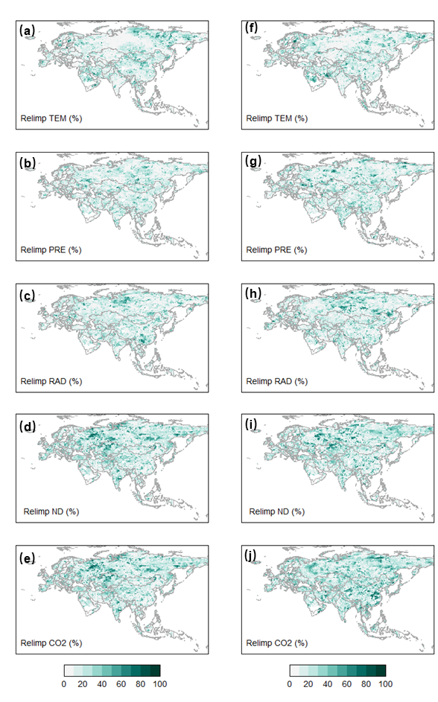
Fig.S1 Relative weight of the environmental factors across Eurasia. a–e showed the relative weight of the TEM, PRE, RAD, ND and CO₂ in regulating γNDVI^{TEM}, respectively. f–j showed the relative weight of the TEM, PRE, RAD, ND and CO₂ in regulatingγNDVI^{PRE}.

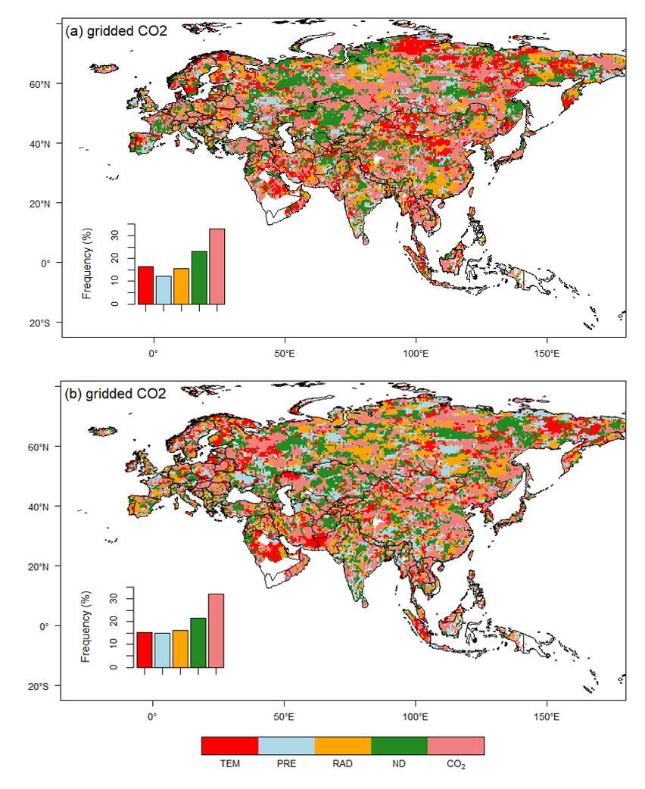
Fig. S2 Spatial patterns of dominant factor regulating γNDVI^{TEM} (a) and γNDVI^{PRE} (b) variations based on in-situ CO₂ and gridded CO₂ data (labeled with gridded CO₂) during 1982–2015.

