**ScalaSDK死活装不上，解决方案：不用scala**

本地java运行wordcount

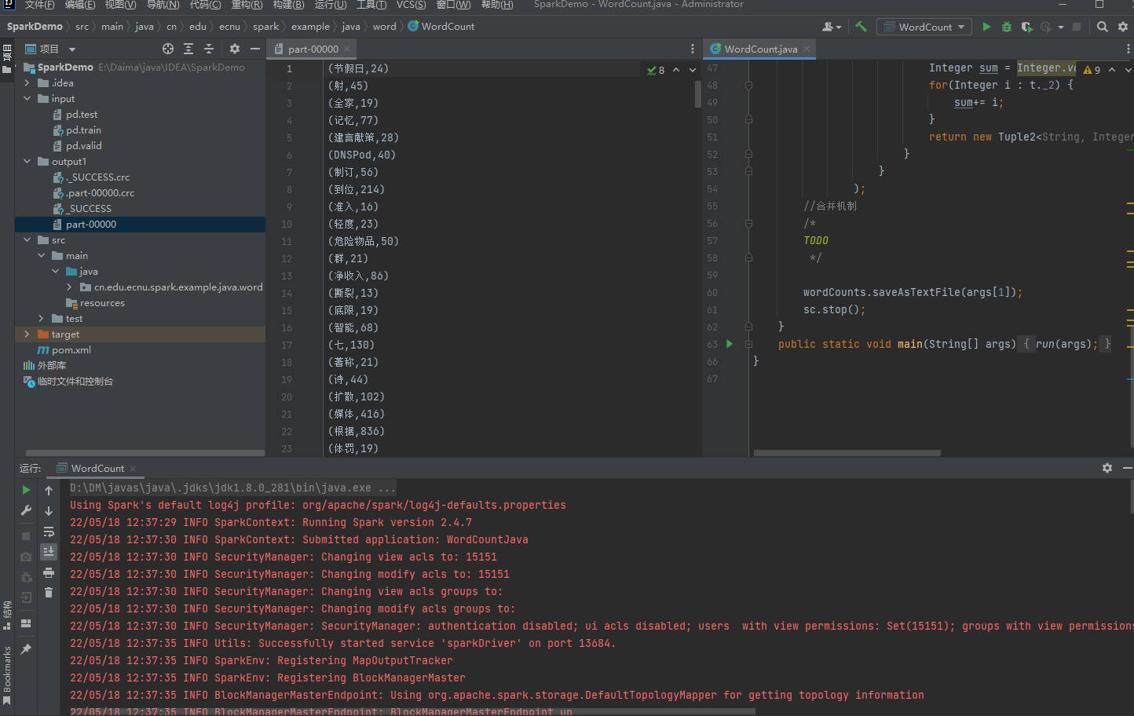

启动dfs服务

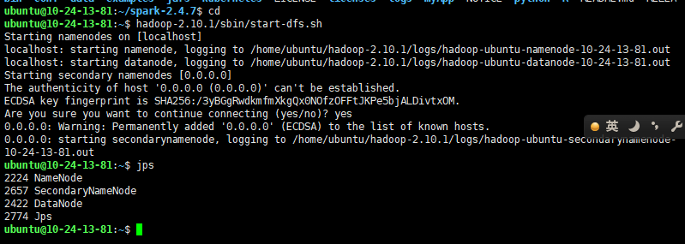

启动spark

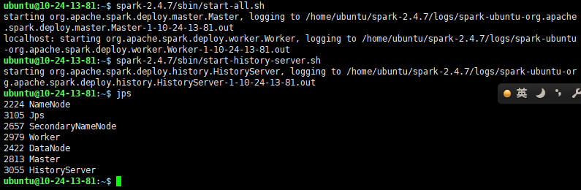

执行

~/spark-2.4.7/bin/spark-submit

--master spark://localhost:7077 --class cn.edu.ecnu.spark.example.java.wordcount.WordCount

/home/ubuntu/spark-2.4.7/myApp/RddWordCountJava.jar hdfs://localhost:9000/user/ubuntu/spark_input hdfs://localhost:9000/user/ubuntu/spark_output

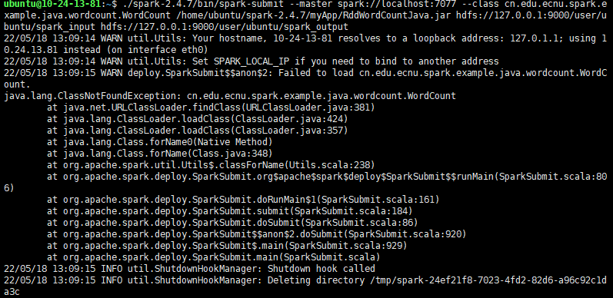

原因是在本地编写目录cn.edu.ecnu.spark.example.java.wordcount时出错

重新执行

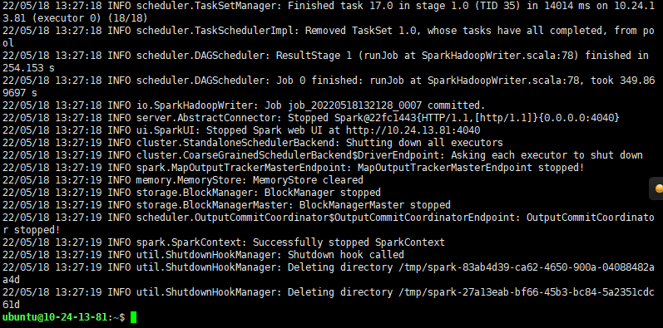

执行hadoop-2.10.1/bin/hdfs dfs -ls

执行hadoop-2.10.1/bin/hdfs dfs -ls spark_output

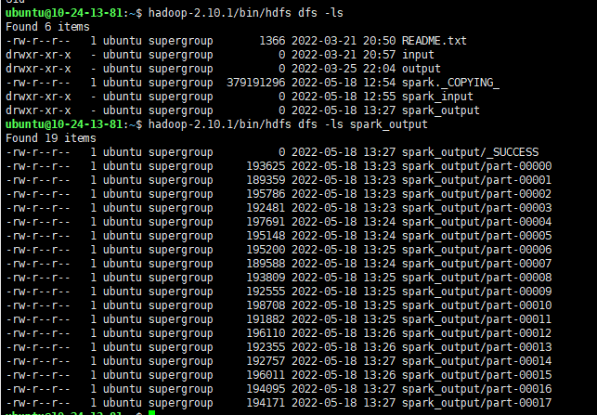

执行hadoop-2.10.1/bin/hdfs dfs -cat spark_output/part-00017

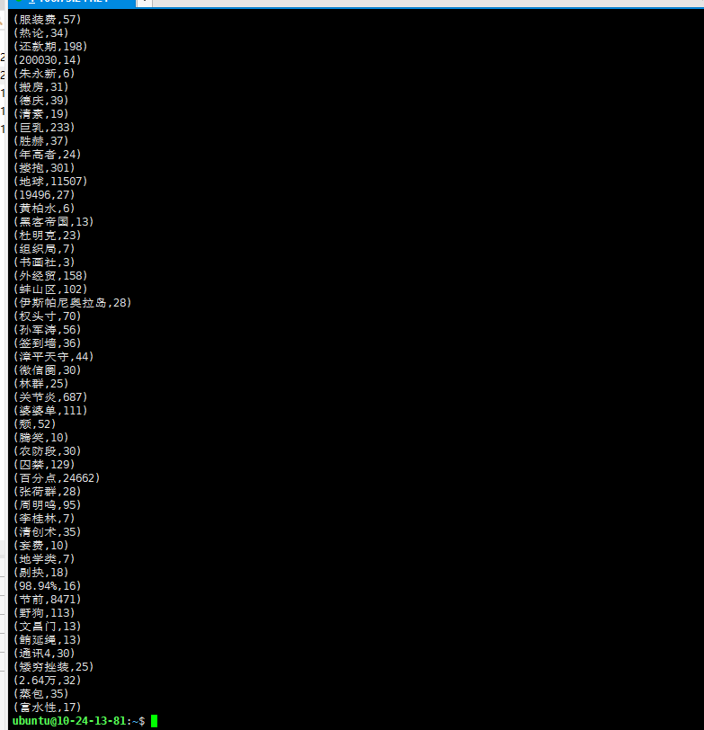

执行

~/hadoop-2.10.1/sbin/stop-dfs.sh

~/spark-2.4.7/sbin/stop-all.sh

~/spark-2.4.7/sbin/stop-history-server.sh

关闭服务

