启动服务

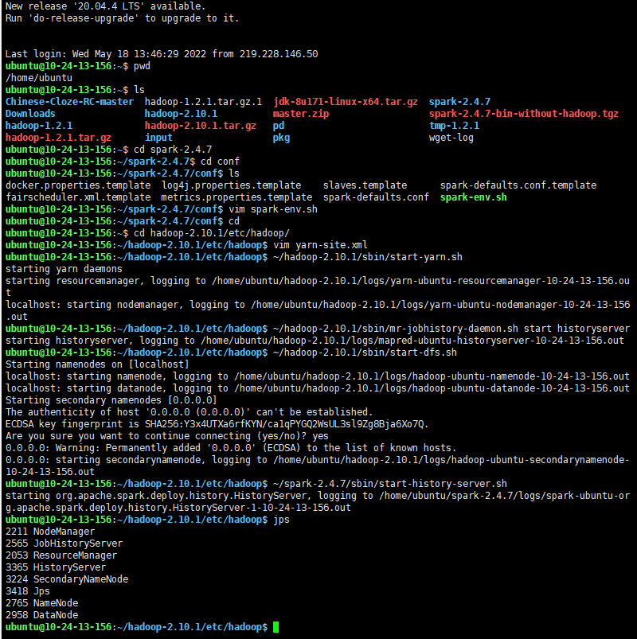

<http://113.31.109.75:8088/cluster>

初始页

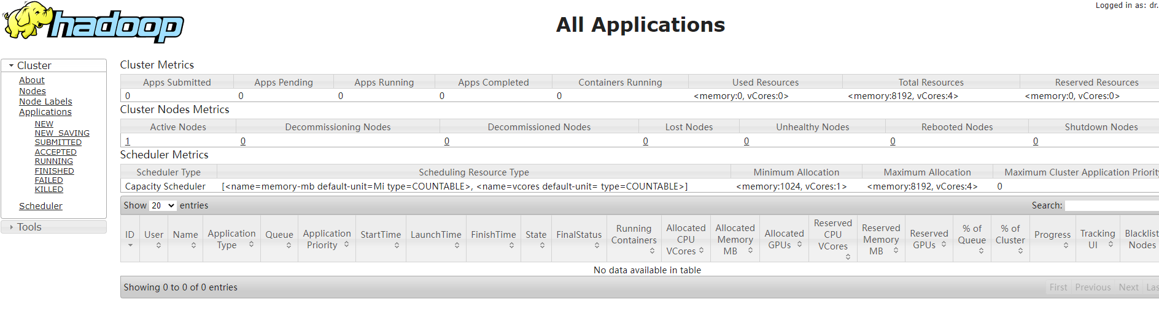

运行Spark程序

sc.textFile("spark_input/RELEASE").flatMap(_.split(" ")).map((_,1)).reduceByKey(_ + _).collect

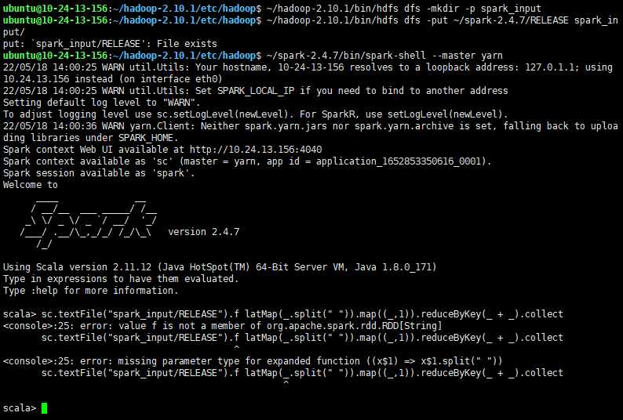

发现是书本印刷错误，faltMap连

重新执行

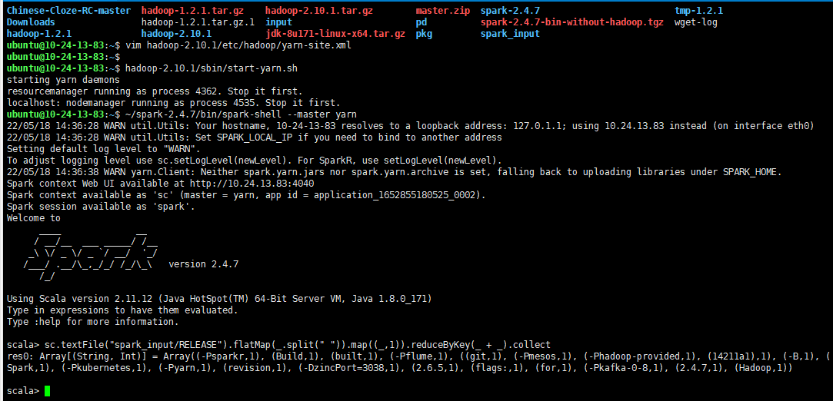

**通过client方式提交**

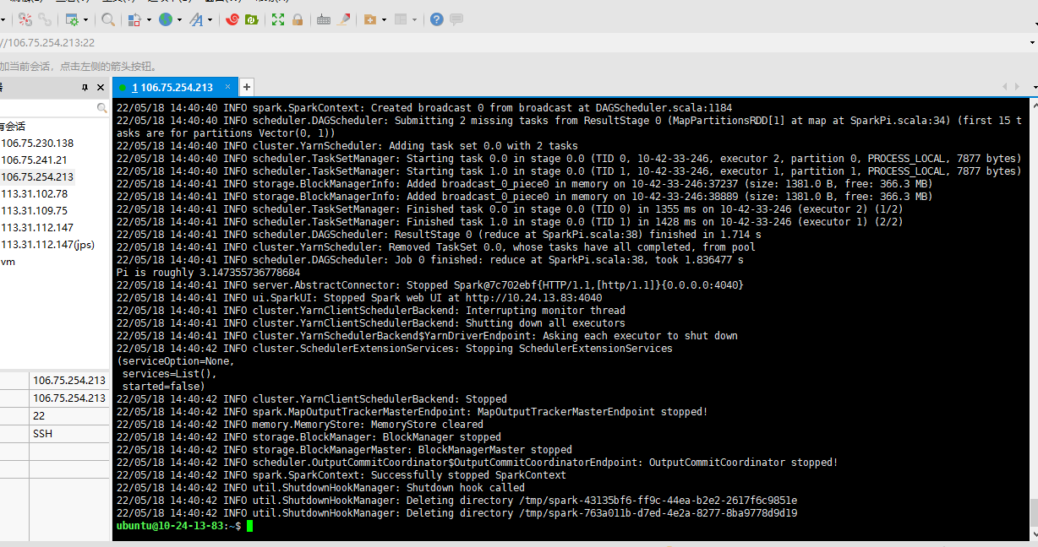

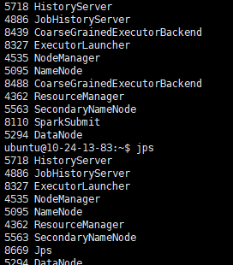

**Cluster方式提交**

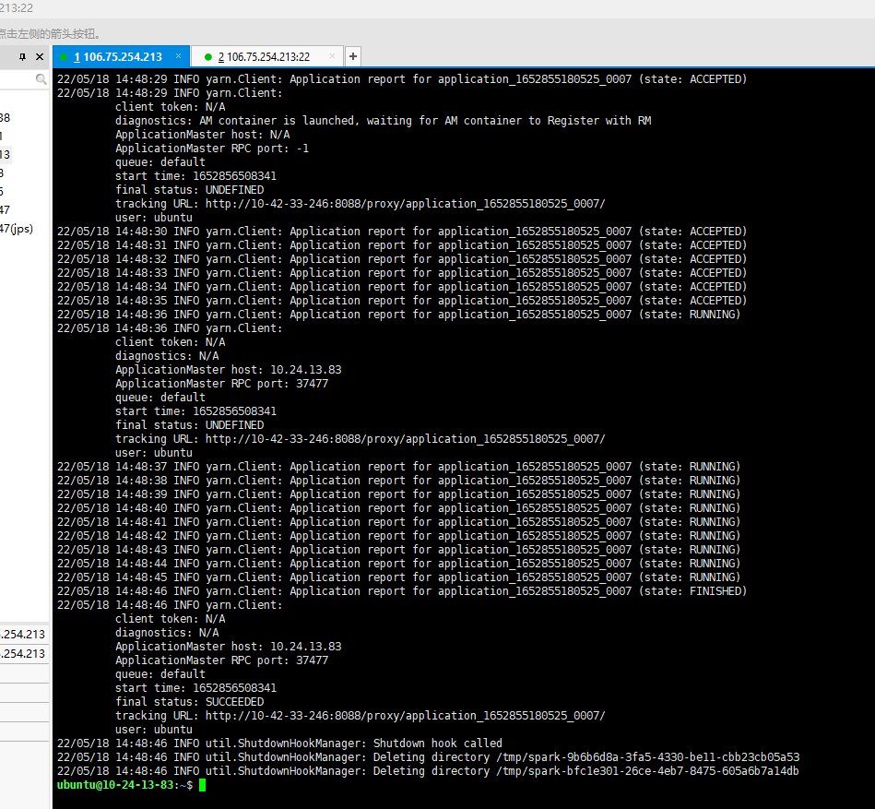

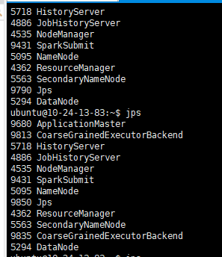 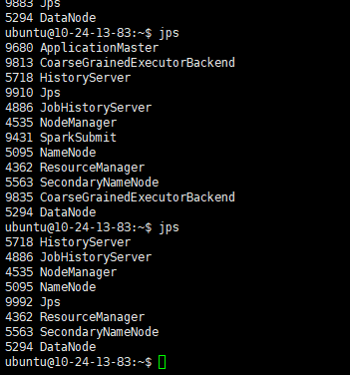

**8088端口**

<http://106.75.254.213:8088/cluster>

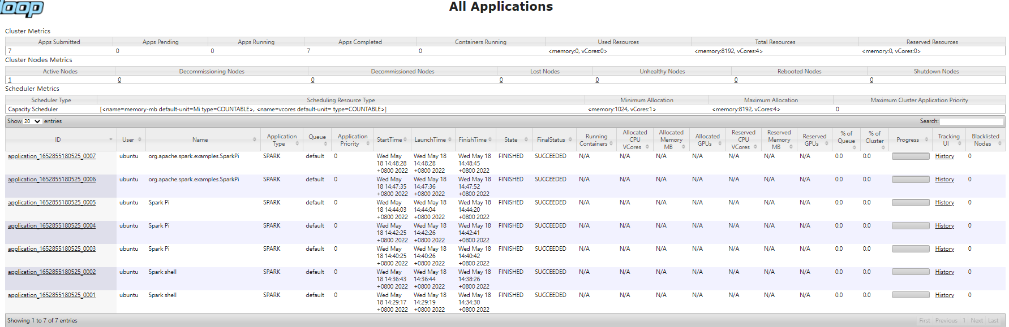

**18080端口**

<http://106.75.254.213:18080/>

