<Project Name>

Final Report

<Date>

Team Member | Contribution

Computer Science and Technology Program
United International College
- Table of Contents
1. Table of Contents 2
2. Project Overview 3
3. Data Set 4
4. Features and Approaches 5
4.1. <Feature 1> 5
4.2. <Feature 2> 5
5. Key Findings 6
6. Conclusion and Discussion 7

- Project Overview
This project focuses on analyzing the The Complete Pokemon Dataset obtained from Kaggle. The dataset contains comprehensive information about 801 Pokemon across 7 generations, including their base stats, types, abilities, and legendary status.

Project Objectives
Perform data cleaning and exploratory data analysis (EDA) on the raw dataset;
Analyze type characteristics and identify the strongest types and type combinations;
Investigate the relationship between capture difficulty and Pokemon strength;
Build a machine learning model to predict whether a Pokemon is legendary.

Key Insights
Legendary Pokemon have significantly higher base stats (mean BST ~680) compared to non-legendary Pokemon (mean BST ~408);
Dragon and Steel types rank highest in average BST, while Bug and Grass types rank lowest;
The strongest dual-type combinations include Dragon + Ice and Dragon + Psychic (BST > 680);
Capture difficulty correlates strongly with Base Total (r ≈ 0.7);
The SGDClassifier model achieves 100% recall in identifying legendary Pokemon;
- Data Set
The dataset used in this project is The Complete Pokemon Dataset from Kaggle, containing 801 Pokemon across 7 generations (Generations 1 to 7).

Dataset Overview
Metric | Value
Total Pokemon | 801
Total Features | 41
Generations | 1-7
Legendary Pokemon | 70 (8.7%)

Column Categories
The 41 columns can be grouped into 8 categories:
Category | Number of Columns | Example Columns
Identification | 5 | name, pokedex_number, generation
Type | 2 | type1, type2
Base Stats | 7 | hp, attack, defense, sp_attack, sp_defense, speed, base_total
Type Effectiveness | 18 | against_bug, against_fire, ...
Physical | 2 | height_m, weight_kg
Gender | 1 | percentage_male
Abilities | 1 | abilities
Other Game Data | 5 | capture_rate, is_legendary

Missing Values
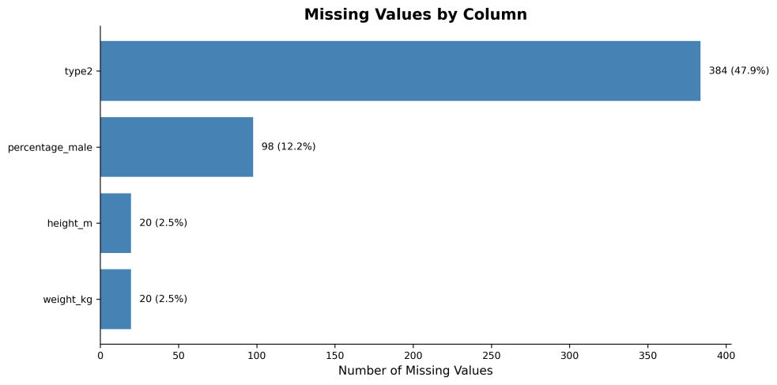
Figure 1: Missing Values by Column

Column | Missing | Percent | Explanation
type2 | 384 | 47.9% | Single-type Pokemon (no secondary type)
percentage_male | 98 | 12.2% | Genderless Pokemon (legendary, mythical)
height_m | 20 | 2.5% | Missing data
weight_kg | 20 | 2.5% | Missing data

Base Total Distribution
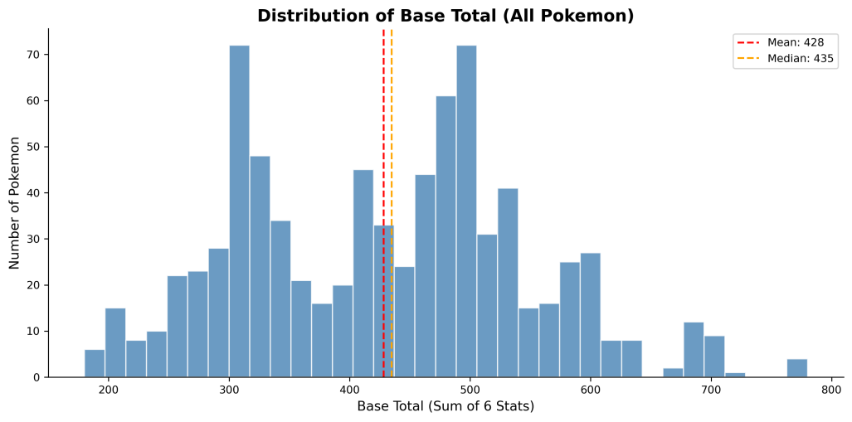
Figure 2: Distribution of Base Total (All Pokemon)

The distribution is roughly normal with a slight right skew, indicating most Pokemon have base totals between 300 and 500.

Generation Distribution
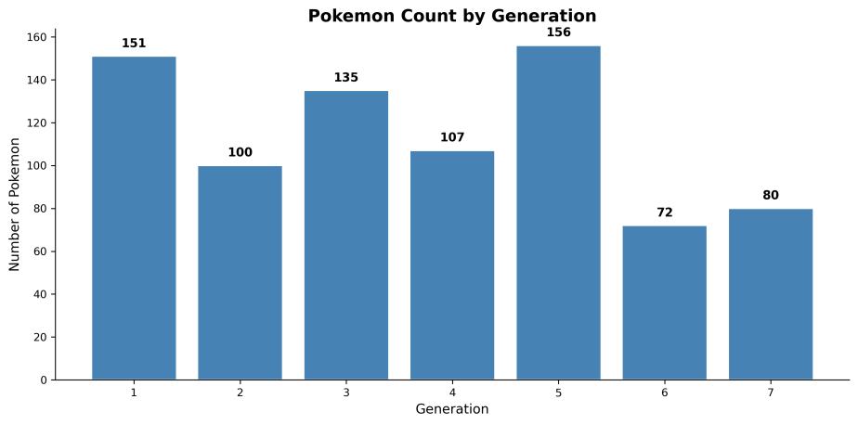
Figure 3: Pokemon Count by Generation

Generation | Count
1 | 151
2 | 100
3 | 135
4 | 107
5 | 156
6 | 72
7 | 80

Generation 5 has the most Pokemon (156), while Generation 6 has the fewest (72).
- Features and Approaches

Type Profile Analysis
Objective:
Analyze how different Pokemon types compare in terms of base stats.
Approach:
Calculate the mean of six base stats (HP, Attack, Defense, Sp. Atk, Sp. Def, Speed) for each type
Compute deviation from global mean for each type
Visualize using radar charts and bar charts
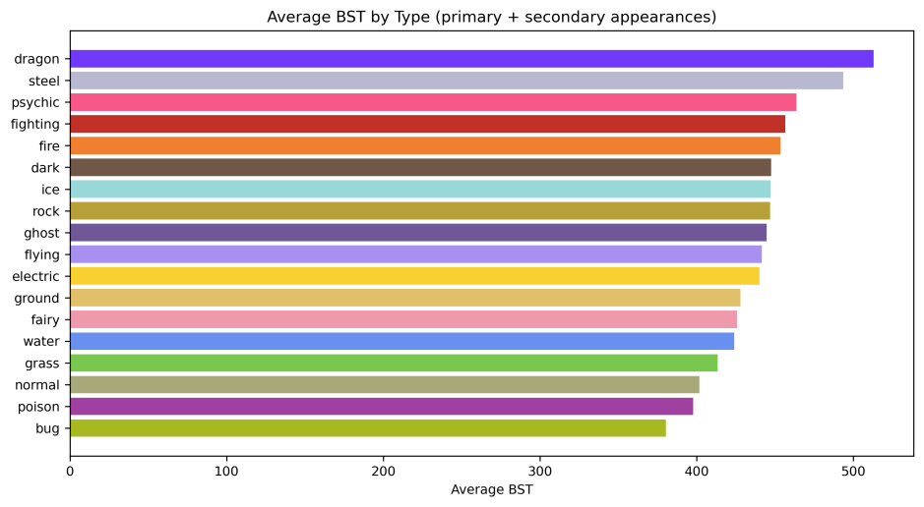
Figure 5: Average BST by Type

Rank | Type | Average BST
1 | Dragon | 513.0
2 | Steel | 493.7
3 | Psychic | 463.8
4 | Fighting | 456.6
5 | Fire | 453.6

Findings:
Dragon types have the highest average BST (513)
Bug types have the lowest average BST (380)
Flying types appear most frequently as secondary types (95 appearances)

Dual-Type Analysis
Objective:
Identify the strongest and most common dual-type combinations.
Approach:
Create dual-type combinations by combining type1 and type2
Calculate average BST for each combination
Generate heatmap of dual-type frequencies

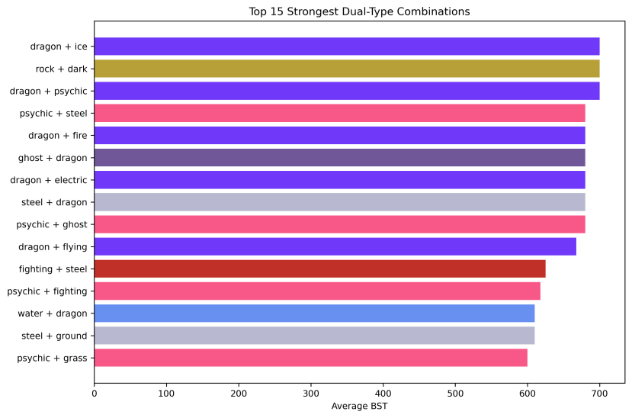
Figure 6: Top 15 Strongest Dual-Type Combinations

Rank | Dual-Type | Average BST | Legendary Ratio
1 | Dragon + Ice | 700.0 | 1.00
2 | Dragon + Psychic | 700.0 | 1.00
3 | Rock + Dark | 700.0 | 1.00
4 | Psychic + Steel | 680.0 | 1.00
5 | Dragon + Fire | 680.0 | 1.00

Findings:
All top 5 dual-type combinations consist entirely of legendary Pokemon
The most common dual-type combination is Normal + Flying
Steel is frequently paired with other types to create strong combinations

Capture Difficulty Analysis
Objective:
Analyze the relationship between capture difficulty and Pokemon strength.
Approach:
Parse capture_rate (which can be a range like "45" or "3") to numeric values
Normalize to a difficulty coefficient (0 = easiest, 1 = hardest)
Calculate correlation with base_total
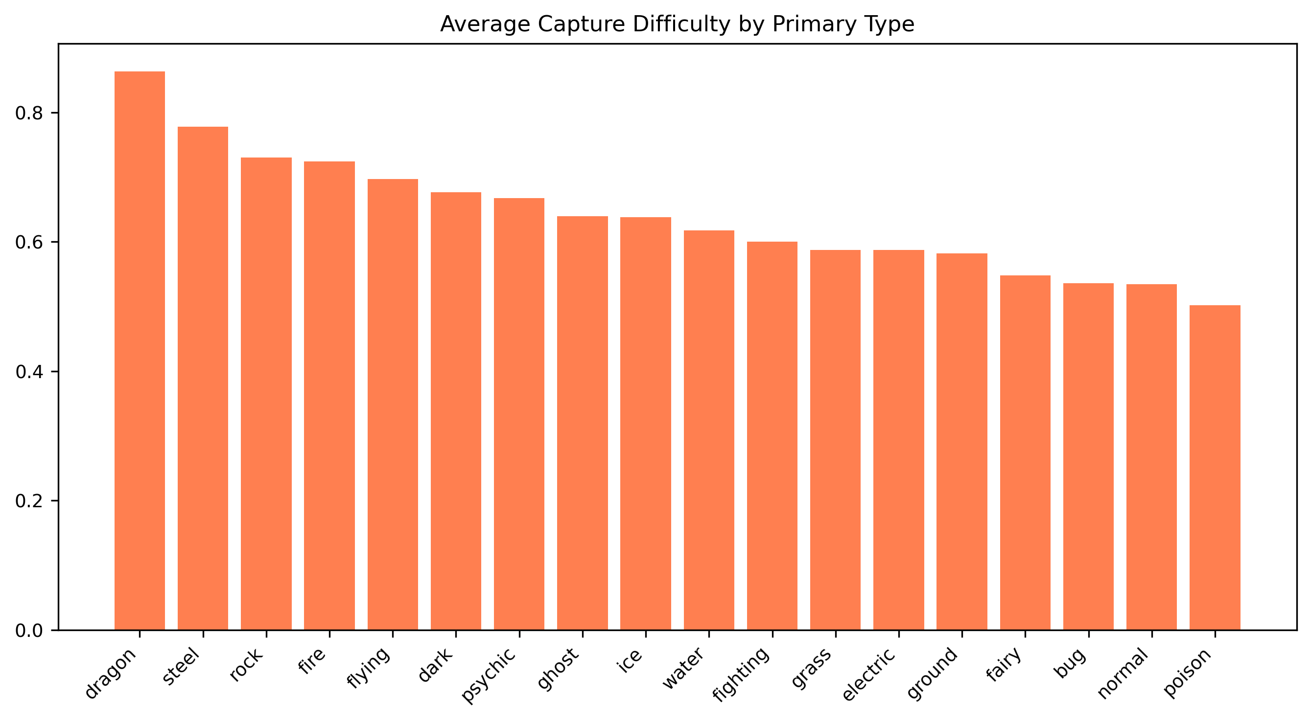
Figure 7: Capture Difficulty by Primary Type

Rank | Type | Avg Difficulty
1 | Dragon | 0.864
2 | Steel | 0.778
3 | Rock | 0.731
4 | Fire | 0.725
5 | Flying | 0.697

Findings:
Correlation between capture difficulty and Base Total is 0.71 (strong positive)
Dragon type Pokemon are the hardest to capture on average
Legendary Pokemon have significantly higher capture difficulty (mean 0.99) than non-legendary (mean 0.84)

Legendary Pokemon Prediction (Machine Learning)
Objective:
Build a model to predict whether a Pokemon is legendary based on its features.
Approach:
Features used: height_m, weight_kg, capture_rate, base_egg_steps, experience_growth, hp, attack, defense, sp_attack, sp_defense, speed, type1 (one-hot encoded), generation
Model: SGDClassifier (logistic regression) with balanced class weights
Train/Test split: 70/30 with stratification

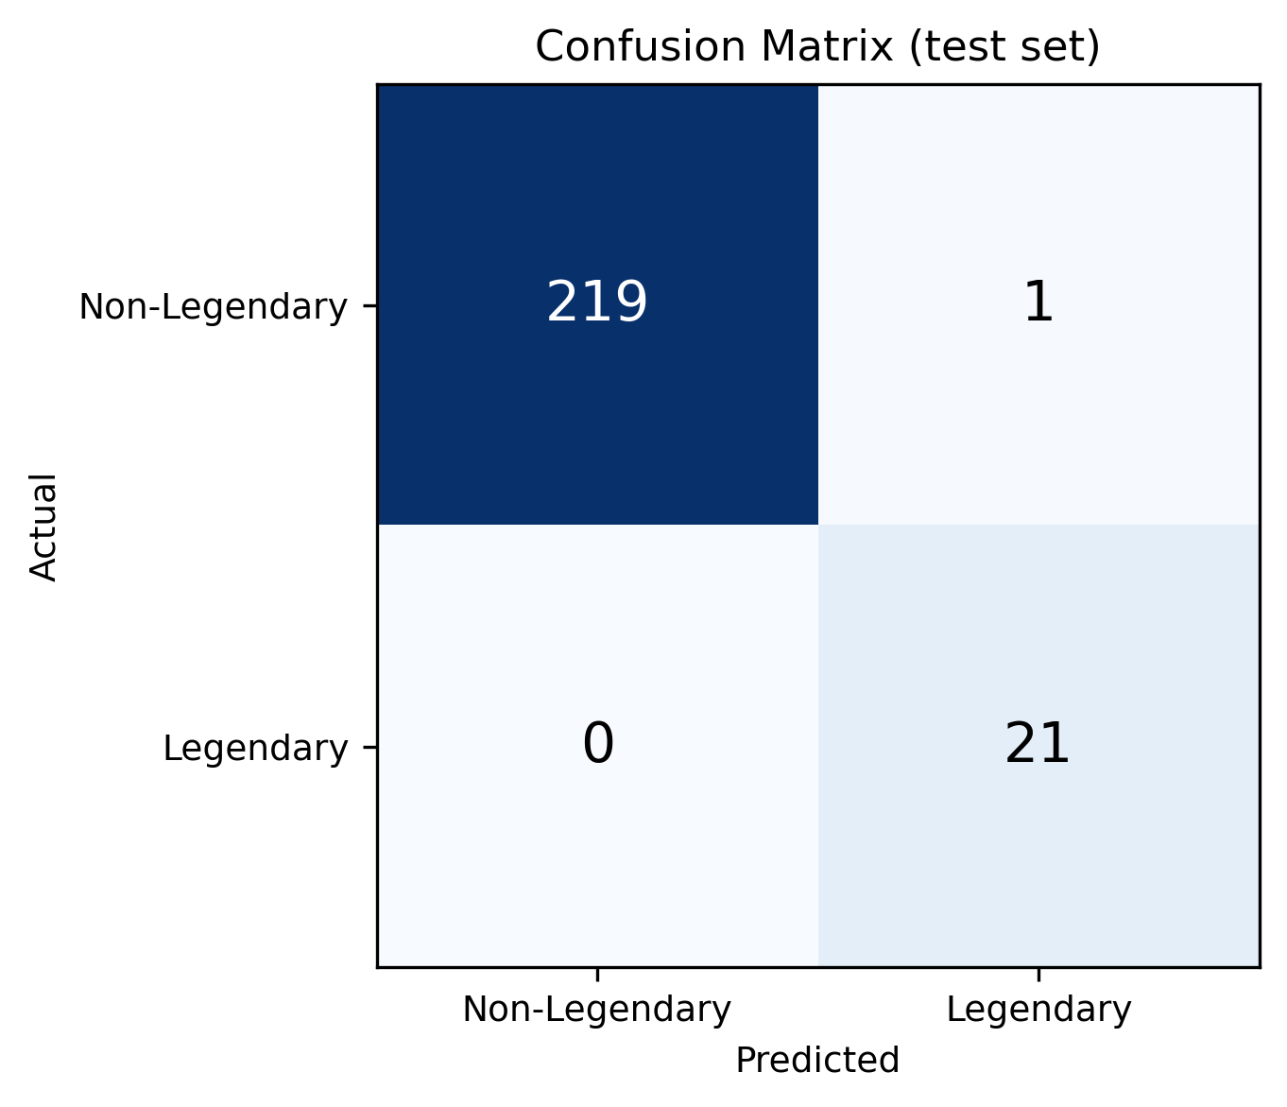
Figure 8: Confusion Matrix

 | Predicted Non-Legendary | Predicted Legendary
Actual Non-Legendary | 219 | 1
Actual Legendary | 0 | 21

Model Performance Metrics:

Metric | Score
Accuracy | 0.996
Balanced Accuracy | 0.998
Recall (Legendary) | 1.000
Precision (Legendary) | 0.955

Findings:
The model achieves 100% recall, successfully identifying every legendary Pokemon in the test set
Only 1 non-legendary Pokemon was misclassified as legendary (Metagross)
The model successfully distinguishes legendary Pokemon based on their stat profiles and game data

- Key Findings

Finding 1: Legendary Pokemon Are Significantly Stronger

Category | Mean BST | Range
Legendary | ~680 | 580 - 780
Non-Legendary | ~408 | 180 - 670

Legendary Pokemon have an average Base Total that is 272 points higher than non-legendary Pokemon.

Finding 2: Dragon and Steel Are the Strongest Types
Dragon: 513.0 average BST
Steel: 493.7 average BST
Bug: 380.4 average BST (weakest)

Finding 3: Top Dual-Type Combinations Are All Legendary
The top 5 strongest dual-type combinations all consist exclusively of legendary Pokemon, with average BST exceeding 680.

Finding 4: Capture Difficulty Strongly Correlates with BST
Correlation coefficient: r = 0.71
Dragon types are hardest to capture (difficulty 0.86)
Poison types are easiest to capture (difficulty 0.50)

Finding 5: ML Model Achieves Perfect Recall
The SGDClassifier model successfully identified all 21 legendary Pokemon in the test set, with only 1 false positive (Metagross, a pseudo-legendary).
The Machine Learning tab displays test-set metrics, a confusion matrix, and predictions using a pre-trained SGDClassifier artifact (`artifacts/ml_results_30.pkl`), which can be regenerated with `train_ml_artifacts.py`.
The sidebar provides five modules: Data Preview, Dual-Type Analysis, Personality Profiles, Capture Difficulty, and Machine Learning. Each page supports filters (type, generation, legendary status where relevant) and Plotly charts in expandable panels.
Besides the notebook analysis, we implemented an interactive Streamlit dashboard to explore the same results. Run it with `streamlit run app.py` from the project root (see README.md for dependencies).
- Interactive Dashboard (GUI)
Besides the notebook analysis, we implemented an interactive Streamlit dashboard to explore the same results. Run it with streamlit run app.py from the project root (see README.md for dependencies).
The sidebar provides five modules: Data Preview, Dual-Type Analysis, Personality Profiles, Capture Difficulty, and Machine Learning. Each page supports filters (type, generation, legendary status where relevant) and Plotly charts in expandable panels.
The Machine Learning tab displays test-set metrics, a confusion matrix, and predictions using a pre-trained SGDClassifier artifact (artifacts/ml_results_30.pkl), which can be regenerated with train_ml_artifacts.py.
- Conclusion and Discussion

This project successfully analyzed the Pokemon dataset across multiple dimensions:

- Data Exploration:
Identified the dataset structure, missing values (type2: 48%, percentage_male: 12%), and key statistics (mean BST: 428)

- Type Analysis:
Dragon types dominate in BST (513), while Bug types rank lowest (380)

- Dual-Type Analysis:
The strongest combinations are legendary-dominated, with Dragon + Ice achieving 700 BST

- Capture Difficulty:
Strong positive correlation with BST (r = 0.71), with Dragon types being hardest to capture

- Machine Learning:
The model achieves 100% recall in identifying legendary Pokemon, demonstrating that legendary status can be reliably predicted from stats and game data

