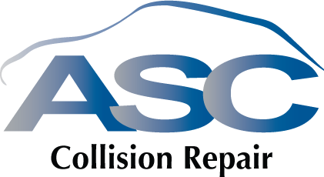 |  |  |  | INVOICE
From: ASC Collision Repair  Richmond BC V6X 2A7  6042788833  GST# 840990709  Asc_collision@telus.net  {{SOLD}} |  |  |  | INVOICE #{{INVOICE}}  Date:{{date}}
  Sold To
salesperson | YEAR&make | VIN NUMBER |  |  | Claim Number | payment terms | PO
Cathy | {{YEAR}} | {{VIN}} |  |  | {{C}} | Due on receipt | {{PO}}

qty | item # | description |  | unit price | discount | line total
 |  | ADAS Calibration – {{LOCATION}} ({{TYPE}} Calibration) |  |  |  | $225.00
Calibration required following {{LOCATION}} related repairs. {{TYPE}} ADAS calibration completed in accordance with manufacturer procedures using OEM-compliant diagnostic equipment. Post-calibration system check performed and no fault codes present. |  |  |  |  | SUBTOTAL | $225.00
 |  |  | 5% GSt |  |  | $11.25
 |  |  | 7% pst |  |  | $15.75
 |  |  | Total |  |  | $252.00
Thank you for your business!

