**Biography**

Zhang Rong is an accomplished vocalist, educator, and doctoral candidate with extensive experience in performance, teaching, and research. She has earned multiple first prizes in China and New Zealand. She has three years of university teaching experience, focusing on vocal performance and music theory, at Yunnan University of Economics and Management. Her international performances have taken her to New Zealand, the United States, and China.

**Contact**

Email: [zharo348@student.otago.ac.nz](mailto:zharo348@student.otago.ac.nz) | [471121392@qq.com](mailto:471121392@qq.com)

**Awards & Scholarships**

Dunedin Performing Arts Competitions (Sep 2024)  
• Class 258 (National Song) – 1st Place  
• Class 260 (NZ Composer) – 3rd Place

Christchurch Competitions Society (Jun 2024)  
• Class 127 (National Song) – 2nd Place

Dunedin Performing Arts Competitions (Sep 2023)  
• Class 257 (Oratorio) – 1st Place  
• Class 263 (Novice) – 1st Place  
• Class 251 (Cleveland Charitable Foundation Scholarship Award) – 1st Place  
• Class 258 (National Song) – 1st Place  
• Class 267 (Song by Woman Composer) – 1st Place  
• Class 261 (17th–18th Century Aria) – 3rd Place

Yunnan Local Song Contest (2018) – 1st Prize (Graduate Group)  
Golden Bell Awards (Yunnan Division, 2016) – Honourable Mention  
Sichuan Normal University (2013–2014) – May Fourth Youth Professional Outstanding Award  
Shenzhou Singing Competition (2014) – Sichuan Division, 3rd Prize

**Scholarships**  
• University of Otago Doctoral Scholarship  
• Professor John Steele Doctoral Scholarship in Musicology  
• Sewanee Summer Music Festival Vocal Scholarship  
• Chinese National Scholarship

**Performance**

• Doctor of Musical Arts Recitals   
• Opera Scenes – Guerry Hall, Sewanee Summer Music Festival (USA)  
• University of Otago Graduation Ceremonies – Dunedin Town Hall (Octagon)  
• Mid-Autumn Festival Concert – Trinity Catholic College (as performer & host)  
• Lan Yuan, Dunedin Chinese Garden  
• All Saints Anglican Church  
• Mornington Methodist Church  
• Hanover Hall, Lunchtime Concert  
• Marama Hall, Lunchtime Concert  
• Opera Otago ChorusFest Choral Workshop

**Videos**

[**L’alra notte in fondo al mare**](https://youtu.be/UySuXvTvXMA) La Gioconda  
Composer: Amilcare Ponchielli  
Text: Arrigo Boito

**[Je dis que rien ne m’épouvante](https://youtu.be/Kht9Mnllsz0" \t "_new)** Carmen  
Composer: Georges Bizet  
Text: Henri Meilhac & Ludovic Halévy

[**Donde lieta uscì (with piano quintet)**](https://youtu.be/1heZOu1fC1g) La Bohème  
Composer: Giacomo Puccini  
Text: Luigi Illica & Giuseppe Giacosa

[**Dunhuang Music (My Original Composition)**](https://youtu.be/6Qmv8q9j11E)  
Composer: Zhang Rong

Piano arrangement: Anthony Ritchie

Poem:Yang Shen

**Profile picture**

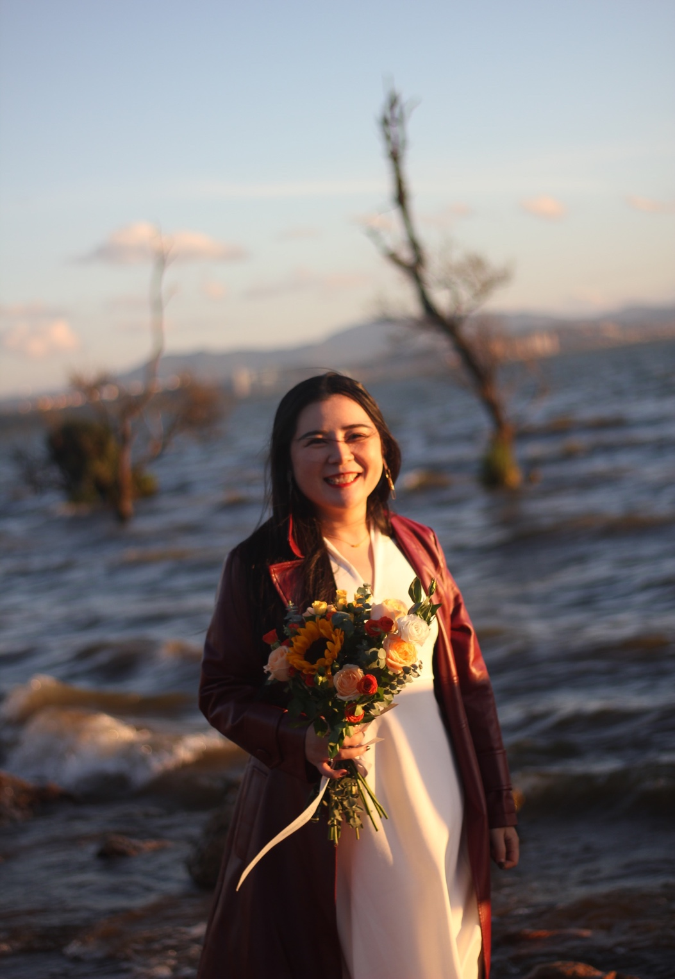

**Performance Photos**

1. Photographed at the Final Doctoral Recital 2025

2. Photographed at a family performance with my father, 2024

3. Photographed at the Graduate Recital

**Travel / Other Photos**

4. Photographed in Xishuangbanna in 2024, featuring traditional Yunnan ethnic minority costumes

5. Photographed in Hollywood during a trip, 2025

6. Photographed at the Grand Canyon during a trip, 2025

