9_24_rock_90_beat_4-4 (GPT3-Davinci)

fill pattern1.1 pattern1.2 pattern1.3 pattern1.4 fill fill pattern2.1

pattern2.2 pattern2.3 pattern2.4 fill pattern3.1 fill fill

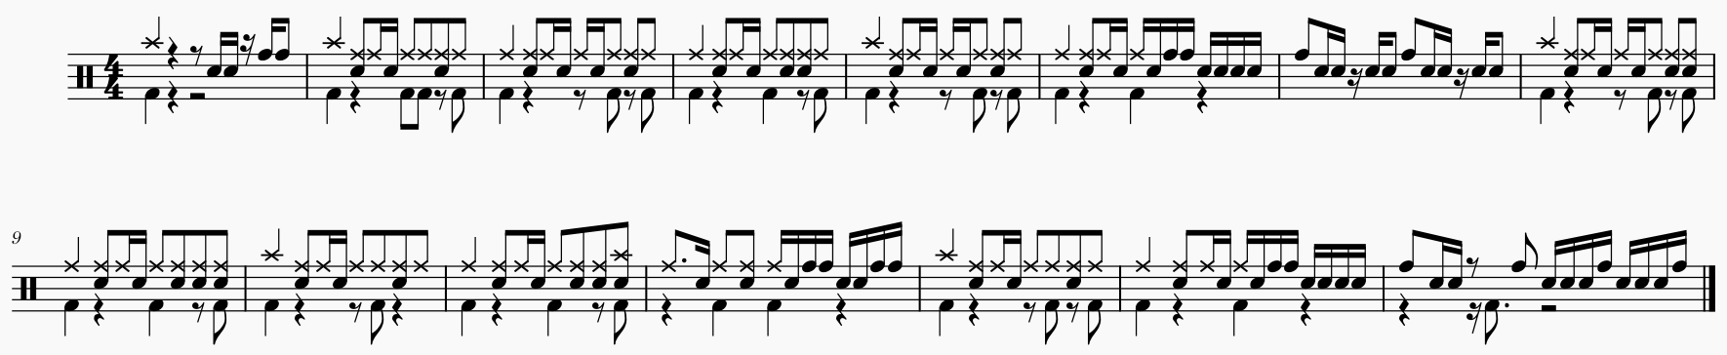

9_24_rock_90_beat_4-4 (Human)

fill pattern1.1 pattern1.2 pattern1.3 fill pattern2.1 pattern2.2 pattern2.3

fill pattern3.1 pattern3.2 pattern3.3 fill pattern4.1 pattern4.2 pattern4.3

