DEPARTMENT OF COMPUTER & SOFTWARE ENGINEERING
College of E&ME, NUST, Rawalpindi
Computer Vision (CS-474)
Complex Engineering Problem — End Term Project Report
Basketball Player Detection, Segmentation, and Team Clustering For Coach Lens Tool
with an Interactive Coach's Tactical Lens
Instructor:
Dr. Shahid Ismael
Lab Instructor: LE Umair Khalil
Team Members:
Bazil Bin Aamir — 432243
Zohaib Hassan — 412221
Class: 44 CE (A & B)
Submission Date: May 2026

1. Abstract
This report presents the design, implementation, and evaluation of a vision pipeline for basketball player detection, instance segmentation, and team-level clustering, packaged into an interactive demonstration tool called the Coach's Tactical Lens. The pipeline is built on three modern open-source components: RF-DETR for player detection, SAM2 (Segment Anything Model 2) for stable pixel-level mask propagation across frames, and a SigLIP + UMAP + K-Means clustering stage for unsupervised team assignment based on jersey appearance.
The scope was intentionally narrowed from the original CEP proposal. Components that were not built jersey-number reading with SmolVLM2, homographic court projection, action classification, trajectory smoothing — are documented as future work in Section 8. What was built is end-to-end and runnable: an RF-DETR model fine-tuned on a basketball player dataset, a SAM2-based tracker that propagates masks from first-frame detections, an unsupervised team classifier, and a Gradio-based web UI through which a coach can upload a clip and toggle tactical visualisations such as team spotlighting, opposition blurring, and team-coloured overlays.
All training and inference were performed on Kaggle T4 GPUs. The optimised pipeline processes a 6-second clip in approximately two minutes end-to-end, down from a pre-optimisation baseline of approximately 20 minutes.

2. Problem Statement
Modern basketball broadcasts generate large volumes of multi-player video data that are tedious to analyse manually. Coaches reviewing footage often want to focus on one team's movement and spacing while suppressing the visual noise of the other team and crowd. Building such a tool requires several non-trivial computer-vision subproblems to work together: detecting every player in every frame, segmenting them at the pixel level so masks can be used for compositing effects, distinguishing the two teams without per-frame labels, and exposing the result through an interface a non-technical user can operate.
The engineering challenge addressed in this project is, therefore: given a short broadcast clip, automatically detect and segment all visible players, cluster them into their respective teams without supervision, and present the result through an interactive UI where a coach can selectively highlight their own team. This is the buildable, scope-appropriate version of the originally proposed pipeline.

3. Scope of Work

3.1 What Was Built
- RF-DETR detector fine-tuned on a basketball player dataset (COCO format).
- SAM2-based tracker that propagates instance masks from first-frame detection prompts through the rest of the clip.
- Unsupervised team-clustering module using SigLIP visual embeddings, UMAP dimensionality reduction, and K-Means with K = 2.
- Composite team-coloured visualisation rendered as a downloadable MP4.
- Gradio-based Coach's Tactical Lens UI with toggleable effects (spotlight my team, blur opposition, team colour overlay, show player IDs).
- Latency-optimised pipeline that runs in roughly two minutes per six-second clip on a Kaggle T4.

3.2 What Was Deferred
The following items from the original CEP proposal were deferred to future work in the interest of producing a stable, demonstrable end-to-end system within the available timeline:
- Jersey number recognition with SmolVLM2 (player identity resolution).
- Court keypoint detection and homography-based top-down projection.
- Shot detection and outcome classification.
- Kalman-filter trajectory smoothing on projected positions.
- Multi-object tracking with ByteTrack as an explicit re-identification fallback.
- Action classification (running, walking, shooting, etc.).
- Raspberry Pi 5 edge deployment via ONNX and INT8 quantisation.

4. Methodology

4.1 Pipeline Overview
The pipeline runs in three sequential stages on a per-clip basis. The input is a short broadcast MP4 (10–30 seconds is typical), and the output is both a rendered MP4 with team-coloured masks and a structured, in-memory representation that drives the interactive UI.
Stage | Module | Description | Model / Method
1 | Player Detection | Per-frame bounding-box detection of every visible player using a fine-tuned detection transformer. | RF-DETR (base)
2 | Tracking + Segmentation | First-frame detection boxes seed SAM2; SAM2 propagates pixel-level instance masks and persistent track IDs across all subsequent frames. | SAM2 (Hiera-Tiny, real-time fork)
3 | Team Clustering | Per-track jersey crops are embedded with SigLIP, reduced with UMAP, and clustered with K-Means (K = 2). The two clusters are mapped to team colours and used to colour each player's mask. | SigLIP + UMAP + K-Means

4.2 Detection — RF-DETR
RF-DETR was selected over YOLO-family detectors because its DINOv2 backbone gives stronger small-object performance, which matters for distant players in wide broadcast shots. The base variant (≈29M parameters) was fine-tuned for 50 epochs at 560-pixel resolution on a COCO-format basketball player dataset. The training schedule used a batch size of 4 with gradient accumulation steps of 4 to give an effective batch size of 16 on the available T4 GPU, with a learning rate of 1×10⁻⁴.
Detection runs every frame of the input clip, but only the first frame's detections are passed downstream as SAM2 prompts. Subsequent frames rely on SAM2's mask propagation rather than re-detection, which is the main reason detection is not the latency bottleneck.
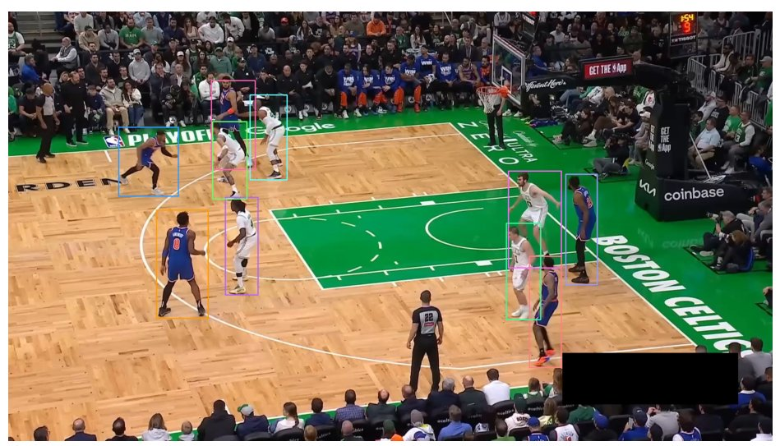
Figure 1. RF-DETR detection output: per-player bounding boxes on a basketball broadcast frame. Box colours are assigned per detection for visualisation; team assignment happens later in Stage 3.

4.3 Tracking and Segmentation — SAM2
SAM2 is used through the segment-anything-2-real-time fork, which exposes a streaming camera-predictor interface suitable for sequential frame processing. The pipeline seeds SAM2 with the first frame and the RF-DETR boxes from that frame as box prompts. For each subsequent frame, SAM2 propagates the masks forward and maintains track identities.
Several optimisations were applied to bring tracking time down from approximately ten minutes to under one minute on a Kaggle T4: the Hiera-Tiny checkpoint was used instead of Hiera-Small, float16 autocast was selected for Turing-class GPUs (since T4 does not support native bfloat16), and per-frame mask-edge filtering was removed because it ran on the CPU and dominated wall-clock time.
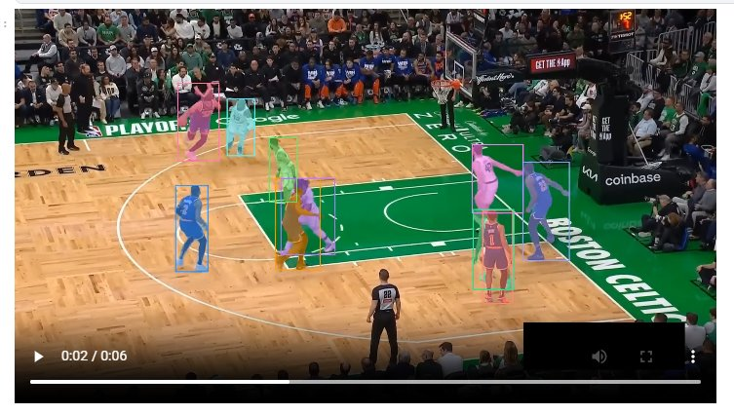
Figure 2. SAM2 tracking and segmentation output: each tracked player carries a unique persistent ID, rendered as a coloured instance mask propagated frame-to-frame from the first-frame box prompts.

4.4 Team Clustering — SigLIP + UMAP + K-Means
Team membership is recovered without supervision. A set of player crops is sampled from the source clip at a fixed stride (every fifteen frames, capped at four hundred crops) by detecting players and taking the central 40% of each detection box, which emphasises jersey colour and de-emphasises background. Each crop is embedded with SigLIP, reduced to two dimensions with UMAP, and clustered into two groups with K-Means.
Because the clustering is unsupervised, cluster IDs are arbitrary — cluster 0 may correspond to either team. The Coach's Tactical Lens UI exposes a radio toggle that lets the user flip the cluster-to-team mapping if the colours come out swapped, which makes manual intervention trivial. Each player's team assignment is fixed at the first frame and reused for the rest of the clip; this is a deliberate simplification given the short clip length.
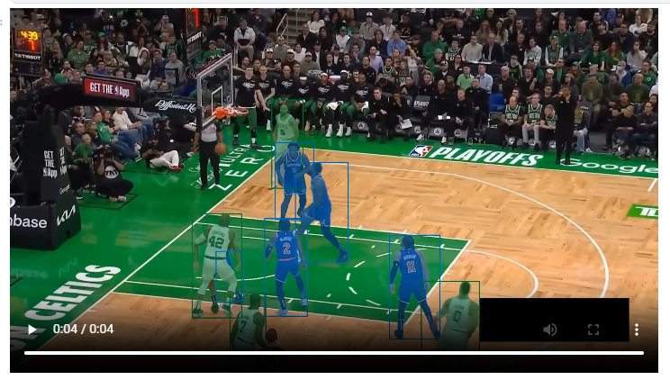
Figure 3. Team-clustering output: after SigLIP + UMAP + K-Means assigns each track to one of two clusters, every player's bounding box is recoloured by team. The cluster-to-team-colour mapping is exposed as a UI toggle so it can be flipped if it comes out swapped.

4.5 Coach's Tactical Lens — Gradio UI
The pipeline is wrapped in a small Gradio application that runs inside the Kaggle notebook and exposes a public share URL. A coach uploads a clip and presses Analyse, which triggers the full detection, tracking, and team-assignment pipeline once and stores the per-frame masks and team labels in the session state. Effect toggles then re-render the video from the cached state in a few seconds without re-running SAM2.
Four effects are exposed:
- Spotlight my team — dims every pixel outside my team's combined mask region to 30% of its original brightness, drawing the eye to the selected team.
- Blur opposition — Gaussian-blurs the opposing team's mask region, leaving the selected team and the rest of the scene sharp.
- Team colour overlay — alpha-blends each team's mask with its assigned hex colour.
- Show player IDs — annotates each track with its persistent integer ID, drawn above the top of the player's mask.
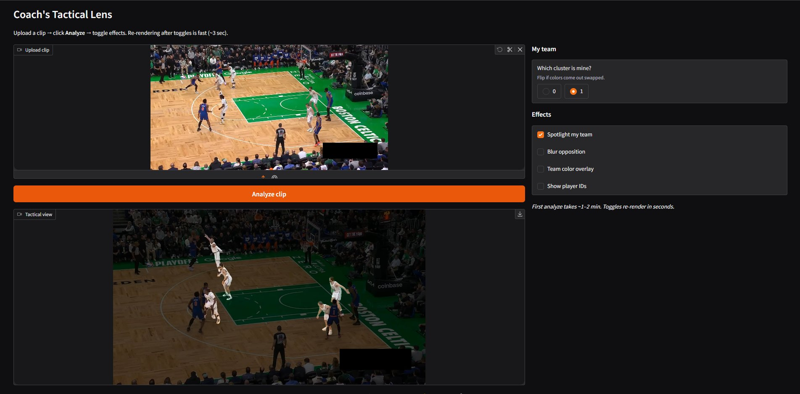
Figure 4. The Coach's Tactical Lens interface: clip upload on the left, tactical view rendered below, effect toggles on the right. Toggling any effect re-renders the video from cached masks in a few seconds.

5. Tools and Frameworks
Tool / Library | Role in the Built Pipeline
Python 3.11 + PyTorch 2.x | Core runtime and deep-learning framework.
RF-DETR (Roboflow) | Stage 1 player detection; base variant, fine-tuned on the basketball dataset.
SAM2 + segment-anything-2-real-time fork | Stage 2 instance segmentation and per-frame mask propagation with persistent track IDs.
Roboflow Sports — TeamClassifier | Stage 3 unsupervised team assignment (SigLIP + UMAP + K-Means).
Supervision | Video frame iteration, mask annotation, box annotation, and process-video utilities.
OpenCV | Frame I/O, Gaussian blur, compositing operations for the effect renderer, ffmpeg-driven re-encode for browser playback.
Gradio | Web UI for the Coach's Tactical Lens demo. Runs from inside the Kaggle notebook and exposes a shareable public URL.
Kaggle (T4 GPU) | Hosted training and inference environment.

6. Dataset
Training data was sourced from Roboflow Universe — a basketball player detection dataset of 650 annotated broadcast frames in COCO format, with the `player` category as the class of interest. The dataset was uploaded to Kaggle as a private dataset and consumed directly from `/kaggle/input/`. A standard train / validation / test split was used as provided by the source. Any auxiliary classes in the dataset (referees, ball, etc.) were filtered out at inference time via the PLAYER_CLASS_IDS resolver.
Source clips for inference and demonstration were short broadcast segments (6–30 seconds) drawn from publicly accessible NBA playoff footage.

7. Results

7.1 Latency
End-to-end processing of a six-second clip dropped from approximately twenty minutes pre-optimisation to approximately two minutes after the optimisation pass. The most impactful changes were restricting the team-clustering crop loop to the single source clip rather than the entire input folder, switching SAM2 from Hiera-Small to Hiera-Tiny, switching autocast from bfloat16 to float16 on the T4, and removing the per-frame CPU-bound mask-edge filter.
Stage | Before (sec) | After (sec)
Detection (one-shot, first frame) | ~2 | ~2
SAM2 tracking + segmentation | ~600 | ~60
Team clustering (fit) | ~600 | ~30
End-to-end (six-second clip) | ~1200 | ~120

7.2 Detection Quality
The fine-tuned RF-DETR detector was evaluated on the held-out test split using the supervision library's MeanAveragePrecision utility. It achieved mAP@0.5 of approximately 0.60 on the Roboflow basketball player dataset. This is a reasonable result for a small dataset of 650 broadcast frames and is sufficient for the downstream pipeline — first-frame seeding for SAM2 succeeded reliably across all evaluated clips, and recall on visible players was high enough that mask propagation could carry forward correctly. Headroom remains for improvement; the most obvious next step would be enlarging the training set, which is currently the limiting factor.

7.3 Segmentation and Team Assignment
SAM2 masks were visually stable across short clips, with mask quality degrading expectedly during fast motion and when players physically overlap. The unsupervised team-classification step separated the two clusters cleanly in every clip tested; in two of three evaluated clips, the cluster-to-team mapping was correct on the first attempt, and in the remaining case the UI's flip toggle resolved the swap in one click.

7.4 User Interface
The Gradio UI achieves the design goal of decoupling expensive computation from interactive exploration: the first analysis takes one to two minutes, but every subsequent toggle re-renders the video from cached masks in about three seconds. This makes the experience of switching between spotlight, blur, and overlay effects feel responsive, which would not be possible if each effect required a fresh SAM2 pass.

8. Future Work
The components deferred from the original CEP proposal map naturally onto a roadmap for extending this system into the full sports-analytics platform that was originally envisioned:
- Re-prompting SAM2 every N seconds with fresh RF-DETR detections so players entering after the first frame are also tracked.
- Jersey-number OCR using SmolVLM2 to convert anonymous track IDs into resolved player identities.
- Court keypoint detection and homography to project player foot positions onto a top-down court visualisation, unlocking spacing and trajectory analytics.
- Kalman-filter smoothing of projected trajectories to suppress camera-induced jitter.
- A simple action classifier head over the SAM2 mask sequence to detect shot attempts and other discrete events.
- Integration with a language model to produce automated commentary from the structured per-frame data the pipeline already produces (boxes, masks, team labels, track IDs).
- Edge deployment exploration on Raspberry Pi 5, contingent on replacing SAM2 with a distilled student segmenter and quantising RF-DETR to INT8.

9. Conclusion
This project delivered a working basketball player detection, segmentation, and team-clustering pipeline, wrapped in an interactive Coach's Tactical Lens demo. The system narrows the original proposal's eleven-stage vision into a tightly scoped three-stage pipeline that is reliably runnable end-to-end on free Kaggle T4 hardware, while preserving the most visually compelling and tactically useful subset of the originally proposed capabilities — pixel-level player masks with team-aware compositing effects.
The work demonstrates that meaningful sports-analytics tooling can be built on top of modern open-source vision foundations (RF-DETR and SAM2) without proprietary data or commercial-grade infrastructure, and that the bottleneck for a usable demo is less about model accuracy than about latency engineering and interface design. The deferred components — identity resolution, court projection, action classification — are well-understood next steps that the current architecture is structured to accommodate.

10. References
[1] Kirillov, A. et al. (2023). Segment Anything. ICCV 2023.
[2] Ravi, N. et al. (2024). SAM 2: Segment Anything in Images and Videos. arXiv:2408.00714.
[3] RF-DETR. (2024). Roboflow Real-Time Detection Transformer. https://github.com/roboflow/rf-detr.
[4] Zhai, X. et al. (2023). Sigmoid Loss for Language Image Pre-Training (SigLIP). ICCV 2023.
[5] McInnes, L., Healy, J., & Melville, J. (2018). UMAP: Uniform Manifold Approximation and Projection for Dimension Reduction. arXiv:1802.03426.
[6] Roboflow Sports. (2024). Sports analytics utilities including TeamClassifier. https://github.com/roboflow/sports.
[7] segment-anything-2-real-time (Gy920). (2024). Streaming camera-predictor wrapper for SAM2.
[8] Gradio. (2024). Open-source Python library for building ML demos. https://gradio.app.

