Department of Computer Science & Engineering



Programme Name: B.Tech Course Code: CS17201

Semester: VII Branch: Computer Science & Engg. Course Name: Distributed Systems (Lab)

**Lab Assignment 7**

Name-Sugandh Mishra

Reg-20204211

Sec- CSE C



**National**

**211004**

|  |  |
| --- | --- |
| **Lab #** | **Name of Experiments** |
| **7** | 1. Implement RPC mechanism for a file transfer across a network in ‘C’.   Server.c----  #include <stdio.h>  #include <stdlib.h>  #include <string.h>  #include <unistd.h>  #include <netinet/in.h>  #include <arpa/inet.h>  #define PORT 12345  void transfer_file(int client_socket) {  FILE *file = fopen("example.txt", "rb");  if (file == NULL) {  perror("File open error");  exit(1);  }  char buffer[1024];  size_t bytesRead;  while ((bytesRead = fread(buffer, 1, sizeof(buffer), file)) > 0) {  send(client_socket, buffer, bytesRead, 0);  }  fclose(file);  }  int main() {  int server_socket, client_socket;  struct sockaddr_in server_addr, client_addr;  socklen_t addr_size;  server_socket = socket(AF_INET, SOCK_STREAM, 0);  if (server_socket < 0) {  perror("Socket creation error");  exit(1);  }  server_addr.sin_family = AF_INET;  server_addr.sin_port = htons(PORT);  server_addr.sin_addr.s_addr = INADDR_ANY;  if (bind(server_socket, (struct sockaddr*)&server_addr, sizeof(server_addr)) < 0) {  perror("Binding error");  exit(1);  }  if (listen(server_socket, 10) == 0) {  printf("Listening...\n");  } else {  perror("Listening error");  exit(1);  }  addr_size = sizeof(client_addr);  client_socket = accept(server_socket, (struct sockaddr*)&client_addr, &addr_size);  transfer_file(client_socket);  printf("File sent successfully.\n");  close(client_socket);  close(server_socket);  return 0;  }  client.c----  #include <stdio.h>  #include <stdlib.h>  #include <string.h>  #include <unistd.h>  #include <netinet/in.h>  #include <arpa/inet.h>  #define SERVER_IP "127.0.0.1" // Change this to the server's IP address  #define PORT 12345  void receive_file(int server_socket) {  FILE *file = fopen("received_file.txt", "wb");  if (file == NULL) {  perror("File create error");  exit(1);  }  char buffer[1024];  int bytesRead;  while ((bytesRead = recv(server_socket, buffer, sizeof(buffer), 0)) > 0) {  fwrite(buffer, 1, bytesRead, file);  }  fclose(file);  }  int main() {  int client_socket;  struct sockaddr_in server_addr;  client_socket = socket(AF_INET, SOCK_STREAM, 0);  if (client_socket < 0) {  perror("Socket creation error");  exit(1);  }  server_addr.sin_family = AF_INET;  server_addr.sin_port = htons(PORT);  server_addr.sin_addr.s_addr = inet_addr(SERVER_IP);  if (connect(client_socket, (struct sockaddr*)&server_addr, sizeof(server_addr)) < 0) {  perror("Connection error");  exit(1);  }  receive_file(client_socket);  printf("File received successfully.\n");  close(client_socket);  return 0;  } |

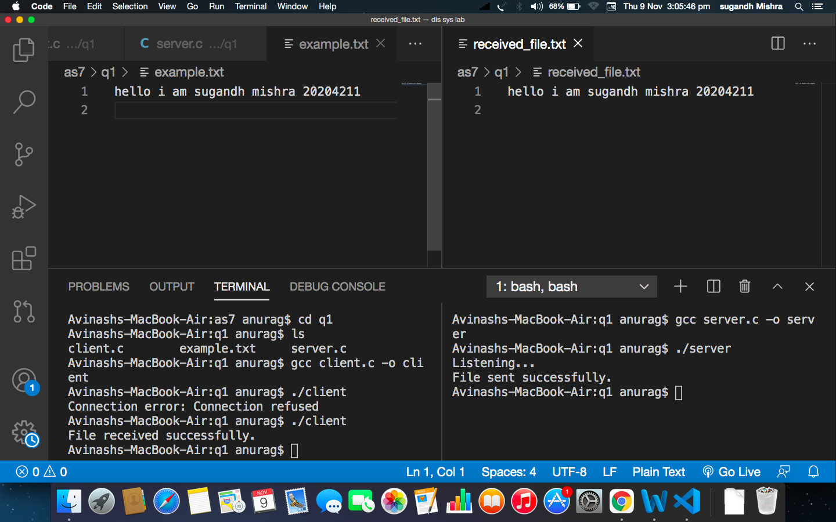

ii) Implement ‘Java RMI’ mechanism for accessing methods of remote systems.

Server.c---

#include <stdio.h>

#include <stdlib.h>

#include <string.h>

#include <unistd.h>

#include <netinet/in.h>

int add(int a, int b) {

return a + b;

}

int main() {

int server_socket, client_socket;

struct sockaddr_in server_addr, client_addr;

socklen_t addr_size;

server_socket = socket(AF_INET, SOCK_STREAM, 0);

if (server_socket < 0) {

perror("Socket creation error");

exit(1);

}

server_addr.sin_family = AF_INET;

server_addr.sin_port = htons(12345);

server_addr.sin_addr.s_addr = INADDR_ANY;

if (bind(server_socket, (struct sockaddr*)&server_addr, sizeof(server_addr)) < 0) {

perror("Binding error");

exit(1);

}

if (listen(server_socket, 10) == 0) {

printf("Listening...\n");

} else {

perror("Listening error");

exit(1);

}

addr_size = sizeof(client_addr);

client_socket = accept(server_socket, (struct sockaddr*)&client_addr, &addr_size);

int a, b, result;

recv(client_socket, &a, sizeof(a), 0);

recv(client_socket, &b, sizeof(b), 0);

result = add(a, b);

send(client_socket, &result, sizeof(result), 0);

close(client_socket);

close(server_socket);

return 0;

}

client.c-----

#include <stdio.h>

#include <stdlib.h>

#include <string.h>

#include <unistd.h>

#include <netinet/in.h>

int main() {

int client_socket;

struct sockaddr_in server_addr;

client_socket = socket(AF_INET, SOCK_STREAM, 0);

if (client_socket < 0) {

perror("Socket creation error");

exit(1);

}

server_addr.sin_family = AF_INET;

server_addr.sin_port = htons(12345);

server_addr.sin_addr.s_addr = INADDR_ANY;

if (connect(client_socket, (struct sockaddr*)&server_addr, sizeof(server_addr)) < 0) {

perror("Connection error");

exit(1);

}

int a = 5, b = 3, result;

send(client_socket, &a, sizeof(a), 0);

send(client_socket, &b, sizeof(b), 0);

recv(client_socket, &result, sizeof(result), 0);

printf("Result: %d\n", result);

close(client_socket);

return 0;

}

