**Product Name: Tablo:** Restaurant Tables Reservation

**Product Version:**1.0

**Product Phase:**Ready to release

**Current Date:**2021-06-14

**Product Overview**

This product is a revolution in the HoReCa industry, which appeared to solve many problems.

First of all, it is an outdated system of booking tables through phone calls. In the era of digital technology, this is considered archaism and it is time to create a replacement to make the process more user-friendly. In addition, this service will allow you to create an eco-system within individual establishments, which will allow integrating web services for not only booking tables, but also ordering food and paying.

**Product Objectives 🎯**

Our product allows users to choose a suitable institution for themselves, by address, reviews, menu and available tables online.

To do this, you no longer need to connect the work of operators, because the whole process will be transferred to a web service with a clear and pleasant user interface.

**Table of Contents ⚓**

**Product Feature/Element 1 ✔️**

The first function of our service is to select an establishment, right on the map of your area. To do this, we have integrated api, the most popular address directory among residents - 2gis. Thanks to this, every user will be able to use this function, since the interface is already recognizable for everyone.

Places indicated on the map immediately provide a rating from users to make it easier for you to make your choice.

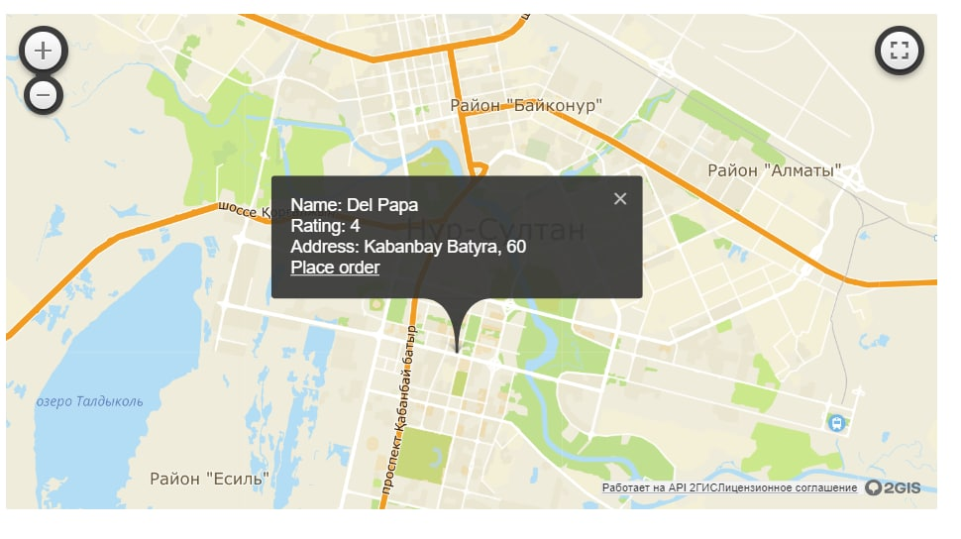

**Product Feature/Element 2 ✔️**

The next important function is the ability to view the layout of the tables in the institution you are interested in, the number of seats and the available time for booking.

An interactive seating map, together with schematic table icons, will give you a complete picture of what is happening to get the full experience of choosing the table that is right for you.

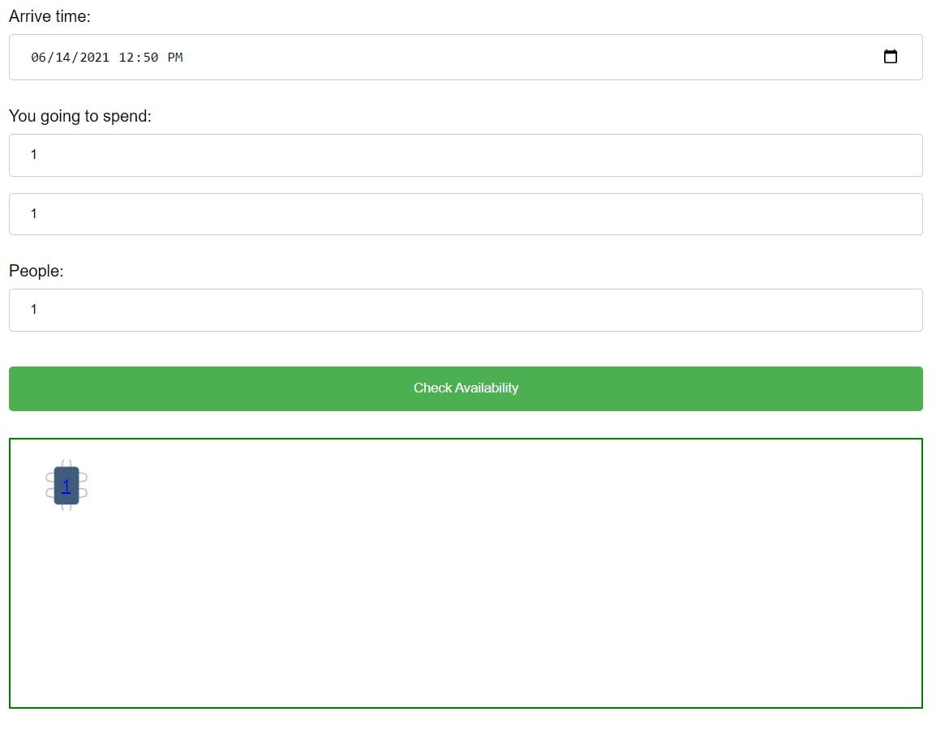

**Product Feature/Element 3 ✔️**

The function of pre-ordering dishes is also available for our users.

A full menu of all positions of the establishment will be available on the screen, with a detailed description, so that each guest can choose what he wants and that his order will be ready for his arrival.

Thus, we provide not only the convenience of using our service, but also save your time.

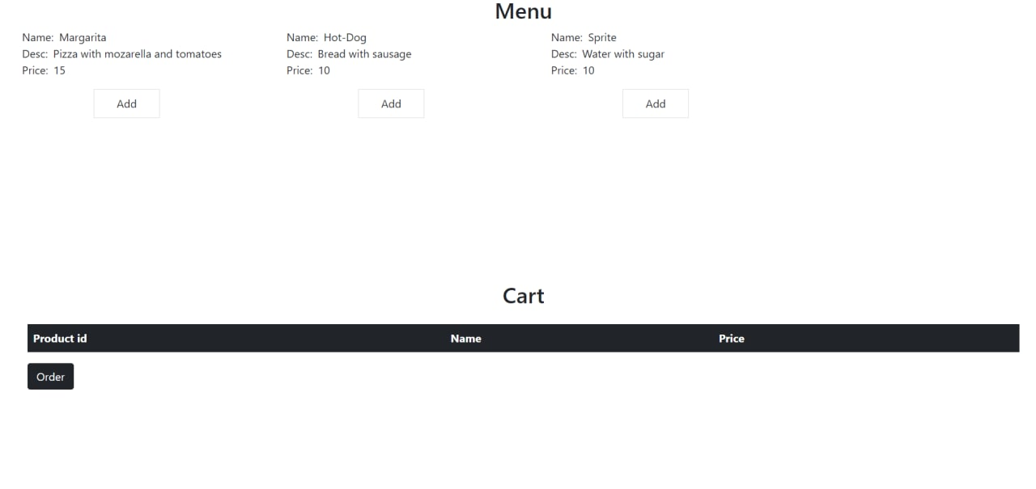

**Product Feature/Element 4 ✔️**

Last but not least, it is the ability to manage all user data. In their profile, each guest can find a list of orders and reservations that have taken place recently.

This is very convenient, since this information can be useful in some circumstances, because we store all operations in a secure database.

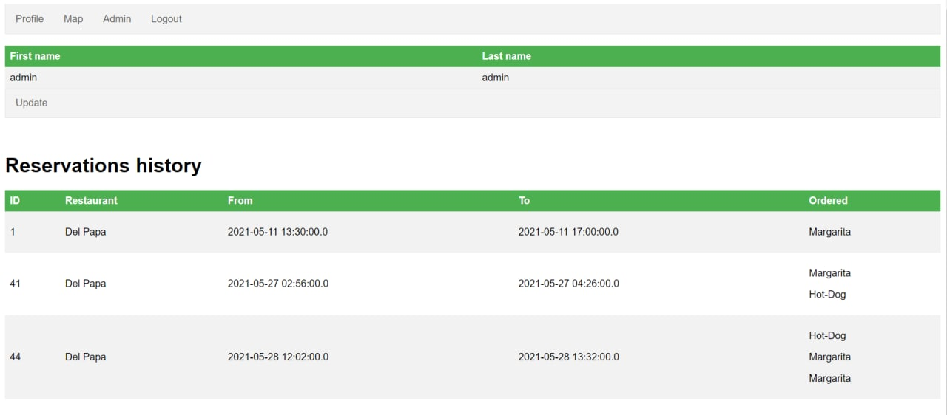

**Frequently Asked Questions (FAQs) 🙋🏽‍♂️**

- What technologies do you use in your product?

- We have quite simple, but strong enough stack of technologies, such as Spring Security with roles and authorities for managing users activity, MySQL database with Hibernate for handling all data we process, Thymeleaf to display your essential information on our precious interfaces and 2GIS API with RESTful requests for map interaction. For programming language, we use Java, as it covers all of other requirements.

- What kind of information do you store in database?

- To answer this question we can provide our ERD diagram

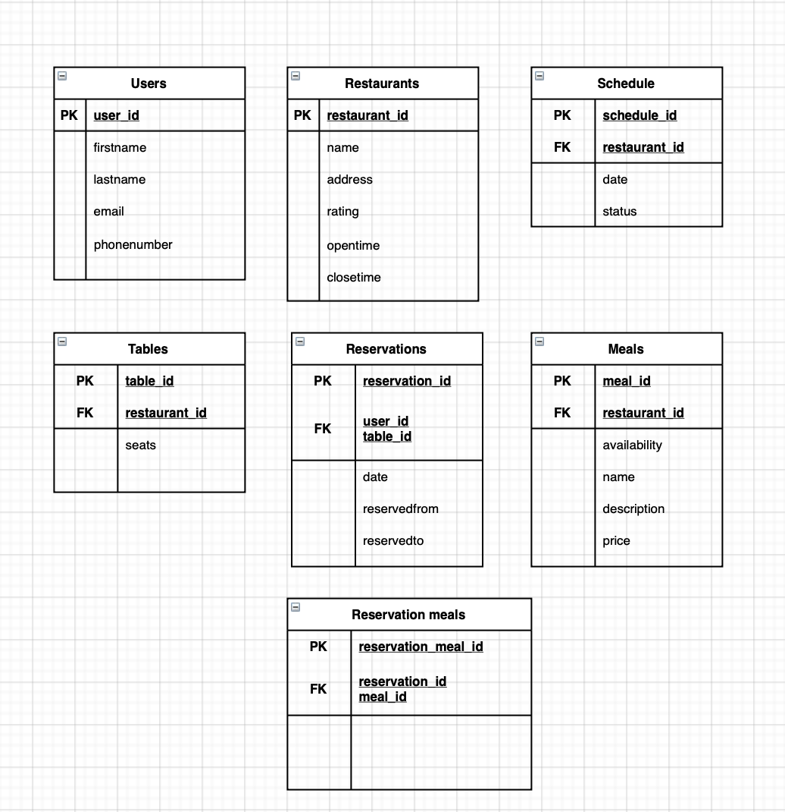

### Additional Resources 👩🏼‍💻

### To get familiar with our code you can visit our GitHub repository: https://github.com/zhaxal/restaurant-app

**Technical Support Contact Information 💬**

In order to get more information, you can always contact developers via Telegram:

@zhaxal

@Danishpan