**User guide**

**Tablo: Restaurant Tables Reservation**

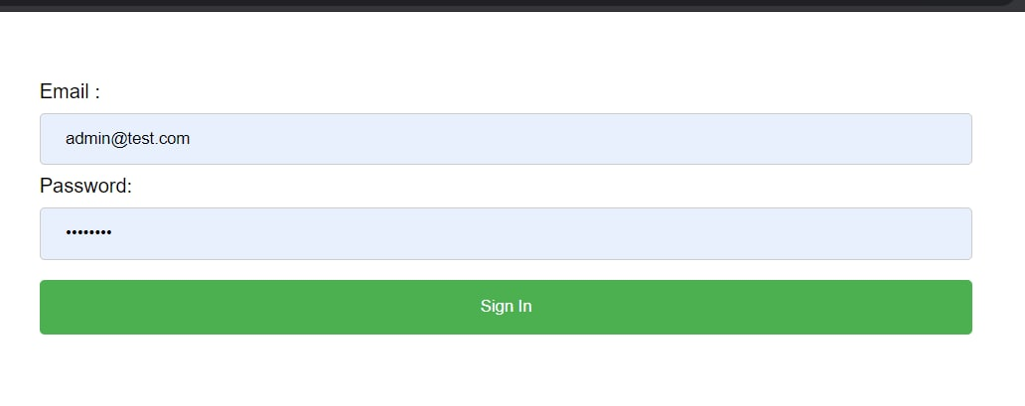

1. First of all, you need to sign in into our system to get access to all the functionality it has

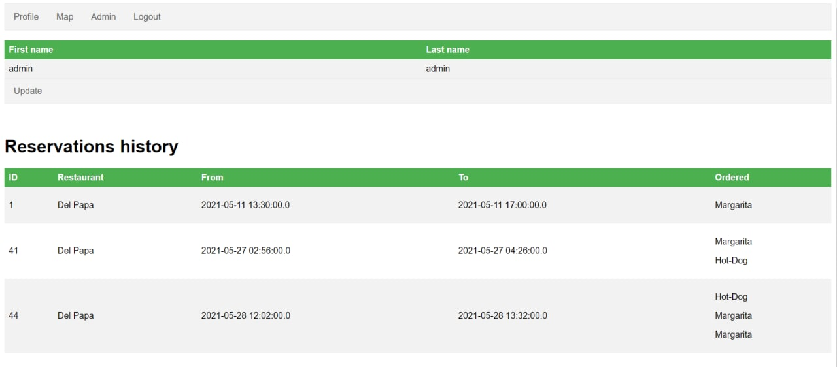

1. Then you will have access to all the pages and the first one is profile page, where you can find your user information, and also history of reservation, including restaurant visited, date and optional orders.

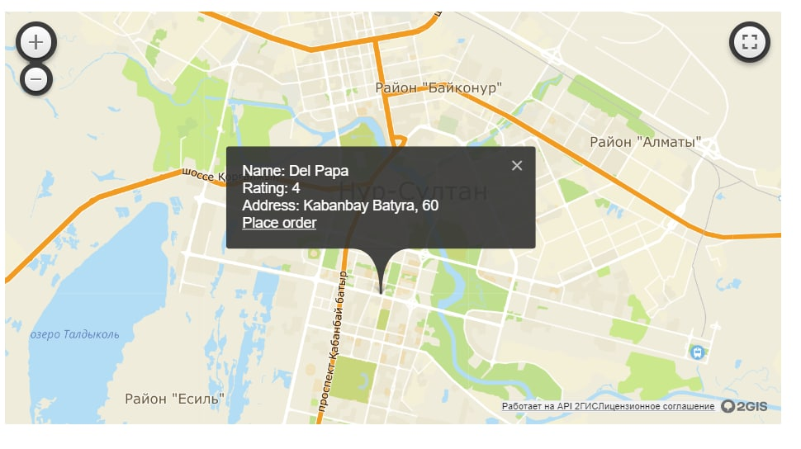

1. In Map page, you can find 2GIS map, where you can find all the restaurants, supported in our system and here we can get rating of this place and also place order.

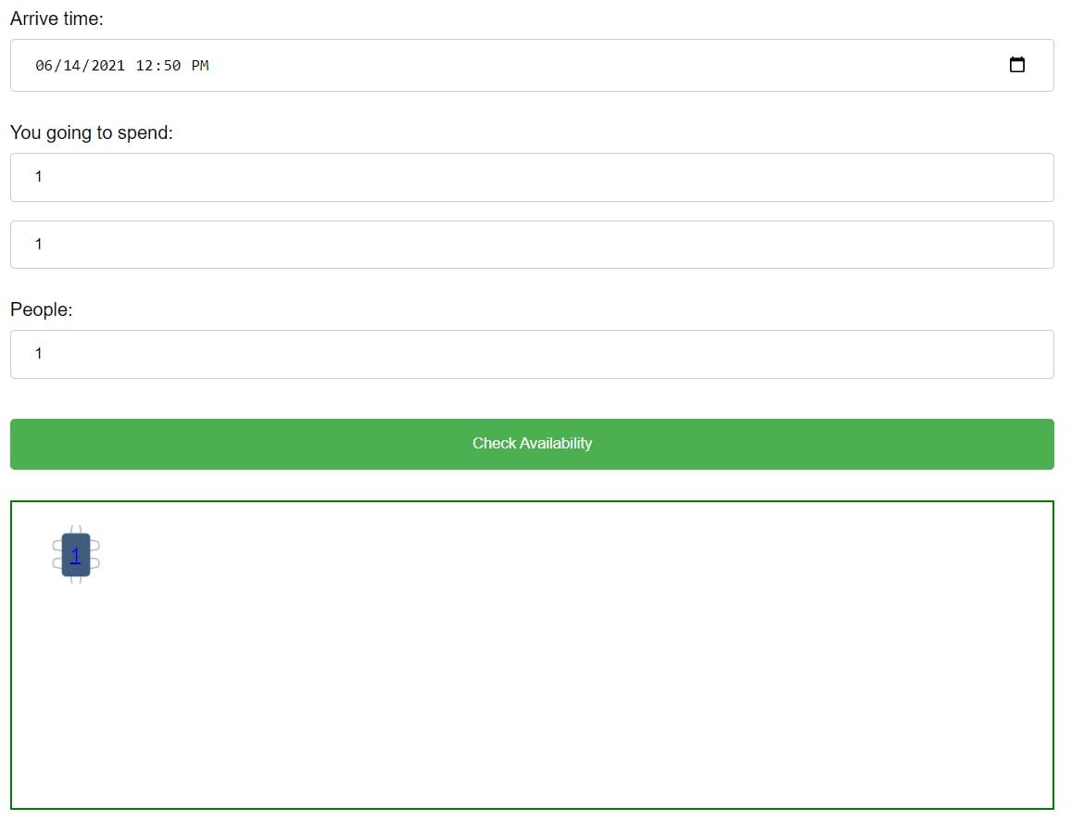

1. In Place an order page, we ability to choose arrival time and number of people to check for availability of tables. Also you could choose among all the tables available in schematic representation.

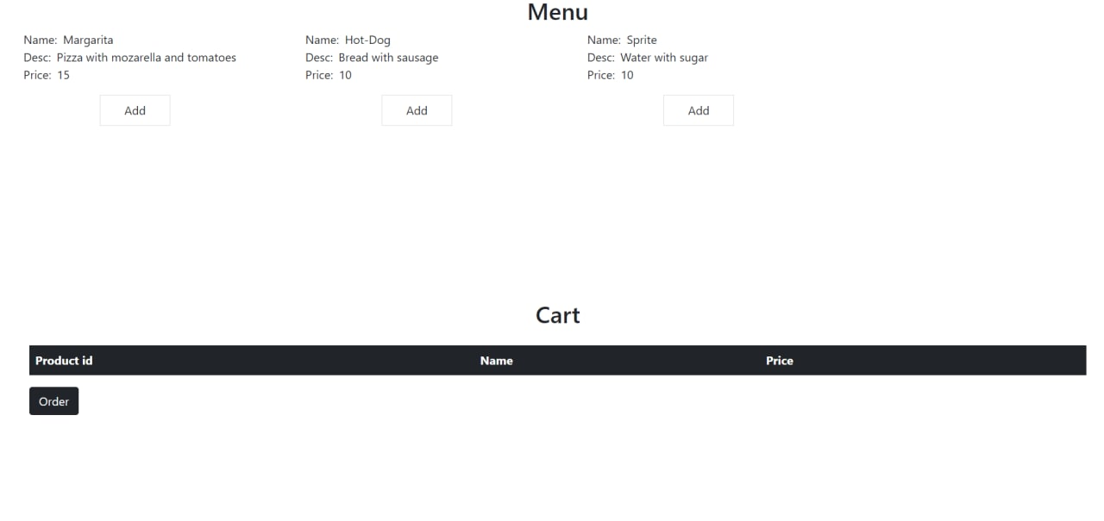

1. At the last page, we may find the addition function of adding meals to pre-order from all available positions in menu and place order.