

本科毕业设计（论文）外文翻译

论文题目： 基于Moodle的程序设计教学

Programming Education Based on Moodle

学 生 姓 名： 陈 强 学 号： 0707080602104
二级学院名称： 新媒体学院 专 业：信息管理与信息系统
指 导 教 师： 张 浩 斌 职 称： 讲师

填表日期：2010 年 12 月 25日
浙 江 传 媒 学 院 教 务 处 制
第一篇：
所译外文资料：
- 作者：Klaus Brandl ,University of Washington
- 书名（或论文题目）: ARE UPI READU FPR ‘MOODLE’?
- 出版社：Language Learning & Technology
- 出版时间（或卷期号）：May 2005,Volume 9,Number 2
- 所译起止页码：ALL
外文原文：
ARE YOU READY TO "MOODLE"?

INTRODUCTION
With the rapidly increasing popularity of the Internet in recent years, the delivery of learning programs has gradually shifted from local desktop to online-based applications. While the XML programming environment has evolved as the new standard for the Internet, building customized learning programs requires the use of authoring systems such as Macromedia Director, Authorware, Dreamweaver, Flash, and Microsoft Frontpage (for a detailed review see Godwin-Jones, 2003), which places high demands on design, programming skills, and time. An alternative to using such applications is the deployment of course or learning management systems. One such system that has been gradually gaining worldwide
popularity is known as Moodle (http://www.moodle.com).

What is Moodle?
Moodle is a course management system for online learning. The acronym MOODLE stands for Modular Object-Oriented Dynamic Learning Environment. Among its many users, however, Moodle has already become a term of its own synonymous with a software package designed to help educators create quality online instruction. It was the brainchild of Martin Dougiamas (http://dougiamas.com), a former WebCT administrator with postgraduate degrees in Computer Science and Education. The design of Moodle is based on socio-constructivist pedagogy. This means its goal is to provide a set of tools that support an inquiry-and discovery-based approach to online learning. Furthermore, it purports to create an environment that allows for collaborative interaction among students as a standalone or in addition to conventional classroom instruction.
One of the advantages of Moodle is that it has been developed as an OpenSource software project. It is entirely supported by a team of programmers and by the user community. This also means that Moodle is available free of charge under the terms of the General Public License (GNU) and has no licensing cost attached. As such, it is accessible to anybody in contrast to commercial software such as Blackboard (http://www.blackboard.com) and WebCT (http://www.webct.com), whose licensing fees have skyrocketed in recent years.

Deployment and Technical Background
Moodle runs without modification on Unix, Linux, Windows, Mac OS X, NetWare, and any other system that supports PHP (HTML-embedded scripting language), including most Web host providers. Data is stored in a single database: MySQL and PostgreSQL are best supported, but it can also be used with Oracle, IBM DB2, Microsoft SQL Server, Borland Interbase, Informix, Visual Foxpro, SAP DB, SQLite, Sybase, Microsoft Access, ADO, and generic ODBC database access, since it uses ADOdb (http://www.adodb.sourceforge.net).

MOODLE AND LANGUAGE LEARNING
Since the development of communicative skills in language learning requires social interaction between the teacher and the students and among the students themselves, the use of computers has for a long time been regarded only as a support tool with regard to certain skill areas. Rapid advances in technology (e.g., fast Internet connections, ample storage capacities, increase in bandwidth) and more compatible cross-platform applications now make the implementation of synchronous and asynchronous learning tasks, in oral and written modes, feasible from a pragmatic point of view (see Cziko & Park, 2003, for a review of computer-mediated audio communication [SCMAC] software). Furthermore, a growing body of research is gradually emerging that provides concrete suggestions on how to exploit instructional online tools effectively or how to integrate the Internet for different language learning goals (Brandl, 2002; González-Lloret, 2003). As a courseware package and learning system, Moodle has great potential for supporting conventional classroom instruction, for example, to do additional work outside of class, to become the delivery system for blended (or hybrid) course formats, or even to be used as a standalone e-learning platform.
In the following section, I will provide an overview of Moodle features and point out those that are in particular useful for language learning. In addition, I will present some sample learning tasks and describe their implementation within a Moodle environment.

Layout and Organization
Moodle is a template-based system to which content must be is added. This makes Moodle's interface very intuitive and allows for easy navigation. The whole page is presented in a "flat view" format. It is laid out in small blocks and organized around sections following a topic or weekly outline. As Robb (2004) describes it, this is different from other systems that often make use of "Chinese boxes" with content inside folders at various levels. Each section has its own tools such as lessons, quizzes, assignments, and forums which are all linked to a built-in gradebook (see section on assessment below). All blocks on a page can be individually arranged, and the elements within each section can be easily moved around or be hidden. Figure 1 shows an example of a course setup in the topic format.
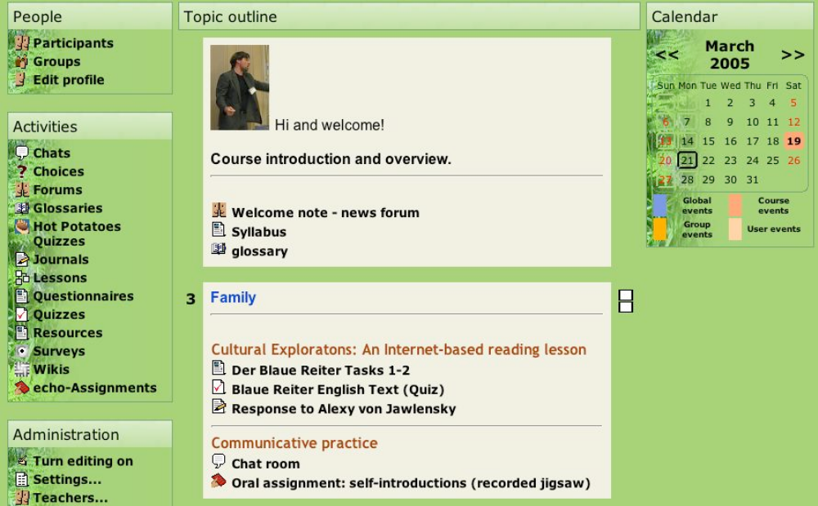
Figure 1. Sample of a course setup in the topic format

Course Management
Moodle is a teacher's dream in terms of course management features that it offers. Access to nearly all lesson assignments can be made time-or password-restricted, however, only quizzes can be password restricted at this point. Moodle also keeps automatic log reports of each student work (see Figure 2 for an example). This means that the teacher knows not only when students have completed or uploaded an assignment, but also how much time they spent on an assigned task or quiz. The teacher can also set deadlines or timeframes when assignments must be completed, and restrict access to learning tasks once the deadline has passed. Students can look up their grades themselves. Teachers have also the option to download student grades in Excel format. Students can look up the assignments on a calendar by moving the cursor over a given day which will list all the assignments for that day. The calendar is optional and can be displayed on the front page.
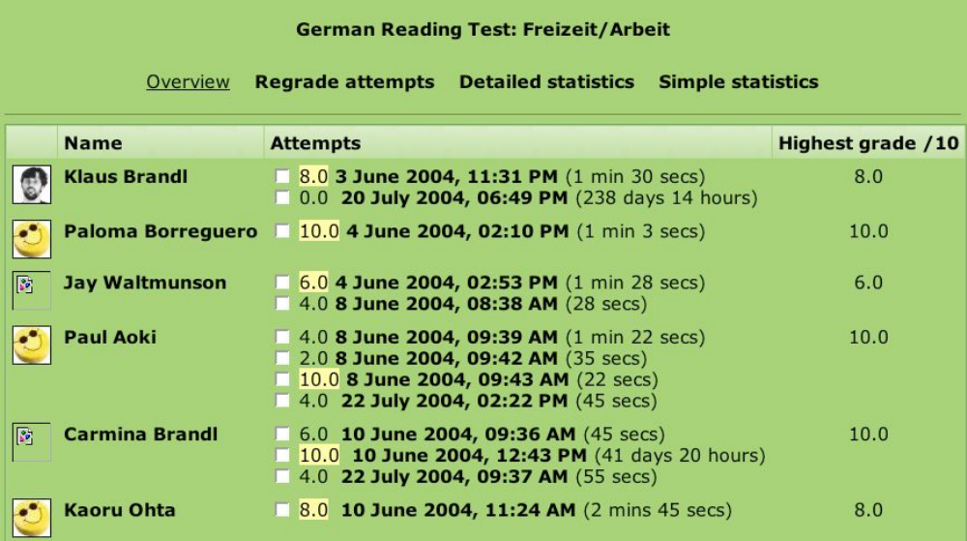
Figure 2. Sample log report of students' work

Content and Resources
Moodle allows for the integration of a wide range of resources. These include any kind of text-based or html-formatted documents, multimedia resources such as graphics, video or audio (e.g., MP3 files), SCORMs (Goodwin-Jones, 2004), PowerPoint, Half-Baked exercises (http://www.halfbakedsoftware.com), or Flash-based applications. Lesson tasks within Moodle can be linked to any resources that are uploaded to one's server or that are available on the Internet. The students' exploration of any of the content-based resources can be easily assessed by using any of the Moodlebased evaluation and feedback tools (see Example 1).
Moodle is quite powerful in content creation due to its built-in HTML editor. The degree of expertise required is essentially the same as for any word processor. More sophisticated presentations such as animations or text-specific feedback provisions need to be created by using outside multimedia authoring programs.
Moodle also has a built-in glossary module. This allows teachers, individually or in cooperation with their students, to create their own text-, course-, or site-specific dictionaries. In this way, texts integrated within Moodle, especially authentic texts or resources, can be tailored to a particular level of language proficiency and thus be made more easily accessible to learners.

Assessment and Testing Strategies
Moodle allows for a wide range of assessment strategies. The quiz module includes the following response types: fill-ins, multiple-choice, multi-choice (more than one answer can be selected), true-false, matching, short-answer (exact matching). All types are supported with automatic tallying and scoring, based on teacher or student-determined rating scales. The essay module allows open-ended questions with built-in comment boxes for instructors to provide feedback. Particularly noteworthy is the workshop module, which is designed on the basis of peer assessment. All of these assessment types can be made time and password restricted, and can be set to allow for limited or multiple retakes.

Learning Management
Moodle is also a learning management system (LMS). LMSs differ from exclusive course management systems because they allow to present information to learners in small units, assess what they have learned, and based on the quality of their achievement branch out into additional review of material or move to the next level. In other words, the lesson module allows to design lessons that closely control the learning path guiding learners step-by-step, and allowing for advancement only if sufficient mastery has been achieved.

Student-Based and Cooperative Learning
Moodle's design is grounded in a socio-constructivist theory of learning. Learning tasks or projects can be designed so as to allow for cooperation between the instructor and students or among students by using different formats of social interaction. Students can be divided into subgroups, interact with each other synchronously in chat rooms, or engage in asynchronous discussions in Wikis1 and forums (see Example 2). The Wiki module in Moodle enables students to compose or work together on a text while online. Old versions are never deleted and can be restored. Forums can also be arranged in different ways. For example, they can be set so that only the teacher or any of the students can post content to a forum or start a new discussion topic (thread). Other options exist that let the teacher either restrict or allow for further discussions and replies within a thread.

Feedback
Students who participate in e-learning environments often complain about the lack of feedback that is available in conventional classroom settings (Brandl, 2004). In Moodle, almost all modules are designed to allow teachers or course participants to provide feedback in qualitative or quantitative form. For example, both the journal and assignment module give the instructor the option to provide their comments in a feedback box (see Figure 4). The assignment module, which is designed so that students can upload their assignments in any file format to the server, also allows the instructor to upload comments about the student's work in form of text-or audio-based (e.g., MP3) files. Feedback can be teacher-restricted or made accessible to all participants in both forums.
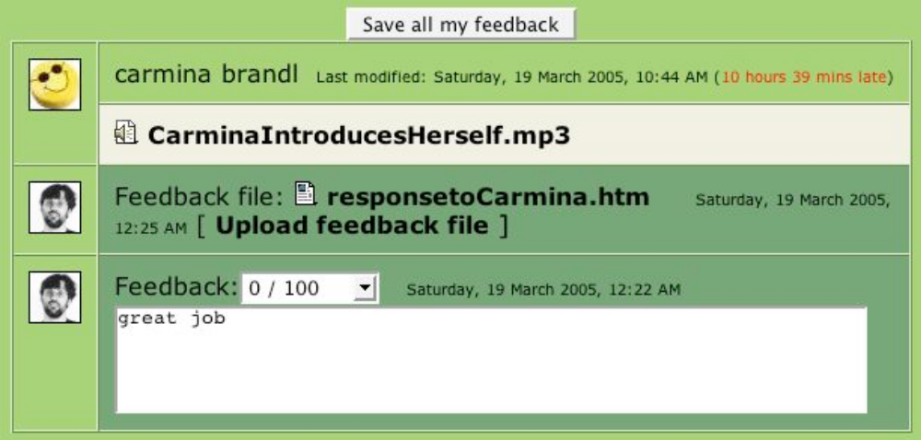
Figure 4. Example of a feedback box

Additional Modules
Numerous additional features and modules facilitate course management and the learning process. For example, Moodle has several built-in standardized questionnaires that allow teachers to collect qualitative and quantitative feedback on students' learning experiences. A questionnaire module allows teachers to create their own questionnaires.

SAMPLE LEARNING TASKS CREATED WITH MOODLE TOOLS
The following section presents several examples of learning tasks. Example 1 demonstrates the
integration of the quiz module with an authentic Internet-based cultural resource used in a second-quarter German class at the University of Washington, Seattle. Examples 2 and 3 represent examples of asynchronous and cooperative learning tasks that can be used in any intermediate language class. The latter two examples, in particular, demonstrate how Moodle allows for the implementation of a socioconstructivist approach to language learning.
Example 1
Theme/context: Der Blaue Reiter (name of a group of German artists)
Task: exploring cultural information
Skills: interpretive (reading) and presentational (writing)
Level/language: low intermediate/German
Modules: journal module, resource module
In this learning task, the students are asked to explore a member of the "Der Blaue Reiter" group of their choice. In particular, they are asked to collect detailed information about the writer's life from a Webbased resource and write about it in English in the journal module (see Figure 5).
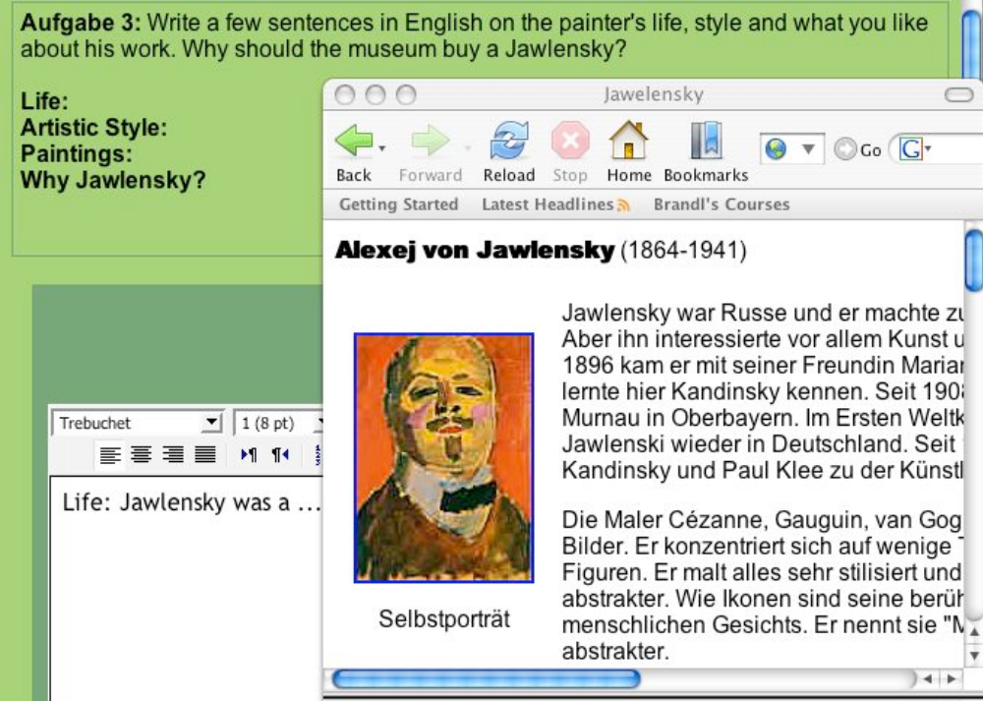
Figure 5. Sample of a journal module learning task based on an Internet resource
Example 2
Theme/context: Use of media
Task: establishing the sequence of a picture story in four acts
Skills: interpretive (reading) and presentational (writing)
Level/language: low intermediate (level may vary dependent on the complexity of picture story and the target language)
Modules: lesson module, forum module, quiz module
The goal of this learning task is to find the correct sequence of a picture story (see Figure 6). Students are divided into groups of four. Each group is asked to describe one component (picture) of the story. The lesson consists of the following steps:
- Students access pictures through the lesson module. Each student can look up only one picture, whose access is password protected.
- Working individually, students describe one picture and post their answers to the forum.
- As soon as a description of each of the four pictures of the story has been posted, students are asked to read the picture descriptions in the forum and establish the correct sequence of pictures.
- Students take a multiple choice quiz to check their answers.
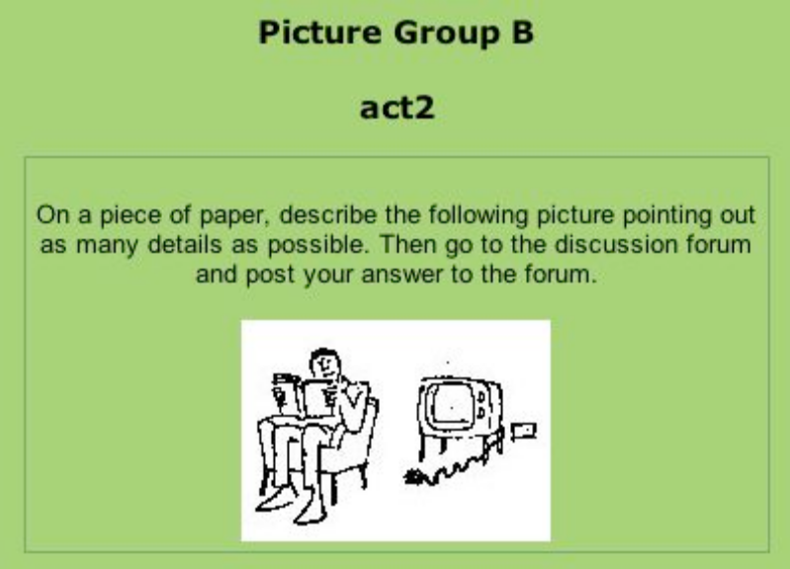
Figure 6. Sample of an asynchronous learning task --describing a picture story
Example 3
Theme/context: Family
Task: Finding out commonalities
Skills: interpretive (listening) and presentational (speaking)
Level/language: low intermediate
Modules: Assignment module, forum module
In this task, students are asked to find commonalities about their family structures.
- Students are asked to briefly describe their families based on questions such as how many brothers and sisters they have, how old they are, what they do, what their names are. To do this, students record their answers with Audacity (http://audacity.sourceforge.net/), an open-source recorder, save their answers as MP3 files, and upload them through the assignment module.
- Working in groups, students listen to each others' descriptions.
- Students report their findings to the teacher through the essay module.

CONCLUSION
In the beginning, I asked what Moodle is. I would like to conclude by commenting on what Moodle is not. It is not a panacea for language learning. It is a course management and delivery system. As such, Moodle has great potential to create a successful e-learning experience by providing a plethora of excellent tools that can be used to enhance conventional classroom instruction, in hybrid courses, or any distance learning arrangements. In whatever form of instruction Moodle is used, the design of the learning tasks must be grounded in theories of second language acquisition.
To find out additional information about Moodle, how to download and install it, go to the official Moodle site at http://moodle.org.
外文翻译：
为迎接MOODLE准备好了吗？
- 简介：
随着近几年互联网的迅速发展，学习管理系统的使用方式已经从桌面应用走向在线应用。尽管基于XML的编程方式已经逐渐演化为互联网的标准，然而制作定制化学习课程仍然需要掌握Macromedia,Authoreware,Dreamweaver,Flash和Microsoft Frontpage等软件（详情见Godwin-Jons,2003）的使用方法,这些软件要求作者掌握较高的视觉设计和编程技术并且都学习也很费时。另外一种替代方案是通过部署学习管理系统来实现，这类系统，如MOODLE就逐渐走近大家的视野。
- MOODLE是什么：
MOODLE是一套在线学习的管理系统。缩略词MOODLE代表Standard Modular Object-Oriented Dynamic Learning Enviroment. 在众多的MOODLE使用者之中，MOODLE已经被赋予了自己独特的语义，即一种被设计用来帮助教育者创建高质量在线教学软件的套件。它的作者是Martin Dougiamas(http://dougiamas.com)，一位前WEBCT 的理科硕士管理员，moodle则是他的思想结晶。Moodle的设计依据的是教育学之中的社会构建学。这意味着moodle的目标是提供一套工具来支持基于询问和发现的在线学习方式。另外，moodle称将打造允许学生协作和互动的独立平台或者说有别于传统教室教学的一个新的环境。
MOODLE的一个优势在于它是的开发体系是基于开源架构。它完全由开发者和使用者社区提供支持。这也意味着Moodle可以在公用许可证(GNU)许可范围之内免费使用，即无许可费。因此，相对于黑板报（http://www.blackboard.com）和WEBCT(http://www.webct.com)这些近些年价格猛涨的商用软件，每个人都可以方便免费获取Moodle。
- 部署和技术背景：
Moodle可以无缝在诸如UNIX,Linux,Windows,Mac OS,NetWare等支持PHP(一种基于html的脚本语言)的不同系统平台和几乎所有WEB主机提供商之中运行。数据存储在数据库之中：完美支持MySQL和PostgreSQL数据库，但也能够在Oracle，IBM DB2，Microsoft SQL Server，Boerland Interbase，Informix，Visual Foxpro，SAPDB,SQLite，Sybase，Microsoft Access，ADO等数据库中运行，并且由于使用ADOdb，moodle原生支持ODBC的数据库方式访问。
- MOODLE 和 语言学习
由于语言学习中交流技巧的提升需要学生和老师、学生自身之间的互动，因此在很长一段时间内，语言教学中，计算机仅仅被当做一种某些方面的辅助工具。然而技术进步（例如，更快的网络互联，充足的存储空间和网络带宽的增加）和更多跨平台应用，使得现在可以被用来实施同步和非同步的学习任务，口语和写作等模块，而且从实际的一个角度（参阅Cziko&Park,2003,纵观计算机媒体的通信软件）来看这些都是可行的。除此之外，一个持续增长的研究群体正在逐渐出现，他们对如何开发有效的在线教育工具或者对如何让互联网与不同语言学习目标集成（Brandl,2002;Gonzalez-Lloret,2003）提出了完整的建设性意见。作为一种课程套件和学习系统，Moodle非常具有潜力来支撑传统课堂教学，比如，完成课下功课，混合式课程中用作作业提交系统，甚至还可以被用作独立的在线学习平台。
在后面的部分，我将提供一份关于MOODLE特色的概述并且指出这些特色对于语言学习的特别作用。除此之外，我讲演示一些学习任务样例并且阐述他们在Moodle环境下的是如何实施的。
- 布局和组织
Moodle 是一个基于模板的系统，这意味着必须添加内容才能使其具有意义。这使得Moodle的界面非常直观并且允许设定简便的导航。整个页面用一种“扁平的视角”来展现。它是由小区块进行布局并且在分区之间通过话题或者周报的形式进行内容组织。引用Robb（2004）的描述，“这种方式区别于其他使用像‘中国盒子’那样在不同层级文件夹放内容的组织形式”。每个分区具有它自己的工具，诸如课程、测验、作业和论坛，这些都被链接到内置的学期表中（见下面）。页面的所有部分都可以被单独安排，每个部分的元素又可以被简单的移动或隐藏。图1是基于话题格式的课程搭建样例。
图1：基于话题格式的课程搭建样例
- 课程管理
Moodle所提供的课程管理是教师的最喜欢的一个特色。所有的课程作业几乎可以基于时间或密码限制的形式访问到，不过当前只有测验模块提供密码限制。Moodle同时会自动记录每个学生的活动（参照图2样例）。这意味着教师不仅仅知道学生何时完成并上交作业，而且可以知道他们花费多长时间来完成作业或测验。老师也可以为作业设置截止日期，并且截止日期之后好拒绝访问学习作业。学生们可以通过鼠标在日历上移动来查看作业情况，这将列出当天的所有作业任务。日历是可选的并且可以被展示在首页。
图2：学生活动日志记录样例
- 内容和资源
Moodle允许广泛的资源集成。这包括任何基于文本或html格式的文档，图像、视频或音频（如mp3）类的多媒体资源，SCORMs（Goodwin-Jones，2004），PowerPoint，Half-Baked练习(http://www.halfbakedsoftware.com). Moodle创建的课程任务可以被链接到上传的服务器资源或其他互联网资源。学们可以利用基于Moodle的评价与反馈工具（见例子1）方便的浏览任何基于内容的资源。
Moodle由于内建的HTML编辑器使得具有强大的内容创建功能。只需拥有操纵任何文字处理工具的技能水平就可以使用Moodle。更复杂的演示，如动画或特别字体的反馈支持需要使用其他的多媒体创作程序。
Moodle具有内建的词汇表模块。这使得教师，特别是教师与学生协作创建基于文本或课程或站点的词典提供了可能。这样，Moodle中集成的文本，特别是权威文本和资源将被提取成语言精要的级别，这样将被学习者更方便获取。
- 评价和测验方法
Moodle具有广泛形式的评价方法。测验模块包括如下反馈类型：填空，单选，多选，判断，匹配，简单。所有类型都自动支持积分功能，他们基于教师或学生自定义的评定设置。论文模块允许开放式问题并且内建评论框用于教学反馈。特别值得注意的是专题讨论会，它是基于对等评价理念而设计的。所有这些评价类型都可以用时间或密码进行约束，也可以进行人数限制或者多次利用。
- 学习管理系统
Moodle也是一个学习管理系统（LMS）。LMS不同于专用课程管理系统因为他们允许为学习者提供小单元的模块的信息展示，评估学生的学习进度，并且根据所学知识程度展现额外学习材料并进入下一等级进行学习。换句话说，学习模块允许对课程进行设计，以便控制学习曲线来指导学习者一步步学习，当熟练掌握基础知识后还提供更高级别知识的学习。
- 基于学生的共同学习
Moodle是基于社会构建理论的一种学习。可以设计学习任务或项目以便允许教师和学生或学生之间通过不同形式的社区交互进行学习。学生可以被分为不同小组，在聊天室中进行同步交流，或参与论坛(将例子2)或维基的非同步讨论。Moodle中的维基模块使得学生能够在线一起进行基于文本的创作或工作。旧的版本永远不会被删除或被恢复。论坛可以用几种方式去使用，例如，他们可以被设置成只有教师或任何学生可以发内容到论坛或开始一个新话题。也可以通过其他选项允许或限制教师对话题讨论和回复的深度。
- 反馈
参与在线学习环境的学生总是抱怨e-learning缺乏传统教室教学的反馈性（Brandl，2004）。在Moodle中，几乎任何模块都被设计成允许教师或课程参与者进行定性或定量形式的反馈。例如，日志和作业模块都为教学提供了评论的反馈框选项（见图4）。作业模块被设计成可以上传任何作业格式的文件，并且允许教学者上传关于学生工作的文本或音频文件评价。论坛中，学生或教师都可以被限制访问。
图4：反馈框事例
- 扩展模块
大量的扩展特色或模块方便了课程管理和学习过程。例如，Moodle具有内建的几个标准问卷允许教师定性或定量收集基于学生学习体验的反馈。问卷模块也可以允许教师创建自己的问卷。
- 使用Moodle工具创建的学习任务示例
下一节展示学习任务的几个例子。例子1展示了在华盛顿大学，西雅图大学中，将测验模块与在德国一半学生使用的基于互联网的文化资源结合的一个例子。例子2,3展示了异步合作学习任务可以被用于任何中等语言课堂。后两个例子，特别展示了Moodle如何支持基于社会构建学进行语言学习。
范例一：
主题/上下文： Der Blaue Reiter(一组德国艺术家的名字)
任务： 探索文化信息
技能： 解释性（阅读）和表象性（写作）
等级/语言： 中低等级/德语
模块： 日志模块，资源模块
在这个学习任务中，学生们被要求去探索‘Der Blaue Reiter’小组的一位成员。特别的是，他们被要求根据网络资源收集关于作者生平的细节信息，并且要在日志模块中用英语写下来。
图5：基于网络资源的日志学习模块
范例二：
主题/上下文： 使用媒体
任务： 四步建立图片故事序列
技能： 解释性（阅读）和表象性（写作）
等级/语言： 低等级（一个可能依赖故事和目标语言复杂度而变化的等级）
模块： 课堂模块，论坛模块，测验模块
这项学习任务的目标是发现一个图片故事的序列（见图6）。学生们被分作4组。每组被要求去描述故事的一个部分（图片）。课堂包括如下步骤。
- 学生通过课程模块接触图片。每名学生只能查看一幅图片，并且他们的图片是被密码保护的。
- 独立学习，学生们描述一幅图片，并将答案发布到论坛之中。
- 一旦四副图片的故事描述被发布之后，学生们被要求在论坛中阅读图片中的描述并建立正确的图片序列。
- 学生们通过多选测验去检测他们的答案。
图6：异步学习模块的样例学习。
- 范例三：
主题/上下文： 家庭
任务： 发现共同特征
技能： 解释性（阅读）和表象性（写作）
等级/语言： 低等级
模块： 指派模块，论坛模块
在这个任务之中，学生们被要求去发现他们家庭结构的共同特征
- 学生们被要求根据问题来简要描述他们的家庭，这些问题包括他们有几个姐妹兄弟，他们都多大，他们的工作，他们的名字。为了完成这个工作，学生们利用Audacity(http:// audacity.sourceforge.net/)一个开源录音软件将他们的结果保存成MP3文件，并上传到他们的指派模块之中。
- 按组学习，学生们倾听每个人的描述。
- 学生通过论文模块发表他们的发现。
- 总结
开始时，我问Moodle是什么。我更愿意用Moodle不是什么作为评论来作总结。它不是语言学习的百灵药。它是一个课程和递送系统。因此，Moodle通过提供大量有用的工具具有非常大的潜能来创建一个成功的用户体验的在线学习，用以增强传统教室教学，用在混合课程或任何远程教学安排中。不管使用任何Moodle教学形式，学习任务必须紧紧以第二语言需求为着力点进行设计。
第二篇：
所译外文资料：
- 作者：Michael Churchward，Jonathan Moore
- 书名（或论文题目）：Moodle1.9 Extension Development
- 出版社（或刊物名称或可获得地址）：Packt Publishing
- 出版时间（或卷期号）：April 2010
- 所译起止页码：P7，P31，P89，P107，P263
外文原文：
Moodle1.9 Extension Development

Preface
Moodle has evolved into one of the most widely-used Learning Management Systems in the world, with over 35,000 installed sites and 25 million users. Much of its popularity is due to its ability to be extended by developers, by using its open source architecture. Understanding how to develop on the Moodle platform provides an organization using Moodle the flexibility to expand its functions.
This book will teach you the inner workings of Moodle, and provide you with the ability to develop code the "Moodle way". You will learn to develop standard Moodle plugins, such as activities and blocks, by creating functioning code that you can execute in your own Moodle installation.
This book will expose you to all of the core code functions in Moodle in a progressive, understandable way. You will learn what libraries are available, what the API calls are, how Moodle is structured, and how it can be expanded beyond the plugin system.

Moodle Architecture
Moodle is an open source Learning Management System (LMS). It can be used to deliver online learning in a variety of settings. These settings include virtual schools, K12, higher education, corporate universities, charter schools, and commercial training, to name but a few. Moodle is designed to be used primarily as an asynchronous learning tool, where learners study at different times. However, it also includes synchronous tools. Moodle is used both as the primary delivery vehicle for courses as well as a supplemental tool for face-to-face learning. To put it simply, Moodle is a teacher's toolkit to help improve learning. Moodle is designed in a community with teachers interacting directly with programmers. Moodle's intuitive and simple interface is the result of this collaboration.
Moodle originally stood for Modular Object-Oriented Dynamic Learning Environment. From a programmer's perspective, the "M" in Moodle is a very important concept. Modularity is designed throughout Moodle. This lets a developer make significant modifications to Moodle without having to modify its code. This is a very important capability in terms of reducing the amount of time taken to make modifications when new versions of Moodle are released. Writing modular plugins for Moodle will be a large focus of this book.
Creating and Modifying Blocks
Moodle blocks are plugins that load in the right-hand side or left-hand side column of a Moodle site and display information to the user in a rectangular block. Each side column can have zero, one, or multiple blocks loaded. If a column contains no blocks, the column will not be displayed. This allows Moodle to support one, two, or three column page layouts. Examples of built-in Moodle blocks include: HTML content, calendars, menus, and course lists, amongst others.

Customizing the Look and Feel
There are two primary ways to change the Moodle look and feel—themes and course formats.
Moodle themes provide a way for you to change the appearance of any Moodle page. Although this is primarily done through the appropriate use of CSS (Cascading Style Sheets) definitions, we will focus on methods of importance to programmers.
Course formats provide a way of changing how a course page is displayed. This allows you to completely change the way in which a course provides its main page information.

Developer's Guide to the Database
Moodle supports a variety of SQL databases to store program information. To do that, Moodle provides powerful code libraries to let you write database-agnostic code. Moodle also enforces strict database layout design, allowing you to understand table structures easily. We will examine Moodle's database structures, policies, and libraries in order to better understand how to build our code.
Every data table in Moodle has one common element: the first field is an integer field called id. This field is a unique field that serves as the Primary Key for every table. It also serves as the Foreign Key to any other data table that contains a reference to that table.
Although this may seem excessive to some database programmers, as there are often other fields that can serve as unique references, this is a core rule to Moodle database programming that should never be broken; Moodle code depends on it! And if you use Moodle's database XML schema to validate your table, it is required.

Creating Moodle Reports
Moodle's goal is learning. One of the key requirements of organizations that are delivering learning is to be able to measure that learning. One of Moodle's great strengths is its logging of user activity in courses. Just about every click within a course is logged, along with the time, date, username, user's IP address, module accessed, and the action performed by the user. Moodle also includes a large library of built-in reports. These reports compile and analyze the log tables and other data in the Moodle database into usable information for administrators, teachers, and students. Examples of these reports include grade reports, activity reports, sitewide statistics, and system health checks, amongst others. Administrators often find that they need a custom report to get the data in exactly the format that their organization desires. Because of Moodle's excellent logging system, we normally have all of the data that we need to provide new reports that meet these needs.

Development for the Adventuresome: Web Services
Moodle currently has two popular implementations for web services: Remote-Learner Web Services library, and Moodle Networking. Remote-Learner Web Services are SOAP-based and Moodle Networking is XML-RPC-based. The SOAP library allows remote manipulation and the creation of courses, users, user enrollments, grade passing, and SSO. It is also a great example of what you might accomplish by leveraging the techniques covered in this book. The XML-RPC library provides a secure channel, SSO, and full Moodle API exposure (with serious caveats) to the trusted site.
During the writing of this book, we had to make what some may consider a controversial decision to focus more pages on the RL Web Services library than on Moodle Networking. Moodle Networking is the official core Moodle method for web services. So this would be the argument in favor of its importance. Or even that it is more important than the RL WS library. However, in practice, while working with our client base, we have developed only one implementation of Moodle Networking (for Jaspersoft) versus 10—12 implementations with the RL WS library. Looking through the Moodle forums gives an impression that developers needing web services access were generally choosing the non-core library. There is a new Web Service implementation in Moodle 2.0 that doesn't require Moodle Networking to be used. This new library is more similar to the light-weight approach of RL WS, but is a totally new library.
译成中文：
Moodle1.9扩展开发
- 前言
Moodle近些年的快速发展使其成为一个使用最广泛的学习管理系统，在全球拥有超过35,000安装站点和25万用户。其受欢迎程度在很大程度上是由于它能够由开发者自由扩展并沿用其开源架构。那些了解如何进行基于Moodle平台开发的程序员形成了一个组织，这个组织使用Moodle灵活地扩展其功能。
本书将教会你Moodle的内部运行机制，并传授给你用“Moodle的方式”进行开发的能力。你将在你自己安装的Moodle中通过创建功能性的代码来学习标准Moodle插件的开发，比如活动和区块。
本书将用一种渐进式、容易理解的方式向你展示Moodle中的所有的核心功能。你将了解哪些类库可以使用，哪些API可以调用，Moodle是如何被架构的，以及如何通过插件机制来扩充Moodle功能。
- Moodle体系结构
Moodle是一个开源学习管理系统（LMS）。它可以根据不同的设置来提供网络学习资源。这些设置包括虚拟学校，K12，高等教育，企业大学，特许学校，商业培训，这仅仅是几个例子。 Moodle主要用来让学习者在不同时间作为异步学习工具来使用。然而，它也包括同步工具。 Moodle既可以用作课程的主要运载工具，也可以作为一个补充工具，进行面对面学习。简单地说，Moodle是一个教师工具，用以帮助改善学习。 Moodle是在一个具有教师和程序员进行交互的社区之中被设计出来的。 Moodle直观和简单的界面是这种合作的结果。
Moodle的最初代表模块化面向对象的动态学习环境。从程序员的角度看，Moodle中的“M”是一个非常重要的概念。‘M’即模块化贯穿整个Moodle的设计。这使得开发者可以做重大的修改而无需修改核心代码。从减少修改花费时间来看，这是一个非常重要的能力，尤其是当新版本的Moodle发布的时候。为 Moodle写模块化的插件将是本书的重要焦点。
- 创建和修改区块
Moodle的区块是Moodle网站左右侧边栏中被加载的插件，以矩形框的形式向用户展示信息。每列可以加载零个，一个或多个块。如果列不包含块，列将不被显示。这使得Moodle的支持一，二，三列的页面布局。包括在Moodle模块中的内置例子有：HTML内容展示，日历，菜单栏，除其他课程列表等。
- 自定义外观和体验
主要有两种方法来改变Moodle的外观主题和课程格式。
Moodle的主题，为你提供了一种改变任何Moodle的页面外观样式的能力。虽然这主要是通过对CSS（层叠样式表）定义来实现的，但是我们将焦点放在对程序员来说重要的功能上。
课程格式提供了一门课程如何改变页面的显示方式。这可以让你彻底改变一门课程主页面信息的呈现方式。
- 数据库开发指南
Moodle支持多种SQL数据库来存储程序信息。要做到这一点，Moodle提供了强大的代码库，让你写数据库无关的代码。 Moodle的也执行严格的数据库结构设计，能够让你更容易得了解数据表结构。我们将研究Moodle的数据库结构，策略，以及类库，以便更好地了解如何构建我们的代码。
Moodle中的每个数据表都有一个共同特征：第一个字段是一个叫做id的整数字段。该字段是一个特殊字段，被用作每一个表的主键。它也在其他包含该字段的数据库表中被用作外键。
虽然这可能对于一些数据库程序员要求似乎过分，因为经常有其他字段可以作为唯一字段，但作为一个Moodle数据库编程的核心规则是不应被打破的; Moodle代码依赖于它！如果你使用Moodle数据库中的XML规则验证你的数据表，它也是必需的。
- 创建Moodle的报告
Moodle的目的是学习。对于组织来说一项重要的需求是，他们所提供学习能够被衡量。Moodle的一个巨大优势是它能够通过日志记录用户的课程活动。几乎课程内的每一个点击都会被记录，包括时间，日期，用户名，用户的IP地址，访问模块，用户执行的操作。Moodle还包括一个内建报告的巨大类库。这些报告类库编译和分析日志表和其他数据，转化为管理人员，教师和学生能够理解的信息。这些报告的例子包括成绩单，活动报告，网站整体统计和其他系统的健康检测。管理员经常发现，他们需要一个定制的报告来得到他们组织期望的特定格式数据。由于Moodle的优秀日志系统，我们可以拥有所有数据，为满足新报告的需求提供支持。
- 创新性开发：Web服务
Moodle目前具有两个流行的Web服务实现：远程学习者Web服务库，和Moodle网络。远程学习者Web服务是基于SOAP，而Moodle网络是基于XML - RPC。SOAP库允许远程操作，课程、用户创建，用户添加和SSO。这也是一个通过本书的学习提升后，能够完成的一个很好例子。XML - RPC库则为信赖站点提供了一个安全通道，SSO和全Moodle API接口（具有严格的注意事项）。
本书的写作，我们不得不做出一些具有传统型争议的决定，即将更多的页面专注于Web服务的RL而不是Moodle网络。 Moodle的网络是官方的Moodle核心的Web服务的方法。因此，这将是其重要的论点支持。甚至认为这是比RL更重要的库。然而，在实践中，同我们的客户工作时，我们仅仅用Moodle网络做过一次开发与部署。然后，与此同时，我们却用RL WS库开发了10~12个应用。 浏览Moodle论坛会给我们一个印象，Web服务开发者一般洗着非核心库来进行开发。Moodle 2.0中有一个新的不需要Moodle的网络Web服务。这个新的类库更像是采用RL WS方法的轻量级类库，但却是全新的一个类库。

指导教师审阅意见：

指导教师签名：
年 月 日

本科毕业设计（论文）文献综述

论文题目： 基于Moodle的程序设计教学

Programming Education Based on Moodle

学 生 姓 名： 陈 强 学 号： 0707080602104
二级学院名称： 新媒体学院 专 业：信息管理与信息系统
指 导 教 师： 张 浩 斌 职 称： 讲师

填表日期：2010 年 12 月 25日
浙 江 传 媒 学 院 教 务 处 制
- 国内外研究现状：
国外研究现状：
UOPX凤凰城大学1989年开始提供在线学习模式。现今已有110个校园与学习中心，分布在美国21个州、波多黎各及加拿大，是美国在校生规模最大的私立大学。目前，凤凰城大学有近20万名学生，近万名在线教师。著名的英国开放大学、都柏林城市大学Moodle系统、美国建设的Moodle课程学校、泰国建设的Moodle课程学校等目前全面引入Moodle在线学习平台。由于开源软件Moodle是免费的，而且其功能强大，迄今为止，有近百个国家的2000余机构采用了Moodle进行在线教育。
一份源自美国最大的教育新闻网站eSchools的研究报告指出，在美国的许多州，中小学教师和教育管理者使用Moodle多样化的功能，满足中小学教学的多种多样的需求。例如，Moodle作为学生和家长的教学信息窗口；Moodle作为混合式课堂教学的公告栏、日程表、协作学习的中心；Moodle作为师生实时交流的社会和传播网络环境；Moodle作为向学生提供远程学习内容和课程的平台；Moodle为教师专业化发展与协作进行教学工作提供渠道。
国内研究现状：
Blackboard是一款功能和服务都很强大的优秀的商品化课程管理系统软件，目前正在国内的许多高校推广。在我国现阶段，教育机构因使用商业软件而需支付的许可费用相当高昂，绝大多数学校难以承受，因此更有必要在计算机类教育中应用低成本的免费开源软件。黎加厚教授认为Moodle“是开源软件、免费、设计的教育理念先进，其开放的理念使得全世界的教师和爱好者都可以参与到系统设计开发中，其功能越来越强大，成为国际上首选的能够替代Blackboard的适合中小学基础教育选用的学习环境。”
由于Moodle不仅适用于中小学，还适用于大学、教师教育、成人教育、企业培训、教育培训、校本研究等领域。
黎加厚教授认为“Moodle作为一项整合了前人研究成果的课程/学习管理系统，站在前人的肩膀上，它的设计理念和技术汇集了近50年来人们对计算机在教育中的应用的实践和理论研究的成果。”2007年，全国教师教育技术能力培训开始引入Moodle课程管理系统，作为教师培训的学习内容、学习环境、学习平台。黎加厚教授在《Moodle课程设计》一书中，认为“Moodle更重要的作用还是帮助教师和学生组织教与学的资源和活动，为教师提供信息化的学习环境，促进高质量教学。”在《以魔灯(Moodle)为媒连接课内外学习——基于魔灯的学习管理系统交互设计初探》一文中，骆莎、黎加厚提出Moodle在国内被形象地比喻为魔灯，意即能为教学带来福音的神灯,是一个开源的学习管理系统，它的出现为连接学生的课内外学习搭建了有力的桥梁，能使教师基于网络管理他们的课堂、课程、作业、活动、测验、考试和资源等等。
- 研究主要成果：
最早出现有关Moodle 的论文是在2004 年, 这篇论文也只是简单介绍了其安装和特点。直到2006 年初, Moodle 平台正式引入我国, 经黎教授的推广, Moodle 平台的应用已有迅速普及之势, 这一年的论文达到14 篇其中有6 篇是介绍Moodle 的相关技术的。而2007 年对Moodle 的研究热情空前高涨, 达37 篇, 其内容也更广泛。从开始的观望态度转为实际使用。
Moodle为教师提供了一个网络课程的开发平台，使网络课程的设计开发工作变得越来越容易。教师不需要掌握复杂的技术，只需要熟悉Moodle中提供的模块功能，就可以自由地设计自己的网络课程，使得搭建在线课程就像搭积木一样简单有趣。
Moodle 在线教学模块采用可自由组合的动态模块化设计，教师在线教学时，可以根据教学特点和要求将教学模块进行任意组合，使用非常方便，帮助教师和学生在一个积极协作的在线环境中进行交流；在线活动记录能够详细呈现与评价； 课程可以被压缩成SCORM 包作为备份或者供其他学习内容管理平台安装使用；提供嵌入式的“所见即所得”的网页编辑器，教师能够很方便地编辑课程内容；支持交互性、探究性、混合性、引领性等类型的学习形式。
对利用Moodle 开展教师培训的研究始于早期Moodle 在中小学教师的应用推广培训， 基于Moodle 蕴涵的巨大潜力， 考虑到传统教师培训的种种弊病，2007 年人们开始尝试利用Moodle 开展多种互动培训活动， 并且提出许多新的培训模式。随着利用Moodle 开展教师教育技术能力培训的实验初步成熟，研究开始转向结合案例总结优化培训的模式和方法以及促进教师专业发展的深化研究。
Moodle 的功能可以通过模块进行扩展， 在实践中根据需要灵活定制Moodle 模块，实现各种集成系统或应用平台，这方面研究已基本成熟。由于环境和课程的差异性，也总会有些个性化的需求出现，所以需要对模块的二次设计与开发这一新领域需要进行进一步研究。
- 发展趋势:
我国国土辽阔，地域之间差异很大，目前还不能够使用网络和计算机进行教学的地方，无法使用Moodle。对这些地方来说，目前的关键问题是解决教育发展的均衡性和教育信息化的基本条件等问题。
对于已经实现了“校校通”工程的地区和学校，网络和计算机建设发展到普及阶段后，基本具备了师生使用Moodle的物质条件，可以参照上面提到的促进教师使用Moodle平台开展网络教研的建议，帮助教师使用好Moodle，促进教师专业化发展。2009年后，随着“云计算辅助教学”（CCAI）在全球的迅速普及，越来越多的中国教师将会逐步利用云计算提供的各种社会化服务来帮助自己的专业化发展。
预计在不久的将来，Google将会融入Moodle等新的功能，为每一位教师和学生提供更方便、更可靠的信息化教学服务，前面提及的学校和教师在安装Moodle、维护Moodle的安全性、支持更多师生并发访问的速度等方面的困难和问题，将不再存在。“云计算辅助教学”将会推动今天的教育发生一个新的飞跃，从而使更多教师更加方便地使用好Moodle，为促进自己的专业发展和提高教学质量服务。
- 存在问题：
目前国内对Moodle 平台的关注重点集中在教育技术专业人士以及中小学教师, 还没受到其他学科人士的关注。其实,Moodle 系统更适合有自主学习能力的学习者, 也就是说更适合人员培训和高校, 但现在Moodle 系统在高校的关注远远不如中小学。希望越来越多的高校参与到Moodle平台的建设和研究中, 高校的师资水平和经济水平将大大加快Moodle 系统的发展, 进一步提高远程教育的质量。
建立网络课程最主要的目的还是资源共享，虽然目前的网络教育资源非常丰富， 但多数都处在各自独立开发的阶段，要想达到资源的完全共享还远远不够，这就直接导致了网络教育资源总是停留在低层次的重复开发上，浪费了大量的人力和资源。因此， 出现了越来越多的符合SCORM（SharableContent Object Reference Model，即共享内容对象参考模型）共享机制的网络教学平台,以解决平台与内容的可分离问题, 从而实现资源的可重复利用和共享。
教师教育技术能力提升和教师的时间精力问题。在目前应试教育的压力下，教师应用教育技术的动力不足。教师普遍反映，除非一种技术能解决教学中的实际问题，减轻教学负担，提高教学效率，否则他们没有精力、也没有动力去应用新技术。就目前情况来说，Moodle还不能很好地减轻他们的教学压力和工作量，他们也没有很多闲暇时间和精力利用Moodle来设计信息化课程。
- 主要参考文献：
[1] 黎加厚.让开源软件走进学校教育, 信息技术教育，2007(6)
[2] 胡晓容 .Moodle在高校网络课程建设中的应用.成人教育 ，2010
[3] 黎加厚.应用Moodle平台的网络教研如何发展.中国信息技术教育，2009
[4] 何蕾，罗刚.对Moodle本土化的理性思考.中小学信息技术教育，2008
[5] Moodle官方网站.http://moodle.org,2010/
[6] Klaus Brandl.ARE YOU READY TO "MOODLE"? .Language Learning &
Technology.May 2005
[7] 开源HUSTOJ官网http://hustoj.googlecode.com，2010
[8] 胡晓容.Moodle在高校网络课程建设中的应用.成人教育,2010/02
[9] 孙柏祥. 基于Moodle的C语言自主学习网站设计研究.电脑知识与技术,2009
[10] 开源JQuery官网http://jquery.com ,2010
[11] 龙小宏.在线考试系统.电子科技大学,2007
[12] 胡斌、肖飞.在线考试系统.中国水运（下半月）,2008
[13] 唐俊武、南理永、坐强.在线考试系统开发中的几个问题及解决方法.计算 机与数学工程 ,2004
[14] HAL SERN、DAVID DAMSTRA、BRAD WILLIAMS.《Professional. Wordpress》.Wrox Book Publish,2008
[15] 冯敏.基于LAMP架构的ACM/ICPC在线评测系统设计.武汉大学硕士论文, 2010
[16] 刘萱.基于Moodle平台的《教育技术学研究方法》教学成效分.中国电化 教育,2010
指导教师审阅意见：

指导教师（签名） .
年 月 日

本科毕业设计（论文）开题报告

论文题目： 基于Moodle的程序设计教学

Programming Education Based on Moodle

学 生 姓 名： 陈 强 学 号： 0707080602104
二级学院名称： 新媒体学院 专 业：信息管理与信息系统
指 导 教 师： 张 浩 斌 职 称： 讲师

填表日期：2010 年 12 月 25日
浙 江 传 媒 学 院 教 务 处 制

- 选题的背景与意义：
网络这一信息时代的产物，已经超出了技术产品本身的内涵，而向社会生活的各个领域扩展，并逐渐形成了具有鲜明时代特色的文化。学习作为延续人类已有物质文化成果、并在原有知识基础上创造出前所未有的内容的活动，已从传统的基于课堂的“教师讲授一学生学习”的模式转变为通过多种途径而实现。网络突破了时间与空间的限制，给予学习者更加灵活的学习方式。
随着计算机网络技术的发展，网络结合音频、视频等的多媒体应用，XML网络文件标准的成熟，或是SCORM可共享学习对象标准的推动，使得网络课程的可读性、可用性及可重用性大大提高。开放原始码的软件的自由使用，让使用者间可以交流彼此资源，如Moodle的着眼点在于通过简单易学的操作介面和通畅的网络环境，快速提供教师课程管理和教学活动，延伸学校教育的覆盖率，让学生只要通过浏览器，即能随时随地修习课程。而网络带宽的大幅提升与网络应用的普及等，在硬件和软件方面给实现网络教学提供了技术支持，使得网络教学的理念渐趋成熟。
网络教学作为一种新型的教学手段充分利用了计算机技术、网络技术、多媒体技术等，使教学能够跨越时间、空间的限制，具有极大的灵活性和交互性，使教学材料的展示越来越灵活、形象、生动，是支持教师指导学生开展自主学习方式的最有力的新型工具，因此越来越受到教师的重视和运用。
Moodle作为一个LMS系统为网络教育注入了一针强心剂，作为东部沿海的浙江，是Moodle研究的一个前沿。我校在此背景下可以说是占尽天时与地利，然而我校的网络教育却走的异常迟缓。Blackboard平台成为极个别教师存放文件的服务器；为了评选精品课程，不少教师花费大量时间甚至金钱去做课程站点。一系列的现象表明，我校的网络课程亟待需要进行革命，而Moodle这个新时代的工具将会是革命之中最强大的武器。拥有它我们将乘风破浪解决我校现今网络教育中存在的种种困难，最终为学生提供一个新时代的教学理念与方法，提高教学效果。
目前Moodle研究中，主要侧重Moodle理论以及Moodle安装配置，但是理论必须经过实践才能变成真金白银的知识，而且人们亟待需要一些成功的案例来可视化的查看Moodle教学效果。因此我们通过程序设计这门课程为范例，依托广泛的Moodle理论研究，通过实践将理论研究的各个环节贯穿起来，用第一手数据，最前沿，最务实，最直白的方式来展现Moodle所带来的教学变革，以达到推广Moodle网络教学，提高教师教学质量与学生学习效果的目标。同时，本课题的开展也将增强我校Moodle理论研究，促进我校全面普及网络教育。
- 研究的基本内容与拟解决的主要问题：
近五年的快速发展，学校的学生数量急剧增加，而师资的储备和教学设施的建设却跟不上学生数量的增加，导致教与学的矛盾日益突出，学校教学面临较大的压力。其师生比失衡、设施紧张的状况在今后的一个时期内会长期存在，教学总量随学生数量的增加而增长，使教师的实验课程、课后辅导答疑、作业批改、考试以及评阅考卷的工作量急剧增长。由此产生利用计算机网络环境，进行辅助教学、答疑、考试以及评阅考卷的实际需求，建立基于网络的辅助教学平台己经势在必行。
同普通高校相比，我校学生的学习素养和知识结构参差不齐，学生个体之间学习自觉性和能动性差异很大。因此利用Moodle平台的曲线学习模块，可以平衡不同学生之间的差异，既可以激发学生的自主学习能力，又可以保证学生的最低学习水平。
目前网络课程的互动性不够。现代远程开放教育以现代信息技术为依托，通过视听、网络、面授等多种形式进行教学，它为学习者创造了一个良好的学习环境，非常适合学习者自主学习。但是，在目前大多网络课程中也暴露出一些问题，例如，内容呈现形式单一、网上教学活动匾乏、师生互动不够等。
最后，针对程序设计教学的特点，结合Moodle插件机制和开源OnlineJudge等系统，解决学生写完程序之后，不知运行结果的尴尬场面。这样学生便能够随时随地写程序并得到运行结果。提供的严格在线编译，还可以帮助学生发现程序中的各种问题，养成学生严谨的编程习惯。以上仅仅是Moodle扩展与程序设计结合的一个应用，如果资源允许，我们还可以进行在线练习，在线比赛等扩展的开发。因此，可以验证的是，Moodle的开放性开发可以满足小众课程的一些特殊需求，通过这种扩展机制可以让不同院校、不同专业、不同课程都移植到Moodle平台之中，并根据其课程特点满足其特殊需求。
- 研究的方法与技术路线：
研究方法：
- 文献调研。由于本文主要是从理论上探讨网络环境下Moodle在教学中应用的一般模式，所以对前人的研究成果的借鉴就成了研究本课题的一项重要举措。在调研过程中，首先查阅了有关社会建构主义理论的相关资料，社会建构主义理论是Moodle系统开发和设计的理论基础，了解了Moodle的理论基础，才能更好的理解Moodle系统的架构。然后，在校园网登录万方数据库和中国学术数字期刊网，从相关专业期刊杂志上查阅了有关Moodle的文献，包括《中国远程教育》、《开放教育研究》、《现代教育技术》等，同时利用英特网上的搜索工具搜索有关Moodle的相关信息。通过对这些文献及网页内容的阅读与分析，了解目前Moodle在国内外的研究现状，Moodle的特点以及其应用的状况。
- 网站调查。因为本研究最终要提出网络环境下Moodle在教学中应用的一般模式，所以关于Moodle网站资料的调查是本文研究的一个不可或缺的重要环节。举例来说，Moodle官方网站http://moodle.org就是最好的一个调查资源。
- 实践操作。实践操作是本文所采用的最为直接有效的研究方法。同过自己搭建LAMP平台，利用所学知识将Moodle配置起来。然后在此平台练习课程搭建，熟悉其教学模式以及其庞大的功能等。
技术路线：
毕业设计所采用的全都是开源技术，不仅是因为Moodle是一款开源软件，更因为Moodle所运行的环境也都为开源技术。从这一点来看，开源技术注定要改变网络教育，改变整个互联网，因此选择开源技术的技术路线就无口厚非了。其中：
- 操作系统选择UBUNTU发行版的LINUX
- 数据库服务器采用MYSQL
- WEB服务器程序采用PHP语言
  - 内部运行Moodle
  - HUSTOJ开源OJ系统
  - 其他Moodle扩展插件等
- 客户端采用HTML/CSS/JAVASCRIPT的经典组合
- 采用流行的RIA等富媒体技术
- 研究的总体安排与进度：
- 2010年11月—12月完成前期资料的查阅，撰写英文翻译、文献综述、开题报告。
- 2010年12月28日进行开题答辩，完成早教系统的分析和设计，并进行中期检。
- 2010年3月底完善该系统的各种功能；
- 2011年4月下旬全面完成设计，并着手开始写论文，完成论文初稿；
- 2011年5月份，修改论文初稿，完成论文终稿，进行答辩。
- 主要参考文献：
[1] Moodle官方网站，http://moodle.org
[2] 何元.基于Moodle的《电子商务基础》网络课程设计和实现.硕士论文，2008
[3] 罗英伟，汪小林，张正熠.编程网格：一个基于Online Judge 的程序设计类课程教学辅助系统.教育与教学研究， 2009
[4] 汪基德、张莉.Moodle国内研究新进展.远程教育杂志，2009
[5] 韩骏,刘菁.开源的网络教学平台Moodle 系统.中小学信息技术教育,2006
[6] 陈声健.基于Moodle的在线考试系统的设计与实施.中国教育信息化，2010
[7] 黎加厚.让开源软件走进学校教育, 信息技术教育，2007(6)
[8] 胡晓容 .Moodle在高校网络课程建设中的应用.成人教育 ，2010
[9] 黎加厚.应用Moodle平台的网络教研如何发展.中国信息技术教育，2009
指导教师审核意见：

指导教师（签名）：

年 月 日

