# Configuration of Modules:

This section allows the user to configure access and dependencies of a module to different parts of the EMR.

To configure a module, Click on the settings symbol C:\Users\Hamza\Desktop\config.png shown next to the disable button in the above figure. This will show the configuration screen as shown below.

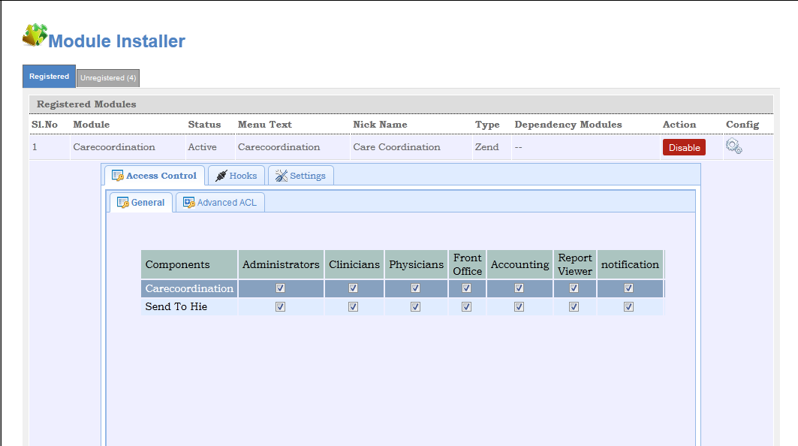

As shown above, the configuartion tab comprises of the below listed sub tabs.

1. Access Control
2. Hooks
3. Setting

These sub tabs are defined in more details

Note: *If you don’t see these tabs on your screen it means that EMR Adminstrator has not given you access right to configuration of the Modules.*

## Access Control:

This enables the user to define access rights to the Module. The Access Control Tab is divided into two sub tabs namely General and Advanced. As the name suggests the General Tab allows to define access from a User Group prepective while the advanced allows more granular definitions not only by user groups but by individual users also

These tabs are highlighted in the below Screen shot:

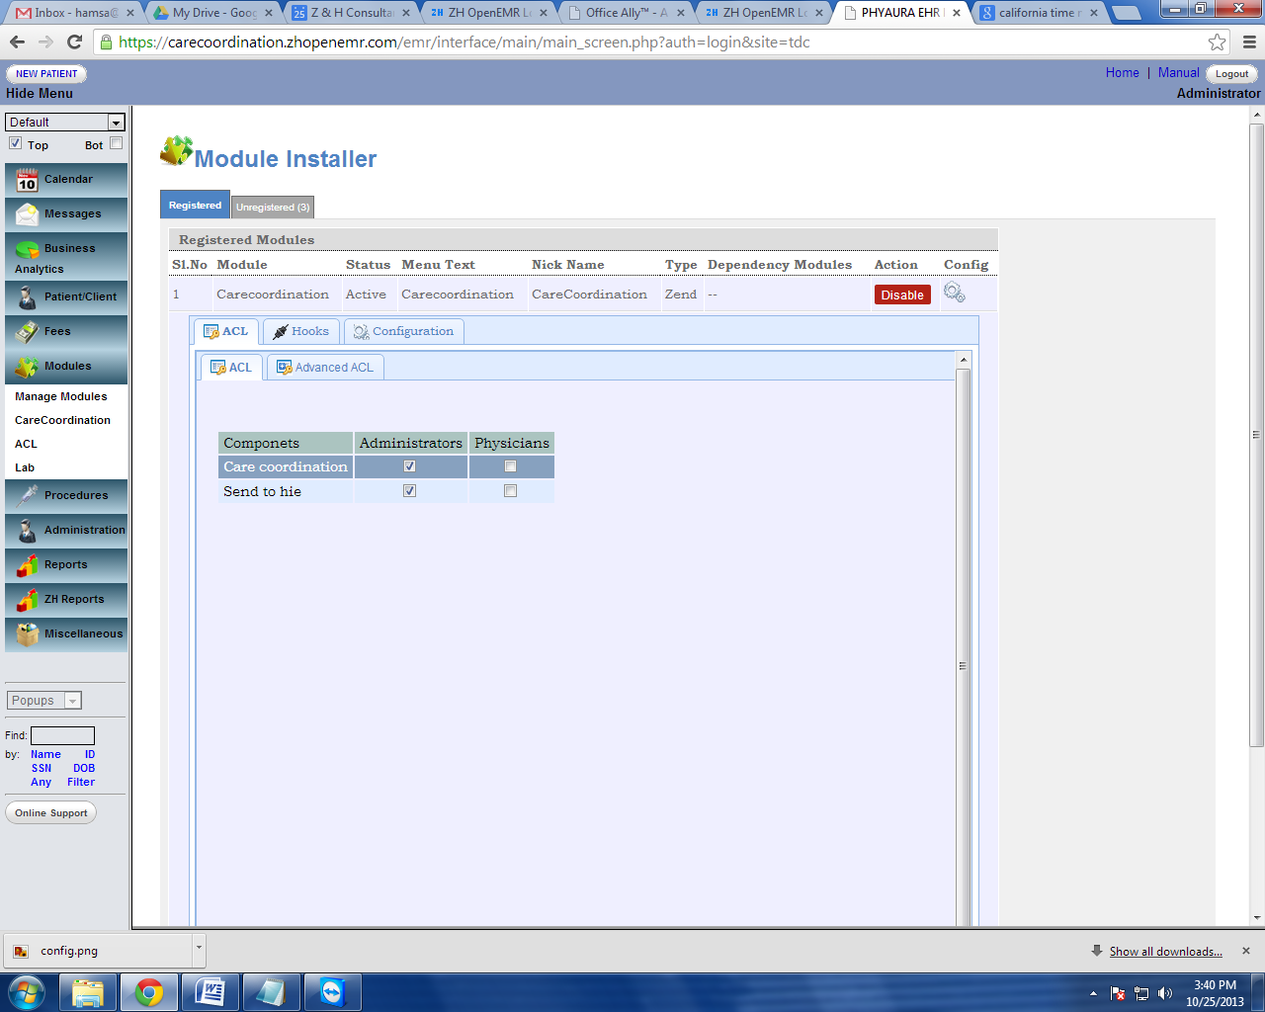

The below screen shows the Genral Tab selected. Here Administrators and Physicians are two User Groups defined in the EMR. Care Cordination is the main Module and Send to HIE is a component under Care Coordination Module. The checks boxes define the access right to these components. In the below example, Administrator have access to the entire Care Cordination Module while the Physician Group does not.

The user can also define access to only sub components from this window.

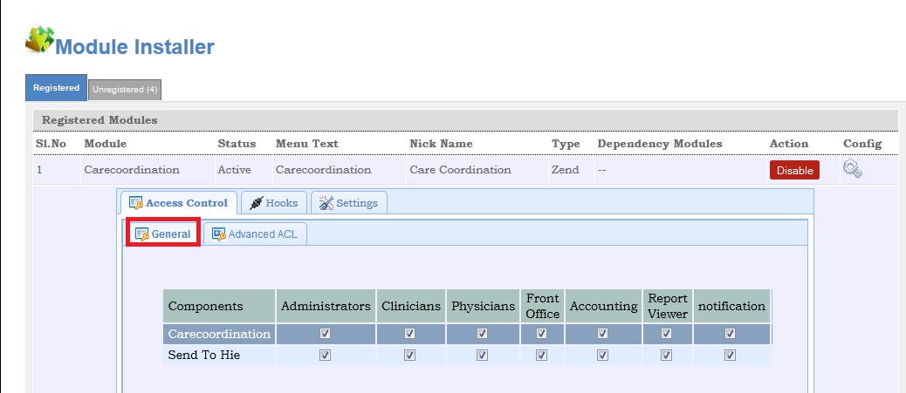

Advanced ACL:

This tab is used to access control for specific users. Even though the above step denied the access for a group, This section helps the administrator to give access for a specific user under the restricted group or in other words over ride the group access controls and define more specific access controls per user.

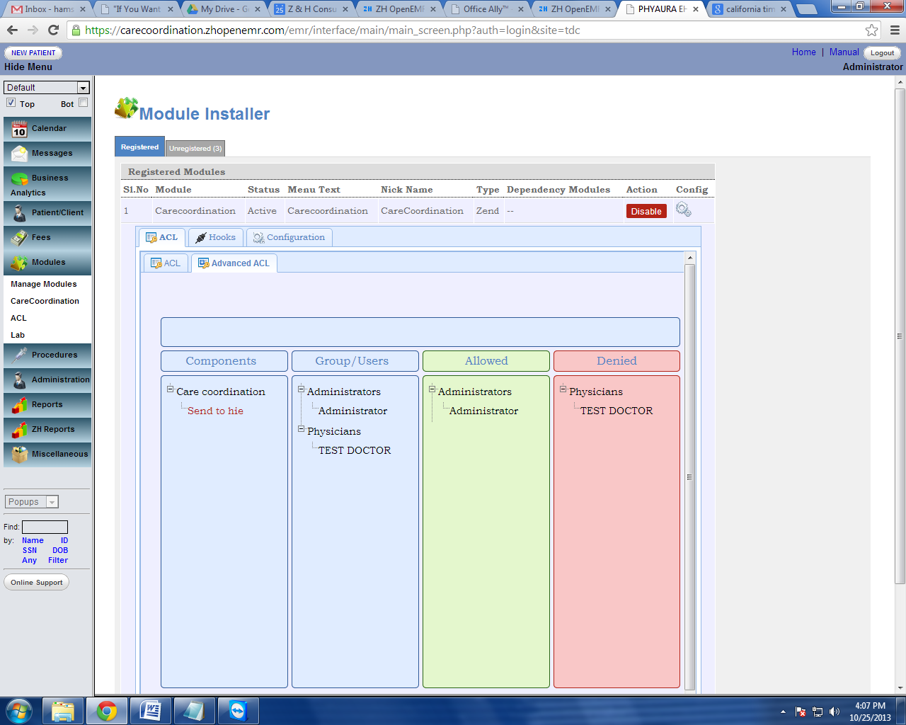

### Using the Advanced Tab:

The adavanced Tab is Drag/Drop enabled. In the above screen inorder to deny access only to User 1 - First Click on the the module form the Component section and then Drag User 1 and Drop the user into the the denied region.

Once done the screen will look as shown above.

Note: *The information is automatically saved as soon the user Drags and Drops the icons*

## Hook Management:

This sections enables the user to connect sub components as Hooks to different part of the of the EMR. For examlple in the above screen Reports, Encounters, Demographics and Combined forms are  parts of the encounter where the Send To HIE component can be placed thus connecting the Component of the Module to the EMR.

As shown below, it defines where all the Hook needs to be deployed in the system.

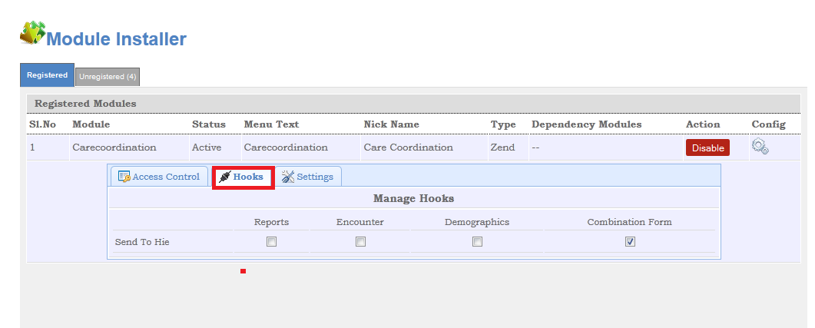

For Ex: Here “Hie” is hooked with Reports, Encounter, Demographics and Combination Forms.

Below screen shot shows how the “Hie” is hooked with the Combination form.Once the SEND TO button is clicked,which ever module is hooked with the combination form appears here.

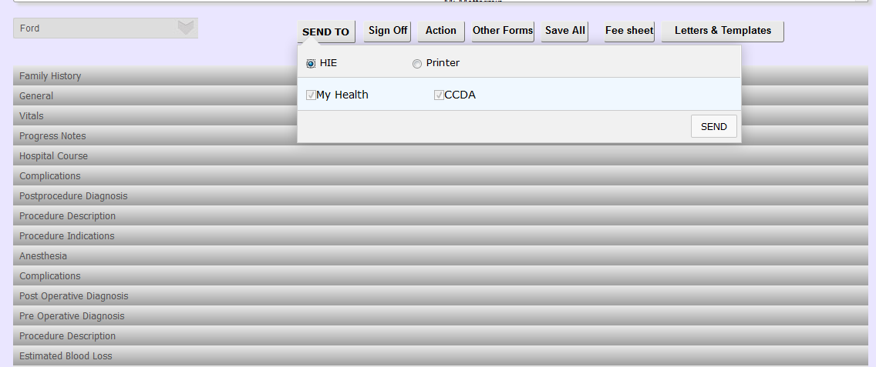

Select the components which are required to send and click the **SEND** button and the documents will be send to MyHealth.

General Settings:

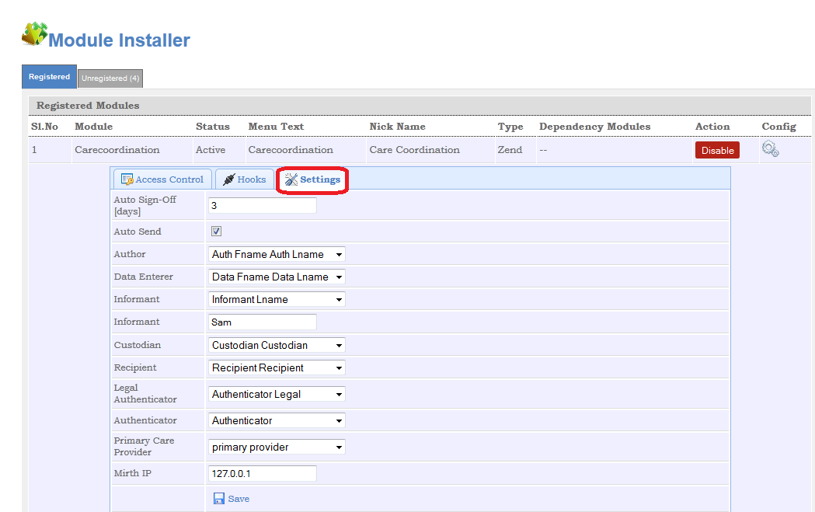

* Auto Sign-Off (day: Number of days upon which the encounter should be automatically signed off.
* Auto Send: Send them automatically
* Author:

Encounter Manager

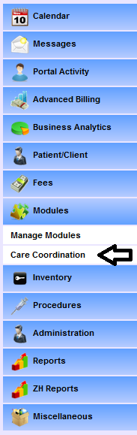

The functionality of care coordination module is of two ways

* Login to MyHealth
* Batch sending of CCDA to MyHealth

As stated in the above statement when the user clicks on the care coordination, it takes the user to the page shown below. It has got two tabs

* My Health :Login to MyHealth
* Encounter Manager: Batch sending to CCDA

MyHealth:

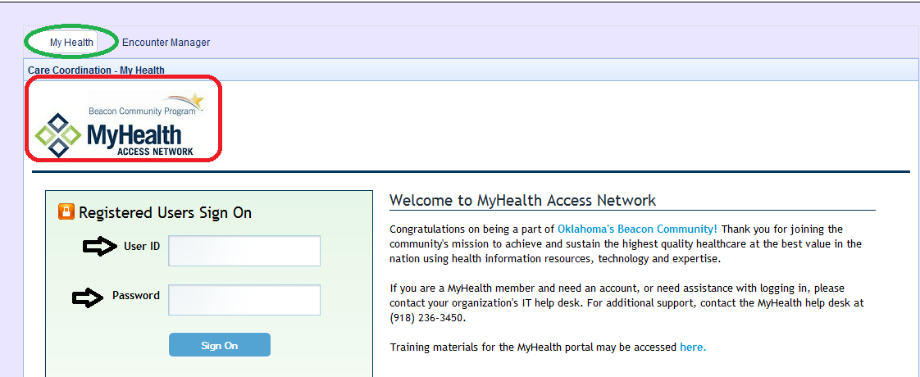

Once the user enter the User ID and password ,it take us to MyHealth.

Encounter Manager:

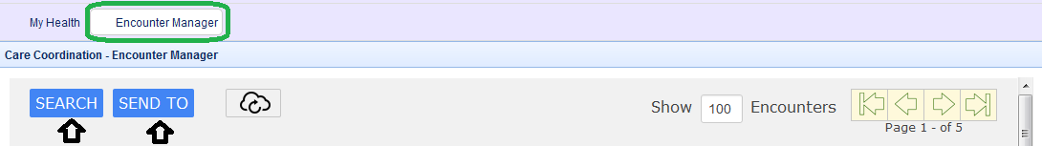

This tab provides the user to select a batch of patients which is to be send to CCDA using the search option provided.

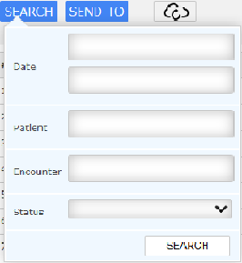

Once the user enters the

* Date
* Patient ID
* Encounter Number
* Status

Or any of the above and click the search button ,it provides us the list of patients which matches the search criteria.

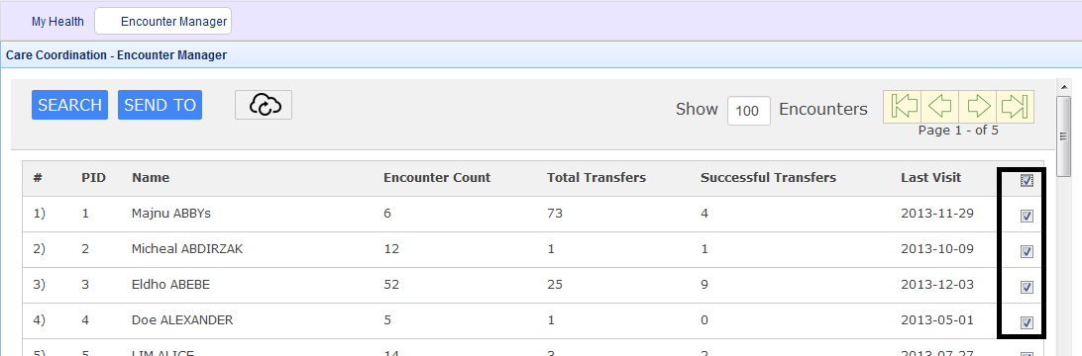

The above screenshot

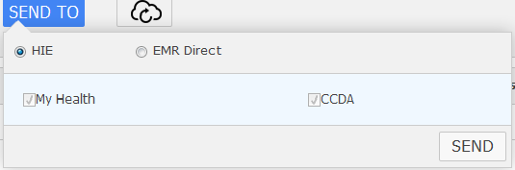

Select the document which is to be send to My Health and click **SEND** button.

*(here the document which is to be send is CCDA)*