Test cases
- Init command — Confirms database and tables are created successfully.
- Full-load command — Verifies all Sakila data is loaded into SQLite (key counts match).
- Incremental (new data) — Ensures new rows added to Sakila appear in SQLite after incremental sync.
- Incremental (updates) — Ensures changed source rows update correctly in SQLite.
- Validate command — Confirms data consistency between MySQL and SQLite over the selected period.
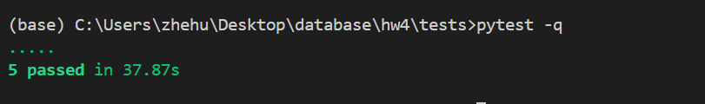

All test are in ./test/test_all.py

