Service protocol packet examples

Device reset

transmit: addr:AB
cmd:Reset
size:0000
crc:ABA0
num:0000

transmitRaw: AB0000A0ABA00000000000000000

Data transmission request

transmit: addr:AB
cmd:Send
size:0008
crc:5D15
num:0000
data:WSERV 0001, WDATA 0002, WDATA AB45, WDATA FFA1

transmitRaw: AB0008A2FFA10001FFA30002FFA3AB45FFA3FFA15D150000000000000000

The transmission of 4 MIL words as the result of this request:
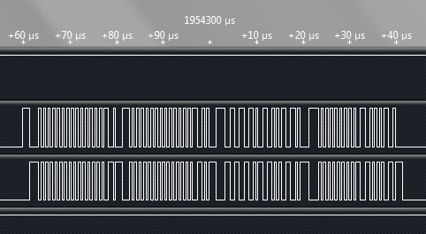

Data receive request

transmit: addr:AC
cmd:Receive
size:0008
crc:B4BA
num:0001

transmitRaw: AC0008B200000000000000000000000000000000B4BA0001000000000000

Data receive reply

receivedRaw: 000000000000AC0008B2FFA10001FFA30002FFA3AB45FFA3FFA15E250001

received: addr:AC
cmd:Receive
size:0008
crc:5E25
num:0001
data:WSERV 0001, WDATA 0002, WDATA AB45, WDATA FFA1

Status request

transmit: addr:AB
cmd:Status
size:0000
crc:ABB0
num:0000

transmitRaw: AB0000B0ABB00000000000000000000000000000

Status reply

receivedRaw: 000000000000AB0003B0000000000001AEB10001

received: addr:AB
cmd:Status
size:0003
crc:AEB1
num:0001
ReceivedQueueSize:0000
TransmitQueueSize:0000
SpiErrorCount:0001

Available packet headers

FFA0 – WSERVERR - service word that was received with error (data receive only)
FFA1 – WSERV - service word
FFA2 – WDATAERR - data word that was received with error (data receive only)
FFA3 – WDATA - data word

Available commands

A0 - device reset
A2 - send data to mil
B0 - status request
B2 - data request

