Technologies:

.NET Core 3.1
.EntityFramework Core
LocalDb
In-memory database provider for Entity Framework Core – in UnitTests project
Microsoft SQL Server database provider for Entity Framework Core – in DAL.Ef project
Shared design-time components for Entity Framework Core tools
AutoMapper
Newtonsoft.Json
Swagger tools for documenting APIs built on ASP.NET Core

Design patterns:

Repository and Unit of Work Patterns
Dependency Injection
Singleton
Factory
Data service
Proxy

Design Diagrams:

Project relationships: all projects used a shared component “Shared” that contains api models and interfaces. The BusinessLogic component and DAL.Ef(Data Access Layer) component are separated. The implementations are registered in separate component ServiceRegistrator used as a Buffer between the Api project and BusinessLogic and DAL.Ef components.
Trough the Di all required implementations are available as interfaces in the controller.
A client can not necessarily tell if it is directly communicating with any server or an intermediate (proxy). This structure allows easy replacement of the BusinessLogic or DAL.Ef if needed.

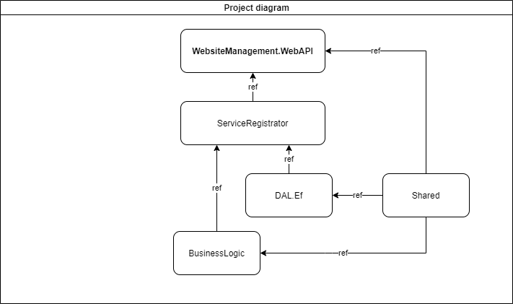

System Layers

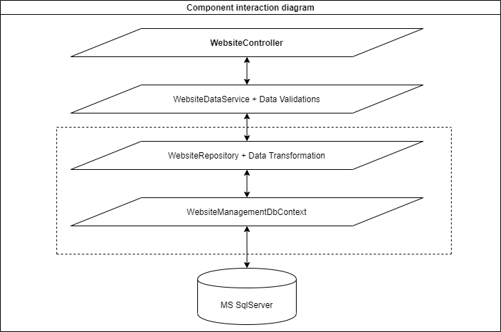

Database Diagram

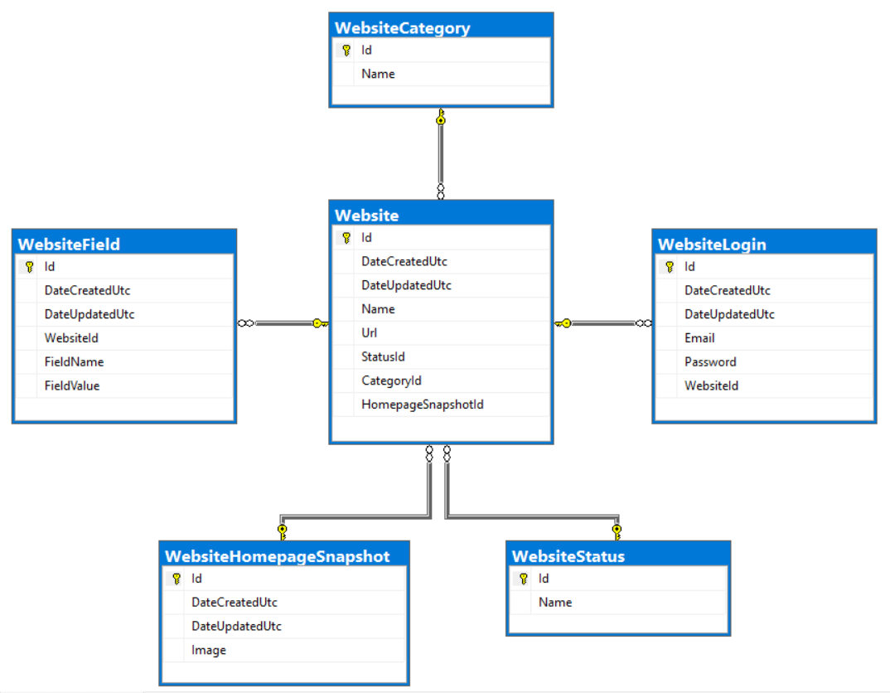

Unit Tests

The system is covered with 27 unit tests. They DO NOT ensure 100% code coverage.
All tests in the project have demonstrative purposes how could be organized testing of some components like testing DbContext configuration, performing integration tests with in memory database, testing some implementation. Proper testing strategy requires more technologies like using a Mocking framework like Moq and a bit more time that 5 days for planning and implementing.
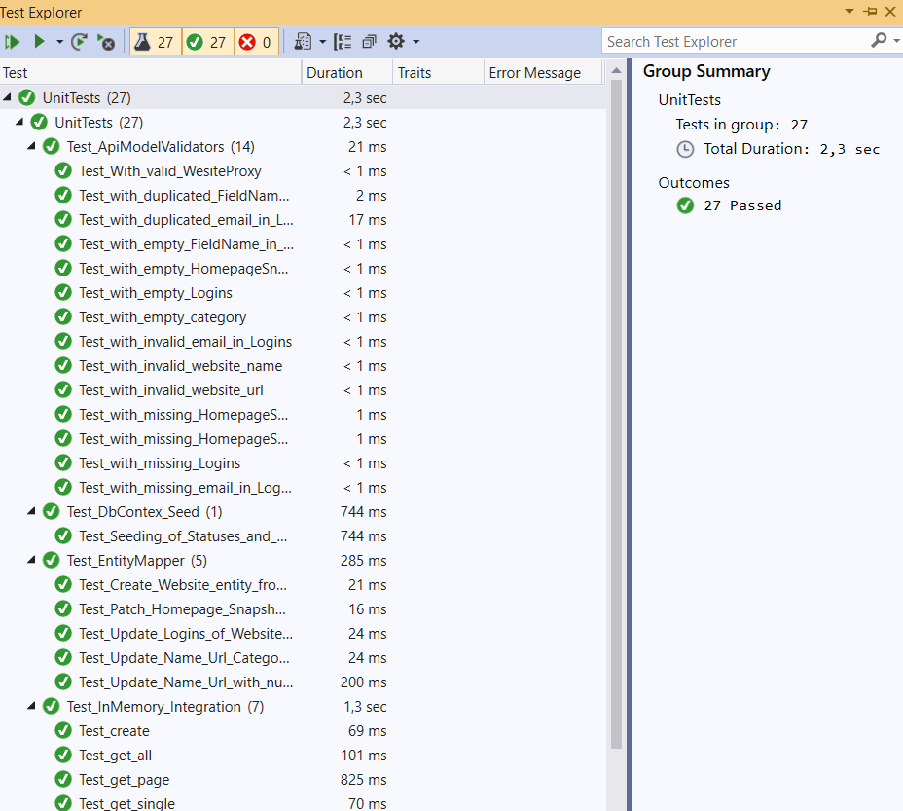

Api Explained

Swagger as startup page – each api action could be tested on startup

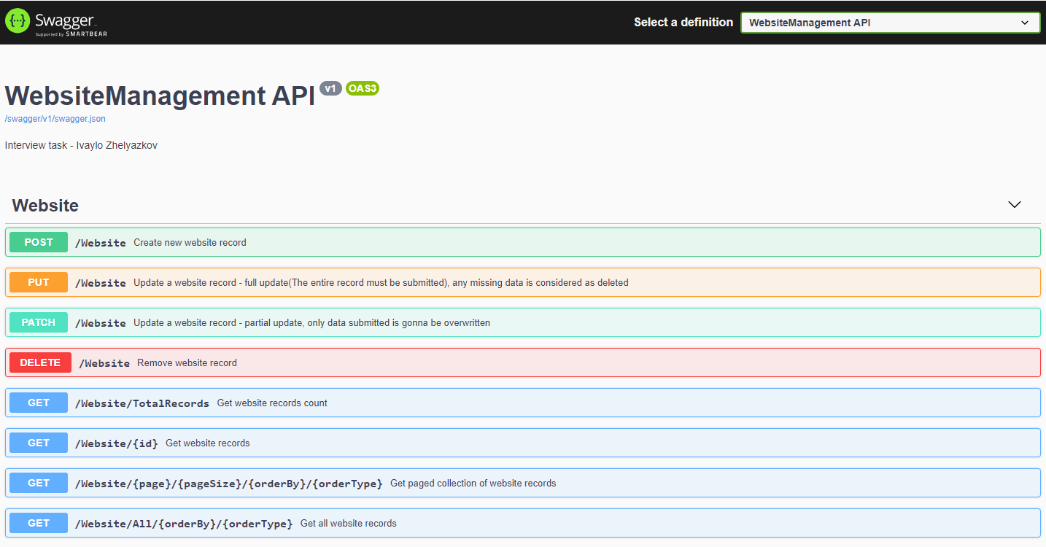

/Website POST method – used for adding new website records

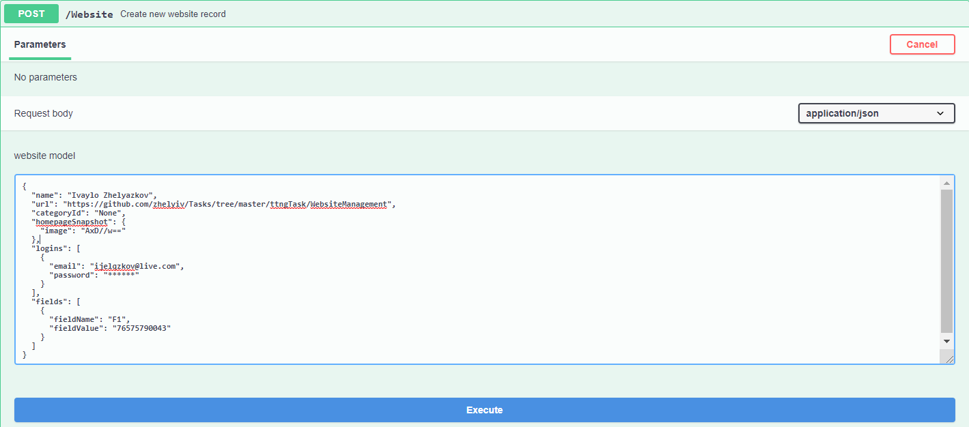

/Website PUT method – used for updating a website records, a complete object should be provided, partially fulfilled jsons may be rejected by the internal validation mechanism. The missing data from the submitted json is considered as removed

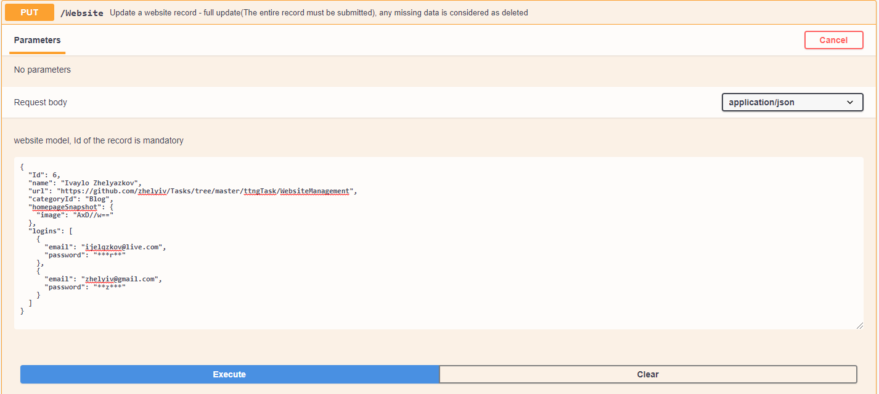

/Website PATCH method – used for partial updating of a website records, only data that needs to be updated or added could be added in the request body

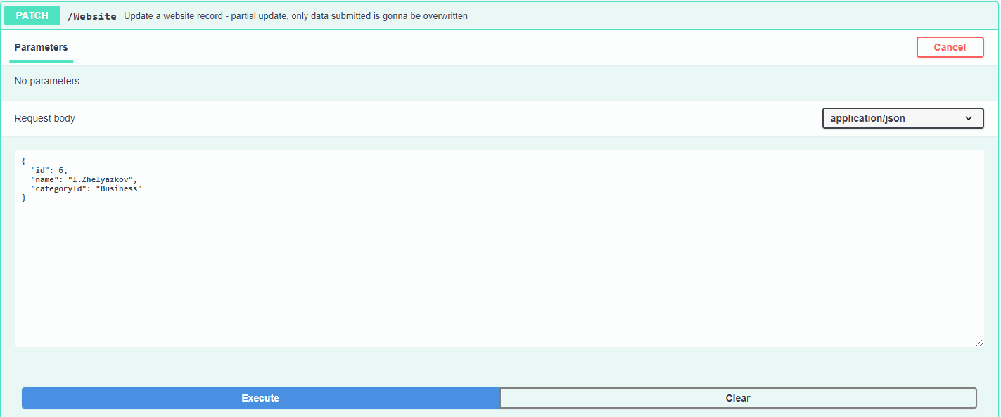

/Website DELETE – performs soft delete, the “deleted” record is marked as Invactive and cannot be extracted or updated
/Website/TotalRecords GET – Returns the number of the active records in database
/Website/{id} GET – Rerurns record by its id
/Website/{page}/{pageSize}/{orderBy}/{orderType} GET - Returns all active records by pages
/Website/All/{orderBy}/{orderType} GET – returns all active records at once

