Changing the config file

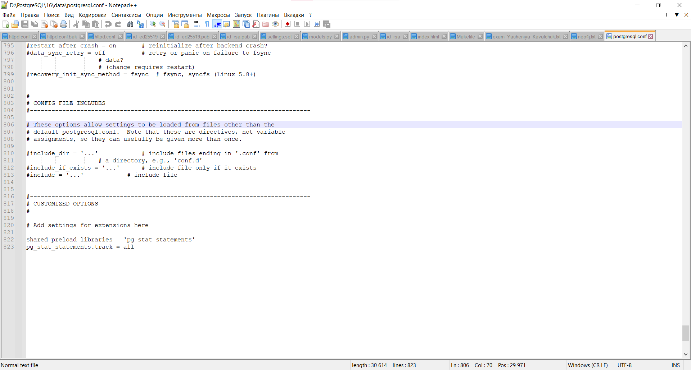

Results of SQL operations: You should submit screenshots displaying the output of at least one executed SQL operation, such as SELECT, UPDATE, or DELETE.

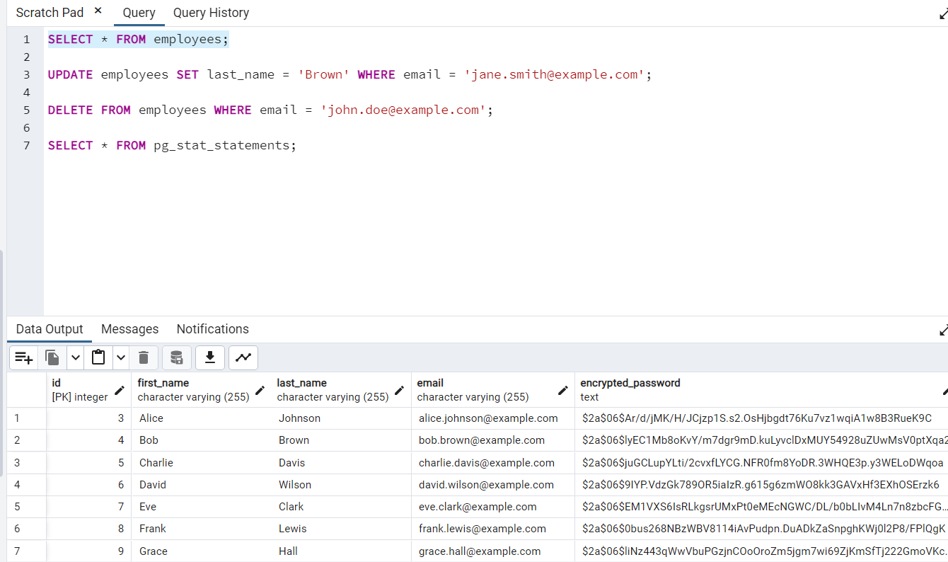

Pgcrypto: You should provide screenshots of the encrypted column in the "employees" table. Can be seen on previous screenshot.

Performance statistics: You should provide a screenshot of the output from the pg_stat_statements

