Elearning-Design
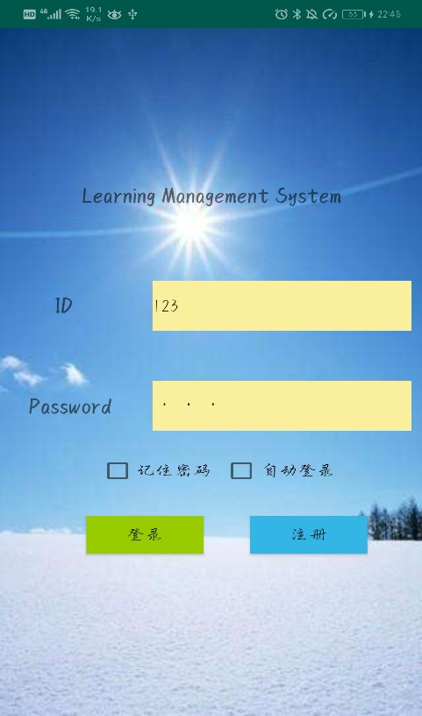
- Login
①Login interface, can remember password and automatic login.
②Log in or prompt by comparing the entered information with the information obtained from the server.
Jump to sign up.
- ③Login to the E-learning platform
User Login input validating

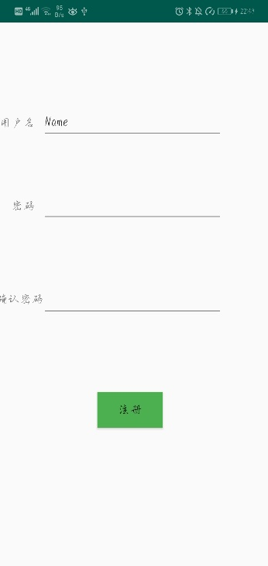
- 注册

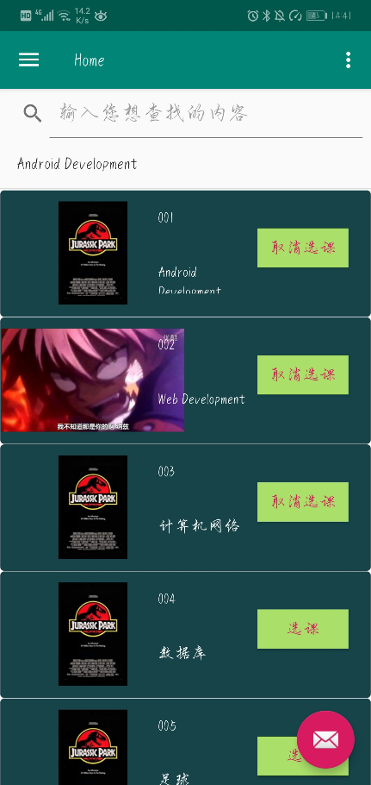
- Home(主页)
- ① Look in the list of courses offered by a e-learing platform
- ②Navigate to the detailed course introductions such as course info , syllabus, registration and calendar and so on.
③Using recyclerview for datasets displaying,
④Fuzzy query

- My course
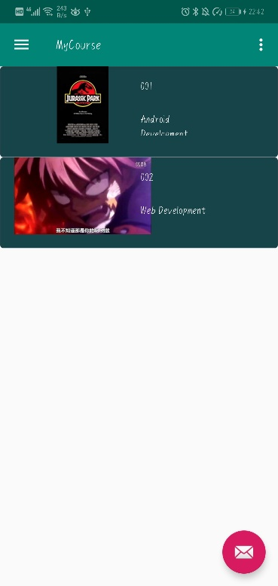
Get information about the courses you have previously selected.

- Slide introduction
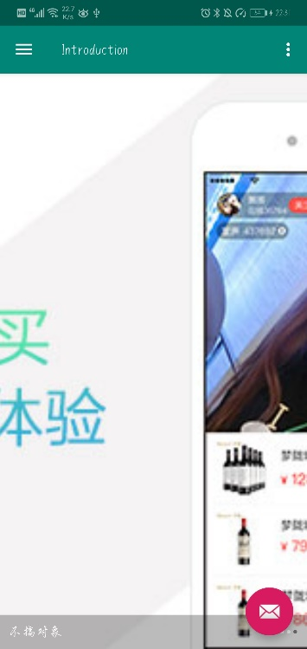
  - Introduction slide page
②Use the carousel to play Introduction slide page

- Personal Info
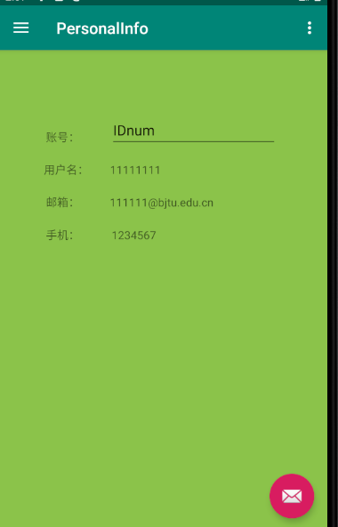
show personal information.

- Course Info
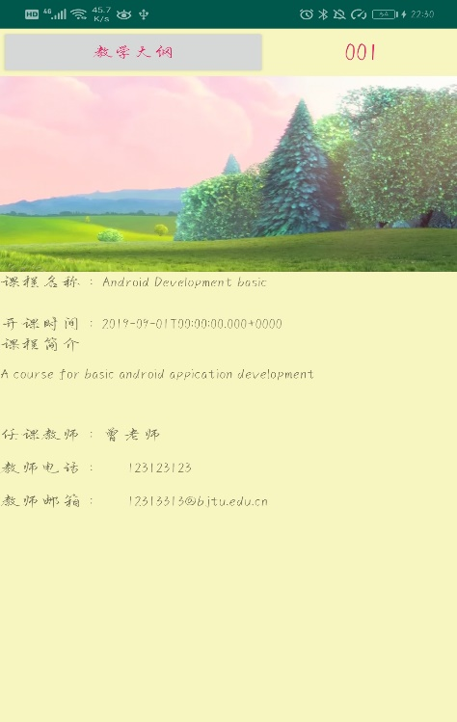
①Datasets such as course information, course materials(course wares) are required to obtain from web server, therefore utilizing apis
②For multi-media, such as video/audio lessons, function implementation

1.Caching the user browsed data in local sqllite database/local file cache,
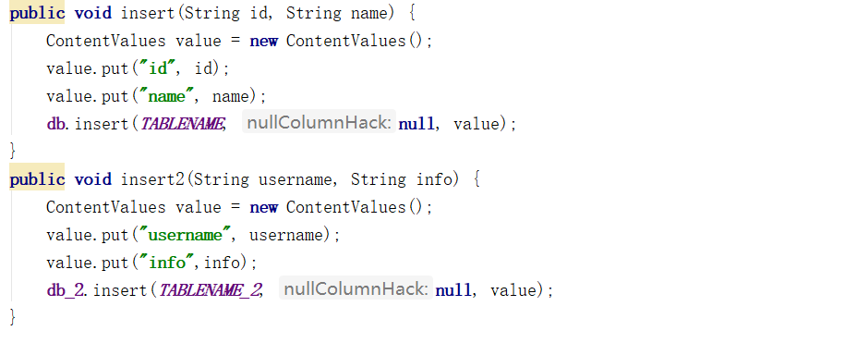
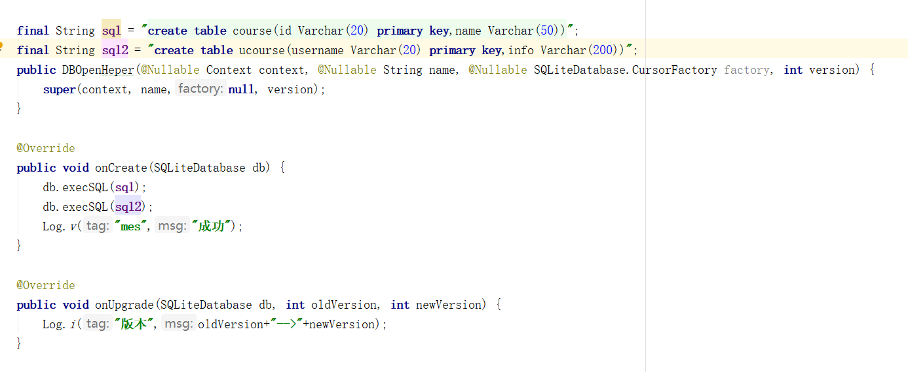
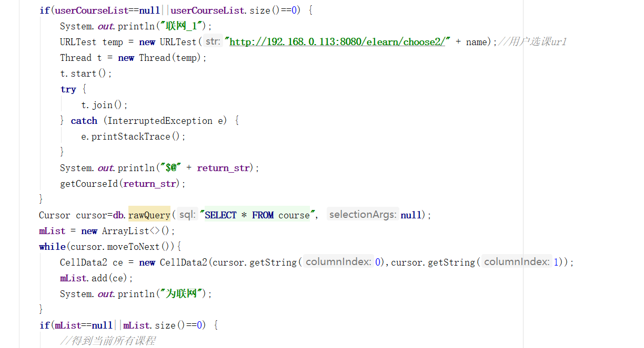
2.For long running jobs such as loading/uploading image or video, store in cache file and etc,

3.provide complete unit test cases and implementing the android testing for at least one activity module.

