**Proposal**

**Menmber information:**

**17301104 汤文正**

**17301105 王颜辉**

**17301108 邢景龙**

**17301107 夏梦愉**

**一．system function narrative：**  
1. Administrator:

Log in,

Registered administrator

Search for student information

Add student information

See the ranking

Modify student information

Delete student information

Forced offline

2. The student:

The login

View personal details

Change the password

In addition to the basic appeal function, we will also optimize it.

1. Add camera to upload personal pictures

2. Add mail validation modifications

3. Information broadcast

4.Resource sharing

5.Qq space sharing

**二．UI SKETCH （简图）**：

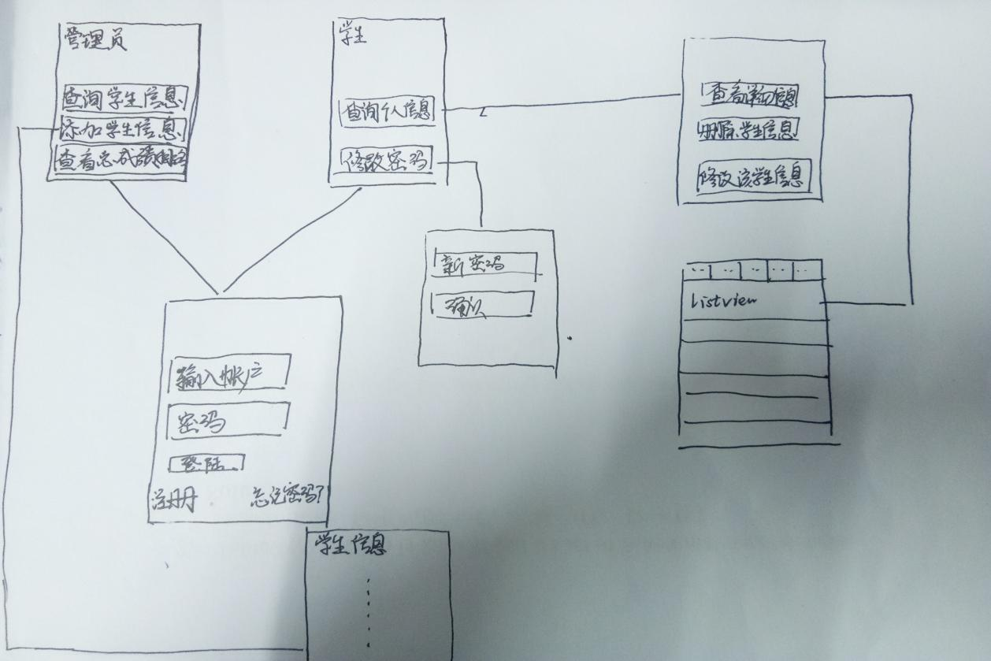

**三．project value proposition：**

Student information management system is aimed at the personnel department of a large number of business school work and the development of management software, is mainly used in the school student information management, overall mission is to realize the student information relationship of systematic and scientific, standardization and automation, and its main task is to use a computer to the student daily management for all kinds of information, such as query, modify, add, delete, also considering the students' course selection, design a student information management system for these requirements