Part one
Q1.
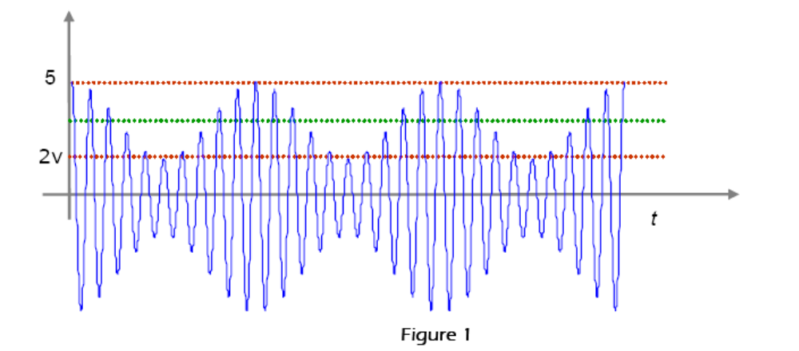
a) The message modulating the AM signal in Figure 1 is a single-tone signal of frequency 5kHz. Find the carrier frequency.
b) Referring to Figure 1 above, calculate the modulation index.
c) What percentage of the total power of this AM signal is contained within the sidebands?
d) Sketch the spectrum of this AM signal, and explain why this form of modulation is also referred to as DSB-LC.
e) Envelope detectors are commonly used to demodulate AM signals. Explain whether this is a form of coherent or non-coherent demodulation?
f) Discuss how the time constant for such a modulator would be selected, using the AM signal in Figure 1 as an example

Q2. Which of the following is/are not true of AM? (Select only one answer)

a) The carrier has constant amplitude.
b) The carrier conveys no information.
c) There are always two sidebands, even when modulation index is zero.
d) Increasing the message signal amplitude increases the depth of modulation.
e) Modulation index must be greater than 1 to avoid distortion.
f) 50% of the signal power is contained in the upper side band.
g) The AM bandwidth is the difference between the highest frequency of the upper sideband and the lowest frequency of the lower sideband.
h) The AM bandwidth is twice the baseband bandwidth.
i) All of the above statements are true.
j) More than one of the above statements is not true.

Q3. Which of the following are true for the following signal spectrum?
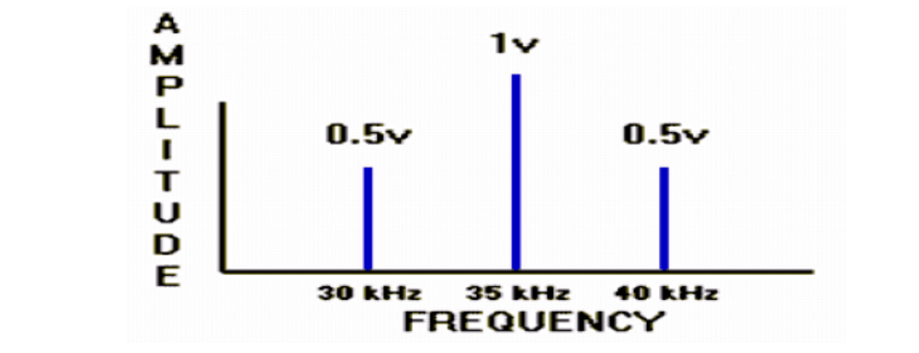
a) The message signal is a pure sinusoid of frequency 35 kHz.
b) The message signal has more than one frequency component.
c) The bandwidth of the AM signal is 5 kHz.
d) The bandwidth of the AM signal is independent of the message amplitude.
e) The carrier frequency is 7 times the message frequency.
f) The modulation index is 0.5.
g) It is not possible to calculate the modulation index from the spectral plot.
h) Approximately 10% of the power of the AM signal is contained in the sidebands.
i) More than one of the above statements is true.
j) None of the above statements is true.

For info:

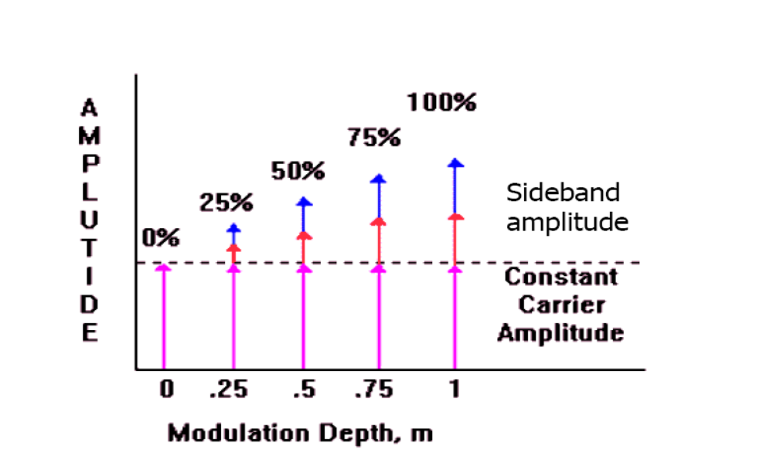
Q4
a) Give three characteristics of a good communications system.
b) Distinguish between baseband and band pass signals, commenting also on the difference between baseband and band pass communications.
c) Explain the meaning of modulation, giving two compelling reasons why it is necessary.
Part two
Q1.
a) Draw the block diagram of a DSB modulator, sketching the signal in the time and frequency domains at each point in this diagram.
b) Draw the block diagram of a coherent DSB demodulator, sketching the signal in the time and frequency domains at each point in this diagram.
c) In DSB demodulation, show how the demodulated waveform will be distorted if the local carrier suffers a phase error of Dq compared to the original carrier frequency.
d) In DSB demodulation, show how the demodulated waveform will be distorted if the local carrier suffers a frequency Dw compared to the original carrier frequency.

