Hou zhengbo

HOU ZHENGBO
DISSERTATION SUBMITTED IN PARTIAL FULFILLMENT OF THE
REQUIREMENTS FOR THE DEGREE OF
MASTER OF COMPUTER SCIENCE
Faculty of Information Science and Technology
UNIVERSITI KEBANGSAAN MALAYSIA
BANGI

HOU ZHENGBO
DISERTASI YANG DIKEMUKAKAN UNTUK MEMENUHI SEBAHAGIAN DARIPADA SYARAT MEMPEROLEH
IJAZAH SARJANA SAINS KOMPUTER
Fakulti Teknologi dan Sains Maklumat
UNIVERSITI KEBANGSAAN MALAYSIA
BANGI

DECLARATION
I hereby declare that the work in this thesis is my own except for quotations and summaries which have been duly acknowledged.
10 June 2026 | hou zhengbo  P154644

ACKNOWLEDGEMENT
In the name of Allah, the Most Gracious and the Most Merciful.
I would like to express my sincere gratitude to my supervisor, Ts. Dr. Ibrahim Mohamed, Deputy Dean (Postgraduate), for his invaluable guidance, continuous support, and insightful advice throughout the course of this research. His expertise and encouragement have greatly contributed to the successful completion of this study.
I would also like to extend my appreciation to the faculty and staff of the Faculty of Information Science and Technology (FTSM), Universiti Kebangsaan Malaysia (UKM), for providing a conducive research environment and necessary resources.
My heartfelt thanks go to my friends and fellow postgraduate students for their support, helpful discussions, and encouragement during this research journey.
Finally, I would like to express my deepest gratitude to my family for their unwavering support, understanding, and motivation throughout my studies.

ABSTRACT
The phenomenon of internationalization has made more and more foreign students studying in the higher education institutions of Malaysia. Among these students, there are many Chinese ones who face challenges of gathering necessary information about the new culture, institutions' rules, and academic materials. For example, as the case of FTSM of UKM University shows, all information needed can be obtained through various sources available mostly in English and Malay languages without having any support to help Chinese international students. Therefore, the goal of the present study is to create an information assistant service based on Retrieval-Augmented Generation and agents to provide better information services for foreign students. This study will integrate the documents from reliable sources and experiences of the Chinese International students to create the database with information in the area of focus. Moreover, the technology of semantic retrieval and large language models is supposed to be used for context-aware question answering. Besides, the ability to have multi-turn interactions and use natural language is also provided in the system. Thus, as the result of the case study, one will be able to find information in natural language about things like academic schedule, supervisors' contacts, the processes of the application procedure, and others. Consequently, by integrating authoritative information and student experiences, the problem of hallucinations is solved, and the information access barrier and information asymmetry are reduced.

TABLE OF CONTENTS
Page
DECLARATION iii
ACKNOWLEDGEMENT iv
ABSTRACT v
TABLE OF CONTENTS vi
LIST OF TABLES viii
LIST OF ILLUSTRATIONS ix
LIST OF ABBREVIATIONS x
CHAPTER I Introduction
1.1 Overview 1
1.2 Research Background 2
1.3 Problem Statement 3
1.4 Research Questions 4
1.5 Research Objectives 4
1.6 Research Significance 4
1.7 Research Scope 5
1.8 Thesis Organization 6
CHAPTER II Literature Review
2.1 Development of AI-Based University Information Services 7
2.2 Information Access Challenges for International Students 7
2.3 Large Language Models in Natural Language Processing 8
2.4 Retrieval-Augmented Generation 8
2.5 Intelligent Question Answering Systems in Education 9
2.6 Multilingual Support in Conversational AI Systems 11
2.7 Related Work 12
2.8 Research Gap and Chapter Summary 14
CHAPTER III Methodology
3.1 Overview of the Proposed Methodology 16
3.2 System Architecture of FTSM-RAG 17
3.3 Knowledge Base Construction and Vectorization 19
3.4 Multilingual Query Processing 20
3.5 Retrieval-Augmented Generation Framework 22
3.6 Semantic Cache Optimization Strategy 26
3.7 System Implementation Details 27
3.8 Summary 29
References 31

LIST OF TABLES
Table No. Page
Table ‎2.1 Comparison of the RAG System with Other AI Models 6

LIST OF ILLUSTRATIONS
Figure No. Page
Figure 2.1 Domain Intersection of LLMs, RAG, and Multilingual QA Systems 15
Figure 3.1 Overall Architecture of the RAG-Based Chatbot System 18
Figure 3.2 Document Processing and Embedding Pipeline for RAG 20
Figure 3.3 Cross-Lingual Query Alignment and Expansion for RAG Retrieval 22
Figure 3.4 (a) FTSM-RAG Interaction and Query Preparation Workflow 25
Figure 3.4 (b) FTSM-RAG Retrieval and Response Generation Workflow 25

Pictures No. Page

LIST OF ABBREVIATIONS
AI Artificial Intelligence
API Application Programming Interface
FAQ Frequently Asked Questions
FTSM Fakulti Teknologi & Sains Maklumat (Faculty of Information Science and Technology)
LLM Large Language Model
NLP Natural Language Processing
QA Question Answering
RAG Retrieval-Augmented Generation
ReAct Reasoning and Acting
UI User Interface
UKM Universiti Kebangsaan Malaysia

  - Introduction
    - Overview
The fast development of large language models (LLMs) has led to a surge of relevance of the intelligent question answering systems that can be used to improve the information access and communication within the different domains. The strong language processing capabilities of modern LLMs offer numerous opportunities for providing information services in particular domain-based environment by responding to natural language inputs from users in a natural way (Zhao et al., 2023). On the other hand, in the organizational environment of universities, students need to get accurate information regarding many issues related to their studies, university administration, university facilities, and student life in general. In traditional information delivery mechanisms, manual searching of information from numerous web pages, notices, and documents is quite inefficient and time-consuming and even more difficult for international students to do due to potential language barriers (Kuhail et al., 2023).
In light of this, this research suggests designing and implementing the retrieval-augmented generation (RAG) question answering system designed for information services in universities. In comparison with the fully generative approach where the information is delivered using only pre-trained parametric knowledge, integration of external knowledge into RAG system makes it possible to provide more precise and contextually accurate information that is also grounded in real-world data (Lewis et al., 2020; Gao et al., 2023). Additionally, various prompt construction techniques and multi-turn dialogues are included into the architecture of the system to ensure higher contextual consistency of the answers. Therefore, this research will be aimed at designing such a system to facilitate information access for Chinese students who face certain language barriers and information asymmetry during adaptation in a cross-cultural environment in the Faculty of Information Science and Technology , Universiti Kebangsaan Malaysia. This chapter covers the background of the study, problem statement, research objectives, research questions, research scope, significance of the research, and project outline.
    - Research Background
The globalization of higher education in Malaysia has resulted in the gradual increase in international student populations in the country. In particular, there has been a noticeable rise in the number of students coming from China. At Universiti Kebangsaan Malaysia (UKM), especially in the Faculty of Information Science and Technology, Chinese students are one of the major international groups of students, but many face considerable challenges when adapting to the new setting. The problem is associated with the fact that critical institutional information, such as the academic calendar, allocation of supervisors, administration processes, and visas, is scattered across several official sources and presented in two languages, namely English and Malay (Saha & Saha, 2024).
Thus, the language gap is combined with information gaps, creating significant barriers to the integration of international students into UKM. In particular, new students may face problems with accessing important resources in English and/or Malay due to their insufficient knowledge of one or both languages. On the other hand, experienced students and graduates are likely to accumulate extensive practical information regarding UKM's work. Unfortunately, these data are not formalized and structured. Within the context mentioned above, creating an intelligent chatbot combining domain-specific institutional knowledge and large language models' abilities is considered a useful idea. Specifically, the use of RAG will allow retrieving accurate content and answering users' questions without introducing any hallucinations (Lewis et al., 2020).
    - Problem Statement
Even though LLMs like ChatGPT are known for their strong capabilities in generating general language content, these models have not been fine-tuned based on any knowledge source of institutional documents, Faculty guidelines, and other reference material. Thus, while dealing with very localized and subject-specific questions, an LLM can produce erroneous or even hallucinated responses, making its use unreliable in the situations where high precision and factual accuracy is a must. The existing information channels at universities are mostly restricted to websites or traditional FAQ services that fail to provide personalized interactive responses to users.
Moreover, previous research shows that work in the field of intelligent question answering and educational chatbots has primarily paid attention to university-level education-related applications, thus illustrating the potential of conversational AI in this sector (Kuhail et al., 2023). It has also been shown that retrieval-augmented generation (RAG) approaches have been successfully used in universities to make the generation of answers less dependent on the internal knowledge of general-purpose LLMs (Gao et al., 2023). Nevertheless, despite the interest in conversational systems aimed at university students, the current body of literature lacks studies addressing dialogue systems aimed at the needs of international students at universities who are natives of China. Especially, there is little research concerning systems that incorporate official documents of universities along with the experiential knowledge accumulated by students over the years. Given the multilingual nature of these students' communication at campuses in Malaysia, where they may ask questions in Chinese, English, or Malay, such a limitation becomes even more crucial (Neupane et al., 2024; Elheneidy and Mohd, 2025).
Thus, the problem addressed in the current paper is related to the lack of a conversational question answering system for international students at universities in Malaysia. Specifically, the study seeks to design such a RAG system that will integrate both official documents of the institution in question and the experiential knowledge accumulated by international students during their time in Malaysia and will be capable of providing a personalized response to each inquiry.
    - Research Questions
- How should official institutional documents and student experiential knowledge be combined into a knowledge base to support multilingual retrieval of information from the student side?
- What is the impact of the hybrid retrieval approach consisting of dense retrieval, BM25 keyword matching, and cross-encoder re-ranking on the relevance of answer retrieval in the multilingual setting of the university question answering?
- What is the effect of semantic caching on the speed of retrieving information and the efficiency of using the API in the domain-specific RAG system?
    - Research Objectives
- The goal of the research is to design and implement a Retrieval-Augmented Generation (RAG)-based question answering system for university information services.
- The objective is to design an effective answer generation mechanism that includes knowledge retrieval, prompt creation, and multi-turn dialogue management to increase the effectiveness and relevance of the generated answers.
- The aim is to analyze the performance of the created system in university information question answering to assess accuracy and usability of the system.
    - Research Significance
The significance of this study can be discussed from practical, technical, academic, and application-oriented perspectives. First, in terms of practical importance, this research aims at designing and implementing a Retrieval-Augmented Generation (RAG)-based question answering system for university information services. The implemented system enables users to access information on various issues regarding faculty members and students, including matters related to academics, campus facilities, visa renewals, and student life. This system is different from conventional keyword-based searches since the question answering system offers a more convenient way of getting information from institutional documents and service materials, especially to international students and those who start studying in a new environment (Saha & Saha, 2024).
Second, in terms of technical and academic importance, this study integrates knowledge base construction, vector retrieval, language generation, prompt construction, and dialogue management in the framework of a comprehensive question answering system. With this respect, the inclusion of retrieved external knowledge makes the answer generation more relevant and reliable because the system reduces the risks of hallucinations associated with general-purpose large language models in domain-specific tasks (Lewis et al., 2020; Gao et al., 2023). Besides, the use of prompt containing system prompt, chat history, user query, and retrieved context allows increasing answer accuracy, relevancy, and controllability. Overall, this study demonstrates how the RAG architecture and prompt engineering could be applied in designing question answering system for university information service and can be valuable for further research in this field (Kuhail et al., 2023).
Finally, this research adds value in terms of knowledge management and applicability of the results to other areas. Through transformation of documents and service materials of universities into a searchable vector-based knowledge base, this project facilitates the use and reuse of institutional resources. Even though the project is built around a specific university, the general framework of the project is applicable to other domains, such as government consultations, business information, healthcare services, and library services. Therefore, the study has immediate practical value and also great potential.
    - Research Scope
The purpose of this study is to develop a Retrieval-Augmented Generation (RAG) query response system to be applied for university information services. Research is limited to tasks related to information query-response between the university and its clients based on text messages only. Information-related issues are limited to the following subjects – undergraduate administration, course scheduling, university services, visa guide, and student life.
As regards the key elements covered by this research, one needs to mention the following issues – knowledge base creation based on specific university documents, document retrieval, prompt generation, multi-step conversation management, and language model generation of the response. It is important to emphasize that the proposed system is aimed at solving information-based query-response problems without any voice processing or automation of task execution. The conversations will be limited to topics covered by the known dataset without any additions to it including open-ended dialogues outside of standard knowledge area.
On the technical side of development, RAG system including vector search and response generation based on the use of a large-scale language model without any pre-training and fine-tuning of base language models is utilized in this work. Evaluation will be limited to the performance of the response generation algorithm for the defined university information topic area only without distribution, large scale deployment and generalization across other domains.
    - Thesis Organization

This thesis paper consists of five chapters. Chapter 1 outlines the background, problem statement, research questions, research objectives, significance of the research, scope of the research, and the organization of the thesis. Chapter 2 reviews the literature related to large language models, Retrieval-Augmented Generation (RAG), prompt engineering, question answering systems in education, and intelligent information service systems. In addition, this chapter gives information about the previous research on the topic and the identified research gap. Chapter 3 describes the research method, the system design, and its components. It outlines the architecture of the question answering system, approaches used for knowledge base construction, vector retrieval, and prompt construction for generating answers. Chapter 4 covers the implementation of the system, the testing procedure, and the findings of the research. It describes the major components of the implemented system, evaluates its performance, and discusses the findings obtained during the testing process. Chapter 5 summarizes this thesis paper by outlining the results of this study and its contribution.
This thesis paper consists of five chapters. Chapter 1 outlines the background, problem statement, research questions, research objectives, significance of the research, scope of the research, and the organization of the thesis. Chapter 2 reviews the literature related to large language models, Retrieval-Augmented Generation (RAG), prompt engineering, question answering systems in education, and intelligent information service systems. Chapter 3 describes the research method, the system design, and its components. It outlines the architecture of the question answering system, approaches used for knowledge base construction, vector retrieval, and prompt construction for generating answers. Chapter 4 covers the implementation of the system, the testing procedure, and the findings of the research. It describes the major components of the implemented system, evaluates its performance, and discusses the findings obtained during the testing process. Chapter 5 summarizes this thesis paper by outlining the results of this study and its contribution.

Literature Review
  - Literature Review
    - Development of AI-Based University Information Services
From the perspective of university information services, advancements have been made from educational chatbots using rule-based approaches to LLMs and Retrieval-Augmented Generation (RAG). Although prior rule-based chatbots were useful in helping with accessing information related to academic needs and queries, their dependency on pre-set questions and answers rendered them ineffective in answering open-ended and context-specific questions (Kuhail et al., 2023). The more recent literature explores the possibility of applying LLMs with institutional knowledge retrieval for answering questions of the users. The study by Saha & Saha (2024) revealed the benefit of applying such an approach in assisting international students at universities. Furthermore, the usefulness of university RAG-based chatbots has been investigated in other studies (Neupane et al., 2024; Antico et al., 2024).
    - Information Access Challenges for International Students
With the internationalization of higher education, there is an increase in the number of Chinese students in Malaysian higher educational institutions, who may experience problems with getting information at their respective institutions (Saha & Saha, 2024; Zhai & Razali, 2022). This type of information includes policies, administrative processes, and the use of certain services provided by the institution. It is important to note that the availability of this type of information requires knowledge of more than one language and platform (Elheneidy & Mohd, 2025; Singh & Jack, 2022). Thus, these aspects could create problems for international students who have just arrived at the institution. This problem is especially relevant due to the impact of language barriers and other factors on the work of students within the institution (Singh & Gupta, 2026).
    - Large Language Models in Natural Language Processing
The advent of large language models (LLMs) is another breakthrough in natural language processing. Most of today's LLMs use the Transformer neural network model and learn from large corpora of texts (Vaswani et al., 2017; Zhao et al., 2023). With scale, LLMs show good results in question answering, text summarization, translation, and even few-shot learning (Brown et al., 2020; Zhao et al., 2023). Moreover, GPT-4 can provide impressive conversational skills: understand complex instructions and produce fluent and appropriate answers (OpenAI, 2023). The application of LLMs in ChatGPT is another example of how this technology can be useful for building informational chatbots.
At the same time, despite the wide range of LLM's abilities, their performance may suffer from insufficient domain knowledge, and some generated outputs might be either incorrect or obsolete (Ji et al., 2023; Zhao et al., 2023). Such problems can be especially dangerous for users who need to access accurate and up-to-date information about, say, university policies, legal rules, and medical practices. Since almost all knowledge in LLMs is encoded in the model's parameters as a result of training, LLMs cannot verify independently if their answers correspond to any recent changes in institutions (OpenAI, 2023). Researches claim that generative models are prone to the problem of hallucination: generating language-based outputs in the absence of factual grounds (Alansari & Luqman, 2025; Ji et al., 2023). Therefore, external retrieval of factual information appears crucial for grounding model-generated answers.
    - Retrieval-Augmented Generation
A retrieval of relevant data is performed by the RAGs from the database, which can be updated and replaced in order to enhance the efficiency of purely parametric models. (Lewis et al., 2020). Retrieval-based research involving the application of RAG indicates that retrieval of data from external sources can significantly enhance the accuracy of model's question-answering performance. (Izacard & Grave, 2021; Karpukhin et al., 2020). In comparison with other large models, the RAG model involves retrieval of relevant information from the database and loading it as cue words for the model. It allows enhancing the accuracy of answers to certain questions, which require accuracy and professionalism, and the database can be frequently updated. (Gao et al., 2023).
The process of retrieval in the RAG system involves two common types of retrieval such as BM25 sparse retrieval through keyword matching and dense retrieval involving vector similarity. Dense retrieval can involve representation of elements in the dataset as vectors and matching or selecting similar items based on semantic similarities. (Karpukhin et al., 2020). Retrieved paragraphs are further introduced into the model in order to facilitate the process of generation of an answer and ensure that additional information can be incorporated in order to improve the accuracy of the answers. (Izacard & Grave, 2021; Lewis et al., 2020). According to studies, RAG can considerably improve relevance and factual accuracy of responses but it depends on retrieval and context selection. (Gao et al., 2023).
It should be noted that recent studies indicate that iterative retrieval, hybrid search, reordering, and query restructuring can enhance the effectiveness of RAG systems. (Gao et al., 2023). The approach of intensive retrieval involves application of key terms for matching through semantic similarity and aggregation of all relevant paragraphs in order to improve the quality of responses through incorporation of additional information. (Izacard & Grave, 2021; Karpukhin et al., 2020). However, at the same time, the relevance and reliability of search materials become critical to enhancing the quality of responses. The relevance of search materials is highly connected with the accuracy of generated answers. (Lewis et al., 2020). Therefore, the findings provide the necessary technical basis for this study, which aims to implement RAG in answering students' questions.
    - Intelligent Question Answering Systems in Education
AI-powered Q&A systems have attracted significant interest in educational institutions seeking scalable solutions for supporting students and staff members (Kuhail et al., 2023; Okonkwo & Ade-Ibijola, 2021). Systematic research demonstrates that educational chatbots have been implemented to provide help with learning, feedback, administrative queries, and provision of information about academic sources (Labadze et al., 2023). The importance of such bots has increased because of the growing diversity of institutional knowledge bases and increasing student needs requiring fast and personalized responses (Saha & Saha, 2024).
The first generation of educational chatbots mostly relied on rule-based systems or keyword matching techniques. Such approaches allowed for effective Q&A in the case of narrow pre-defined domain, but could not be helpful in cases where questions required a broader understanding of context and ambiguity of intentions (Kuhail et al., 2023; Okonkwo & Ade-Ibijola, 2021). In recent years, educational chatbots have included LLMs and knowledge retrieval mechanisms. Although the integration of these components increases flexibility of responses and their semantic consistency, accurate results and effective evaluation are still critical issues in this area (Labadze et al., 2023; Zhao et al., 2023).
There were several studies that indicated the potential of using RAG to create an educational chatbot for universities. For example, Barkplug V.2 effectively used university resources to provide answers concerning academic subjects, campus facilities, and student services. Evaluation of the chatbot revealed very good RAGAS and usability scores (Neupane et al., 2024). On the other hand, users considered the conversational tone and structured presentation of the answer by Unimib Assistant as valuable. Nevertheless, the evaluation showed some omissions, inaccuracies, and unworkable links provided in answers (Antico et al., 2024). Similarly, other university chatbot projects also demonstrated positive outcomes for retrieval of institution-specific information via RAG while acknowledging the importance of the knowledge base and retrieval accuracy (Hartono et al., 2025; Saha & Saha, 2024). As seen, these results confirm the outcomes of systematic review according to which reliability and accuracy are key concerns associated with educational chatbots (Labadze et al., 2023).
However, despite promising results obtained from implementing RAG to develop educational bots, most of reported university chatbots have been developed for a single language and fail to satisfy cross-language information queries (Antico et al., 2024; Neupane et al., 2024). It is important to consider this aspect in Malaysia because of the necessity of addressing Chinese students' needs to find information in one language while retrieving resources in another one (Singh & Jack, 2022; Zhai & Razali, 2022).
    - Multilingual Support in Conversational AI Systems
Multilingual support is a crucial design consideration for the development of a conversational artificial intelligence in multicultural and multilingual environments (Kuhail et al., 2023). Reviews of educational chatbots revealed that among the criteria related to accessibility and provision of personalized services is the possibility to provide service to users with various linguistic backgrounds (Labadze et al., 2023). It is possible due to the cross-lingual meaning transfer made possible with multilingual pretrained models and sentence embedding techniques (Conneau et al., 2020; Reimers & Gurevych, 2020). Multilingual support will be useful when addressing questions formulated by Malaysian students using English, Malay, and Chinese languages.
Both approaches to multilingual modeling allow for the representation of text in various languages in the same vector space. Cross-lingual transfer resulting from large-scale multilingual training contributed to better performance on cross-lingual classification and question answering tasks (Conneau et al., 2020). Also, sentence embedding techniques enable comparing documents and queries in various languages in terms of their semantic similarity, irrespective of whether they were created in English, Malay, or other languages (Feng et al., 2022; Reimers & Gurevych, 2020). The developments contribute to cross-lingual semantic search, although its efficiency may depend on various factors such as language type and corpus availability (Zhao et al., 2023).
The recent research demonstrated the effectiveness of multilingual embeddings and semantic chunking in improving cross-lingual search for information retrieval accuracy and factuality on college campuses (Singh & Gupta, 2026). Generally speaking, research into multilingual representation learning proved that aligned sentence embeddings enable connecting queries and documents in multiple languages (Conneau et al., 2020; Feng et al., 2022; Reimers & Gurevych, 2020). The findings are important for the project as the search for evidence will have to retrieve information from the document written in Malay or English before formulating a response to Chinese questions.
    - Related Work
Several studies have explored the creation of RAG-powered or LLM-driven information service platforms in universities. Saha & Saha (2024) created an AI support system for international graduate students based on LLMs and RAG. Antico et al. (2024) developed the Unimib Assistant and confirmed that institutional grounding helped enhance answer relevance despite retrieval and link-generation challenges. Neupane et al. (2024) showed that a RAG pipeline dealing with academic programs, facilities, and services can obtain good RAGAS and usability outcomes. Hartono et al. (2025) also utilized RAG on queries from prospective and enrolled university students. Such studies mirror the general tendency within the educational chatbot literature of providing access to instant help while underlining the ongoing need for precision and reliability (Labadze et al., 2023). Yet, few existing solutions can offer tri-lingual support together with official documents and student expertise.
Table 2.1 shows that general-purpose models like ChatGPT, DeepSeek, and Qwen3-Max native can respond fluently but have difficulty with institution-specific and up-to-date information (Zhao et al., 2023). At the same time, a RAG-based model can base its responses on retrieval and offer more traceability although its quality is still dependent on retrieval and knowledge bases (Gao et al., 2023)
Table 2.1 Comparison of Large Language Models and RAG-based Systems for University Student Information Services
Comparison Criteria | ChatGPT | DeepSeek | Native Qwen3-Max | Basic RAG System | Prompt-Optimized Qwen3-Max RAG
Model type | Pure large language model | Pure large language model | Pure large language model | Retrieval-Augmented Generation system | Retrieval-Augmented Generation system with prompt optimization
Training scale and general knowledge | Large-scale pretraining with broad general knowledge | Large-scale pretraining with broad general knowledge | Large-scale pretraining with broad general knowledge | Depends on external retrieval and base model | Combines external retrieval with Qwen3-Max
Knowledge source for answering | Internal pretrained knowledge | Internal pretrained knowledge | Internal pretrained knowledge | External knowledge base plus language model | External knowledge base plus Qwen3-Max
Ability to answer general questions | High | High | High | Moderate to high | High
Ability to answer UKM FTSM-specific questions | Limited without external knowledge support | Limited without external knowledge support | Limited without external knowledge support | High | Very high
Use of updated UKM FTSM information | Limited | Limited | Limited | High | High
Hallucination risk in institution-specific responses | Relatively high | Relatively high | Relatively high | Lower | Lower
Answer grounding and traceability | Low | Low | Low | High | High
Domain-specific response guidance | General prompting | General prompting | General prompting | Standard prompting | Optimized prompting
Suitability for UKM FTSM student services | Moderate | Moderate | Moderate | High | Very high

    - Research Gap and Chapter Summary
From the analysis of relevant literature on Large Language Models, Retrieval-Augmented Generation, Intelligent Chatbots in Education, International Student Information Access, and Multilingual and Cross-lingual NLP, one can highlight three key gaps in existing research. First, while many studies have been devoted to the development of educational question answering systems, there have been too few works devoted specifically to the problem of international Chinese students' studying at the Malaysian universities (Kuhail et al., 2023; Saha & Saha, 2024). Such students need unique information support since they encounter various difficulties related to language and academic communication that are not addressed within the framework of a generic campus chatbot (Singh & Jack, 2022; Zhai & Razali, 2022).
Secondly, in most cases, the development of chatbots for universities does not provide evidence of successful operations in trilingual interaction with Chinese, English, and Malay language users (Conneau et al., 2020; Feng et al., 2022; Reimers & Gurevych, 2020). Additionally, existing university case studies on RAG do not include official documents together with the information from experienced students (Antico et al., 2024; Neupane et al., 2024). Consequently, there exist significant gaps both in multilingual knowledge retrieval and heterogeneous sources' integration.
Therefore, the purpose of the research is to bridge the mentioned gaps by developing a multilingual conversation platform based on RAG technology to address information needs of international Chinese students studying at the Faculty of Information Science and Technology. To achieve this aim, the proposed solution will rely on the external retrieval to base the answer on domain knowledge (Gao et al., 2023; Lewis et al., 2020). The design of the system will also consider the language and informational needs of the Chinese community revealed in recent studies (Saha & Saha, 2024; Zhai & Razali, 2022).
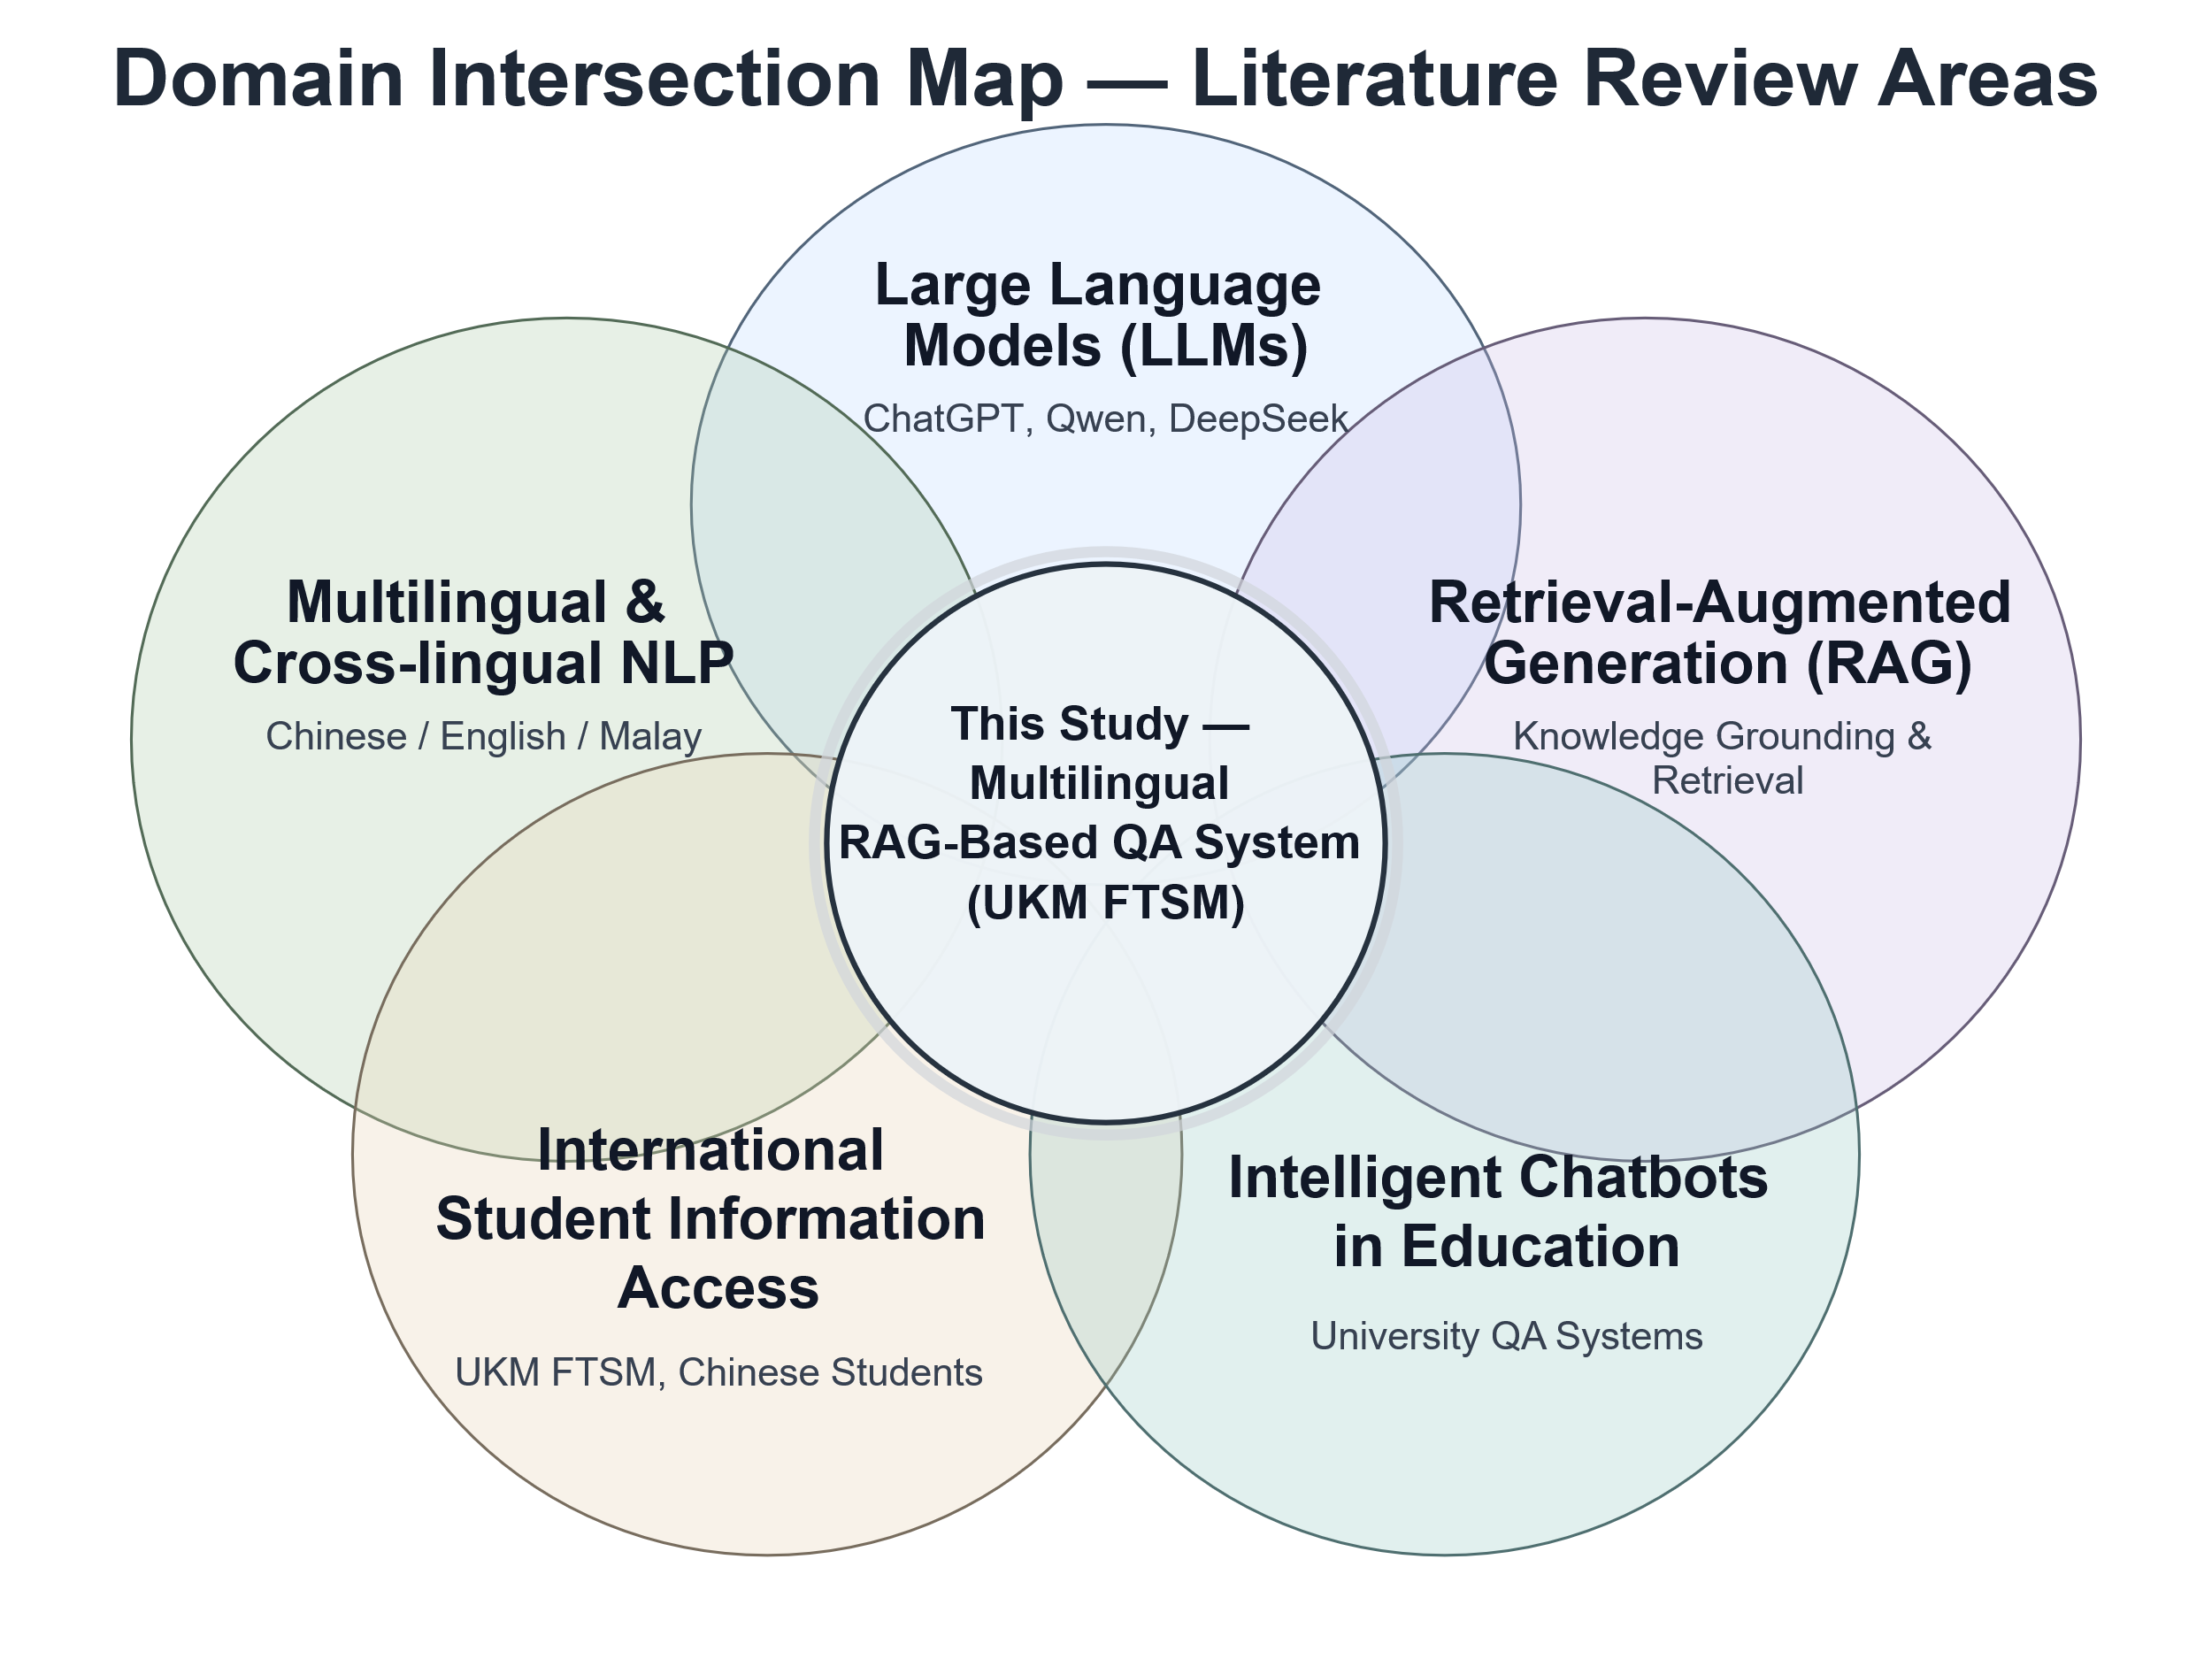
Figure 2.1 Domain Intersection of LLMs, RAG, and Multilingual QA Systems

METHODOLOGY
  - Methodology
    - Overview of the Proposed Methodology
With increasing sophistication in information needs of students enrolled in institutions of higher learning, there arises a need for the development of an intelligent system. Traditional FAQ pages or institutional websites cannot cater to such information needs of students that require instant responses regarding registration for classes, supervision, accommodation, visa processing, and many other aspects that are essential for a smooth campus experience (Kuhail et al., 2023). Such needs arise particularly when universities accommodate students from different backgrounds, who may use multiple languages for their communication such as Chinese, English, and Malay. Recent research by Elheneidy and Mohd (2025) highlights these challenges within multilingual universities.
A technologically feasible solution for dealing with these concerns comes from the concept of Retrieval Augmented Generation (RAG). In comparison to standalone Large Language Models (LLMs), where parametric knowledge is gained through pretraining, RAGs retrieve relevant documents from an external source before generating any responses, which ensures contextual grounding and prevents hallucinations (Lewis et al., 2020; Alansari and Luqman, 2025). Studies in recent times have proven the feasibility of adopting the RAG approach for developing information assistants for universities such as chatbots (Saha and Saha, 2024), resource navigators (Neupane et al., 2024), and academic assistants for faculty members (Antico et al., 2024). This chapter relies on the architectural foundations developed through such prior studies.
This chapter contains the entire methodological discussion pertaining to the process of designing, building and implementing the FTSM-RAG system, which is a specialized RAG designed specifically for serving FTSM, UKM, the Faculty of Information Science and Technology. The system will include a LangChain-based agentic framework (Chase, 2022), Chroma vector database, DashScope text-embedding-v4 model and Qwen LLM, all of which are connected via the FastAPI back-end. One of the major innovations in the architecture proposed is that of semantic caching and a multilingual query processing mechanism to address the latency issues and multilinguism challenges seen in other applications of RAGs on campuses (Singh and Gupta, 2026; Gao et al., 2023).
The rest of the chapter has been structured as follows: section 3.2 discusses the architecture of the entire system and how the layers interact. Section 3.3 elaborates on the process of document extraction, text chunking with RecursiveCharacterTextSplitter, and text embedding using DashScope model. Section 3.4 discusses the process of processing multilingual queries by normalizing the text and doing Traditional to Simplified Chinese conversion as well as synonyms substitution. Section 3.5 discusses the retrieval augmented generation process by discussing the interplay of the LangChain agent, rag_summarize tool and Qwen. Section 3.6 talks about the semantic cache optimization technique and describes how it uses cosine similarity threshold as well as TTL-based expiry. Section 3.7 discusses the FastAPI architecture, project files and data storage.
    - System Architecture of FTSM-RAG
A general schema of the FTSM-RAG system architecture is depicted in Figure 3.1, providing information about its components and connections between them. The first boundary represents the users' interaction with the system, conducted through the User Interface, forwarding all the users' queries to the Application Service, taking care of the sessions, requests' validation, and forwarding the requests further. As a mediator between the user interface and the processing backend, the Application Service ensures consistent communication between these components while persisting all interaction records to the Conversation Storage (Gao et al., 2023).
The core element of the architecture is the Intelligent Processing Module, which performs all the actions required to create answers to questions asked by users. This component communicates bi-directionally with three other elements of the architecture: the Large Language Model (LLM) used for generating answers, a Vector Database for document search using semantic indexing, and a Knowledge Base including curated institutional documents of FTSM, UKM. As soon as a request arrives, the module uses vector database and knowledge base to build the context and passes it to the LLM to generate a grounded answer, following the framework described by Lewis et al. (2020) and known as Retrieval-Augmented Generation (RAG). Interaction records and all knowledge base updates are stored to the Conversation Storage using corresponding pipelines, presented in Figure 3.1 as dashed arrows.
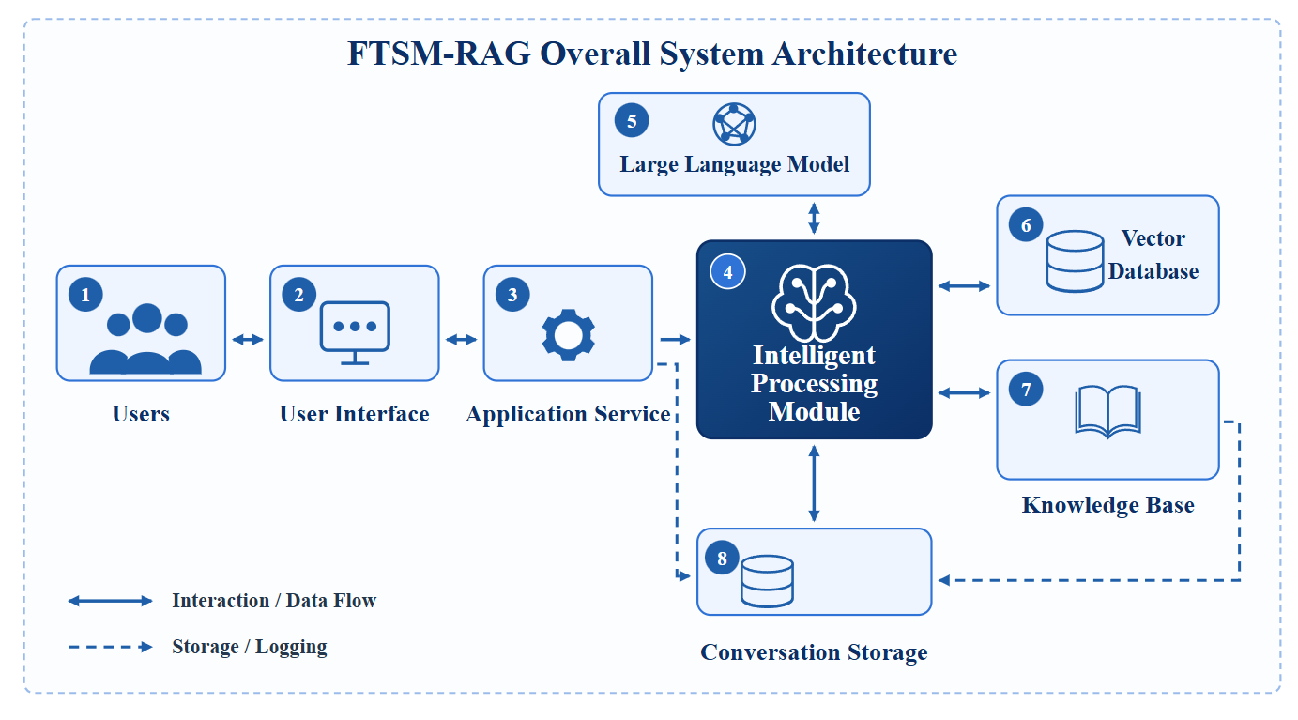
Thus, the system architecture described above allows all the components to function in a modular way, enabling updates of each component separately. In reality, the Application Service is implemented using FastAPI, Langchain agentic framework is used as the foundation for Intelligent Processing Module (Chase, 2022), Vector Database works on Chroma technology, and LLM is Tongyi Qwen retrieved via DashScope API (Zhao et al., 2023). Moreover, optimization mechanisms such as multilingual preprocessing of the queries and a semantic cache mechanism are integrated into Intelligent Processing Module and described in sections 3.4 and 3.6 accordingly (Gao et al., 2023; Qdrant, 2024; Singh and Gupta, 2026).
Figure 3.1 Overall Architecture of the RAG-Based Chatbot System
    - Knowledge Base Construction and Vectorization
This stage consists of five consecutive sub-stages that convert raw institutional documents into searchable semantic vector representations that will be saved in Chroma. As shown in Figure 3.2 below, these sub-stages include raw document ingestion, text extraction, text chunking, embedding generation, and indexing to Chroma Vector Database. The input format of this pipeline is one of four – TXT, PDF, PNG, and JPG – depending on the type of institutional communication. During each iteration of the pipeline, the ingested file is checked against validity rules to see whether a SourceDocument metadata object needs to be created, consisting of parameters like doc_id, hash, filename, and file_path. Then, if the hash value of the ingested file is already stored in ingestion_manifest.json, the file is ignored because hashing is a suggested best practice for de-duplication in production RAG ingestion pipelines. This is done to avoid the re-indexing of identical files, and thus to maintain consistency across indexing sessions (Lewis et al., 2020; Xu et al., 2025).
The next step in the pipeline is text extraction from each of the documents, with the corresponding file type (TXT, PDF, PNG, or JPG) defining the method of extracting the data. For the purposes of this pipeline, TXT documents are ingested as-is, PDF files are parsed using specialized libraries, and PNG/JPG images undergo OCR processing for text recovery. The obtained texts pass the filter to the text chunking sub-stage, where they are chunked recursively by paragraphs, sentences, and characters to the extent that each of the chunks does not exceed configured chunk_size with an overlapping of configured chunk_overlap values to provide smooth transition between chunks (Chase, 2022). Contrary to fixed splitters, which produce equal-sized text chunks regardless of document structure, RecursiveCharacterTextSplitter starts cutting large chunks of text, falling back to smaller chunks only if it is required. This approach makes it ideal for diverse corporate documents (Latif et al., 2025). In addition, each text chunk is annotated with a set of chunk-level metadata fields: chunk_id, chunk_index, doc_id, and source_type, to help retrieve documents by provenance information. Chunking strategy and overlap values have been found to significantly influence retrieval efficiency and accuracy in RAG systems (Qu et al., 2024; Gomez-Cabello et al., 2025).
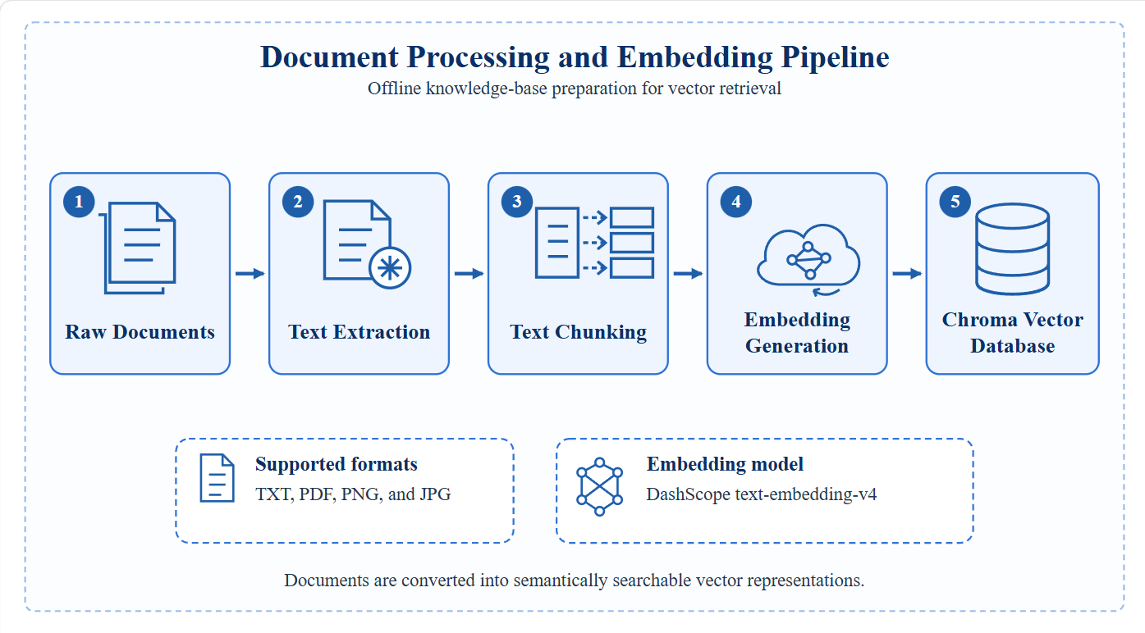
In the final sub-stage, chunks are converted into vector representations using DashScope text-embedding-v4 model as shown in Figure 3.2. This model was chosen due to its top retrieval efficiency in benchmark tests, possibility to tune task instructions with a parameter (text_type), and support for sparse and dense vector output, making it the most versatile model of all in DashScope API library (Alibaba Cloud, 2025). Obtained embeddings are stored together with their corresponding metadata as collections in a local Chroma Vector Database (Gao et al., 2023). After successful indexing, the document hash, chunk_id(s), and indexed_at field are added to ingestion_manifest.json (Alibaba Cloud, 2025).
Figure 3.2 Document Processing and Embedding Pipeline for RAG
    - Multilingual Query Processing
One of the crucial challenges for applying an intelligent assistant for students at a multilingual institution, like UKM, relates to the heterogeneity of the incoming requests in terms of the language used. Thus, students' queries may contain information in Simplified Chinese, Traditional Chinese, English, or Malay, and even if the same concept is used, its wording may be different. As a result, without additional preprocessing, such queries generate inconsistently embedded vectors with poor alignment with the respective chunk vectors stored in Chroma. Ultimately, this results in suboptimal performance of the system (Singh and Gupta, 2026). In order to tackle this issue, the FTSM-RAG model employs a multilingual query processing pipeline, depicted in Figure 3.3. This pipeline normalizes and enriches all incoming requests prior to executing the retrieval operation.
Firstly, the system applies text normalization, during which the original input text is cleaned up with respect to extra whitespaces, punctuation marks, and script inconsistencies. Specifically, the system converts Traditional Chinese into Simplified Chinese with the help of character-level conversion. This is required since the documents stored in the knowledge base use the Simplified script, and any differences in script representation will render semantically similar queries to have low alignment when comparing embeddings (Gao et al., 2023). In other words, students who submit their queries written in Traditional Chinese script, which is more common in the academic environment in Taiwan or Hong Kong, would experience the same level of retrieval performance as those using Simplified script.
Secondly, after performing text normalization, the system performs multilingual synonym expansion on the normalized query, adding domain-related synonyms or paraphrases in Chinese, English, and Malay. For example, the term "supervisor" can be replaced with "penyelia" in Malay or "导师" in Chinese, while "scholarship" can become "biasiswa" or "奖学金". Expansion is performed using a domain synonym dictionary specifically crafted for FTSM. Currently, it includes synonyms pertaining to knowledge domains like visas and permits, course enrolment, supervision, housing, scholarships, and student affairs. The choice of this approach follows the recommendations from recent RAG research suggesting expanding a user's query into multiple semantically close alternatives as part of a multi-query retrieval (Gao et al., 2023; Neupane et al., 2024). The set of alternative queries is subsequently passed to the
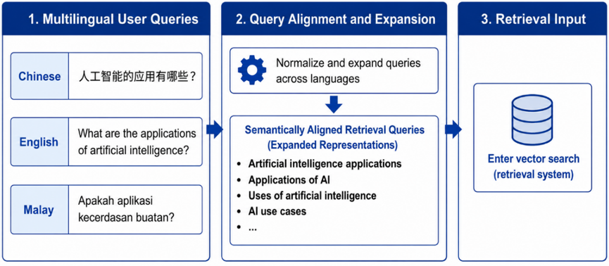
retrieval module, and duplicates with regard to page_content are filtered out before context extraction occurs.
Figure 3.3 Cross-Lingual Query Alignment and Expansion for RAG Retrieval
    - Retrieval-Augmented Generation Framework
The Retrieval-Augmented Generation (RAG) model forms the backbone of the FTSM-RAG question answering model. Contrary to traditional models that solely depend on parameterised knowledge to generate responses, RAG generates answers by retrieving relevant institutional content related to the specific field at the time of inference, thereby grounding its responses and minimizing the risk of errors – especially important in student services where erroneous answers about programmatic issues or institutional policies can negatively mislead the users (Lewis et al., 2020; Alansari and Luqman, 2025).
Agent Initialization and Tool Decision. As depicted in the left portion of Figure 3.3, all user queries go through a LangChain Agent which is initialized by the create_agent function. The create_agent function binds the Qwen LLM with the rag_summarize tool, an operation that makes the agent work under the ReAct (Reasoning and Acting) approach by Yao et al. (2022). Upon receiving a query from the student, the agent conducts a ReAct-based tool decision. In particular, in case there is a need for domain knowledge, the agent decides to call the rag_summarize tool; otherwise, the agent provides the response without calling any tools (Chase, 2022).
Upon invocation, the rag_summarize tool receives the aligned and expanded query variants produced by the multilingual preprocessing pipeline described in Section 3.4. To maximize retrieval coverage and precision, the system employs a three-stage hybrid retrieval pipeline, as illustrated in Figure 3.3.
In the first stage, namely dual-path candidate recall, each query variant is processed by two complementary retrievers executed concurrently via a thread pool, with the vector retriever processing all query variants in parallel and the BM25 retriever scoring the original query simultaneously, such that the total recall latency equals the duration of the slower path rather than the sum of both. A dense vector retriever encodes each variant using the DashScope text-embedding-v4 model and submits it to the Chroma Vector Database for top-$k$ semantic retrieval, with $k=12$, returning the most contextually relevant chunks based on cosine similarity. Simultaneously, a sparse BM25 retriever performs keyword-based retrieval over the same corpus. BM25 scores a candidate document $D$ against a query $Q$ as
$$score(D,Q)=\sum_{i=1}^{n}{IDF}(q_{i})⋅\frac{f(q_{i},D)⋅(k_{1}+1)}{f(q_{i},D)+k_{1}⋅\left(1-b+b⋅\frac{∣D∣}{avgdl}\right)}$$
where $f(q_{i},D)$ denotes the frequency of term $q_{i}$ in document $D$, $∣D∣$ is the document length, and $avgdl$ is the average document length in the corpus. In this study, $k_{1}=1.5$ and $b=0.75$, following the standard BM25 setting. The inverse document frequency is defined as
$$IDF(q_{i})=ln⁡\left(\frac{N-n(q_{i})+0.5}{n(q_{i})+0.5} + 1\right)$$
where $N$ is the total number of documents and $n(q_{i})$ is the number of documents containing term $q_{i}$. This dual-path design allows the system to recover candidates that dense retrieval may miss because of vocabulary mismatch, especially for domain-specific acronyms, abbreviations, and proper nouns commonly found in institutional documents (Robertson and Zaragoza, 2009).
In the second stage, namely rank fusion, the two candidate lists are merged using Reciprocal Rank Fusion (RRF), which assigns each document a combined score according to its rank across multiple ranked lists:
$$RRF(d)=\sum_{r∈R}{\frac{1}{k+{rank}_{r}(d)}}$$
where $R$ denotes the set of ranked lists, ${rank}_{r}(d)$ is the position of document $d$ in ranked list $r$, and $k=60$ is a smoothing constant used to prevent top-ranked items from dominating the final score. RRF is adopted because it is simple, robust, and does not require manual tuning of fusion weights, while still performing strongly across heterogeneous retrieval sources (Cormack et al., 2009).
In the third stage, namely cross-encoder re-ranking, the top candidates produced by RRF are rescored using the DashScope gte-rerank-v2 cross-encoder model. In contrast to the bi-encoder architecture used in dense retrieval, where the query and document are encoded independently and then compared by a similarity function,
$$s_{bi}(q,d)=sim(Enc(q),Enc(d))$$
the cross-encoder concatenates the query and document into a single sequence and produces a relevance score through joint encoding:
$$s_{cross}(q,d)=f_{θ}([q⊕d])$$
where $⊕$ denotes sequence concatenation and $f_{θ}$ represents the cross-encoder model. This formulation allows full self-attention interaction between query tokens and document tokens, resulting in more precise relevance estimation. However, because cross-encoders are computationally more expensive than bi-encoders, re-ranking is applied only to the small candidate set produced by the upstream fusion stage rather than to the full corpus (Nogueira and Cho, 2019). Finally, the top-6 documents ranked by the cross-encoder are selected as the final retrieval context and assembled for answer generation.
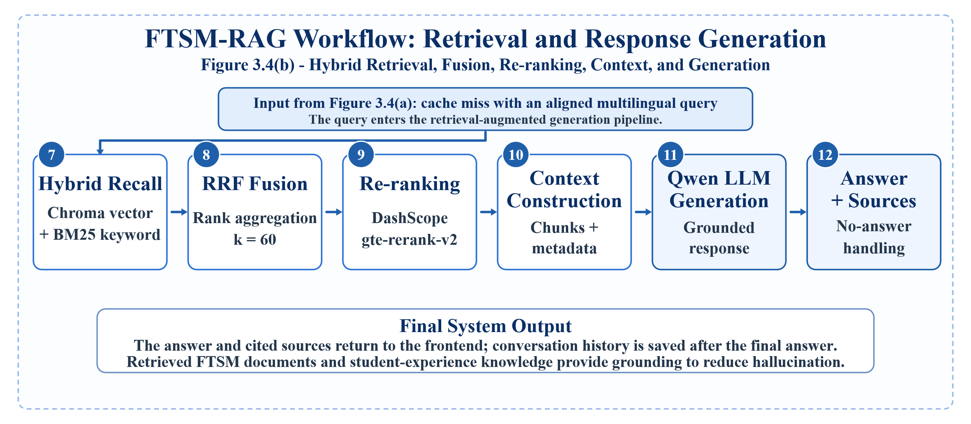
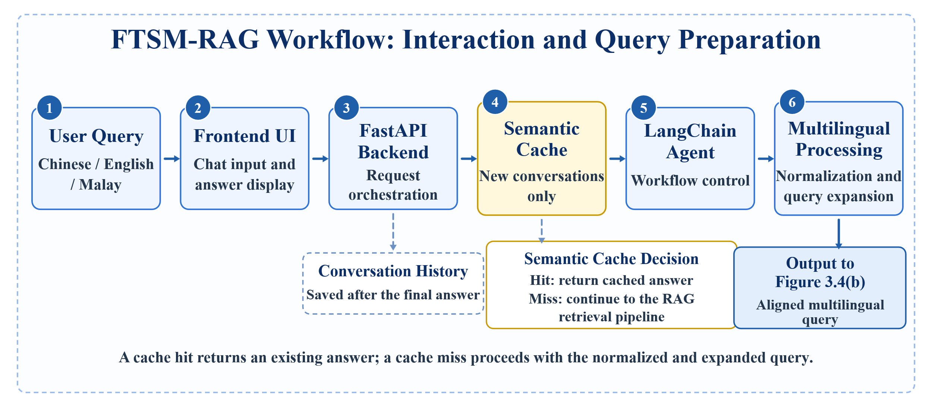
Both the simulated context and query are sent to the Qwen Large Language Model, which produces an institutionalized response without any hallucinations, as illustrated in Figure 3.3. In addition, a Source Summary document is attached that consists of all the sources and snippets used in the response, so students can validate their answers against institutional documents. Then, the response is sent back to the FastAPI Backend for session management before being sent to the Frontend Display with its source summary. Furthermore, queries, answers, sources, and metadata are stored in Conversation History Storage to ensure consistency in multi-turn conversations (Zhao et al., 2023).
Figure 3.4 (a) FTSM-RAG Interaction and Query Preparation Workflow
Figure 3.4 (b) FTSM-RAG Retrieval and Response Generation Workflow
    - Semantic Cache Optimization Strategy
One of the recurring limitations of implementing standard RAG architectures in environments with a large number of educational interactions is the additional computational costs associated with repeating embedding, retrieving, and querying operations for semantically equivalent student queries. Often, users send requests asking the same informational question but in different terms: for instance, "What are the requirements for the Master's program?" and "What do I need to apply for the Master's program?". In the current implementation, RAG pipelines do not understand whether two queries are semantically equivalent and will process every query independently, resulting in extra embeddings generation, vector searches, and API calls to the LLM. To solve this problem, the FTSM-RAG system uses the Semantic Cache component that acts as an intercepting stage in the pipeline. While the previous solutions match student queries via the surface form, the cache component is based on semantic equivalence comparison by checking the query embeddings (see Figure 3.4). Thus, the cache can effectively detect and provide answers to equivalent but differently phrased queries.
The algorithm of the cache component is as follows: when receiving a student query, the system first generates an embedding vector out of it with the use of DashScope text-embedding-v4 model. Then, the system calculates the similarity of this query vector to all cached vectors available in semantic_cache.json by performing cosine similarity measurement. By finding the angle between two vectors, cosine similarity produces a numeric result ranging from 0 to 1 (the values closer to one mean that two vectors have the same content). The system finds the most similar pair of vectors and, if the highest similarity score is 0.92 or more, returns the corresponding answer and thus skips all other retrieval and generation stages (it is referred to as cache hit). Otherwise, cache miss occurs, the full RAG pipeline is executed as described above in section 3.5, and after generating the response, the new query vector, the answer, and the current timestamp get added to semantic_cache.json for future usage. The threshold of 0.92 was chosen in order to minimize chances of misclassification: values lower than the threshold may cause answering irrelevant queries with the help of the cache, while higher values would make hit rate significantly low (Qdrant, 2024).
In order to prevent unbounded cache storage growth and avoid stale answers, two constraints were implemented. First, every item is assigned with Time-To-Live expiration period according to the timestamp, and thus every outdated item becomes invalid and gets automatically deleted from the cache store. This way, answers concerning time-sensitive data (application deadlines or dates for obtaining scholarships) do not become outdated in time. Additionally, a certain maximum cache entry size constraint was set up, so if the limit was exceeded, least recently used items got deleted. These restrictions guarantee efficient performance and accuracy of the semantic cache solution in the long-term operation. The effects of having this component are obvious: a significant reduction in the amount of API calls to the embedding model, reduced latency of repeated requests, and increased system throughput under user concurrency. As stated previously, all these are some of the most commonly mentioned advantages of using semantic cache in RAG-based systems (Qdrant, 2024; Gao et al., 2023). To enable runtime monitoring of cache performance metrics, /api/cache/stats endpoint is provided that shows hit count, miss count, and hit rate metrics cumulatively.
    - System Implementation Details
The FTSM-RAG system implementation is a lightweight standalone application that runs locally without reliance on any external infrastructure except the DashScope API. Specifically, the FTSM-RAG implementation follows the modular design principles where the web backend, agent layer, retrieval pipeline, and data storage are encapsulated into distinct modules interfaced via clear-cut boundaries. The entrance point of the application is web_app.py, which initializes the FastAPI application, adds all routes, serves the static frontend and opens up the locally hosted web service.
FastAPI was chosen as the web backend for the following reasons. First, the capability of handling asynchronous requests allows serving the streaming answers generated by the Qwen language model without blocking concurrent requests. This is crucial for chat interface implementations that feature response delays of several seconds. Second, the tight integration of FastAPI with the Python ecosystem allows seamless work with LangChain, Chroma, and the DashScope SDK. Finally, request validation provided by the framework eases implementation and maintenance efforts. The backend serves the frontend pages at the GET /, GET /manage, and GET /settings routes and exposes a variety of API endpoints, namely POST /api/chat, POST /api/upload, GET /api/documents, GET /api/settings, POST /api/settings, POST /api/training/start, and GET /api/cache/stats. Chatting functionality is achieved via POST /api/chat endpoint which validates the presence of the configured DASHSCOPE_API_KEY, checks if the incoming message is not empty, generates or reuses the corresponding conversation_id, and responds with the StreamingResponse providing the generated answer via Server-Sent Events (SSE). SSE is a standard of the WHATWG that enables server-side push mechanism through the unidirectional HTTP connection which allows streaming of the generated tokens without the connection management overhead associated with the WebSocket protocol (WHATWG, 2026). This solution is suitable for RAG chat interfaces where client-server communication suffices. The stream_chat_answer(...) method in services/chat_service.py handles the chat message: invokes semantic cache check, performs agent execution, persists the conversation, and updates the cache as a part of one single request processing flow. Recent chat messages are fetched via the ConversationStore object and supplied to the agent as the short-term dialogue context (Chase, 2022).
The FTSM-RAG implementation features logical separation of components by directories. Agent/ holds the LangChain ReAct agent code (react_agent.py) along with the implementation of the rag_summarize tool (agent/tools/agent_tools.py). Retrieval and generation operations are encapsulated in the rag/ directory (rag_service.py, vector_store.py, ingestion.py). Various utility functions (e.g., query preprocessing and semantic caching) are contained in utils/. Configuration (chunk size parameters, Chroma settings, prompt templates) is managed via YAML files placed in config/. Static frontend, consisting of HTML templates and JS files, is served by FastAPI directly from the web/ directory.
Integration with DashScope API takes place in model/factory.py, which uses the lazy initialization scheme, i.e., instantiates the clients only upon first use. Embedding model is fixed at text-embedding-v4 for consistency in the ingestion and retrieval phases. By default, the chat model is set to qwen3-max, but it can be set to any value through CHAT_MODEL_NAME environment variable. The runtime configuration options such as models names and API keys are saved and loaded from the .env file by means of services/settings_service.py. Thus, administrators can change system parameters via Settings Page without restarting the application manually (Alibaba Cloud, 2025).
All persistent data is stored locally using JSON files and a Chroma vector database. Conversations are stored in data/ukm_ftsm/conversations/ directory, where the index.json file maintains the list of all existing conversations, while each conversation is stored as a UUID-named JSON file holding the id, title, updated_at time, and the array of messages. Each message keeps information about the role, message content, and created_at time. Semantic cache is persisted in the data/ukm_ftsm/semantic_cache.json file, where each entry contains the original question, generated answer, embedding vector, and created_at time, having a similarity threshold of 0.92, TTL of seven days, and limit of 500 entries. Ingestion metadata are logged in data/ukm_ftsm/ingestion_manifest.json. The Chroma vector store is configured via config/chroma.yml with collection named ftsm_rag_agent. The Chroma database is stored locally at chroma_db_ftsm/ directory with chunk_size = 800, chunk_overlap = 120, and topk = 6. Local JSON persistence with the locally deployed Chroma instance was consciously chosen because it does not rely on any external database and makes deployment easier for institutions with restricted networks. All student data stays local, complying with the privacy requirements (Lewis et al., 2020). Whenever the knowledge documents are uploaded, removed, or knowledge base trained anew, the semantic cache is erased to ensure no stale responses are returned with altered knowledge.
    - Summary
This chapter provides an overview of the complete methodology behind the design and deployment of the FTSM-RAG system, which can be understood as a multilingual intelligent assistant that works within a particular domain. In this chapter, we started with a general description of the system architecture, which was outlined in Section 3.2. The main interactions among the user interface, the application service, the intelligent processing module, the large language model, the vector database, knowledge base, and conversation storage were considered. The knowledge base construction and vectorization process was covered in Section 3.3 and comprised document indexing, hash-based duplication removal, structure-aware text chunking by means of RecursiveCharacterTextSplitter, and the generation of text embeddings by using the DashScope text-embedding-v4 API, where all documents were indexed and stored in the local Chroma vector database. Section 3.4 provided an account of the query processing pipeline, including normalization of incoming queries in Chinese, English, and Malay, optional conversion of scripts, and semantic diversification by expanding the query to its synonyms. The core framework of Retrieval-Augmented Generation was presented in Section 3.5, which describes the collaborative work performed by the LangChain ReAct agent, rag_summarize utility, a three-stage hybrid retrieval process with BM25 keyword retrieval, RRF rank fusion, cross-encoder re-ranking, context construction, and Qwen answer generation resulting in factually correct and institutionally verified answers with reduced hallucination rate. Section 3.6 described an approach to semantic caching of queries, where incoming queries are compared against the cached query vectors in terms of cosine similarity and the stored answers returned for those whose similarity score exceeds a value of 0.92. The implementation section (3.7) outlined FastAPI architecture, integration with the DashScope API, module structure of the project, as well as design of the local JSON and Chroma data storage.
As a whole, the methodological elements introduced in this chapter tackle the three key challenges stated in Chapter 2: the necessity to ensure factual correctness of information provided in a particular domain, multilingual query processing capabilities, as well as efficient performance of the system under repeated query patterns. All technical aspects covered in this chapter provide a technical basis for evaluating the performance of the system presented in Chapter 4.

References
Alansari, A. and Luqman, H. (2025) Large Language Models Hallucination: A Comprehensive Survey. arXiv:2510.06265. Available at: https://arxiv.org/abs/2510.06265 (Accessed: 20 April 2026).
Alibaba Cloud (2025) Text Embedding Models: DashScope API Documentation. Alibaba Cloud Model Studio. Available at: https://www.alibabacloud.com/help/en/model-studio/embedding (Accessed: 26 April 2026).
Antico, C., Giordano, S., Koyuturk, C. and Ognibene, D. (2024) Unimib Assistant: Designing a Student-Friendly RAG-Based Chatbot for All Their Needs. Proceedings of the Italian Workshop on Artificial Intelligence for Human Machine Interaction (AIxHMI 2024), Bolzano, Italy, 26 November 2024. arXiv:2411.19554. Available at: https://doi.org/10.48550/arXiv.2411.19554 (Accessed: 20 April 2026).
Brown, T. B., Mann, B., Ryder, N., Subbiah, M., Kaplan, J. D., Dhariwal, P., Neelakantan, A., Shyam, P., Sastry, G., Askell, A., Agarwal, S., Herbert-Voss, A., Krueger, G., Henighan, T., Child, R., Ramesh, A., Ziegler, D. M., Wu, J., Winter, C. and Amodei, D. (2020) Language Models are Few-Shot Learners. Advances in Neural Information Processing Systems, 33, pp. 1877-1901. Available at: https://proceedings.neurips.cc/paper/2020/hash/1457c0d6bfcb4967418bfb8ac142f64a-Abstract.html (Accessed: 6 June 2026).
Chase, H. (2022) LangChain. Available at: https://github.com/langchain-ai/langchain (Accessed: 10 April 2026).
Conneau, A., Khandelwal, K., Goyal, N., Chaudhary, V., Wenzek, G., Guzmán, F., Grave, E., Ott, M., Zettlemoyer, L. and Stoyanov, V. (2020) Unsupervised Cross-lingual Representation Learning at Scale. Proceedings of the 58th Annual Meeting of the Association for Computational Linguistics, pp. 8440-8451. Available at: https://doi.org/10.18653/v1/2020.acl-main.747 (Accessed: 6 June 2026).
Cormack, G. V., Clarke, C. L. A. and Buettcher, S. (2009) Reciprocal Rank Fusion outperforms Condorcet and individual Rank Learning Methods. Proceedings of the 32nd International ACM SIGIR Conference on Research and Development in Information Retrieval, pp. 758–759. Available at: https://dl.acm.org/doi/10.1145/1571941.1572114 (Accessed: 28 April 2026).
Elheneidy, S. S. A. M. and Mohd, Z. S. (2025) Exploring Challenges and Coping Strategies for Mental Well-Being among International Students in Malaysia. Journal of Cognitive Sciences and Human Development, 11(1), pp. 19-34. Available at: https://doi.org/10.33736/jcshd.8719.2025 (Accessed: 20 April 2026).
Faculty of Information Science and Technology (FTSM), Universiti Kebangsaan Malaysia (2024) Faculty of Information Science and Technology Official Website. Available at: https://ftsm.ukm.my/v6/ (Accessed: 10 April 2026).
Feng, F., Yang, Y., Cer, D., Arivazhagan, N. and Wang, W. (2022) Language-agnostic BERT Sentence Embedding. Proceedings of the 60th Annual Meeting of the Association for Computational Linguistics, pp. 878-891. Available at: https://doi.org/10.18653/v1/2022.acl-long.62 (Accessed: 6 June 2026).
Gao, Y., Xiong, Y., Gao, X., Jia, K., Pan, J., Bi, Y., Dai, Y., Sun, J., Wang, M. and Wang, H. (2023) Retrieval-Augmented Generation for Large Language Models: A Survey. arXiv:2312.10997. Available at: https://doi.org/10.48550/arXiv.2312.10997 (Accessed: 10 April 2026).
Gomez-Cabello, C. A., Prabha, S., Haider, S. A., Genovese, A., Collaco, B. G., Wood, N. G., Bagaria, S. and Forte, A. J. (2025) Comparative Evaluation of Advanced Chunking for Retrieval-Augmented Generation in Large Language Models for Clinical Decision Support. Bioengineering, 12(11), 1194. Available at: https://doi.org/10.3390/bioengineering12111194 (Accessed: 26 April 2026).
Hartono, L. S., Setiawan, E. I. and Singh, V. (2025) Retrieval Augmented Generation-Based Chatbot for Prospective and Current University Students. International Journal of Engineering, Science, and Information Technology, 5(3), pp. 268-277. Available at: https://doi.org/10.52088/ijesty.v5i3.951 (Accessed: 20 April 2026).
Izacard, G. and Grave, E. (2021) Leveraging Passage Retrieval with Generative Models for Open Domain Question Answering. Proceedings of the 16th Conference of the European Chapter of the Association for Computational Linguistics, pp. 874-880. Available at: https://doi.org/10.18653/v1/2021.eacl-main.74 (Accessed: 6 June 2026).
Ji, Z., Lee, N., Frieske, R., Yu, T., Su, D., Xu, Y., Ishii, E., Bang, Y. J., Madotto, A. and Fung, P. (2023) Survey of Hallucination in Natural Language Generation. ACM Computing Surveys, 55(12), pp. 1-38. Available at: https://doi.org/10.1145/3571730 (Accessed: 6 June 2026).
Karpukhin, V., Oguz, B., Min, S., Lewis, P., Wu, L., Edunov, S., Chen, D. and Yih, W.-t. (2020) Dense Passage Retrieval for Open-Domain Question Answering. Proceedings of the 2020 Conference on Empirical Methods in Natural Language Processing, pp. 6769-6781. Available at: https://doi.org/10.18653/v1/2020.emnlp-main.550 (Accessed: 6 June 2026).
Kuhail, M. A., Alturki, N., Alramlawi, S. and Alhejori, K. (2023) Interacting with Educational Chatbots: A Systematic Review. Education and Information Technologies, 28, pp. 973-1018. Available at: https://doi.org/10.1007/s10639-022-11177-3 (Accessed: 10 April 2026).
Labadze, L., Grigolia, M. and Machaidze, L. (2023) Role of AI Chatbots in Education: Systematic Literature Review. International Journal of Educational Technology in Higher Education, 20, 56. Available at: https://doi.org/10.1186/s41239-023-00426-1 (Accessed: 6 June 2026).
Latif, S., Ameer, H., Akram, M. H. and Fatima, M. (2025) The Chunking Paradigm: Recursive Semantic for RAG Optimization. In Proceedings of the 8th International Conference on Natural Language and Speech Processing (ICNLSP-2025), pp. 137-145. Association for Computational Linguistics. Available at: https://aclanthology.org/2025.icnlsp-1.15/ (Accessed: 26 April 2026).
Lewis, P., Perez, E., Piktus, A., Petroni, F., Karpukhin, V., Goyal, N., Küttler, H., Lewis, M., Yih, W.-t., Rocktäschel, T., Riedel, S. and Kiela, D. (2020) Retrieval-Augmented Generation for Knowledge-Intensive NLP Tasks. Advances in Neural Information Processing Systems (NeurIPS). Available at: https://doi.org/10.48550/arXiv.2005.11401 (Accessed: 10 April 2026).
Neupane, S., Hossain, E., Keith, J., Tripathi, H., Ghiasi, F., Golilarz, N. A., Amirlatifi, A., Mittal, S. and Rahimi, S. (2024) From Questions to Insightful Answers: Building an Informed Chatbot for University Resources. arXiv:2405.08120. Available at: https://doi.org/10.48550/arXiv.2405.08120 (Accessed: 20 April 2026).
Nogueira, R. and Cho, K. (2019) Passage Re-ranking with BERT. arXiv:1901.04085. Available at: https://doi.org/10.48550/arXiv.1901.04085 (Accessed: 28 April 2026).
Okonkwo, C. W. and Ade-Ibijola, A. (2021) Chatbots Applications in Education: A Systematic Review. Computers and Education: Artificial Intelligence, 2, 100033. Available at: https://doi.org/10.1016/j.caeai.2021.100033 (Accessed: 6 June 2026).
OpenAI (2023) GPT-4 Technical Report. arXiv preprint arXiv:2303.08774. Available at: https://doi.org/10.48550/arXiv.2303.08774 (Accessed: 10 April 2026).
Qdrant (2024) Semantic Cache: Accelerating AI with Lightning-Fast Data Retrieval. Available at: https://qdrant.tech/articles/semantic-cache-ai-data-retrieval/ (Accessed: 26 April 2026).
Qu, R., Bao, F. and Tu, R. (2024) Is Semantic Chunking Worth the Computational Cost? arXiv:2410.13070. Available at: https://doi.org/10.48550/arXiv.2410.13070 (Accessed: 26 April 2026).
Reimers, N. and Gurevych, I. (2020) Making Monolingual Sentence Embeddings Multilingual Using Knowledge Distillation. Proceedings of the 2020 Conference on Empirical Methods in Natural Language Processing, pp. 4512-4525. Available at: https://doi.org/10.18653/v1/2020.emnlp-main.365 (Accessed: 6 June 2026).
Robertson, S. and Zaragoza, H. (2009) The Probabilistic Relevance Framework: BM25 and Beyond. Foundations and Trends in Information Retrieval, 3(4), pp. 333–389. Available at: https://dl.acm.org/doi/10.1561/1500000019 (Accessed: 28 April 2026).
Saha, B. and Saha, U. (2024) Enhancing International Graduate Student Experience through AI-Driven Support Systems: A LLM and RAG-Based Approach. 2024 International Conference on Data Science and Its Applications (ICoDSA). Available at: https://ieeexplore.ieee.org/document/10651944/ (Accessed: 12 April 2026).
Singh, H. and Gupta, G. (2026) Optimizing Cross-Lingual Information Retrieval in Campus Administration using Retrieval-Augmented Generation and Semantic Chunking. International Journal for Research in Applied Science and Engineering Technology, 14(1), pp. 447-455. Available at: https://doi.org/10.22214/ijraset.2026.76860 (Accessed: 20 April 2026).
Singh, J. K. N. and Jack, G. (2022) The Role of Language and Culture in Postgraduate International Students' Academic Adjustment and Academic Success: Qualitative Insights from Malaysia. Journal of International Students, 12(2), pp. 444-466. Available at: https://doi.org/10.32674/jis.v12i2.2351 (Accessed: 6 June 2026).
Vaswani, A., Shazeer, N., Parmar, N., Uszkoreit, J., Jones, L., Gomez, A. N., Kaiser, L. and Polosukhin, I. (2017) Attention Is All You Need. Advances in Neural Information Processing Systems, 30. Available at: https://proceedings.neurips.cc/paper/7181-attention-is-all-you-need (Accessed: 6 June 2026).
WHATWG (2026) HTML Living Standard: Server-sent events. Available at: https://html.spec.whatwg.org/multipage/server-sent-events.html (Accessed: 28 April 2026).
Xu, X., Weytjens, H., Zhang, D., Lu, Q., Weber, I. and Zhu, L. (2025) RAGOps: Operating and Managing Retrieval-Augmented Generation Pipelines. arXiv:2506.03401. Available at: https://arxiv.org/abs/2506.03401 (Accessed: 26 April 2026).
Yao, S., Zhao, J., Yu, D., Du, N., Shafran, I., Narasimhan, K. and Cao, Y. (2022) ReAct: Synergizing Reasoning and Acting in Language Models. arXiv:2210.03629. Available at: https://doi.org/10.48550/arXiv.2210.03629 (Accessed: 10 April 2026).
Zhai, X. and Razali, A. B. (2022) International Chinese Postgraduate Students' Adaptation Strategies for Oral English Communication Practices in Malaysian Higher Education Institutions. Education Research International, 2022, 6439726. Available at: https://doi.org/10.1155/2022/6439726 (Accessed: 6 June 2026).
Zhao, W. X., Zhou, K., Li, J., Tang, T., Wang, X., Hou, Y., Min, Y., Zhang, B., Zhang, J., Dong, Z., Du, Y., Yang, C., Chen, Y., Chen, Z., Jiang, J., Ren, R., Li, Y., Tang, X., Liu, Z., Liu, P., Nie, J. Y. and Wen, J. R. (2023) A Survey of Large Language Models. arXiv:2303.18223. Available at: https://doi.org/10.48550/arXiv.2303.18223 (Accessed: 10 April 2026).

