Urlrewrite地址重定向的实现

UrlRewrite就是我们通常说的地址重写，用户得到的全部都是经过处理后的URL地址。其优点有：

（1）提高安全性，可以有效的避免一些参数名、ID等完全暴露在用户面前，如果用户随便乱输的话，不符合规则的话直接会返回个404或错误页面，这比直接返回500或一大堆服务器错误信息要好的多。

（2）美化URL，去除了那些比如*.do之类的后缀名、长长的参数串等，可以自己组织精简更能反映访问模块内容的URL。

（3）更有利于搜索引擎的收入，通过对URL的一些优化，可以使搜索引擎更好的识别与收录网站的信息。

实现过程：

1 建立一个名为urlrewrite_demo的Maven Project，具体步骤见

<http://blog.csdn.net/haishu_zheng/article/details/51490299>

2 文件目录结构如下图所示

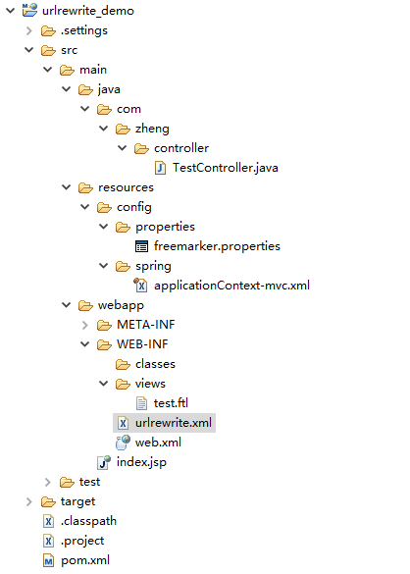

3 在pom.xml中添加四个jar包：

spring-webmvc

spring-context-support

urlrewritefilter

freemarker

添加完之后的完整内容为

<project xmlns=*"http://maven.apache.org/POM/4.0.0"* xmlns:xsi=*"http://www.w3.org/2001/XMLSchema-instance"*

xsi:schemaLocation=*"http://maven.apache.org/POM/4.0.0 http://maven.apache.org/xsd/maven-4.0.0.xsd"*>

<modelVersion>4.0.0</modelVersion>

<groupId>urlrewrite_demo</groupId>

<artifactId>urlrewrite_demo</artifactId>

<version>0.0.1-SNAPSHOT</version>

<packaging>war</packaging>

<name>urlrewrite_demo</name>

<description />

<properties>

<project.build.sourceEncoding>UTF-8</project.build.sourceEncoding>

</properties>

<dependencies>

<dependency>

<groupId>org.springframework</groupId>

<artifactId>spring-webmvc</artifactId>

<version>3.2.9.RELEASE</version>

</dependency>

<dependency>

<groupId>org.springframework</groupId>

<artifactId>spring-context-support</artifactId>

<version>3.2.9.RELEASE</version>

</dependency>

<dependency>

<groupId>org.tuckey</groupId>

<artifactId>urlrewritefilter</artifactId>

<version>4.0.3</version>

</dependency>

<dependency>

<groupId>org.freemarker</groupId>

<artifactId>freemarker</artifactId>

<version>2.3.23</version>

</dependency>

<dependency>

<groupId>javax</groupId>

<artifactId>javaee-api</artifactId>

<version>7.0</version>

<scope>provided</scope>

</dependency>

</dependencies>

<build>

<plugins>

<plugin>

<artifactId>maven-compiler-plugin</artifactId>

<version>2.3.2</version>

<configuration>

<source>1.7</source>

<target>1.7</target>

</configuration>

</plugin>

<plugin>

<artifactId>maven-war-plugin</artifactId>

<version>2.2</version>

<configuration>

<version>3.1</version>

<failOnMissingWebXml>false</failOnMissingWebXml>

</configuration>

</plugin>

</plugins>

</build>

</project>

4 web.xml中的完整内容为

<?xml version=*"1.0"* encoding=*"UTF-8"*?>

<web-app xmlns:xsi=*"http://www.w3.org/2001/XMLSchema-instance"*

xmlns=*"http://xmlns.jcp.org/xml/ns/javaee"*

xsi:schemaLocation=*"http://xmlns.jcp.org/xml/ns/javaee http://xmlns.jcp.org/xml/ns/javaee/web-app_3_1.xsd"*

id=*"WebApp_ID"* version=*"3.1"*>

<display-name>urlrewrite_demo</display-name>

<filter>

<filter-name>UrlRewriteFilter</filter-name>

<filter-class>org.tuckey.web.filters.urlrewrite.UrlRewriteFilter</filter-class>

</filter>

<filter-mapping>

<filter-name>UrlRewriteFilter</filter-name>

<url-pattern>/*</url-pattern>

<dispatcher>REQUEST</dispatcher>

<dispatcher>FORWARD</dispatcher>

</filter-mapping>

<servlet>

<servlet-name>dispatcher</servlet-name>

<servlet-class>org.springframework.web.servlet.DispatcherServlet</servlet-class>

<init-param>

<param-name>contextConfigLocation</param-name>

<param-value>/WEB-INF/classes/config/spring/applicationContext-mvc.xml</param-value>

</init-param>

<load-on-startup>1</load-on-startup>

</servlet>

<servlet-mapping>

<servlet-name>dispatcher</servlet-name>

<url-pattern>/service/*</url-pattern>

</servlet-mapping>

</web-app>

5 /src/reources/config/spring/applicationContext-mvc.xml中的完整内容为：

<?xml version=*"1.0"* encoding=*"UTF-8"*?>

<beans xmlns=*"http://www.springframework.org/schema/beans"*

xmlns:xsi=*"http://www.w3.org/2001/XMLSchema-instance"* xmlns:context=*"http://www.springframework.org/schema/context"*

xmlns:aop=*"http://www.springframework.org/schema/aop"* xmlns:p=*"http://www.springframework.org/schema/p"*

xmlns:tx=*"http://www.springframework.org/schema/tx"* xmlns:mvc=*"http://www.springframework.org/schema/mvc"*

xsi:schemaLocation=*"http://www.springframework.org/schema/beans*

*http://www.springframework.org/schema/beans/spring-beans-3.2.xsd*

*http://www.springframework.org/schema/context*

*http://www.springframework.org/schema/context/spring-context-3.2.xsd*

*http://www.springframework.org/schema/aop*

*http://www.springframework.org/schema/aop/spring-aop-3.2.xsd*

*http://www.springframework.org/schema/tx*

*http://www.springframework.org/schema/tx/spring-tx-3.2.xsd*

*http://www.springframework.org/schema/mvc*

*http://www.springframework.org/schema/mvc/spring-mvc-3.2.xsd"*>

<!-- 有 @Controller注解的表现层控制器组件 -->

<context:component-scan base-package=*"com.zheng.controller"* />

<!-- 配置Freemarker属性文件路径 -->

<bean id=*"freemarkerConfiguration"*

class=*"org.springframework.beans.factory.config.PropertiesFactoryBean"*>

<property name=*"location"*

value=*"classpath:config/properties/freemarker.properties"* />

</bean>

<!-- 配置freeMarker模板加载地址 -->

<bean id=*"freemarkerConfig"*

class=*"org.springframework.web.servlet.view.freemarker.FreeMarkerConfigurer"*>

<!-- 视图解析器会在/WEB-INF/views/路径下扫描视图文件 -->

<property name=*"templateLoaderPath"* value=*"/WEB-INF/views/"* />

<property name=*"freemarkerVariables"*>

<map>

<entry key=*"xml_escape"* value-ref=*"fmXmlEscape"* />

</map>

</property>

<property name=*"freemarkerSettings"* ref=*"freemarkerConfiguration"*>

</property>

</bean>

<bean id=*"fmXmlEscape"* class=*"freemarker.template.utility.XmlEscape"* />

<!-- 配置freeMarker视图解析器 -->

<bean id=*"freemakerViewResolver"*

class=*"org.springframework.web.servlet.view.freemarker.FreeMarkerViewResolver"*>

<property name=*"viewClass"*

value=*"org.springframework.web.servlet.view.freemarker.FreeMarkerView"* />

<property name=*"cache"* value=*"true"* />

<property name=*"suffix"* value=*".ftl"* />

<property name=*"contentType"* value=*"text/html; charset=UTF-8"* />

<property name=*"exposeRequestAttributes"* value=*"true"* />

<property name=*"exposeSessionAttributes"* value=*"true"* />

<property name=*"exposeSpringMacroHelpers"* value=*"true"* />

<property name=*"requestContextAttribute"* value=*"request"* />

<!-- 给视图解析器配置优先级，你可以给之前jsp视图解析器的值配为2 -->

<!-- <property name="order" value="1" /> -->

</bean>

</beans>

6 /src/resources/config/properties/freemarker.properties中的完整内容为

tag_syntax=auto_detect

classic_compatible=true

whitespace_stripping=true

template_update_delay=2

default_encoding=UTF-8

output_encoding=UTF-8

url_escaping_charset=UTF-8

locale=zh_CN

date_format=yyyy-MM-dd

time_format=HH:mm:ss

datetime_format=yyyy-MM-dd HH\:mm\:ss

7 /src/main/java/com/zheng/controller/TestController.java中的完整代码为

**package** com.zheng.controller;

**import** org.springframework.stereotype.Controller;

**import** org.springframework.web.bind.annotation.RequestMapping;

@Controller

@RequestMapping("/login")

**public** **class** TestController {

@RequestMapping("/toLoginIndex")

**public** String toLoginIndex(){

**return** "/test";

}

}

8 /src/main/webapp/WEB-INF/views/test.ftl中的完整代码为：

<!DOCTYPE html PUBLIC "-//W3C//DTD HTML 4.01Transitional//EN" "http://www.w3.org/TR/html4/loose.dtd">

<html>

<head>

<meta http-equiv="Content-Type"content="text/html; charset=UTF-8">

<title>Insert titlehere</title>

</head>

<body>

Hello, World!

</body>

</html>

9 /src/main/webapp/WEB-INF/urlrewrite.xml中的完整代码为

<?xml version=*"1.0"* encoding=*"utf-8"*?>

<!DOCTYPE urlrewrite PUBLIC "-//tuckey.org//DTD UrlRewrite 4.0//EN"

"http://www.tuckey.org/res/dtds/urlrewrite4.0.dtd">

<urlrewrite decode-using=*"UTF-8"*>

<rule>

<from>/$</from>

<to>/service/login/toLoginIndex</to>

</rule>

</urlrewrite>

注意：这里的<from>和<to>决定了

<http://localhost:8080/urlrewrite_demo> 映射为

<http://localhos:8080/urlrewrite_demo/service/login/toLoginIndex>

假如<from>/$</from>改为<from>/abc</from>，则

<http://localhost:8080/urlrewrite_demo/abc> 映射为

<http://localhos:8080/urlrewrite_demo/service/login/toLoginIndex>

10 将urlrewrite_demo添加进Tomcat 7中并运行

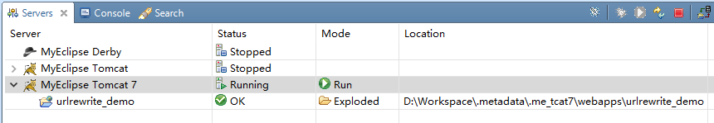

在浏览器中输入<http://localhost:8080/urlrewrite_demo>

显示结果为

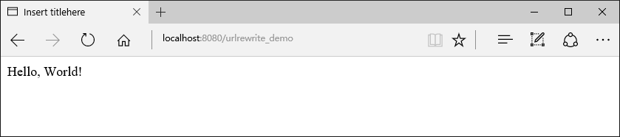

在浏览器中输入<http://localhost:8080/urlrewrite_demo/service/login/toLoginIndex>

显示结果为

