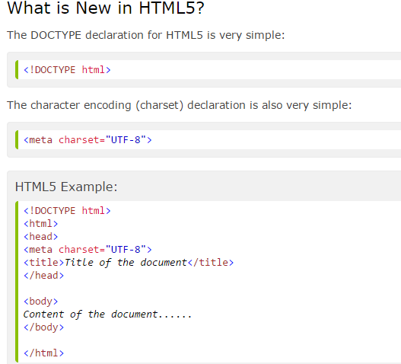

**New elements in HTML5** [**http://www.w3schools.com/html/html5_new_elements.asp**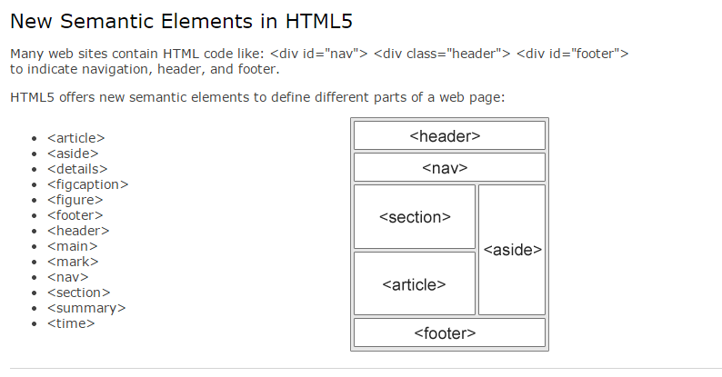](http://www.w3schools.com/html/html5_new_elements.asp#)

**经典HTML5 的例子** [**http://www.w3schools.com/html/tryit.asp?filename=tryhtml5_html5_skeleton**](http://www.w3schools.com/html/tryit.asp?filename=tryhtml5_html5_skeleton)

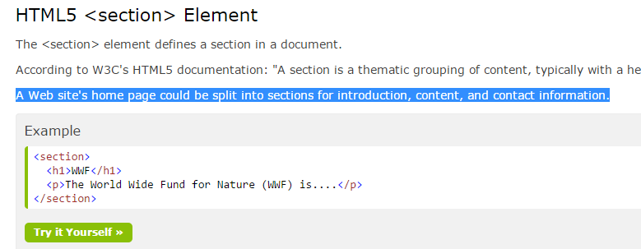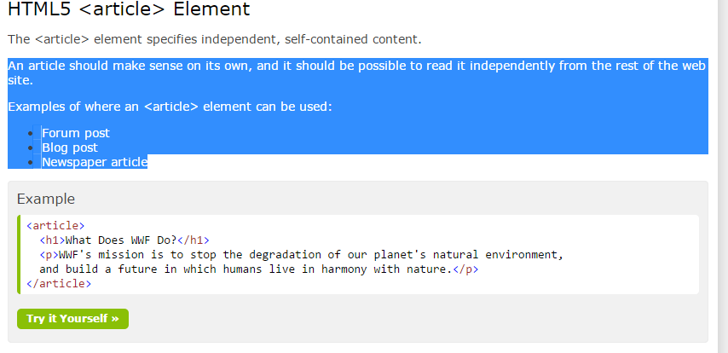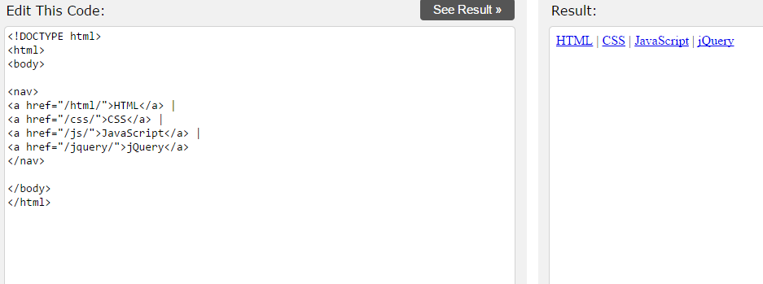

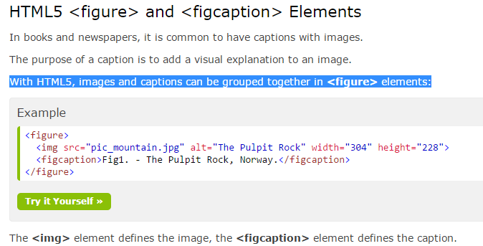

**图片和标题**

**Migration from HTML4 to HTML5**

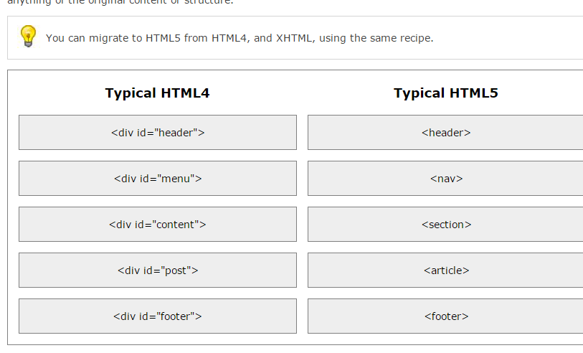

**第一步 改变 抬头 的代码**

**第二步 加以下代码 让html4学会学习**

**第三步 改变css格式。不用#id 直接名字**

**第四步 改变 标签名 ex**

**具体查看以下网址。重要。如何从html4代码转为html5代码。**

[**http://www.w3schools.com/html/html5_migration.asp**](http://www.w3schools.com/html/html5_migration.asp)

Change the <div> elements with **id="header"** and **id="footer"**:---<header> <footer>

Change the <div> element with **id="menu"**: to <nav>

Change the <div> element with **id="content"**: to an HTML5 semantic **<section>** element:

Change all <div> element with **class="post"**:

to HTML5 semantic **<article>** elements:

Remove these "no longer needed" <style> elements:

## The Difference Between <article> <section> and <div>

There is a confusing (lack of) difference in the HTML5 standard, between <article> <section> and <div>.

In the HTML5 standard, the <section> element is defined as a block of related elements.

The <article> element is defined as a complete, self-contained block of related elements.

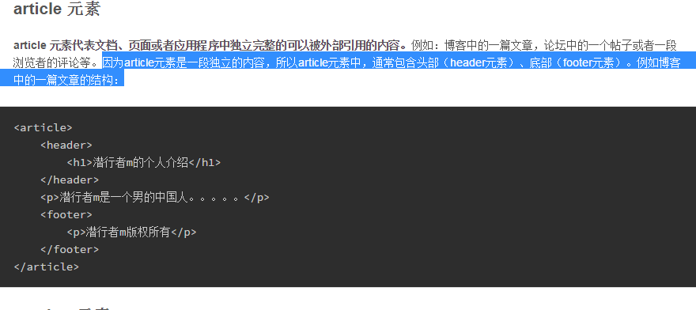 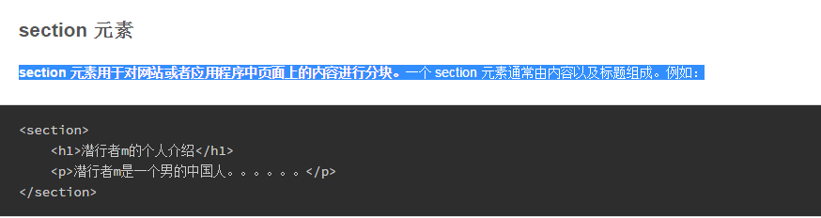

从上例可以看出，**section 元素中，需要包含一个<hn>标题元素**，而一般不用包含头部（header元素）或者底部（footer元素）。通常用 section 元素为那些有标题的内容进行分段。 section 元素的作用，是对页面上的内容分块处理，例如对文章分段等，相邻的 section 元素的内容，应当是相关的，而不是像 article 那样独立。

**div就是用来布局大块，在不同的内容块中，我们按照需求添加 article、section 等内容块，并且显示其中的内容，这样才是合理的使用这些元**

The <div> element is defined as a block of children elements.

HTML5 的编码风格：

## Use Lower Case Element Names

## 

## Close All HTML Elements

## 

## Use Lower Case Attribute Names

## 

## Quote Attribute Values

## 

## Required Attributes

## 

## Spaces and Equal Signs

## 

## 注意：编码的时候几乎不需要空格。Space-less

## Blank Lines and Indentation

Do not add blank lines without a reason.

For readability, add blank lines to separate large or logical code blocks.

For readability, add 2 spaces of indentation. Do not use TAB.

Do not use unnecessary blank lines and indentation.

## 

## 编码的时候 行与行之间 不怎么需要空行。

## 除了各个大类之间，如p和body header之间

## HTML Comments html5的注释风格！！！！！

## Style Sheets！！！！！CSS style的编写风格

## 

* **Use one space before the opening bracket. 大括号前一个空格**
* **Use space after each comma or semicolon.分号或冒号后加空格**
* **Use semicolon after each property-value pair, including the last.任何value加分号**
* **Only use quotes around values if the value contains spaces.**
* **Place the closing bracket on a new line, without leading spaces.结尾的大括号，闭合的大括号 另起一行 不需要空格**

## Use Lower Case File Names

## 

## All drawing on the HTML canvas must be done with **JavaScript**:

## 

## 

## Differences Between SVG and Canvas

SVG is a language for describing 2D graphics in XML.

Canvas draws 2D graphics, on the fly (with a JavaScript).

## 

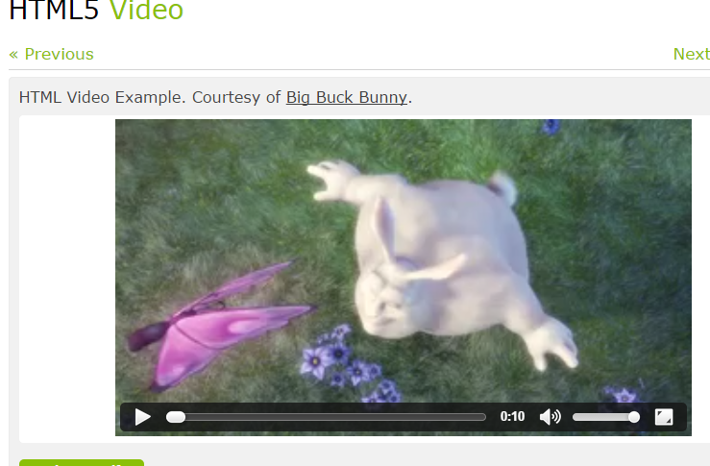 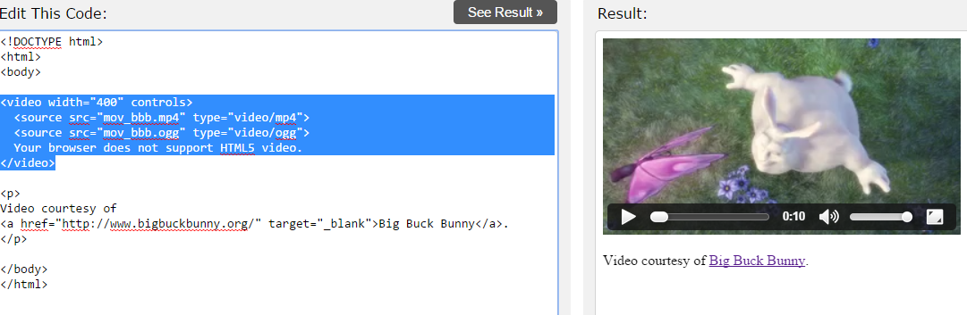

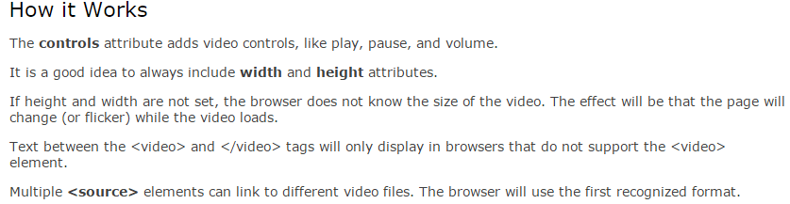

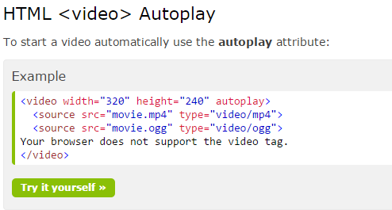

如果加了control就可以自己控制播放暂停。如果是autoplay就会自动播放

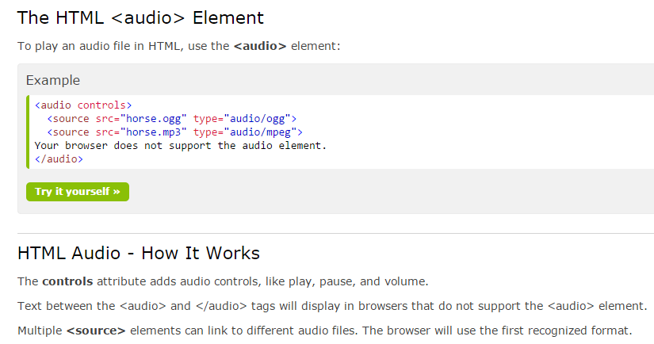 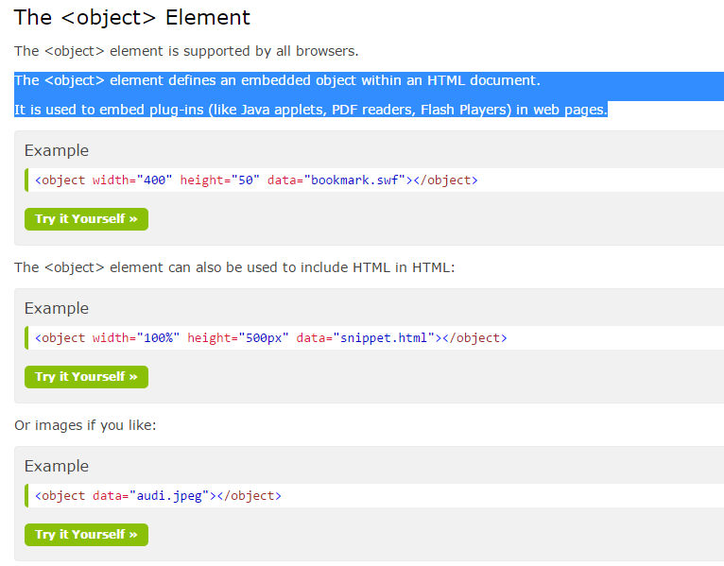 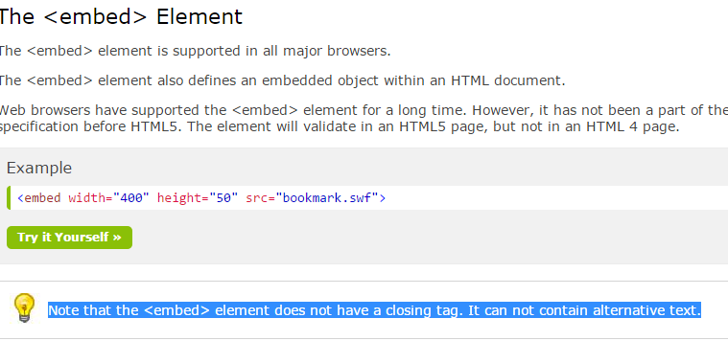

## Playing a YouTube Video in HTML

**（分别用<embed>和<object>）**

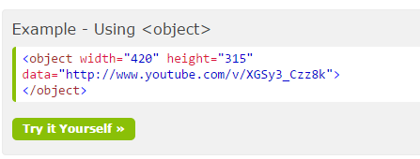 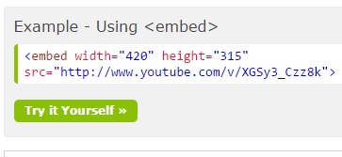

**Object 用的是data。 embed用的是src。而且embed标签不用关闭。**

**API：**

**1．定位**

## Displaying the Result in a Map

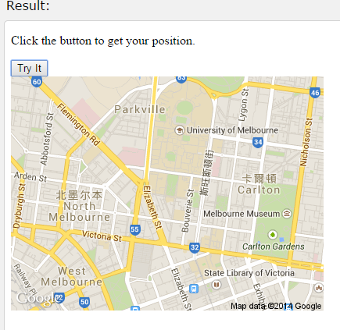 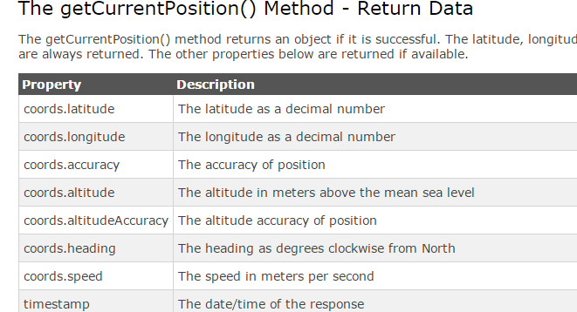

**API 2。拖拽**

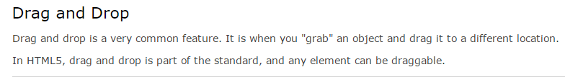 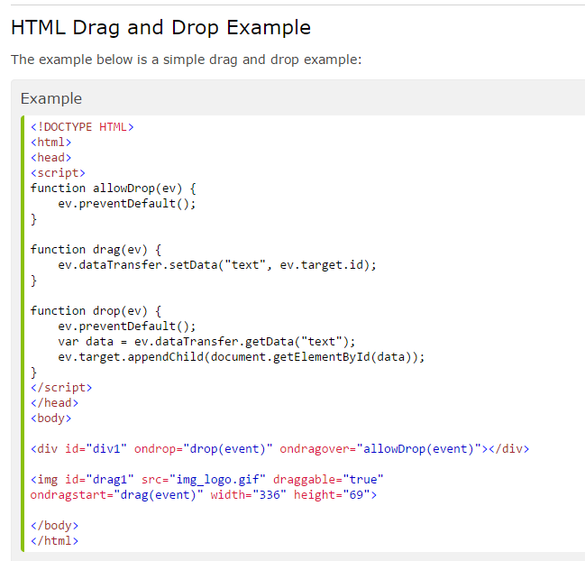

**例子拖拽使用js实现：**

**http://www.w3schools.com/html/html5_draganddrop.asp** 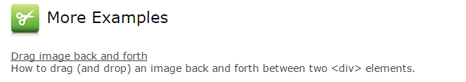

**API 3。HTML5 Local Storage （web存储）**

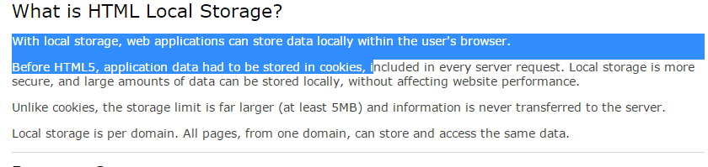

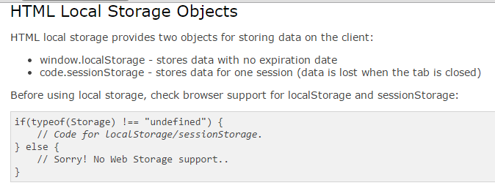 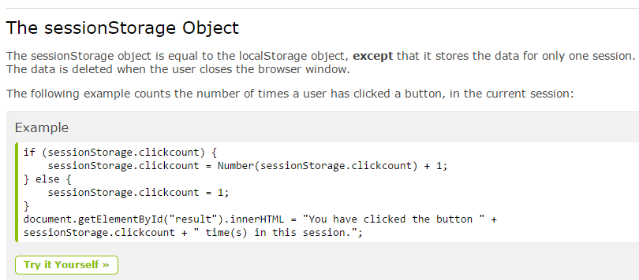

# API 4. HTML5 Application Cache应用缓存

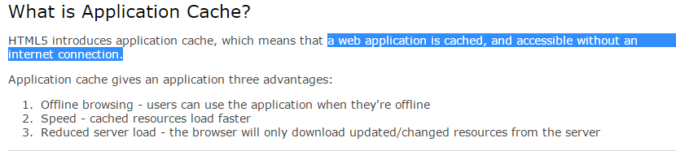 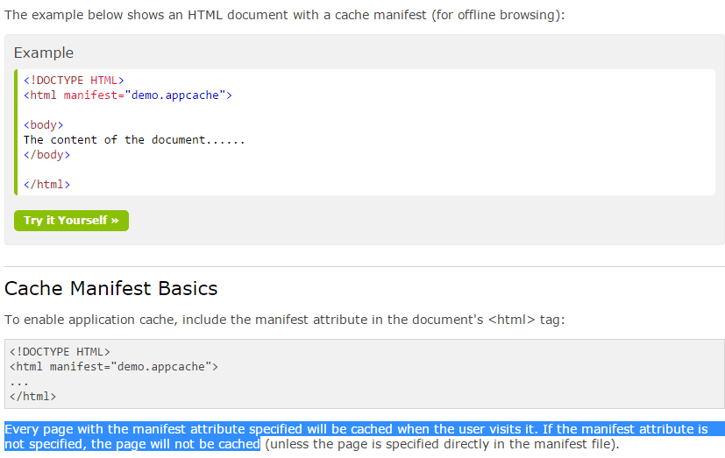

# API 5. HTML5 Web Workers

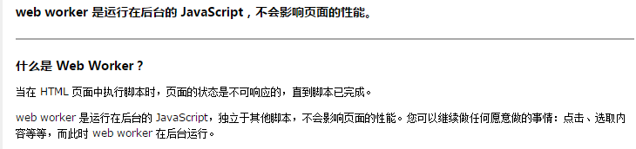

# API 6. HTML5 Server-Sent Events

