中山大学数据科学与计算机学院本科生实验报告
（2017年秋季学期）
课程名称：手机应用平台开发 任课教师： 刘宁
年级 | 15级 | 专业（方向） | 软件工程（计应）
学号 | 15331421 | 姓名 | 郑佳锋
电话 | 13719325472 | Email | 1773643139@qq.com
开始日期 | 10.14 | 完成日期 | 10.15

实验题目
Lab5

实现内容
- 用RecyclerView实现主界面。先在xml布局文件中声明：
- <android.support.v7.widget.RecyclerView
- android:id="@+id/id_recyclerview"
- android:divider="#ffff0000"
- android:dividerHeight="10dp"
- android:layout_width="match_parent"
- android:layout_height="match_parent" />

在MainActivity中设置Adapter，为了实现动画效果，调用ScaleInAnimationAdapter类。
- final HomeAdapter myAdapter = new HomeAdapter();
- ScaleInAnimationAdapter animationAdapter = new ScaleInAnimationAdapter(myAdapter);
- animationAdapter.setDuration(1000);
- final RecyclerView myRecView = (RecyclerView) findViewById(R.id.id_recyclerview);
- myRecView.setLayoutManager(new LinearLayoutManager(this));
- myRecView.setAdapter(animationAdapter);
- myRecView.setItemAnimator(new OvershootInLeftAnimator());
再来看自定义的类HomeAdapter，该类继承自RecyclerView的Adapter类，以自定义的类中类MyViewHolder作为参数。MyViewHolder继承自RecyclerView的ViewHolder类，该类包含两个成员，即主界面每个条目中的Button和TextView。HomeAdapter中实现了5个方法：
(1)public MyViewHolder onCreateViewHolder(ViewGroup parent, int viewType)；
调用inflate方法获取将要呈现的布局。
(2)public void setOnItemClickLitener(OnItemClickLitener mOnItemClickLitener)；
RecyclerView没有点击和长按事件，需要自己定义。OnItemClickLitener也是自定义的接口，包含onItemClick和onItemLongClick方法。
(3)public void onBindViewHolder(final MyViewHolder holder, int position)；
该方法将数据绑定到布局中的对应元素。同时处理点击和长按事件，将位置信息作为参数传递给onItemClick和onItemLongClick方法。
(4)public void removeData(int position)；
长按删除某个条目，通知数据移除相关信息。
(5)public int getItemCount()；
返回条目的数量。
HomeAdapter的完整定义如下：
- class HomeAdapter extends RecyclerView.Adapter<HomeAdapter.MyViewHolder>
- {

- @Override
- public MyViewHolder onCreateViewHolder(ViewGroup parent, int viewType)
- {
- MyViewHolder holder = new MyViewHolder(LayoutInflater.from(
- MainActivity.this).inflate(R.layout.item_home, parent,
- false));
- return holder;
- }

- private OnItemClickLitener mOnItemClickLitener;

- public void setOnItemClickLitener(OnItemClickLitener mOnItemClickLitener)
- {
- this.mOnItemClickLitener = mOnItemClickLitener;
- }

- @Override
- public void onBindViewHolder(final MyViewHolder holder, int position)
- {
- holder.tv.setText(mDatas.get(position));
- holder.btn.setText(mDatas.get(position).substring(0,1));
- if (mOnItemClickLitener != null)
- {
- holder.itemView.setOnClickListener(new View.OnClickListener()
- {
- @Override
- public void onClick(View v)
- {
- int pos = holder.getLayoutPosition();
- mOnItemClickLitener.onItemClick(holder.itemView, pos);
- }
- });

- holder.itemView.setOnLongClickListener(new View.OnLongClickListener()
- {
- @Override
- public boolean onLongClick(View v)
- {
- int pos = holder.getLayoutPosition();
- mOnItemClickLitener.onItemLongClick(holder.itemView, pos);
- return false;
- }
- });
- }
- }

- public void removeData(int position) {
- mDatas.remove(position);
- notifyItemRemoved(position);
- }

- @Override
- public int getItemCount()
- {
- return mDatas.size();
- }

- class MyViewHolder extends RecyclerView.ViewHolder
- {

- TextView tv;
- Button btn;

- public MyViewHolder(View view)
- {
- super(view);
- tv = (TextView) view.findViewById(R.id.id_num);
- btn = (Button) view.findViewById(R.id.button);
- }
- }
- }
自定义的OnItemClickLitener接口：
- interface OnItemClickLitener {
- void onItemClick(View view, int position);
- void onItemLongClick(View view , int position);
- }
在RecyclerView中重写点击和长按事件，点击打开新页面，使用Intent类，将商品名传递给新的页面；长按删除条目信息，弹出toast信息。
- myAdapter.setOnItemClickLitener(new OnItemClickLitener()
- {

- @Override
- public void onItemClick(View view, int position)
- {
- Intent intent = new Intent(MainActivity.this, NewActivity.class);
- String extra = mDatas.get(position);
- intent.putExtra("passname", extra);
- MainActivity.this.startActivity(intent);
- }

- @Override
- public void onItemLongClick(View view, int position)
- {
- Toast.makeText(MainActivity.this, "移除第" + position + "个商品",
- Toast.LENGTH_SHORT).show();
- myAdapter.removeData(position);
- }
- });
RecyclerView的布局，使用FrameLayout布局实现：
- <?xml version="1.0" encoding="utf-8"?>
- <FrameLayout
- android:layout_height="wrap_content"
- android:layout_width="match_parent"
- xmlns:android="http://schemas.android.com/apk/res/android">

- />
- <Button
- android:id="@+id/button"
- android:layout_width="60dp"
- android:layout_height="60dp"
- android:background="@drawable/shape"
- android:text="E"
- android:textSize="35dp"
- android:textColor="@color/buttontext"
- android:layout_marginLeft="20dp"
- android:layout_marginTop="53dp"
- />

- <TextView
- android:id="@+id/id_num"
- android:layout_width="match_parent"
- android:layout_height="50dp"
- android:gravity="left"
- android:text="1"
- android:textColor="@color/black"
- android:textSize="27dp"
- android:layout_marginLeft="90dp"
- android:layout_marginTop="66dp"
- />

- </FrameLayout>
RecyclerView的数据，使用initData进行初始化：
- private void initData(){
- mDatas = new ArrayList<String>();
- mDatas.add("Enchated Forest");
- mDatas.add("Arla Milk");
- mDatas.add("Devondale Milk");
- mDatas.add("Kindle Oasis");
- mDatas.add("waitrose 早餐麦片");
- mDatas.add("Mcvitie's 饼干");
- mDatas.add("Ferrero Rocher");
- mDatas.add("Maltesers");
- mDatas.add("Lindt");
- mDatas.add("Borggreve");
- }
至此，RecyclerView基本完工。
2.设置悬浮按钮，点击一下转到购物车界面，再点击一下回到主界面，按钮背景会跟着改变。
Xml：
- <FrameLayout
- android:layout_width="match_parent"
- android:layout_height="match_parent">
- <android.support.design.widget.FloatingActionButton
- android:id="@+id/floatButton"
- android:layout_width="wrap_content"
- android:layout_height="wrap_content"
- android:layout_gravity="bottom|end"
- android:layout_margin="45dp"
- android:elevation="20dp"
- android:src="@mipmap/shoplist"
- android:background="#FFF"
- app:backgroundTint="#FFFFFF" />
- </FrameLayout>
在MainActivity中设置点击事件，tag变量是0或者1，用来记录当前是哪个界面：
- final FloatingActionButton floatBtn = (FloatingActionButton) findViewById(R.id.floatButton);
- floatBtn.setOnClickListener(new View.OnClickListener() {
- @Override
- public void onClick(View v) {
- if (tag == 0) {
- myRecView.setVisibility(View.INVISIBLE);
- shopList.setVisibility(View.VISIBLE);
- floatBtn.setImageResource(R.mipmap.mainpage);
- tag = 1;
- }
- else if (tag == 1){
- shopList.setVisibility(View.INVISIBLE);
- myRecView.setVisibility(View.VISIBLE);
- floatBtn.setImageResource(R.mipmap.shoplist);
- tag = 0;
- }
- }
- });
从上面代码可以看出，点击悬浮按钮后并没有条状到新的activity中。也就是说主界面的RecyclerView和购物车的ListView处于同一个布局文件中。所谓的“跳转”只是设置它们的可见性而已。下面开始实现购物车的ListView。
3.购物车页面布局，包括一个Button和两个TextView，用LinearLayout布局实现：
- <LinearLayout
- android:layout_width="match_parent"
- android:layout_height="match_parent"
- android:descendantFocusability="blocksDescendants"
- xmlns:android="http://schemas.android.com/apk/res/android">

- <Button
- android:id="@+id/shopButton"
- android:layout_width="40dp"
- android:layout_height="40dp"
- android:background="@drawable/shape"
- android:text="*"
- android:textSize="20dp"
- android:textColor="@color/buttontext"
- android:layout_marginLeft="20dp"
- android:layout_marginTop="22dp"
- />
- <TextView
- android:id="@+id/goods"
- android:layout_width="wrap_content"
- android:layout_height="wrap_content"
- android:padding="15dp"
- android:textSize="15sp"
- android:textColor="#000000"
- android:layout_marginTop="15dp"
- android:layout_marginBottom="15dp"
- android:text="购物车购物车购物车"
- />
- <TextView
- android:id="@+id/price"
- android:layout_weight="1"
- android:layout_width="0dp"
- android:layout_height="wrap_content"
- android:gravity="end"
- android:padding="15dp"
- android:textSize="15sp"
- android:textColor="#000000"
- android:layout_marginTop="15dp"
- android:layout_marginBottom="15dp"
- android:text="价格"
- />
- </LinearLayout>
实现ListView，先声明，注意和RecyclerView的声明在一块：
- <ListView
- android:id="@+id/shoppinglist"
- android:layout_width="match_parent"
- android:layout_height="wrap_content"
- android:clickable="true"
- xmlns:android="http://schemas.android.com/apk/res/android">

- </ListView>
在MainActivity中实现ListView，先初始化数据，购物车页面第一栏比较特殊，它的Button中符号为“*”,而其他条目是名称的第一个字母，所以需要特殊处理：
- final ListView shopList = (ListView) findViewById(R.id.shoppinglist);
- String[] goods = new String[]{"购物车"};
- String[] price = new String[]{"价格"};
- for (int i = 0; i < goods.length; i++) {
- Map<String, String> temp = new LinkedHashMap<String, String>();
- temp.put("goods", goods[i]);
- temp.put("price", price[i]);
- if (goods[i] == "购物车"){
- temp.put("shopButton", "*");
- }
- else{
- temp.put("shopButton", goods[i].substring(0, 1));
- }
- data.add(temp);
- }
使用SimpleAdapter：
- simpleAdapter = new SimpleAdapter(MainActivity.this, data, R.layout.item_shop,
- new String[]{"goods", "price","shopButton"}, new int[]{R.id.goods, R.id.price, R.id.shopButton});
- shopList.setAdapter(simpleAdapter);
设置点击事件：同样将点击位置的商品名称作为Intent的参数传递给下一个界面，注意界面的第一栏同样需要特殊处理，点击后没有响应；设置长按事件：弹出移除商品的对话框，点击取消返回原界面，点击确定删除位置的商品，并通知数据队列更新数据：
- shopList.setOnItemClickListener(new AdapterView.OnItemClickListener() {
- @Override
- public void onItemClick(AdapterView<?> parent, View view, int position, long id) {
- if (position == 0){}
- else {
- Intent intent = new Intent(MainActivity.this, NewActivity.class);
- Map<String, String> extra = data.get(position);
- intent.putExtra("passname", extra.get("goods"));
- MainActivity.this.startActivity(intent);
- }
- }
- });
- shopList.setOnItemLongClickListener(new AdapterView.OnItemLongClickListener(){
- @Override
- public boolean onItemLongClick(AdapterView<?> arg0, View arg1,
- final int arg2, long arg3) {
- AlertDialog.Builder dialogbuilder = new AlertDialog.Builder(MainActivity.this);
- dialogbuilder.setTitle("上传头像");
- String temp = data.get(arg2).get("goods");
- dialogbuilder.setMessage("从购物车移除" + temp +"?");
- dialogbuilder.setNegativeButton("取消", click1);
- dialogbuilder.setPositiveButton("确定",
- new DialogInterface.OnClickListener() {
- @Override
- public void onClick(DialogInterface dialogInterface, int i) {
- data.remove(arg2);
- simpleAdapter.notifyDataSetChanged();
- }
- });
- AlertDialog dialog = dialogbuilder.create();
- dialog.show();
- return true;
- }
- private DialogInterface.OnClickListener click1 = new DialogInterface.OnClickListener(){
- @Override
- public void onClick(DialogInterface arg0, int arg1){
- arg0.cancel();
- }
- };
- });
至此，主界面基本完工。下面开始新页面的设计。
4.新页面总体使用约束布局实现。顶部图片占三分之一使用引导线实现，底部更多商品信息同样使用ListView实现。布局文件如下：
- <android.support.constraint.ConstraintLayout
- android:layout_width="match_parent"
- android:layout_height="match_parent"
- android:background="#FFF"
- xmlns:android="http://schemas.android.com/apk/res/android"
- xmlns:app="http://schemas.android.com/apk/res-auto">
- <android.support.constraint.Guideline
- android:id="@+id/guideline1"
- android:layout_width="match_parent"
- android:layout_height="match_parent"
- android:orientation="horizontal"
- app:layout_constraintGuide_percent="0.333333"
- />
- <android.support.constraint.Guideline
- android:id="@+id/guideline2"
- android:layout_width="match_parent"
- android:layout_height="match_parent"
- android:orientation="vertical"
- app:layout_constraintGuide_percent="0.25"
- />
- <android.support.constraint.Guideline
- android:id="@+id/guideline3"
- android:layout_width="match_parent"
- android:layout_height="match_parent"
- android:orientation="vertical"
- app:layout_constraintGuide_percent="0.75"
- />
- <android.support.constraint.Guideline
- android:id="@+id/guideline4"
- android:layout_width="match_parent"
- android:layout_height="match_parent"
- android:orientation="horizontal"
- app:layout_constraintGuide_percent="0.46"
- />
- <ImageView
- android:id="@+id/leftBlank"
- android:layout_width="wrap_content"
- android:layout_height="0dp"
- android:adjustViewBounds="true"
- android:src="@mipmap/background"
- app:layout_constraintTop_toTopOf="parent"
- app:layout_constraintBottom_toBottomOf="@+id/guideline1"
- app:layout_constraintLeft_toLeftOf="parent"
- app:layout_constraintRight_toLeftOf="@+id/photo"
- />
- <ImageView
- android:id="@+id/rightBlank"
- android:layout_width="wrap_content"
- android:layout_height="0dp"
- android:adjustViewBounds="true"
- android:src="@mipmap/background"
- app:layout_constraintTop_toTopOf="parent"
- app:layout_constraintBottom_toBottomOf="@+id/guideline1"
- app:layout_constraintRight_toRightOf="parent"
- app:layout_constraintLeft_toRightOf="@+id/photo"
- />
- <ImageView
- android:id="@+id/photo"
- android:layout_width="wrap_content"
- android:layout_height="0dp"
- android:adjustViewBounds="true"
- android:src="@mipmap/ferrero"
- app:layout_constraintTop_toTopOf="parent"
- app:layout_constraintBottom_toBottomOf="@+id/guideline1"
- app:layout_constraintLeft_toLeftOf="@+id/guideline2"
- app:layout_constraintRight_toRightOf="@+id/guideline3"
- />
- <TextView
- android:id="@+id/shopName"
- android:layout_width="wrap_content"
- android:layout_height="wrap_content"
- android:text="Enchated Forest"
- android:textColor="@color/black"
- android:textSize="20sp"
- android:layout_marginLeft="20dp"
- app:layout_constraintLeft_toLeftOf="parent"
- app:layout_constraintBottom_toBottomOf="@+id/guideline1"
- android:layout_marginBottom="20dp"
- />
- <ImageView
- android:id="@+id/star"
- android:layout_width="35dp"
- android:layout_height="35dp"
- android:src="@mipmap/empty_star"
- app:layout_constraintBottom_toBottomOf="@+id/shopName"
- app:layout_constraintRight_toRightOf="parent"
- android:layout_marginRight="20dp"
- />
- <TextView
- android:id="@+id/shopPrice"
- android:layout_width="wrap_content"
- android:layout_height="wrap_content"
- android:text="￥5.00"
- android:textColor="#D5000000"
- android:layout_marginLeft="20dp"
- app:layout_constraintLeft_toLeftOf="parent"
- app:layout_constraintTop_toBottomOf="@id/leftBlank"
- android:layout_marginTop="10dp"
- />
- <TextView
- android:id="@+id/shopInfo"
- android:layout_width="wrap_content"
- android:layout_height="wrap_content"
- android:text="作者 Johanna Basford"
- android:textColor="#8A000000"
- android:layout_marginLeft="20dp"
- app:layout_constraintLeft_toLeftOf="parent"
- app:layout_constraintTop_toBottomOf="@+id/shopPrice"
- android:layout_marginTop="10dp"
- />
- <ImageView
- android:id="@+id/shopBus"
- android:layout_width="30dp"
- android:layout_height="30dp"
- android:foreground="@mipmap/shoplist"
- app:layout_constraintTop_toBottomOf="@+id/guideline1"
- app:layout_constraintRight_toRightOf="parent"
- android:layout_marginRight="20dp"
- android:layout_marginTop="20dp"
- />
- <View
- android:layout_height="0dp"
- app:layout_constraintTop_toBottomOf="@+id/guideline1"
- android:layout_width="1dp"
- android:background="#1E000000"
- android:orientation="vertical"
- android:layout_marginTop="15dp"
- app:layout_constraintRight_toLeftOf="@+id/shopBus"
- app:layout_constraintBottom_toBottomOf="@+id/shopBus"
- android:layout_marginRight="20dp"
- />
- <View
- android:layout_width="fill_parent"
- app:layout_constraintTop_toBottomOf="@+id/guideline4"
- android:layout_height="1dp"
- android:background="#1E000000"
- android:orientation="horizontal"
- android:layout_marginLeft="10dp"
- android:layout_marginRight="10dp"
- />
- <TextView
- android:id="@+id/more"
- android:layout_width="match_parent"
- android:layout_height="wrap_content"
- android:text="更多产品信息"
- android:textColor="#D5000000"
- android:textSize="20sp"
- app:layout_constraintTop_toTopOf="@id/guideline4"
- android:layout_marginTop="10dp"
- android:layout_marginLeft="20dp"
- />
- <View
- android:id="@+id/moreLine"
- android:layout_width="fill_parent"
- app:layout_constraintTop_toBottomOf="@+id/more"
- android:layout_height="20dp"
- android:background="#1E000000"
- android:orientation="horizontal"
- android:layout_marginTop="10dp"
- />
- <ImageView
- android:id="@+id/back"
- android:layout_width="30dp"
- android:layout_height="30dp"
- android:foreground="@mipmap/back"
- app:layout_constraintTop_toTopOf="parent"
- app:layout_constraintLeft_toLeftOf="parent"
- android:layout_marginLeft="20dp"
- android:layout_marginTop="12dp"
- />
- <ListView
- android:id="@+id/moreInfo"
- android:layout_width="match_parent"
- android:layout_height="wrap_content"
- app:layout_constraintTop_toBottomOf="@+id/moreLine"
- >

- </ListView>

- </android.support.constraint.ConstraintLayout>
ListView实现类似，直接上代码：
Xml：
- <LinearLayout
- android:layout_width="match_parent"
- android:layout_height="match_parent"
- xmlns:android="http://schemas.android.com/apk/res/android">

- <TextView
- android:id="@+id/infoItem"
- android:layout_width="wrap_content"
- android:layout_height="wrap_content"
- android:paddingLeft="0dp"
- android:textSize="20sp"
- android:textColor="#D5000000"
- android:layout_marginLeft="20dp"
- android:layout_marginTop="13dp"
- android:layout_marginBottom="13dp"
- android:text="一键下单"
- />
- </LinearLayout>
Java：
- ListView moreInfo = (ListView) findViewById(R.id.moreInfo);
- List<Map<String, String>> data = new ArrayList<Map<String, String>>();
- String[] infoItem = new String[]{"一键下单","分享商品","不感兴趣","查看更多商品促销信息"};
- for(int i = 0; i < infoItem.length; i++){
- Map<String, String> temp = new LinkedHashMap<String, String>();
- temp.put("infoItem", infoItem[i]);
- data.add(temp);
- }
- SimpleAdapter simpleAdapter = new SimpleAdapter(NewActivity.this, data, R.layout.more_info,
- new String[]{"infoItem"}, new int[]{R.id.infoItem});
- moreInfo.setAdapter(simpleAdapter);
点击星标空心和实心切换，使用flag来“记住”状态：
- final ImageView star = (ImageView) findViewById(R.id.star);
- star.setOnClickListener(new View.OnClickListener() {
- @Override
- public void onClick(View v) {
- if (flag == 0){
- star.setImageResource(R.mipmap.full_star);
- flag = 1;
- }
- else if (flag == 1){
- star.setImageResource(R.mipmap.empty_star);
- flag = 0;
- }
- }
- });
设置返回按钮，点击后调用finish()即可：
- ImageView back = (ImageView) findViewById(R.id.back);
- back.setOnClickListener(new View.OnClickListener() {
- @Override
- public void onClick(View v) {
- finish();
- }
- });
至此，新页面除了数据以外，基本的布局已经完成。最后讲讲页面之间的信息传递。
5.前面已经讲到，主界面的RecyclerView或者ListView被点击之后，被点击的商品名称会作为Intent的参数传递给新页面并打开新界面。之所以只传递商品名称，是因为我在新页面的java文件中保存了所有的商品信息，通过商品名称就可以map到其他的信息再将它们渲染在新页面中。比较棘手的是图片的信息，可以将图片的id转化为String与商品名称存在map中，使用时再将它转化为int类型的id。如下：
商品信息：
- final Map<String, String> name_price = new LinkedHashMap<String, String>();
- name_price.put("Enchated Forest", "¥5.00");
- name_price.put("Arla Milk", "¥59.00");
- name_price.put("Devondale Milk", "¥79.00 ");
- name_price.put("Kindle Oasis", "¥2399.00");
- name_price.put("waitrose 早餐麦片", "¥179.00");
- name_price.put("Mcvitie's 饼干", "¥14.90");
- name_price.put("Ferrero Rocher", "¥132.59 ");
- name_price.put("Maltesers", "¥141.43");
- name_price.put("Lindt", "¥139.43");
- name_price.put("Borggreve", "¥28.90 ");
- Map<String, String> name_info = new LinkedHashMap<String, String>();
- name_info.put("Enchated Forest", "作者 Johanna Basford");
- name_info.put("Arla Milk", "产地 德国");
- name_info.put("Devondale Milk", "产地 澳大利亚");
- name_info.put("Kindle Oasis", "版本 8GB");
- name_info.put("waitrose 早餐麦片", "重量 2Kg");
- name_info.put("Mcvitie's 饼干", "产地 英国");
- name_info.put("Ferrero Rocher", "重量 300g");
- name_info.put("Maltesers", "重量 118g");
- name_info.put("Lindt", "重量 249g");
- name_info.put("Borggreve", "重量 640g");
- Map<String, String> name_pic = new LinkedHashMap<String, String>();
- name_pic.put("Enchated Forest", String.valueOf(R.mipmap.enchatedforest));
- name_pic.put("Arla Milk", String.valueOf(R.mipmap.arla));
- name_pic.put("Devondale Milk", String.valueOf(R.mipmap.devondale));
- name_pic.put("Kindle Oasis", String.valueOf(R.mipmap.kindle));
- name_pic.put("waitrose 早餐麦片", String.valueOf(R.mipmap.waitrose));
- name_pic.put("Mcvitie's 饼干", String.valueOf(R.mipmap.mcvitie));
- name_pic.put("Ferrero Rocher", String.valueOf(R.mipmap.ferrero));
- name_pic.put("Maltesers", String.valueOf(R.mipmap.maltesers));
- name_pic.put("Lindt", String.valueOf(R.mipmap.lindt));
- name_pic.put("Borggreve", String.valueOf(R.mipmap.borggreve));
使用Bundle提取其他页面传递过来的信息，然后设置本页面的信息：
- Bundle bundle = getIntent().getExtras();
- if(bundle != null){
- passname = bundle.getString("passname");
- }
- TextView shopname = (TextView) findViewById(R.id.shopName);
- shopname.setText(passname);
- String price = name_price.get(passname);
- TextView shopprice = (TextView) findViewById(R.id.shopPrice);
- shopprice.setText(price);
- String info = name_info.get(passname);
- TextView shopinfo = (TextView) findViewById(R.id.shopInfo);
- shopinfo.setText(info);
- ImageView photo = (ImageView) findViewById(R.id.photo);
- photo.setImageResource(Integer.parseInt(name_pic.get(passname)));
另外一个消息传递是，点击新页面的购物车按钮后，该商品被添加到主页面的购物车中去，可以使用eventBus实现。
新建类FirstEvent，设定需要发布的信息：
- public class FirstEvent {
- private String namemsg;
- private String pricemsg;
- public FirstEvent(String str1, String str2) {
- namemsg = str1;
- pricemsg = str2;
- }
- public String getNamemsg(){
- return namemsg;
- }
- public String getPricemsg(){
- return pricemsg;
- }
- }
在新页面中设置发布者：
- ImageView shopbus = (ImageView) findViewById(R.id.shopBus);
- shopbus.setOnClickListener(new View.OnClickListener() {
- @Override
- public void onClick(View v) {
- Toast.makeText(NewActivity.this, "商品已加入购物车", Toast.LENGTH_SHORT).show();
- EventBus.getDefault().post(
- new FirstEvent(passname, name_price.get(passname)));
- }
- });
在主界面中设置注册，解除注册和处理时间：
- EventBus.getDefault().register(this);
- protected void onDestroy(){
- super.onDestroy();
- EventBus.getDefault().unregister(this);//反注册EventBus
- }
- @Subscribe
- public void onEventMainThread(FirstEvent event) {
- Map<String, String> temp = new LinkedHashMap<String, String>();
- temp.put("goods", event.getNamemsg());
- temp.put("price", event.getPricemsg());
- temp.put("shopButton", event.getNamemsg().substring(0,1));
- data.add(temp);
- simpleAdapter.notifyDataSetChanged();
- }
至此，实验完成。

实验结果
主界面： 购物车界面： 商品详情界面：

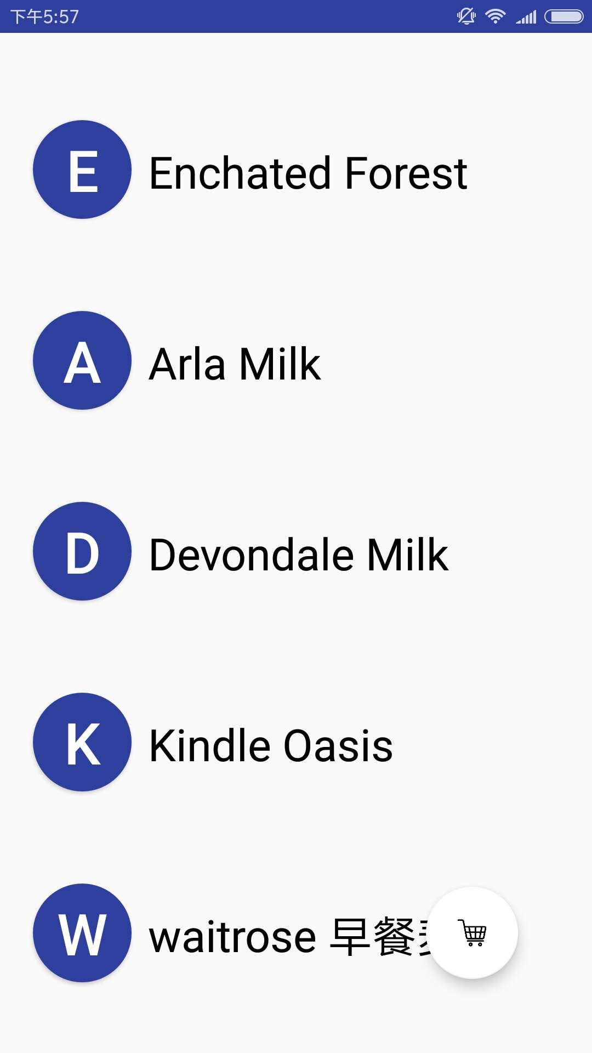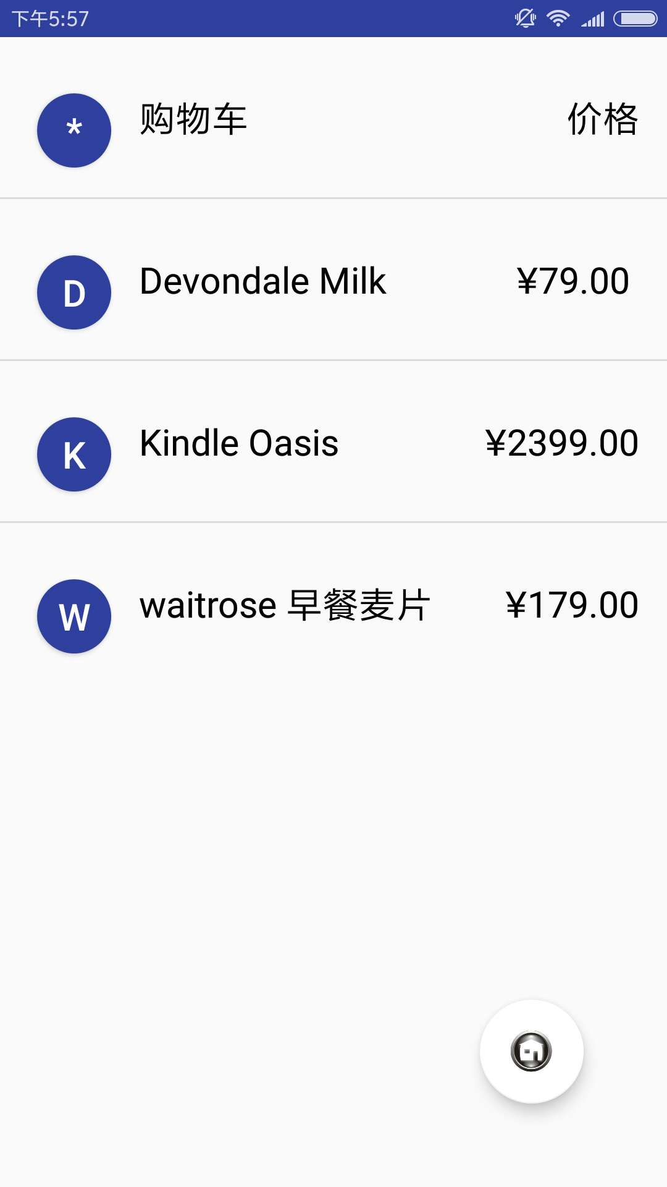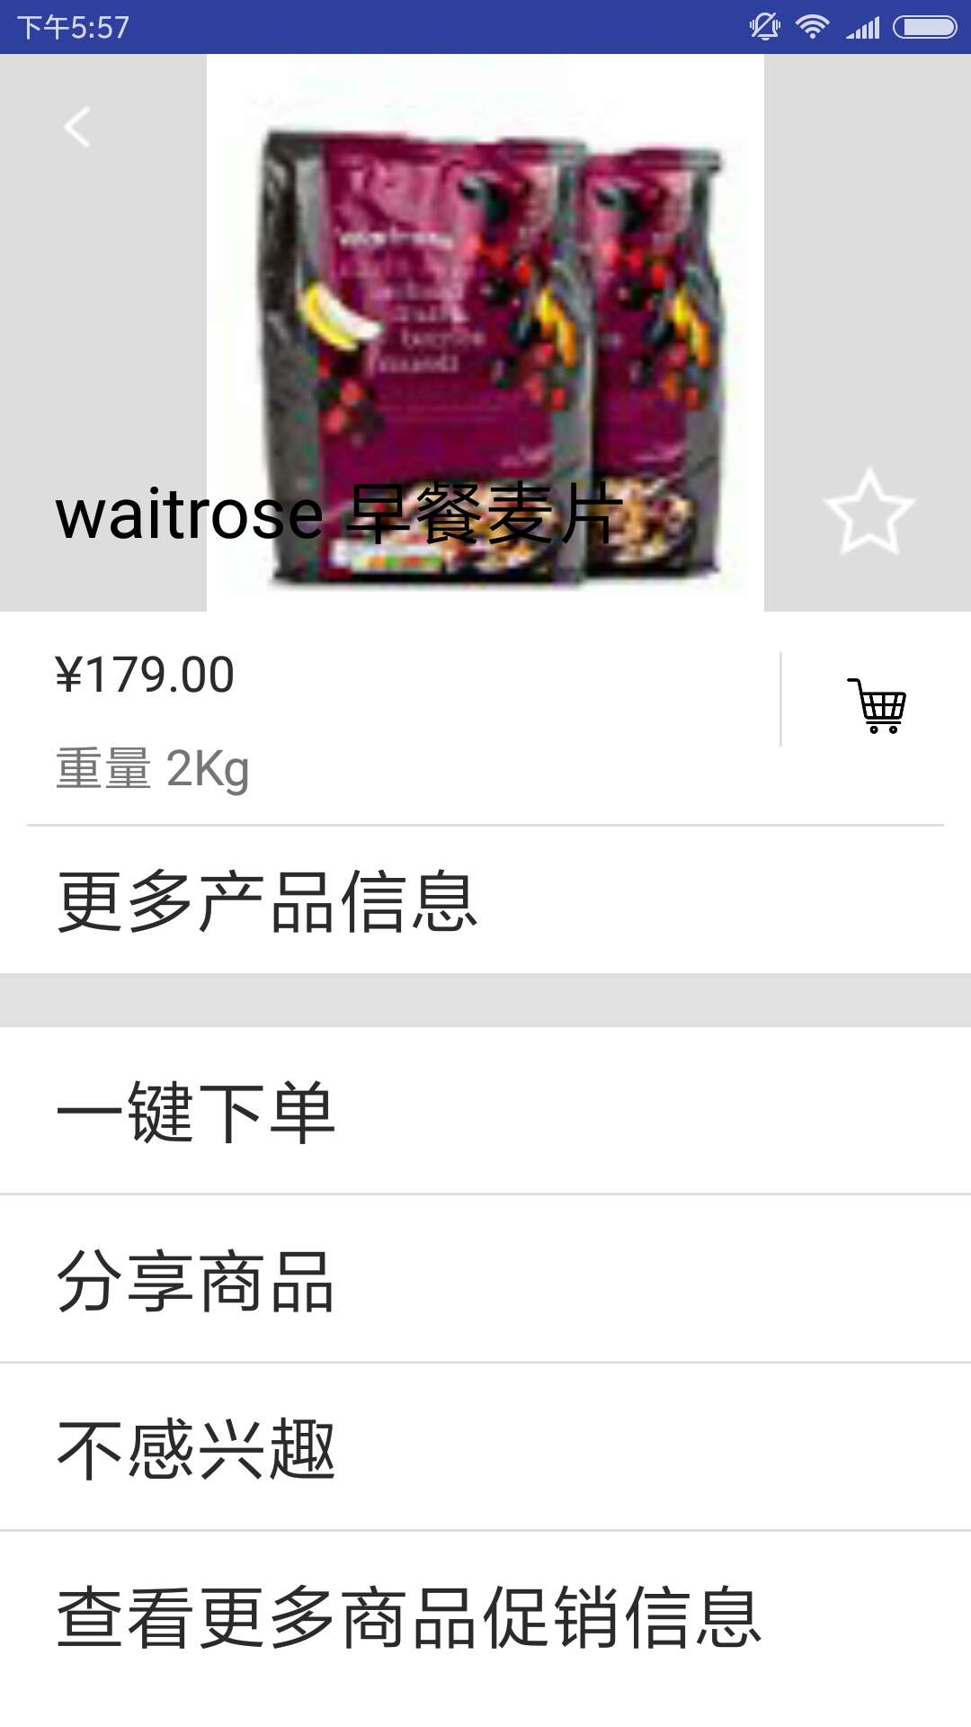
- 实验遇到的困难和解决方法

首先遇到的困难是RecyclerView的使用，网上关于RecyclerView的博客有很多，但内容出入很大，改了很多次都不成功。后来耐心理解了RecyclerView各个方法的含义，才真正学会了使用RecyclerView。
遇到的另一个困难是商品详情页面的布局。最顶部占屏幕的1/3，而且图片还要居中，刚开始尝试了各种各样的布局，都搞不定，可能是用不熟悉的缘故。后来用约束布局的引导线，轻松解决，现在真心觉得约束布局是最好用的布局。
还遇到一个问题，就是点击购物车图标后商品添加到购物车。最开始想到的还是Intent，但是Intent貌似一定要跳转到其他页面去……后来经过TA提示，才知道可以用eventBus。于是就百度了eventBus的用法。按照教程一步一步添加代码后，还是不行。最后偶然看到一篇博客，才知道大多数博客中漏掉了@Subscribe这一句。

五、实验思考及感想
这次实验，难度相较前几次实验，有了质的飞跃……以前碰到这种老大难的作业，大概会很急躁，自暴自弃。但是由于对android比较感兴趣，所以就一直鼓励自己，只要多花一点时间，就一定能够完成。结果，差不多花了两三天的时间，终于完整地做出来了。对比自己的app和给的demo，基本没有什么差异，真的蛮有成就感。这次感触比较深的关于博客的使用。刚开始接触一个知识点，什么都不会，首先想到的当然是去网上看看人家怎么用，然后再依样画葫芦，慢慢熟悉这个知识点。网上的博客不乏精品，的确给了我很大的帮助。但是也有一些博客，断章取义，代码这摘一段那摘一段，让人十分糊涂，白白浪费很多时间，所以总结一点就是，遇到新的知识点，可以先查看官方文档，努力去理解，而不是照搬博客的内容，遇到它们不对的地方也能够有辨识力，不至于往坑里跳。

