Made by: Jerry Zheng
Feel free to modify these variables to check the mitigation effects:
In Server:
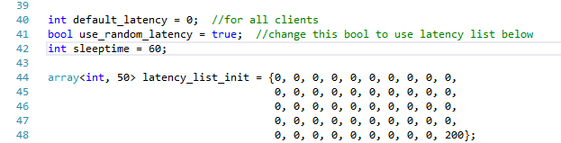
- To add latency to all messages/packets in the message queue, please modify the global parameter default_latency.
- Change use_random_latency global variable from false to true to enable random artificial latency. For checking result more clearly, we create a “latency list,” which stores all latency numbers to be added in a loop. Feel free to change those numbers and check the result.
- Change sleeptime variable to change game frame rate. This variable also influences the latency. Because we call Sleep(60) in periodicHandler(), messages to be sent will be delayed by this Sleep for 0-60ms, depending on when the message is received.

In Client (JavaScript part):
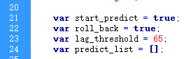
- Two Global variables to turn on prediction and roll back.
- lag_threshold is a variable for how long do we predict from last received message. 65 means if the next message has not come for 65ms, the client will start to predict.

In Client (Html part):
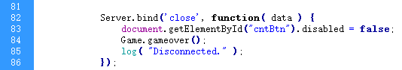
- Feel free to using “//” comment on line 84 (Game.gameover()) to check what will happen after the server is closed when start_predict == true. Disable this statement and close the server will cause the client to keep predicting (basically become a offline game).

