6.3
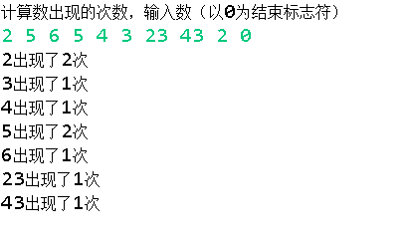

6.9


6.19
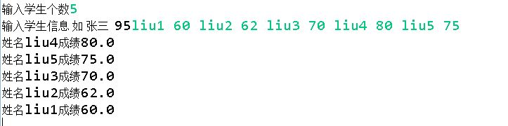

6.25


6.27


