First, inputting image by using the code ‘imread’, then displaying the image.

Second, extracting image information. In this stage, I quantized each color channel (RGB) to reduce the number of colors. In order to do that, I used a ‘for’ loop.

Third, segmenting the input image to super pixels. In this step, I transformed the image to lab form, and set the size of each segment to 30. The function I used was vl_slic, and then gradiented the image to display it.

Next, inputting the figures of each segment into one dimensional vector to analyses the image. By using the code named ‘hist’, I worked out the histogram.

Fifth, I computed histogram distance through the results of the step four. A formulation could be used to work out the distance.

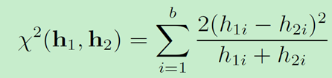

Sixth, I figured out the contrast ratio of the segments, and converted it to pixel contrast ratio.

Finally, using prior to enhance the result. To get the final map with good quality, I selected the central prior and multiplied the initial saliency map with the prior.

